Additional Information
Figures and figure legends
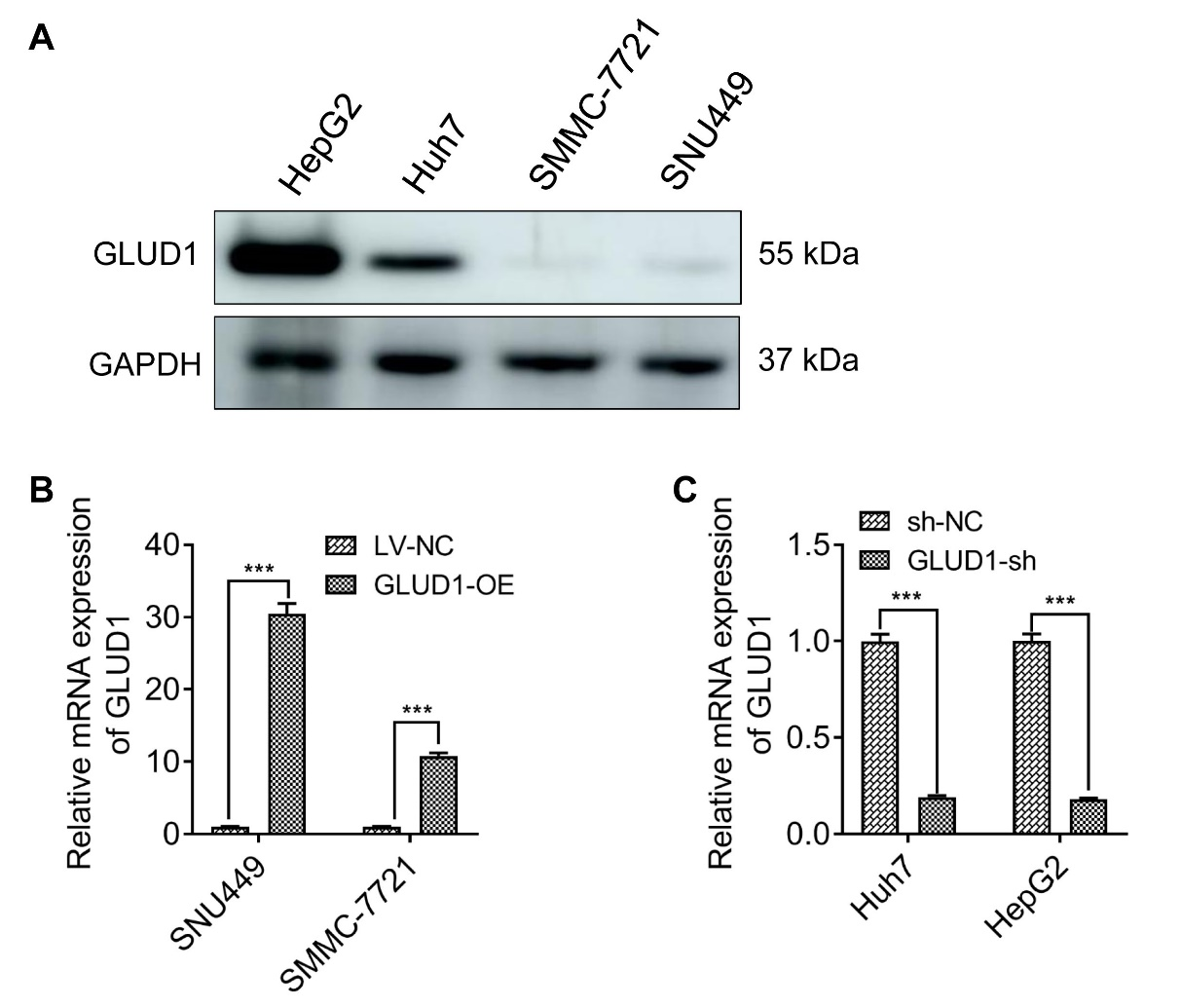
Fig.S1 Detection of GLUD1 in HCC cell lines. (A) Westwen blot analysis of GLUD1 in different HCC cell lines; (B) and (C) RT-qPCR analysis of GLUD1 in GLUD1 overexpressing (B) or knockdown (C) and control HCC cells. GLUD1-OE represents GLUD1 overexpressing HCC cell line, LV-NC represents control HCC cell line, GLUD1-sh represents GLUD1 knockdown HCC cell line, sh-NC represents control HCC cell line. ***p < 0.001.

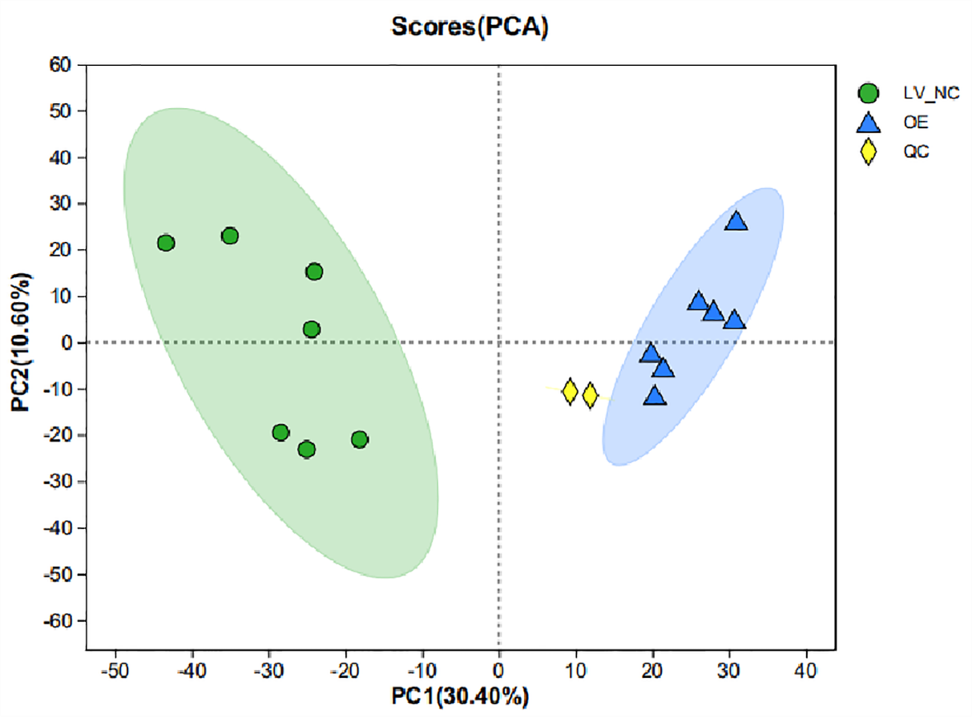
Fig.S2 PCA of peak areas detected in negative-ion modes in QC, GLUD1 overexpressing SNU449 cells, and control SNU449 cells.

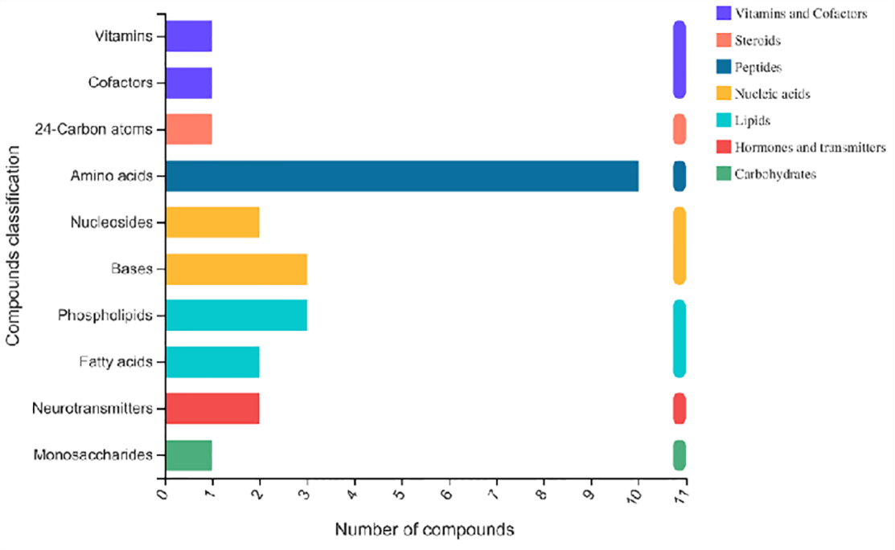
Fig.S3 Compounds classification of differentially expressed metabolites.

