Fig 3C FAM83D-1 WB
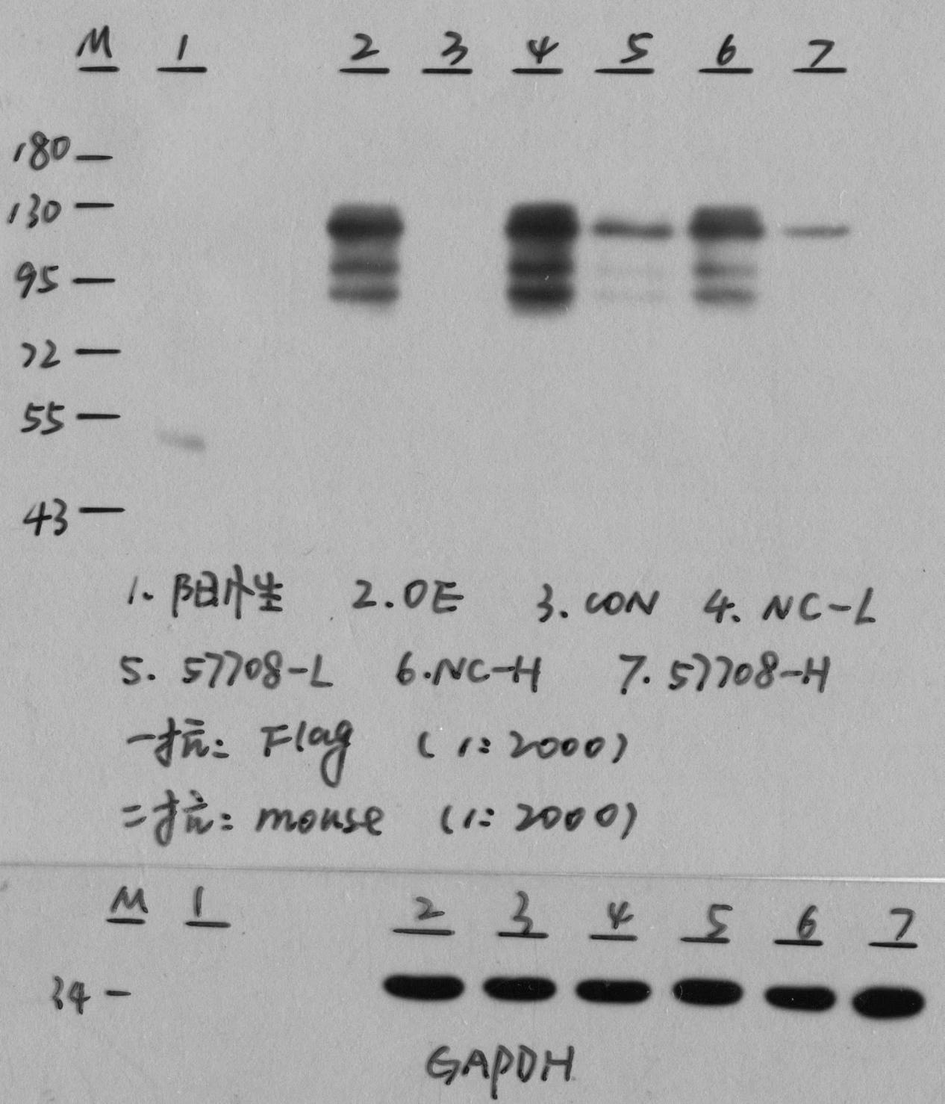

Fig 3C FAM83D-2 WB
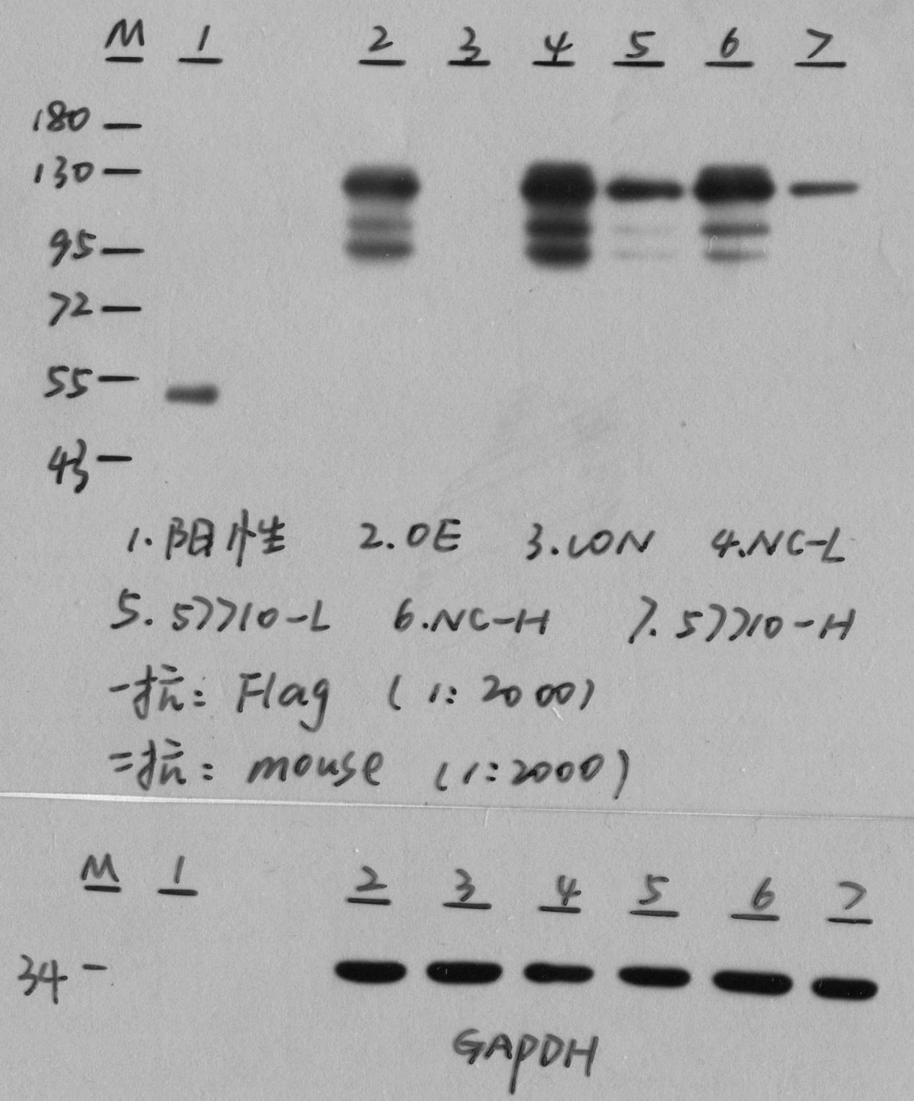

Fig 5F CDK1；BIRC5；GAPDH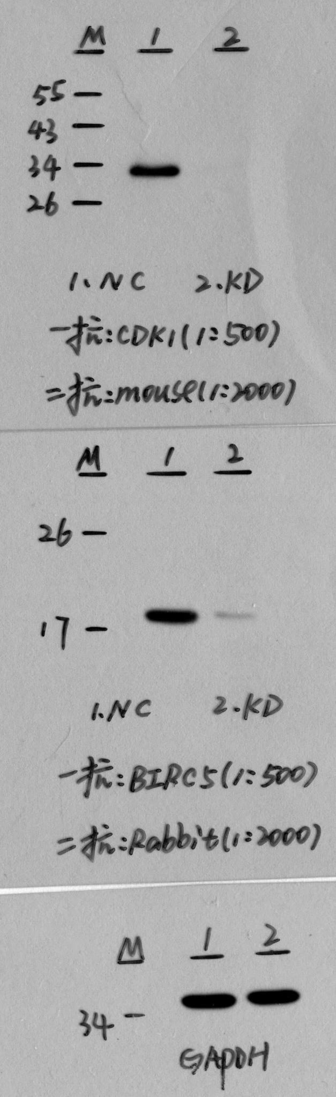
Fig 5F MCM2；CCNE1；GAPDH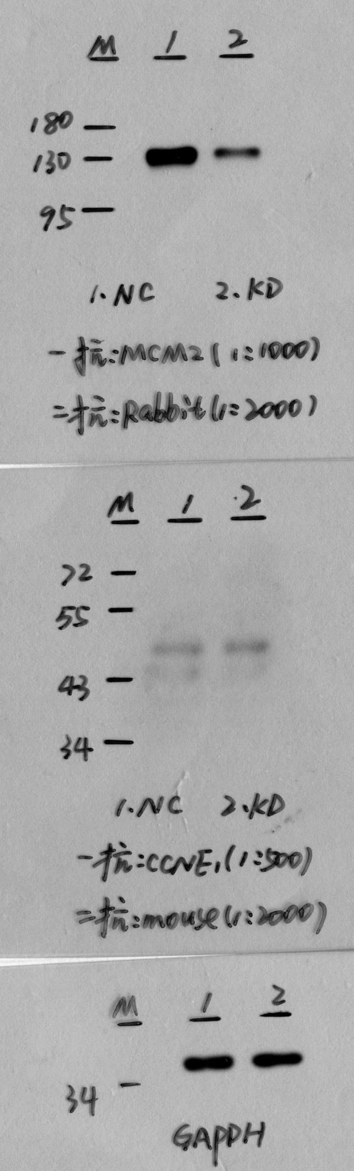
Fig 5F STAT1；GAPDH