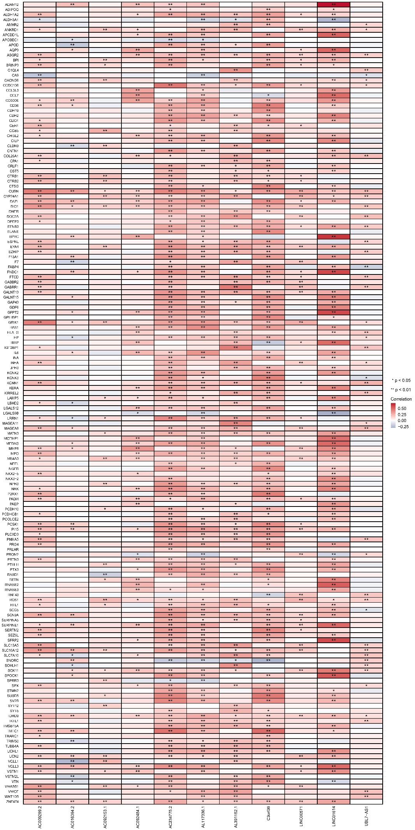
Supplementary figure S2: Heatmap for the correlation between 11 NETs-related lncRNAs and differential mRNA expression between high-risk group and low-risk group

