MR Method
 |  |  | Inverse variance weighted MR Egger
1 S EIV | 4  3  2  1  0 | Calcium on Bladder cancer βIV
   |  |  |  |  |  | 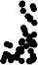 | 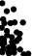
  −60 −40 −20 0

MR Test
 |  |  | Inverse variance weighted MR Egger  Simple mode |  | Weighted median Weighted mode
SNP effect on outcome | 0  −1  −2 | 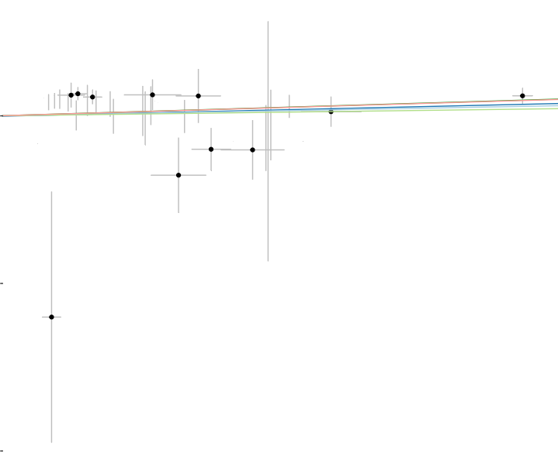  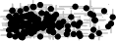
0.05 0.10 0.15 0.20
SNP effect on calcium

rs
rs1r8
rsr
rsr
rr
rsr
rsr
rsr
rsrr
rs
rs1r4
rsr
rs
rsr
rsr
rsr8
rsr0
rsr
rsr
rs
rs1r
rsrr
rsr
rsr
rsr
rsrr
rs
rsr
rsr23
rsr
rs11r
rs
rsr
rs9
rsr
rs1r
rsr
rs1r
rsr
rsr
rr
rs
rs
rsr
rsrr
rsrr
rs
rs
rr
rs
rs
rs
rsr
rsr
rs
rs
rs110
rs
rr
rs1
rs
rsr6
rsr
rr
rsr
rs
All
0.0 0.1 0.2 0.3 0.4 0.5
MR leave−one−out sensitivity analysis for 'Calcium' on 'Bladder cancer'

MR Method
 |  |  | Inverse variance weighted MR Egger
1 S EIV | 3  2  1 |     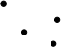      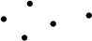          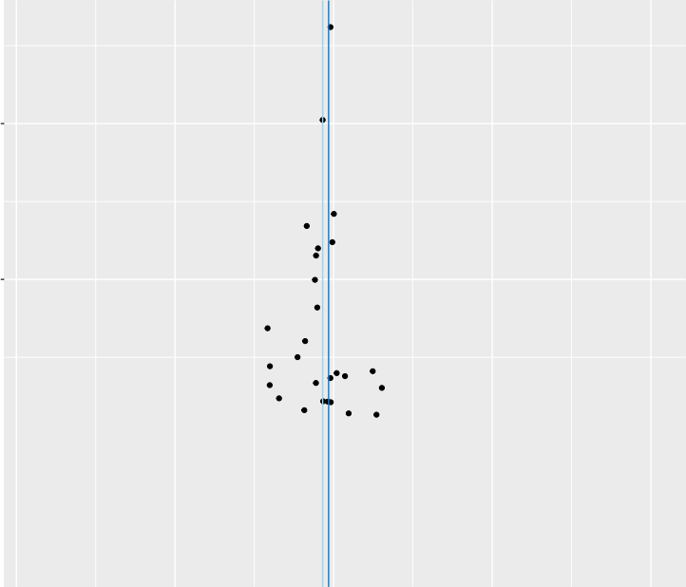  −6 −3 0 3 6  SHBG on Bladder cancer βIV

MR Test
 |  |  | Inverse variance weighted MR Egger  Simple mode |  | Weighted median Weighted mode
SNP effect on outcome | 0.4  0.2  0.0  −0.2 | 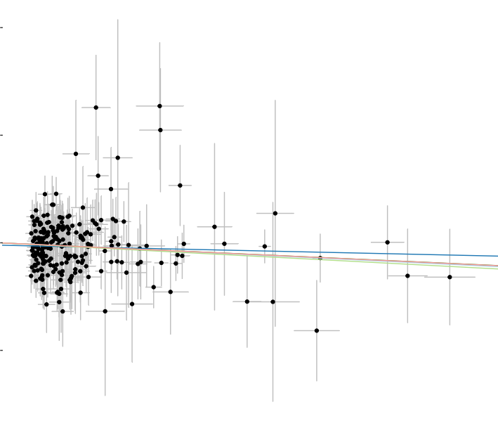
0.05 0.10 0.15 0.20
SNP effect on SHBG

rr
rs
rsrr
rsrr
rsrr
rsr
rsrr7
rsr
rs
rs
rsr
rs
rsr
rsr
rsrr
rs2r
rr
rs1r
rsr
rs1r
rsr
rs
rsrr
rs
rsr
rsr
rs1r
rs
rr
rsrr
rsrr
rsr
rr2
rsr
rsr
rs
rsr
rsr
rrr
rsr
rr
rsrr
rsr
rsrr
rsr
rr
rsr
rsr
rsr
rsr
r
rr
rr
rsrr
rsr
rsr
rs
rsr
rsrr56
rsrr
rs
rsr
rsrr
rs
r
rsrr
All
−0.4 −0.3 −0.2 −0.1 0.0
MR leave−one−out sensitivity analysis for 'SHBG' on 'Bladder cancer'

MR Method
 |  | Inverse variance weighted MR Egger
1 S EIV | Gamma_glutamyltransferase on prostate cancer βIV
  7.5
  5.0
  2.5
   |  |  |  | 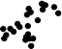 | 
  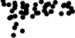
  −4 −2 0 2 4

MR Test
 |  |  | Inverse variance weighted MR Egger  Simple mode |  | Weighted median Weighted mode
SNP effect on outcome | 0.2  0.1  0.0  −0.1 | 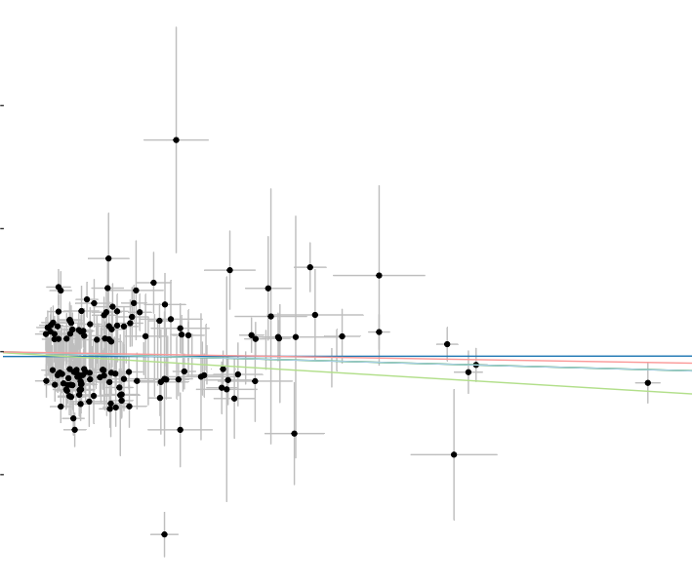  
0.04 0.08 0.12
SNP effect on Gamma_glutamyltransferase

rsr
rsr
rs
rsrr
rsr0
rsrrr
rsr
rs
rsrr
rsr
rs
rsr
rsr
rs1
rsrr
sr
rsr
rsr
rsrr
rsr
rsrr
rsr
rsrr
rsr
sr
rsrr
rsr
rs
rsr
rsr
sr
rsr
rsrr
rsr
rsr
sr
rsrr
sr
rs1
rsr
rsr
rs1
rr
rs
rs
rsr
rsr
rs1r
rsr
rsrrr
rsrr
rsr
rsrr
rsrr
rs1r
rsrrr
rr
rsr
rsrr
rsrr
rsrrr
rsrr
rsrr
rsr

sr
rsrr
rs1324693ll
−0.20 −0.15 −0.10 −0.05 0.00
MR leave−one−out sensitivity analysis for
'Gamma_glutamyltransferase' on 'prostate cancer'

MR Method
 |  |  | Inverse variance weighted MR Egger
1 S EIV | 6  4  2 | −6 −4 −2 0 2  IGF_1 on prostate cancer βIV

MR Test
 |  |  | Inverse variance weighted MR Egger  Simple mode |  | Weighted median Weighted mode
SNP effect on outcome | 0.2  0.1  0.0  −0.1  −0.2
0.04 0.08 0.12 0.16
SNP effect on IGF_1

rsr
rs1r
rsrr
rs
rsr
rsr
rsrr
rsr
rsrr
rsrr
rs
rsr
rs
rr
rsr
rsrr
rsr
rsrr
rsrr
rsrr
rsrr
rsr
rrrr
rsr
rs
rsrr
rsrr
rsrr
rsr
rs1rrr
rsrrr
rsr
rsrrr
rrr
rsrr
rsr
rsrrr
rrr
rsr
rsr
rr
rsr
rr
rsrr
rsr
rs
rsr
rsrrr
rsr
rsrr
rsr
rsr
rs1rr
rsrr
rr
rsrr
rsr
rsr
rsrr
rsr
rsr
rsrr
rsr
rrr

rsr
rsr
rs1r08l
0.10
0.05
0.00
0.15
0.20
MR leave−one−out sensitivity analysis for 'IGF_1' on 'prostate cancer'

MR Method
 |  | Inverse variance weighted MR Egger
1 S EIV  20  15  10  5  0 | Lipoprotein_A on prostate cancer βIV
  −0.5 0.0 0 |  |  |  |  |  |  |  | .5

MR Test
 |  |  | Inverse variance weighted MR Egger  Simple mode |  | Weighted median Weighted mode
SNP effect on outcome | 0.3  0.2  0.1  0.0  −0.1 | 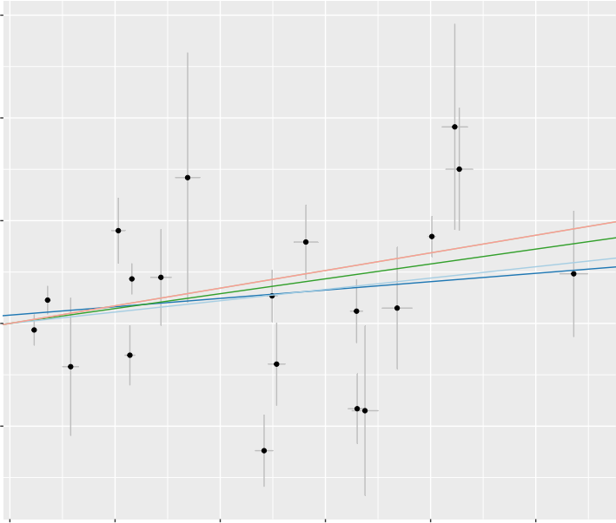
SNP effect on outcome | 0.3  0.2  0.1  0.0  −0.1 | 0.0 0.1 0.2 0.3 0.4 0.5  SNP effect on Lipoprotein_A

rs117629249  rs142717575  rs77087651  rs633863  rs138491411  rs1065853  rs73022312  rs9295127  rs183130  rs8178824  rs145221006  rs75274517  rs62438067  rs1086567  rs149316622  rs56203233  rs77920501  rs77613626  rs12179053  rs3127580  All | 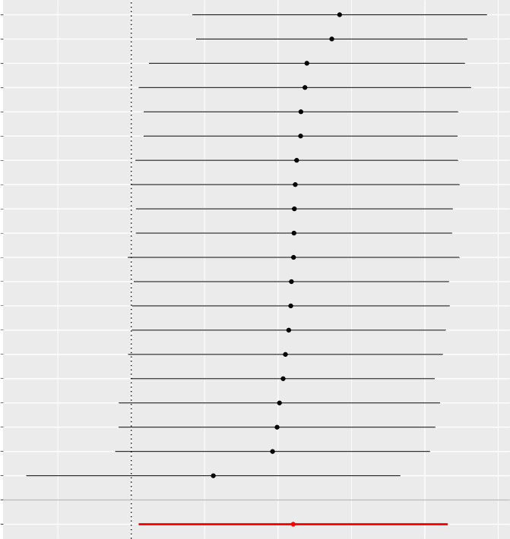  0.0 0.1 0.2
MR leave−one−out sensitivity analysis for 'Lipoprotein_A' on 'prostate cancer'

MR Method
 |  |  | Inverse variance weighted MR Egger
1 S EIV | 6  4  2 | 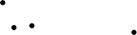  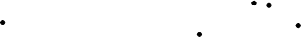    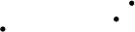  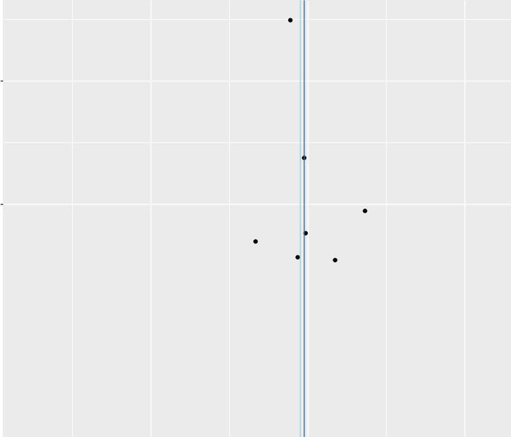  −2 0 2  Non_albumin_protein on prostate cancer βIV

MR Test
 | Inverse variance weighted MR Egger  Simple mode |  | Weighted median Weighted mode

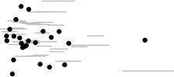
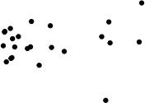
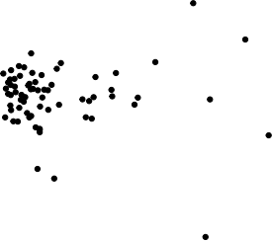
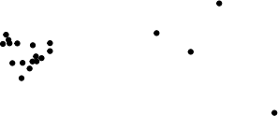
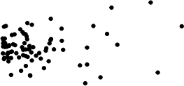
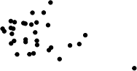
SNP effect on outcome

0.2

0.0

−0.2
0.05 0.10 0.15
SNP effect on Non_albumin_protein

rsr
rsrr
rsr
rrr
rsrr
rsr
rsrrr
rsr
rsrr
sr
rsrr
rsrr
rsrr
r
rs1r2
rsr
rsr
rsrr
rsrr
rsrr
rsr
rsr
rs11r
rsrr2
rsr
rs1
rsrr
rsrr
rs
rsrr
rsrr
rsr
rsrr
rsrr
rsr
rsr
rs
rsrr
rs1r
sr
rsr
rsr
rsr
rs3r
rsr
rsrr
rs1r4r
rs2rr
rsr
rsr
rsr
rsrr
rs
rsrrr
rsr
rsrr
rsrrr
rs
rsr
rsrr
rsrr
rsrr
rsr
rsr
rsrr

rs389116ll
rs
−0.10
−0.20 −0.15
−0.05 0.00
MR leave−one−out sensitivity analysis for 'Non_albumin_protein' on 'prostate cancer'

MR Method
 |  | Inverse variance weighted MR Egger
1 S EIV
  3
  2
  1
  ● ●  ●  −2.5 0  −5.0 |  |  |  |  |  | .0 2 |  | ●  .5
Non_albumin_protein on kidney cancer |  |  | βIV

MR Test
 |  |  | Inverse variance weighted MR Egger  Simple mode |  | Weighted median Weighted mode
SNP effect on outcome | 0.4  0.0  −0.4  −0.8 | 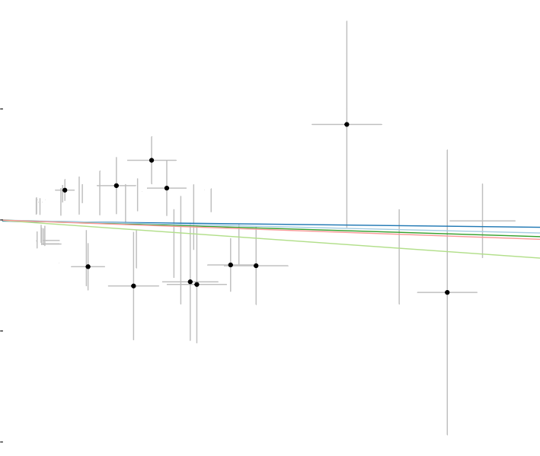    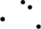      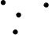  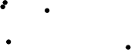  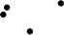    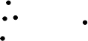  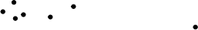  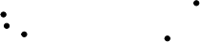      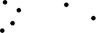  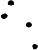      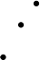  
0.05 0.10 0.15
SNP effect on 'Non_albumin_protein'

rsr
rsr
rsrr
rs14r
rsr
rsr
sr
rsrr
rs1rr
rsr
rs
rsrr
rsrr
rsr
sr
rsrr
rsrr
rsr
rsr
sr
rsrr
rsr
rsrr
rsr
rs1rr
rsr
rs1r
rsr
sr
rsrrr
rsr9
rsrr
1r
rsr
rsr
rsr
rsr
rsr
rsr
rsrrr
rsr
rsr
rsrr
rs
rsr
rsrr
rsr
rsrr
rsrr
rsrr
sr
rsr
rr
rsr
rsr8
rsr
rs1
rsr
rr
rsr
rsrr
rsr
rs1rr
rsr

rsrrr
rsrrr
rs389116ll
−0.3
−0.4
−0.2
−0.1
0.0
MR leave−one−out sensitivity analysis for 'Non_albumin_protein' on 'kidney cancer'

MR Method
 |  | Inverse variance weighted MR Egger
1 S EIV
  2.0
  1.5
  1.0
  0.5
  −3
  −6
  0
  3
Total_protein on kidney cancer βIV

MR Test
 |  |  | Inverse variance weighted MR Egger  Simple mode |  | Weighted median Weighted mode
SNP effect on outcome | 0.0  −0.4  −0.8 | 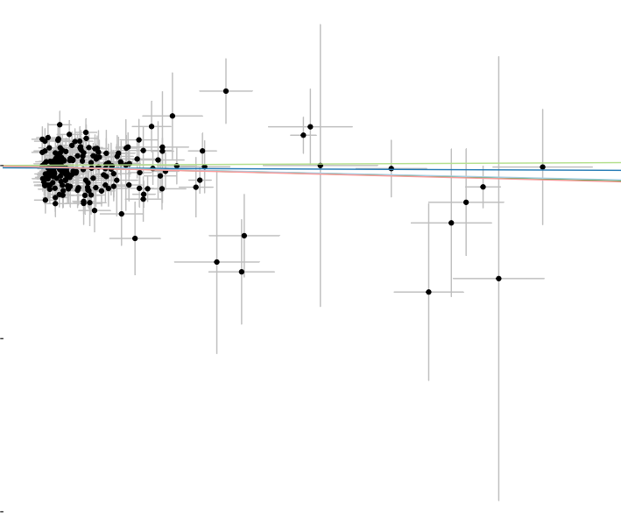
0.05 0.10
SNP effect on 'Total_protein'

rs7
rs
rsr
rr
rsrr
rsr1
rr
rr
rsr
rsr
rsr7r
rsr
rsr
rsr
rr
rrr
rsr
rsr
rsr
rsr1r
rsr
rsr
rs
rsr
rsr
rr
rsr
rsr
rs
rsr
rs
rrr
rsr
rr
rs
rsrr
rs0
rs
rsrr
rs1r
rs1rr
rrr
rsr
rsr
rs9
rsr
rsr
rs
rsr
rsr
rsr
rsr
rsr
rsr3
rs1rr
rs
rs1
rsr
rsr
rs1r
rsr
rs
rsr
rrr
rsr
rs
All
−0.5 −0.4 −0.3 −0.2 −0.1 0.0
MR leave−one−out sensitivity analysis for 'Total_protein' on 'kidney cancer'

MR Method
 |  | Inverse variance weighted MR Egger
1 S EIV | 1.00  0.75  0.50  0.25
1 S EIV | −10 0 10 20
Apolipoprotein_A on renal pelvic cancer βIV

MR Test
 |  |  | Inverse variance weighted MR Egger  Simple mode |  | Weighted median Weighted mode
SNP effect on outcome | 3  2  1  0  −1 | 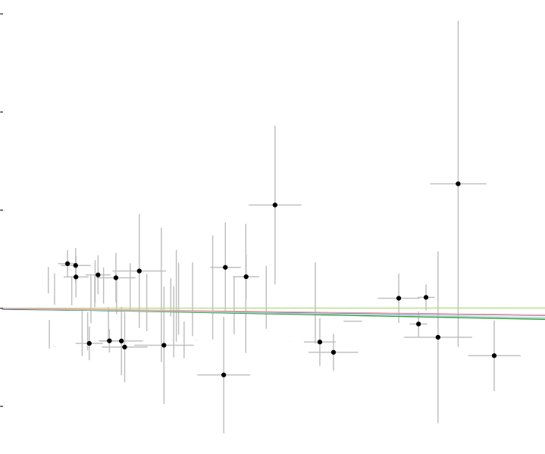  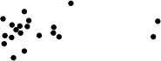  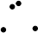      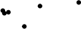  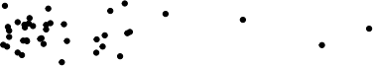  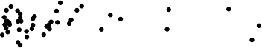  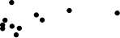    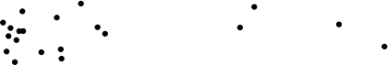
0.04 0.08 0.12 0.16
SNP effect on 'Apolipoprotein_A'

rsrr
rrr
rs1r
rrsr
rsr
rs
rs
rs
rsr
rsr
rsrrr
rsr
rsr
rsr
rs
rsrr
rsr
rsr
rs
rsr
rssr
rs
rsr
rs1r
rs
rs1r
rs
rsr6
rs
rsr
rsr
rsr
rs5
rsr
rrs9r
rrrr
rsrr
rsr
rsr
rs
rsr
rsr
rsr
rsr
rs
rs
rsrr
rs1rr
rrsr
rsr
rs
rsrr
rsr6
rs
rrss1r
rs
rs
rsr
rsrr
rr
rsr
rs
rs1r
rsrr
rs

All
rsrr
−0.5
−1.0
0.0
MR leave−one−out sensitivity analysis for 'Apolipoprotein_A' on 'renal pelvic cancer'

MR Method
 |  |  |  |  | Inverse variance weighted MR Egger
0.75 -
1 S EIV | 0.50 -
0.25 -

−20 −10 0 10 20
Urate on renal pelvic cancer βIV

MR Test
 |  | Inverse variance weighted MR Egger  Simple mode |  | Weighted median Weighted mode
SNP effect on outcome  2  1  0  −1 |     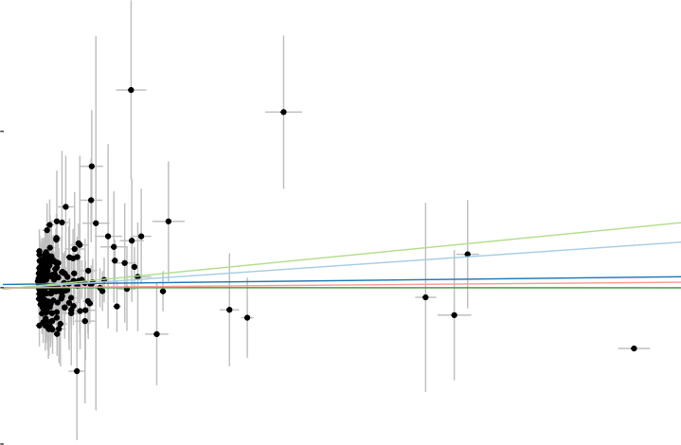
0.0 0.1 0.2 0.3 0.4
SNP effect on 'Urate'

rsr4
rs1rr
rsrr
rs1r
r
rs7r
rsr
rsrrr
rs6
rs
rsr
rr4
rsrrr
rs1r0
rr
rs
rrrr
rsr
rsrr
rsr
rsrr
rs3rr
rsr2r
rsr
rsr
rs1rr
rs1r
rs
rs
rsr
rsr
rsr
rr
rsr
rsrr
rr
rsr
rr
rsrr
rs
rr
rsr
rsrrr
rsrr
rsr
rsrr
rrr
rs
rsr
rs
rsr
rsr
rsr
rsrr
rs
rs7
rr
rr
rsr
rsr
rsr
rsr
rs
rsr
rsr

All
rs
0.5
0.0
1.0
MR leave−one−out sensitivity analysis for 'Urate' on 'renal pelvic cancer'

