MR Method
 |  | Inverse variance weighted MR Egger
1 S EIV | 600  400  200
1 S EIV | −0.02 −0.01 0.00 βIV 0.01 0.02 0.03
Non_albumin_protein on Bladder cancer || id:ieu-b-4874

MR Test
 | Inverse variance weighted MR Egger  Simple mode |  | Weighted median Weighted mode

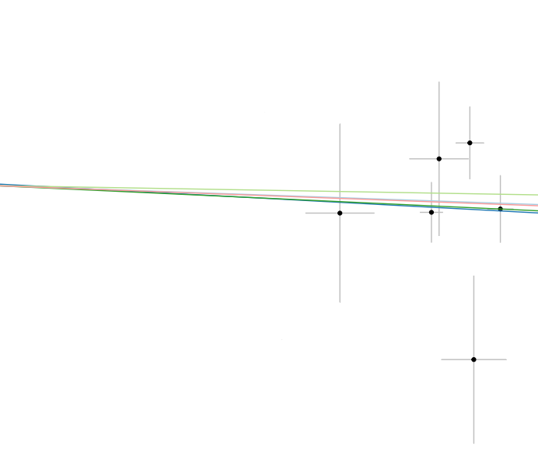
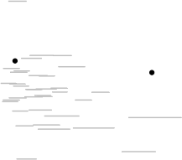
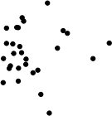
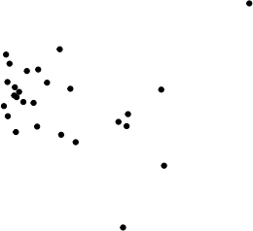
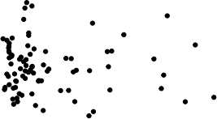
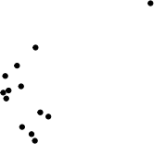
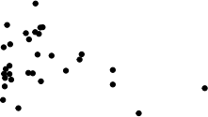
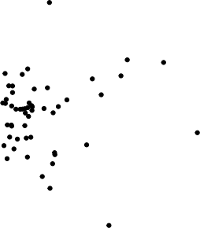
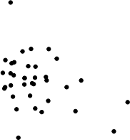
SNP effect on Bladder cancer || id:ieu−b−4874

0.001

0.000

−0.001

−0.002
0.05 0.10 0.15
SNP effect on Non_albumin_protein

rsrr
sr
rsr
rsr
rsr
rr
rsr
rsrrr
rsr
rsr1rr
rsrr
rsrr
sr
rsrr
sr
sr
rsrr
rrr
rsr
rsrr
rrr
rsrrr
rsrrr
rs11r
rsrr
sr
rsr
rs1rr
rsr
rs
rrrr
rsrr
rsr
rrr
rsr
rsrr
rsr
rsr
rsr
rsr
rsr
rsr
rsr
rsr
sr
rsrrr
rsr
rsrr
rsrr
rsrr
rs1rr
rrr
rsrr
rsrrr
rsrrr
rsrr
rsrr
rsrrr
rs
rsrr
rs
rsrrr
sr
rsrr

rsr
rsrr
rs1012799ll
−0.0015 −0.0010 −0.0005 0.0000
MR leave−one−out sensitivity analysis for
'Non_albumin_protein' on 'Bladder cancer || id:ieu−b−4874'

MR Method
 |  | Inverse variance weighted MR Egger
1 S EIV
  16
  12
  8
  4 |  |  |  | 
  −2 0 2 4
Gamma_glutamyltransferase on Prostate cancer βIV

MR Test
 |  |  | Inverse variance weighted MR Egger  Simple mode |  | Weighted median Weighted mode
SNP effect on Prostate cancer || id:ieu−b−85 | 0.2  0.1  0.0  −0.1 | 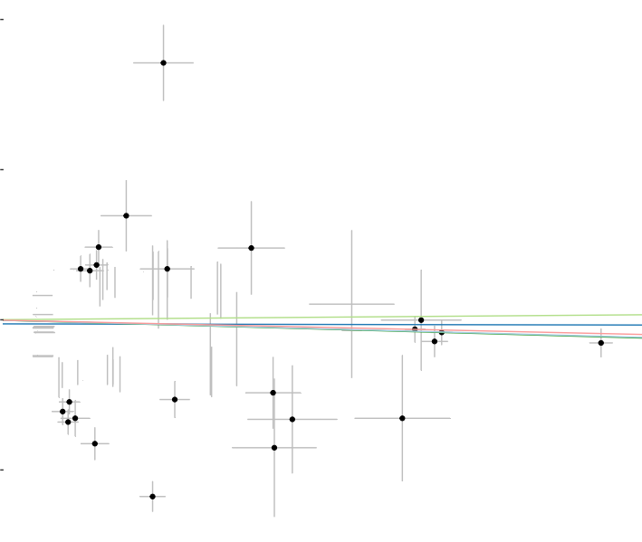  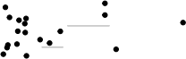  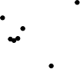          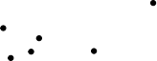      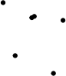        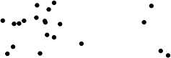    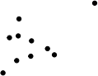  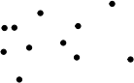  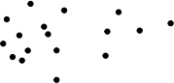    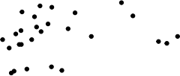  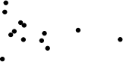
0.04 0.08 0.12
SNP effect on 'Gamma_glutamyltransferase'

rsr
rsrr
rsrr
rsrr
rsr
rsrr
rs1r
rsrr
rsr
rsr
rsr
rs
rs
rsr
rsrr
rsr
rsr
rsrrr
rsr7
rsr
rs1r
rsr
rsrr
rs1r
rr
rsr
rr
rsr
rs
rsr
rsrr
rs
r
rsr
rsr
rsrrr
rsr
rsrr
rsr
rsr
rsr
rsrr
rsrr
rsr
rsr
sr
rsr
rsr
rsr
rs
rsr1
rs1
rs
rsr
rs1
rsr
rsrr
rsrr
rsrr
rsr
rr
rs1r
rsrr
rs1rr

rsr
rsr
rs466592ll
−0.15 −0.10 −0.05 0.00
MR leave−one−out sensitivity analysis for
'Gamma_glutamyltransferase' on 'Prostate cancer || id:ieu−b−85'

MR Method
 |  | Inverse variance weighted MR Egger
1 S EIV
  10 -
  5
   |  |  |  |  | 
−4 −2  IGF_1 on Prostate cancer |  | 0  βIV | 2 | 4

MR Test
 |  |  | Inverse variance weighted MR Egger  Simple mode |  | Weighted median Weighted mode
SNP effect on Prostate cancer || id:ieu−b−85 | 0.1  0.0  −0.1 | 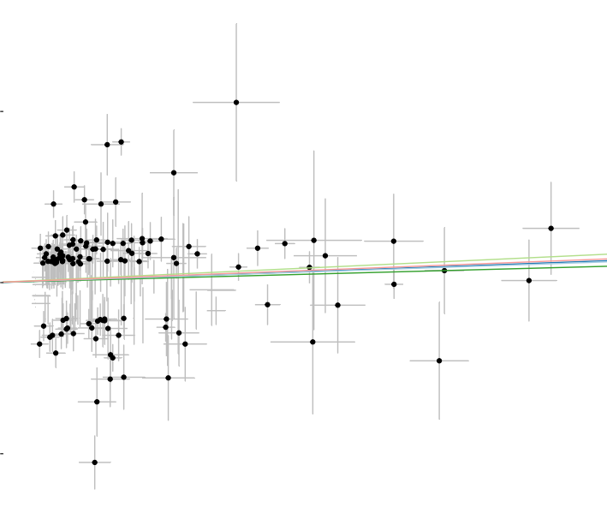  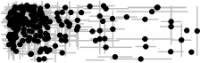
0.04 0.08 0.12 0.16
SNP effect on IGF_1

rsr
rr
rsr
rsrrr
rrrr
rsr
rs
rsrr
rrr
rsrr
rsrr
rsr
rs
rsr
rsrr
rr
rsr
rsrrr
rsrr
rsrr
rsrr
rsr
rsrr
rs
rsrr
rsrr
rsrr
rs1r
rs
rsr
rsr
rsrr
rsrr
rsrr
rsrr
rsrr
rsr
rrrr
rsrr
rsr
rsr
rsr
rs
rsr
rs
rsr
rsr
rsr
rs
rsr
rs
rsr
rsrrr
rs1rr
rsrr
rsrr
rs1rr
rsr
rsrr
rsrr
rsrr
rsr
rr
rsrr
rsrrr

rsr2l
rs1r
0.10
0.00
0.05
0.15
MR leave−one−out sensitivity analysis for 'IGF_1 on 'Prostate cancer || id:ieu−b−85'

MR Method
Inverse variance weighted MR Egger
1 S EIV

30 -

20 -

10 -
−0.6 −0.3 0.0 0.3
Lipoprotein_A on Prostate cancer βIV

MR Test
 |  |  | Inverse variance weighted MR Egger  Simple mode |  | Weighted median Weighted mode
SNP effect on Prostate cancer || id:ieu−b−85 | 0.1  0.0  −0.1 | 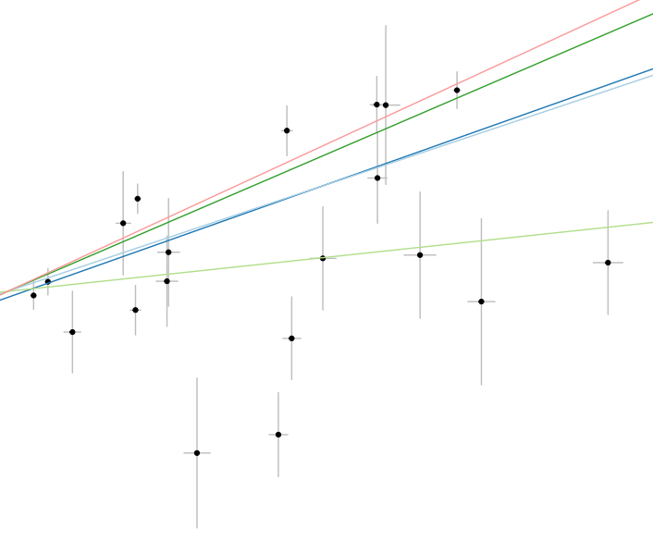
SNP effect on Prostate cancer || id:ieu−b−85 | 0.1  0.0  −0.1 | 0.0 0.1 0.2 0.3 0.4 0.5  SNP effect on Lipoprotein_A

rs9295127  rs142717575  rs77087651  rs1065853  rs149316622  rs73022312  rs77920501  rs75274517  rs368185446  rs8178824  rs117629249  rs183130  rs1086567  rs62438067  rs56203233  rs138491411  rs12179053  rs633863  rs145221006  rs3127580  All
  0 | .0 0 |  | .1 0 |  | 0.3  .2
MR leave−one−out sensitivity analysis for
'Lipoprotein_A' on 'Prostate cancer || id:ieu−b−85'

