Supplementary Figure1 Single cell data processing for gastric cells
A nCount-RNA and nFeature-RNA show high-intensity gene expression in tumor cells. The B chart shows the percentage of gene expression and the correlation between nCount-RNA and nFeature-RNA, while C represents the average expression level and standardized variation of genes.

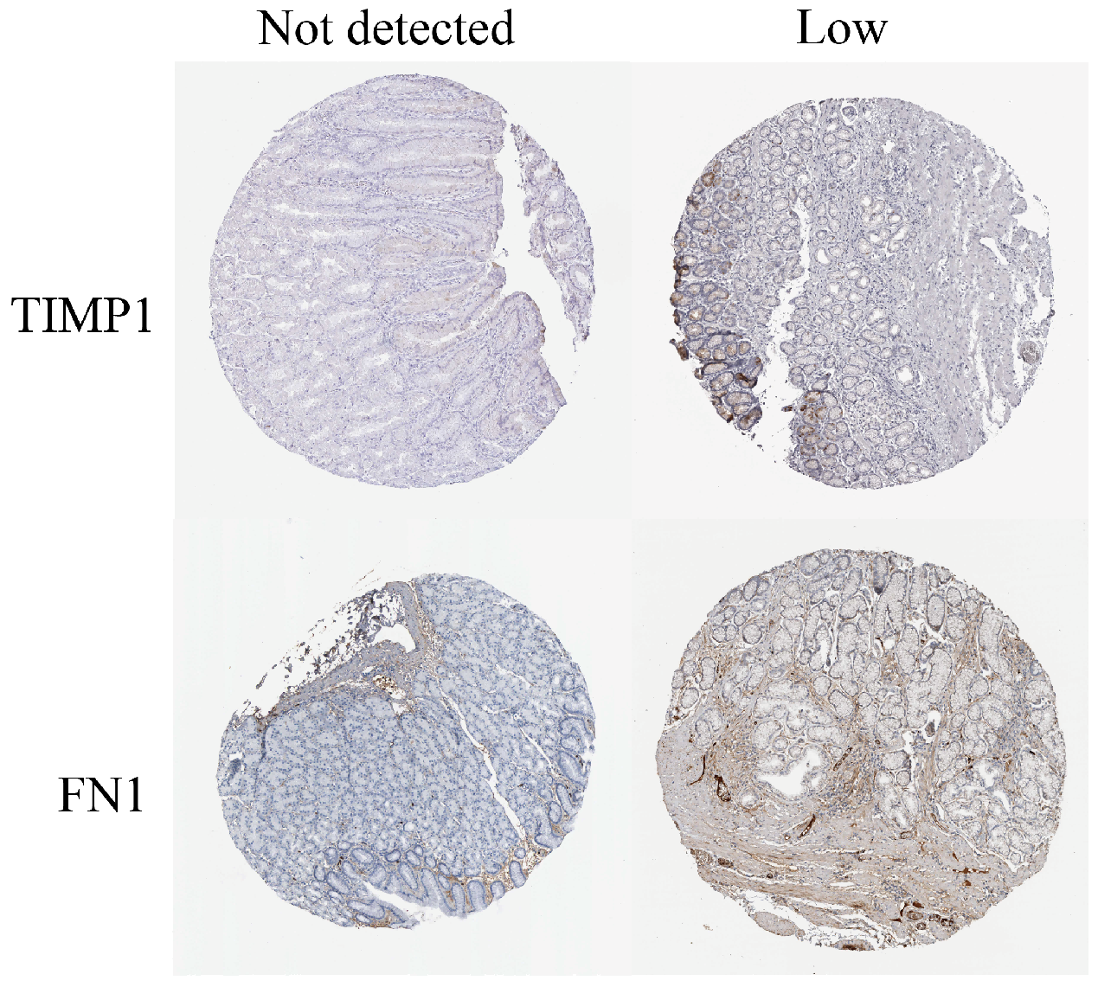
Supplementary Figure2 The expression levels of TIMP1 and FN1 in tissue samples. TIMP1: The first image labeled "Not detected" indicates no visible TIMP1 expression, while the second image labeled "Low" shows a low level of TIMP1 expression in the tissue. FN1: Similarly, the first image labeled "Not detected" shows no FN1 expression, and the second image labeled "Low" depicts a low level of FN1 expression.

