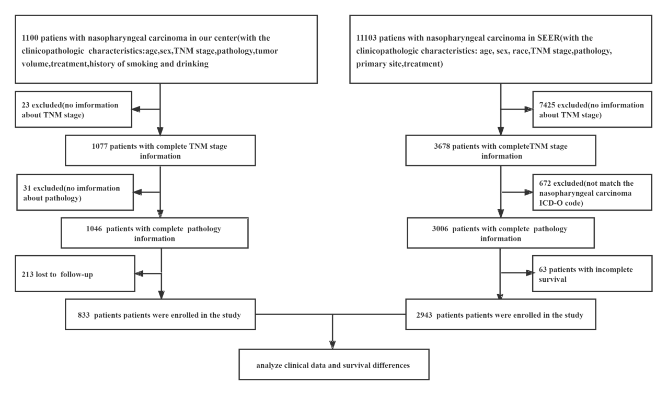
Figure S1 Flow chart for Nasopharyngeal cancer patients in both SEER database and our center

