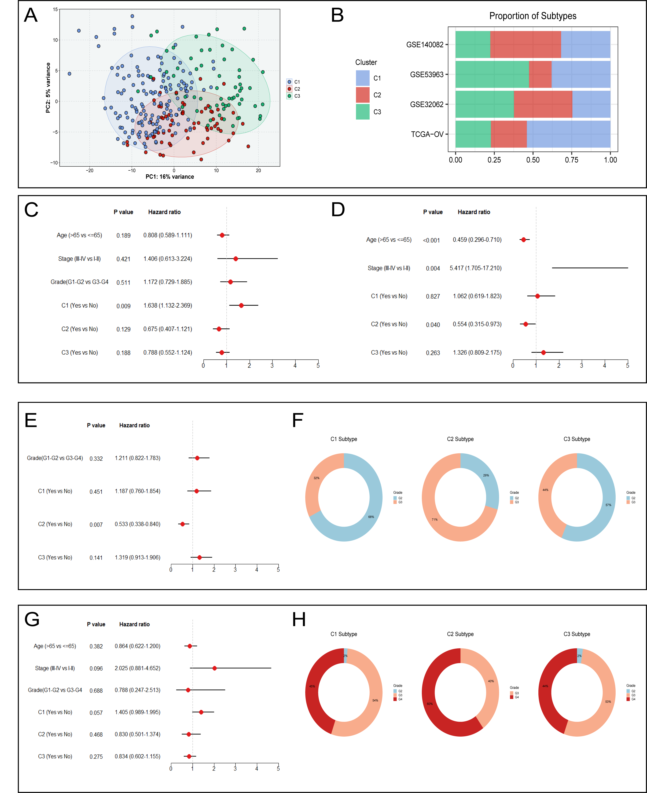
Supplementary Fig. S1 (A). The PCA algorithm displayed the two-dimensional principal component diagram of three subtypes, with each point representing a single sample. (B). Proportion of each subtype in the four cohorts, including GSE140082, GSE53963, GSE32062, and TCGA-OV. (C-E, G). The multivariate Cox regression analysis in the TCGA-OV (C), GSE140082 (D), GSE32062 (E), and GSE53963 (G) cohorts. (F). Proportion of different grades of the subtypes in GSE32062. (H). Proportion of different grades of the subtypes in GSE53963.

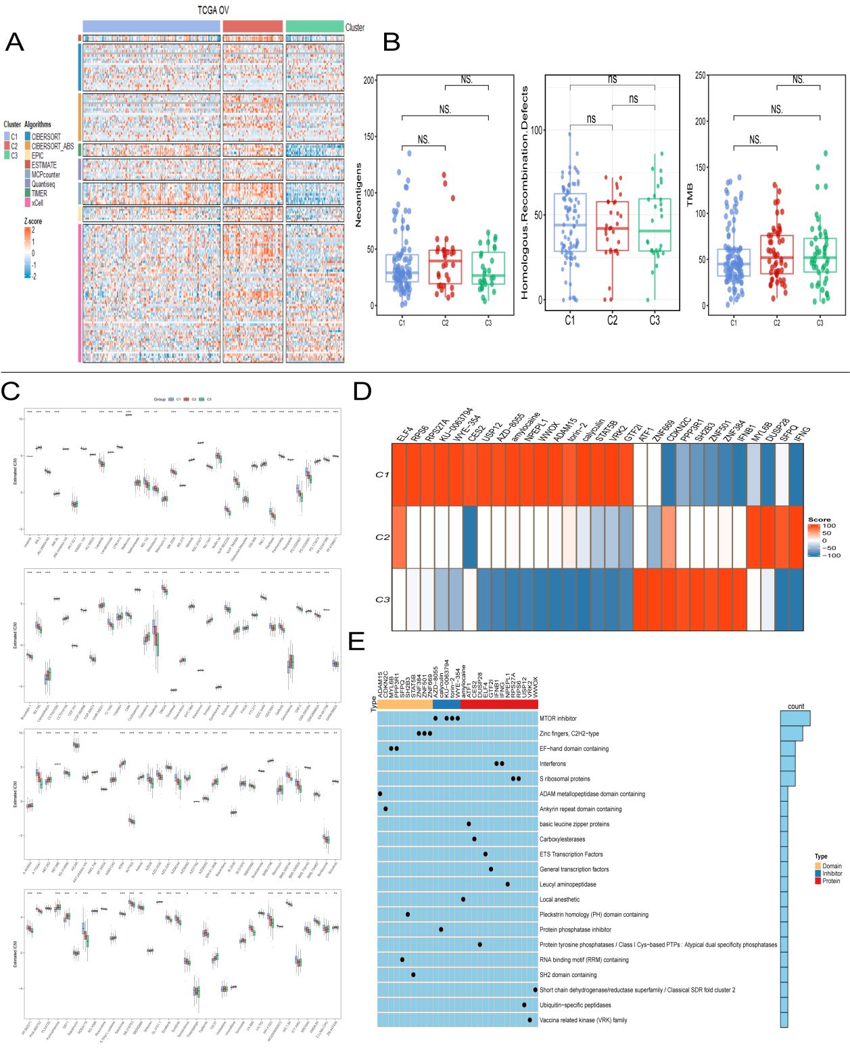
Supplementary Fig. S2 (A). The heatmap of immune infiltration load between subtypes by eight algorithms. (B). Comparison of HRD, new antigen and TMB levels of three subtypes. (C). Candidate drugs of each subtype developed based on ridge regression model. (D). Heatmap of enrichment score generated from potential therapeutic compounds. (E).The description of the mode of action (MoA) of compounds targeting corresponding molecular pathways. P values are shown as *P < 0.05, **P < 0.01, ***P < 0.001, and ns was the abbreviation of no significance.

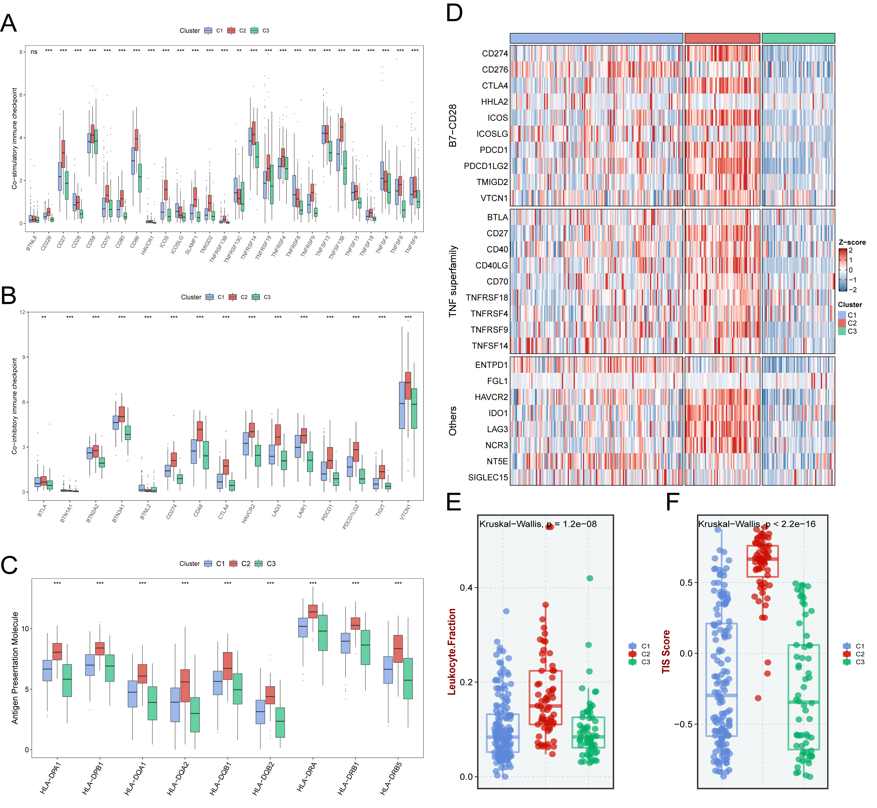
Supplementary Fig. S3 (A-C). Expressions of checkpoint co-stimulator genes (A), checkpoint co-inhibitor genes (B), and HLA molecular (C) between GSTKKs-based subtypes. (D). The immune checkpoint profifiles of the three subtypes, including B7-CD28 superfamily, TNF superfamily, and other molecules. (E-F). The comparison of leukocyte fraction (E) and T-cell inflflammatory signature (TIS) prediction scores (F) between GSTKKs-based subtypes.

Supplementary Fig. S4 (A). The promising therapeutic agents for patients in C1, including Doxorubicin, Cytarabine, TW.37, and QS11. (B). The promising therapeutic agents for patients in C2, including AZD6482, Z.LLNle.CHO, CGP.082996 and Pazopanib. (C). The promising therapeutic agents for patients in C3, including Bryostatin.1, Bortezomib, RDEA119, and NVP.BEZ235.

