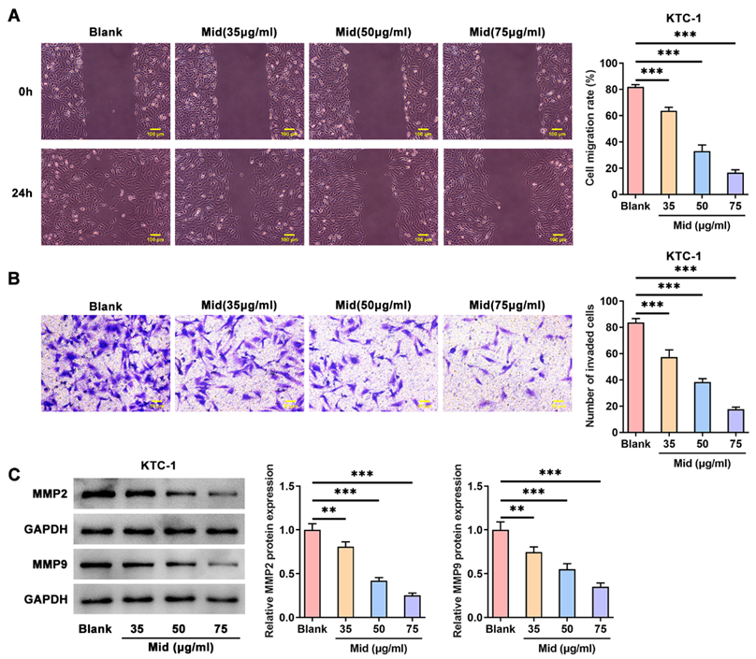
Figure S1 Midazolam concentration-dependently inhibits KTC-1 cell migration and invasion. A. Wound healing assay was used to detect KTC-1 cell migration. B. Transwell assay was used to detect KTC-1 cell invasion. C. Western blot was used to detect the expressions of MMPs in KTC-1 cells. All experiments were performed at least three times. **P<0.01 and ***P<0.001.

Figure S2 Midazolam concentration-dependently induces KTC-1 cell apoptosis. A. Flow cytometry assay was used to detect KTC-1 cell apoptosis. B. Western blot was used to detect the expressions of apoptotic proteins in KTC-1 cells. C. Immunofluorescence staining was used to detect cleaved caspase3 expression in TPC-1 cells. All experiments were performed at least three times. **P<0.01 and ***P<0.001.

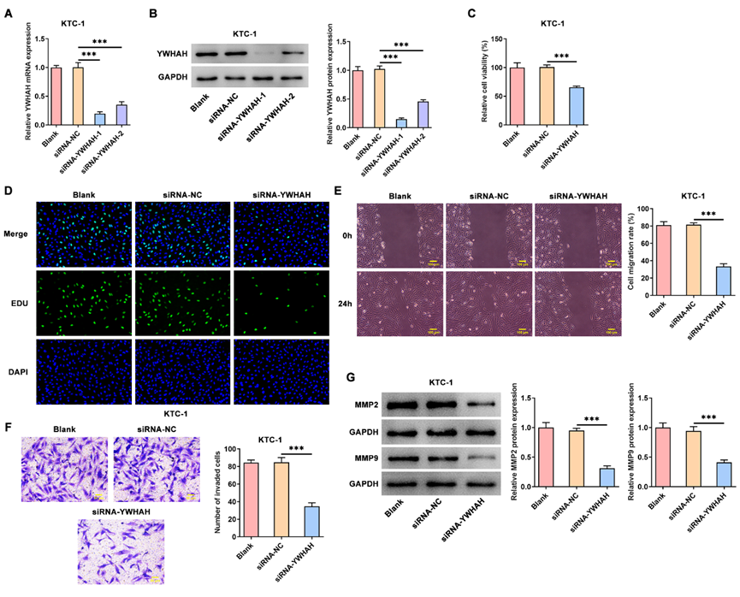
Figure S3 YWHAH knockdown suppresses KTC-1 cell proliferation, migration as well as invasion. A-B. Examination of transfection efficacy of siRNA-YWHAH-1/2 in KTC-1 cells. C. CCK-8 method was used to detect KTC-1 cell viability. D. EDU staining was used to detect KTC-1 cell proliferation. E. Wound healing assay was used to detect KTC-1 cell migration. F. Transwell assay was used to detect KTC-1 cell invasion. G. Western blot was used to detect the expressions of MMPs in KTC-1 cells. All experiments were performed at least three times. ***P<0.001.

