Reduced-Dose Chemotherapy Followed by Blinatumomab for Newly Diagnosed Philadelphia Chromosome-Negative B-cell Precursor Acute Lymphoblastic Leukemia: A Propensity-Matched Comparison with Hyper-CVAD

Supplementary Material

Table S1. Comparison of the propensity-matched hyper-CVAD group with the data of the entire retrospective cohort.
Data of hyper CVAD group | Entire hyper-CVAD  (N=56) | PSM hyper-CVAD  (N=35) | P*

Baseline characteristics
Age years, median (IQR) | 38 (24–51) | 41 (24–51) | 0.29
15–39 | 29 (52%) | 14 (40%)
40–65 | 27 (48%) | 21 (60%)
Sex |  |  | 0.38
Male | 34 (61%) | 18 (51%)
Female | 22 (39%) | 17 (49%)
WBC counts at diagnosis |  |  | 0.34
≤30×10⁹/L | 43 (77%) | 23 (66%)
>30×10⁹/L | 13 (23%) | 12 (34%)
Bone marrow blasts proportion, median (IQR) | 90 (78–95) | 90 (79–94) | 1.0
Cytogenetic/molecular risk stratification at diagnosis |  |  | 0.12
Standard risk | 39 (70%) | 18 (51%)
Poor risk | 17 (30%) | 17 (49%)

Outcomes

Induction phase, n (%)[95% CI]
Composite complete remission | 41 (73%) [60–83] | 22 (63%) [46–77] | 0.35
MRD <0.01% | 26 (46%) [34–59] | 15 (43%) [28–59] | 0.74

Overall treatment course
CR, n (%)[95% CI] | 48 (86%) [74–93] | 28 (80%) [64–90] | 0.57
MRD <0.01%, n (%)[95% CI] | 40 (71%) [59–82] | 22 (63%) [46–77] | 0.49
Time to achieve CR, day, median (IQR) | 34 (26–43) | 35 (28–45) | 0.51
Duration of remission, day, median (IQR) | 401 (137–962) | 300 (137–600) | 0.76
Relapse among remission | 26 (54%) | 15 (54%) | 1.0
Allogenetic–HSCT | 22 (39%) | 13 (37%) | 0.84
OS, months, median (IQR) | 32.3 (9.9–49.7) | 16.8 (6.2–42.6) | 0.49

*The p-values were calculated with Fisher's exact test for categorical variables and Mann–Whitney test for continuous variables.

CR, complete remission; MRD, measurable residual disease; WBC, white blood cell; CI, confidence interval; HSCT, hematopoietic stem cell transplantation

Table S2. The matching status of each covariate before and after propensity score adjustment

Baseline Covariates | SMD before PSM | SMD after PSM
Age (≥40years,) | -0.12 | 0.011
WBC counts at diagnosis (>30×10⁹/L) | -0.069 | 0.17
Cytogenetic/molecular poor risk stratification at diagnosis (Yes) | 0.39 | 0
SMD, standardised mean differences; PSM, propensity score matching.

Table S3. Distribution of Poor Cytogenetic and Molecular Risk Features in the RDC-Blinatumomab and PSM-HyperCVAD Groups
Poor cytogenetic / molecular risk | RDC-Blinatumomab-2W  (N=35) | PSM-hyper CVAD  (N=35)
Complex karyotype | 3 (9%) | 3 (9%)
Hypodiploidy | 3 (9%) | 1 (3%)
ZNF384 rearrangement | 3 (9%) | 0
KMT2A rearrangement | 3 (9%) | 1 (3%)
TP53 mutation | 3 (9%) | 2 (6%)
BCR::ABL1 like | 5 (14%) | 5 (14%)
Alterations of IKZF1 | 1 (3%) | 4 (11%)
MEF2D rearrangement | 1 (3%) | 0
IgH rearrangement | 0 | 1

Table S4. List of sites from which patients were recruited
No. | Site | Location | Name of Principle investigator | Recruited patient number
1 | The First Affiliated Hospital of Soochow University | Suzhou | Suning Chen | 24
2 | The First Affiliated Hospital of Nanjing Medical University | Nanjing | Yu Zhu | 3
3 | The Affiliated Wuxi People's Hospital of Nanjing Medical University | Wuxi | Xin Zhou | 3
4 | Soochow Hopes Hematonosis Hospital | Suzhou | Bin Gu, Jun Wang | 3
5 | Affiliated Changzhou Second Hospital of Nanjing Medical University | Changzhou | Xuzhang Lu | 2
6 | The First Affiliated Hospital of Nanjing Medical University | Nanjing | Yu Zhu | 56 (Historical control cohort)

Figure S1. Reduced-Dose chemotherapy followed by blinatumomab trial scheme
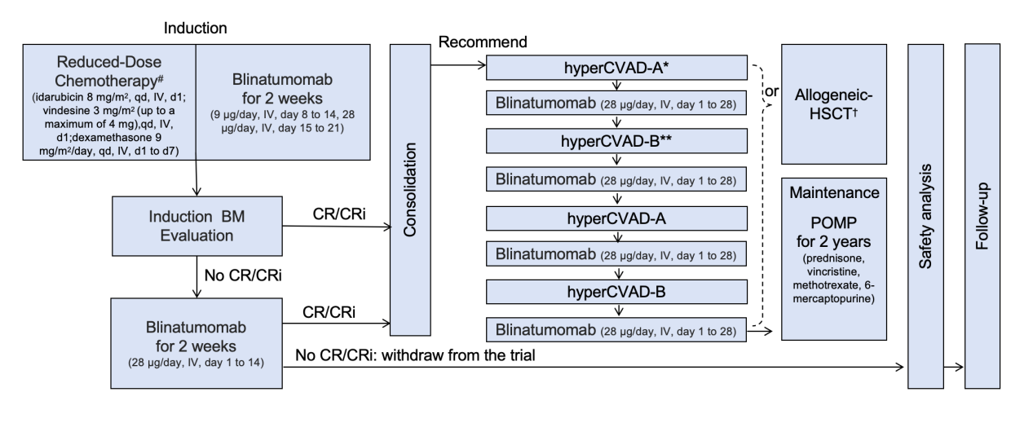
BM, bone marrow; CR, complete response, CRi, complete response with incomplete recovery; HSCT, Haematopoietic stem cell transplantation; IV, intravenous

# Per protocol, prephase treatment with dexamethasone 9 mg/m²/day (up to 5 days before the reduced-dose chemotherapy) was required for patients with peripheral white blood cell ≥30,000/μL. A repeat bone marrow assessment performed after reduced-dose chemotherapy prephase and before blinatumomab treatment was recommended to assess bone marrow blasts.

† The choice to undergo allogeneic hematopoietic stem cell transplantation (Allogeneic-HSCT) was based on the patient’s status of measurable residual disease and donor availability.

* hyper-CVAD-A regimen: hyperfractionated cyclophosphamide, vincristine, doxorubicin, and dexamethasone

** hyper-CVAD-B regimen: high-dose methotrexate and cytarabine

