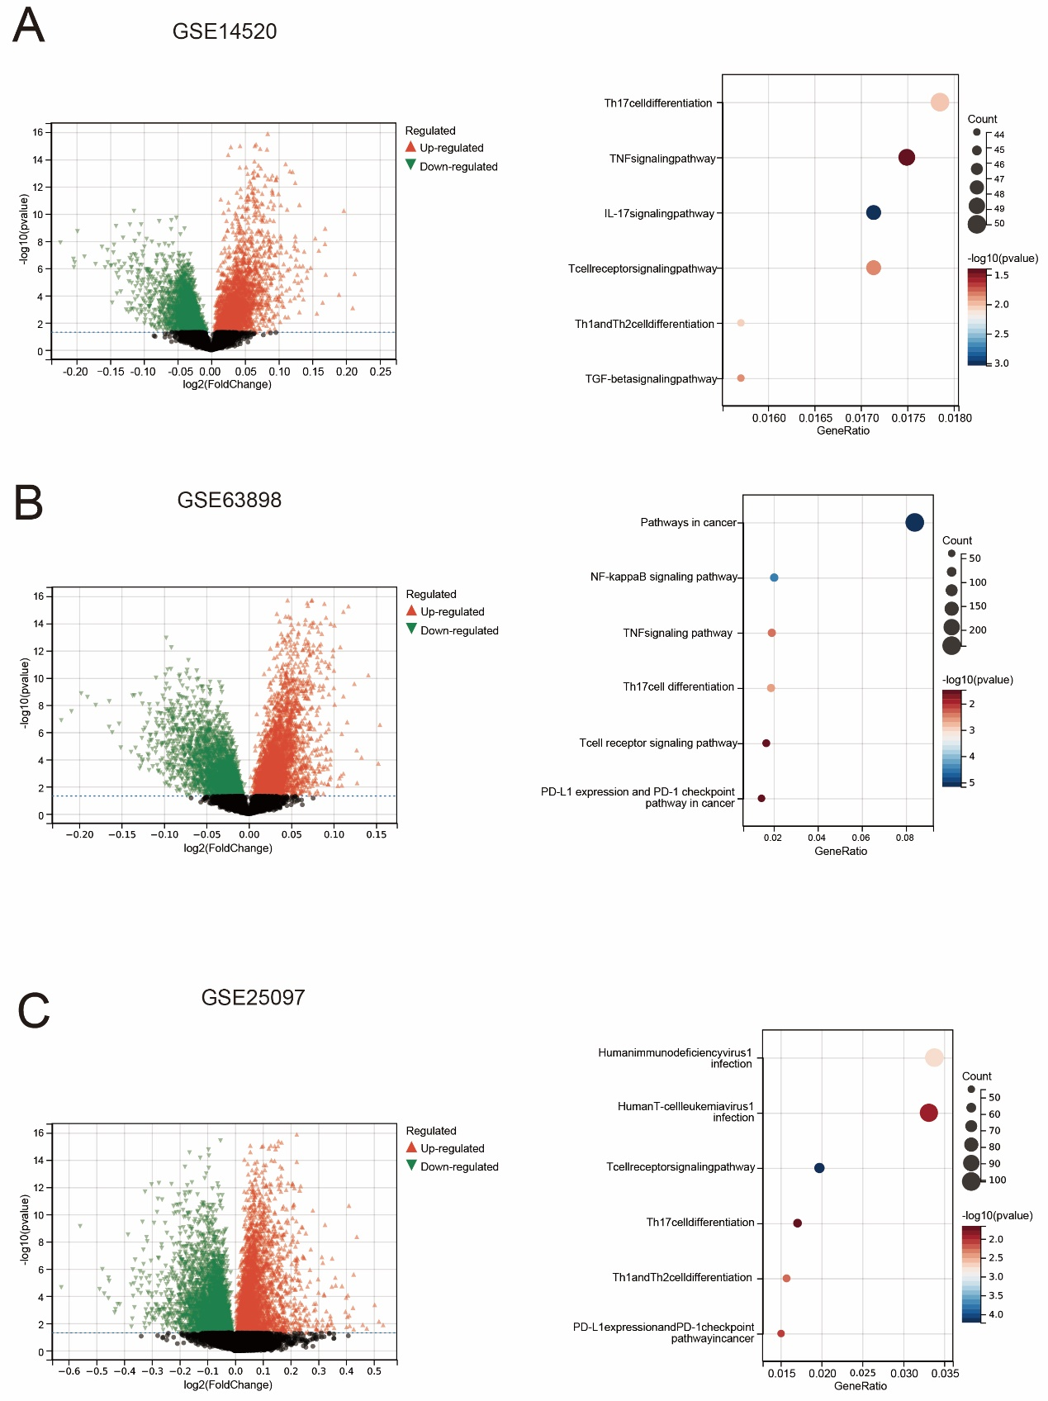
FigS.1. Differentially VPS72 expressed analysis.A-C volcano plot and KEGG pathway analysis

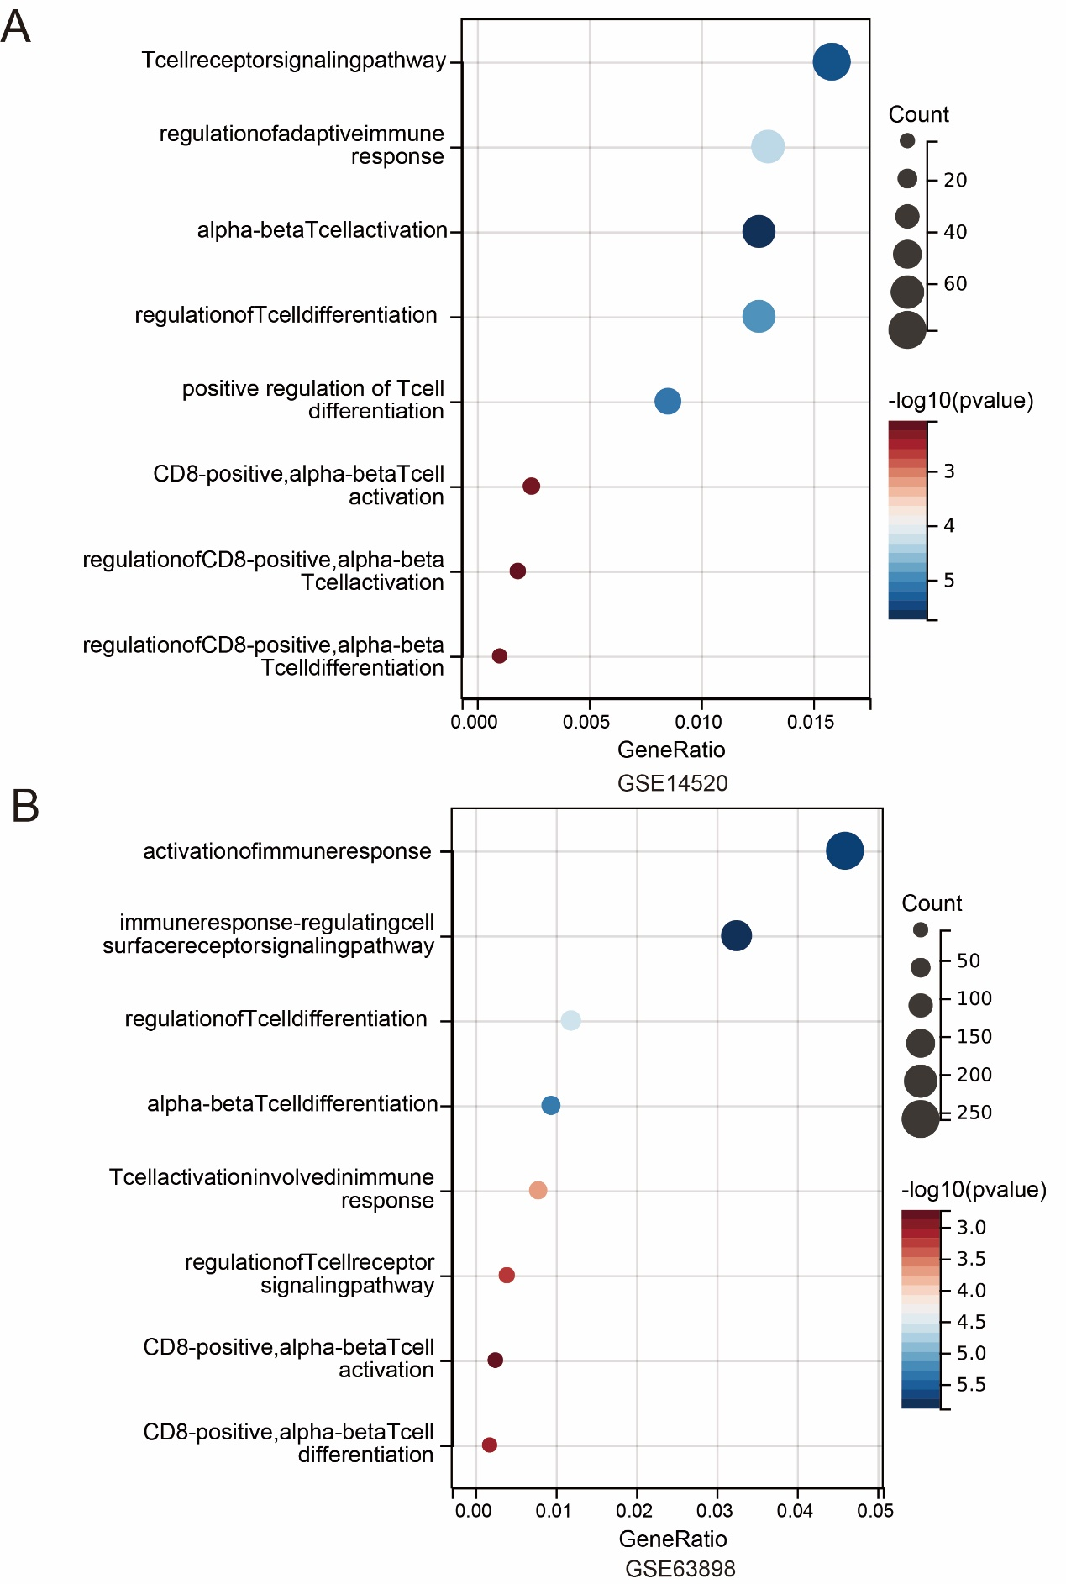
FigS.2. GO enrichment analysis. A-B GO enrichment analysis reveals enrichment of differentially expressed genes in CD8 and T cell activation pathways.

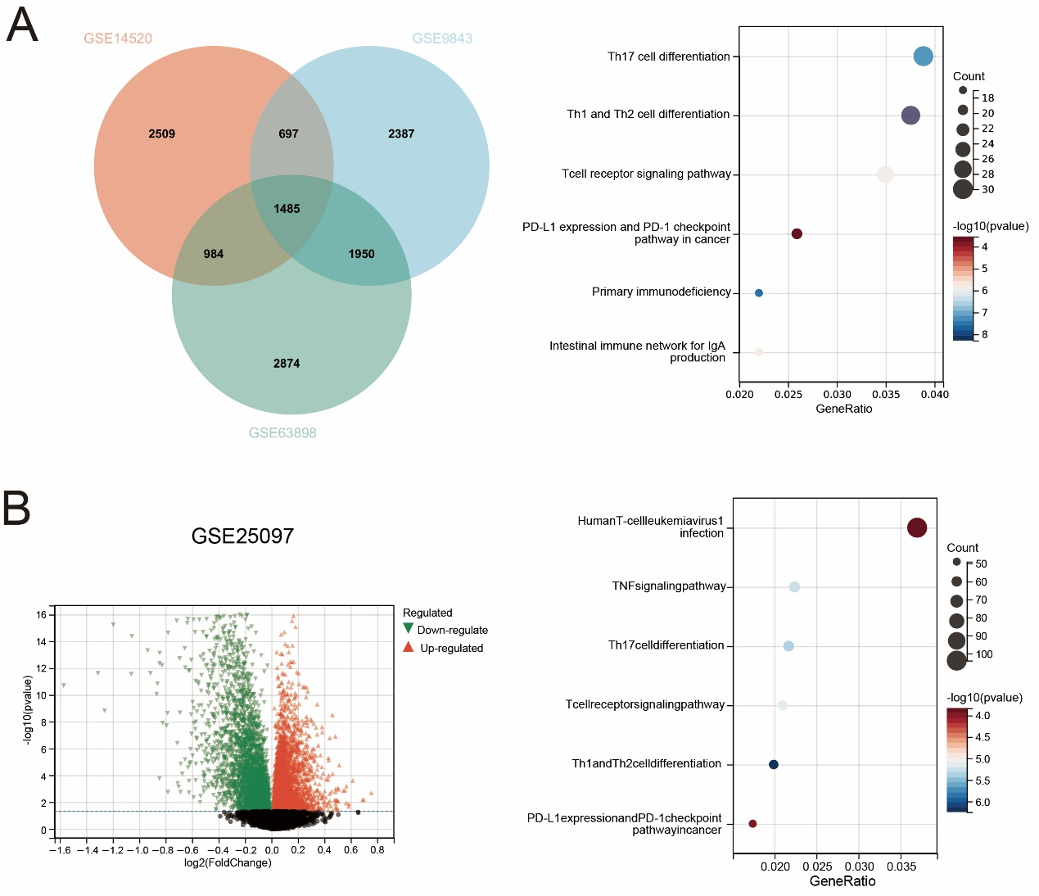
FigS.3. Differentially Lo-Immune and Hi-Immune expressed analysis. A. Venn diagram analysis and KEGG pathway analysis. B. volcano plot and KEGG pathway analysis

FigS.1. Differentially VPS72 expressed analysis.A-C volcano plot and KEGG pathway analysis
FigS.2. GO enrichment analysis. A-B GO enrichment analysis reveals enrichment of differentially expressed genes in CD8 and T cell activation pathways.
FigS.3. Differentially Lo-Immune and Hi-Immune expressed analysis. A. Venn diagram analysis and KEGG pathway analysis. B. volcano plot and KEGG pathway analysis

Table S1. The correlation between VPS72 and 6 major immune cell types (CD8+ T cells, B cells, CD4+ T cells, neutrophils, macrophages, and myeloid dendritic cells).
Table S2 Clinical characteristics of the patients with VPS72 in our IHC cohort
Table S3 VPS72 and CD8A coexpression in hepatocellular carcinoma in our cohort

