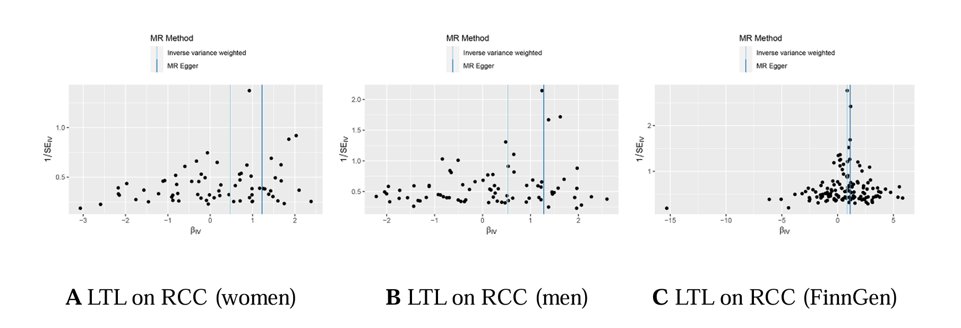
Supplementary Figure S1. Forest plot of SNPs associated with LTL and risk of RCC. SNPs: single nucleotide polymorphisms; LTL: leucocyte Telomere length; RCC: renal cell carcinoma

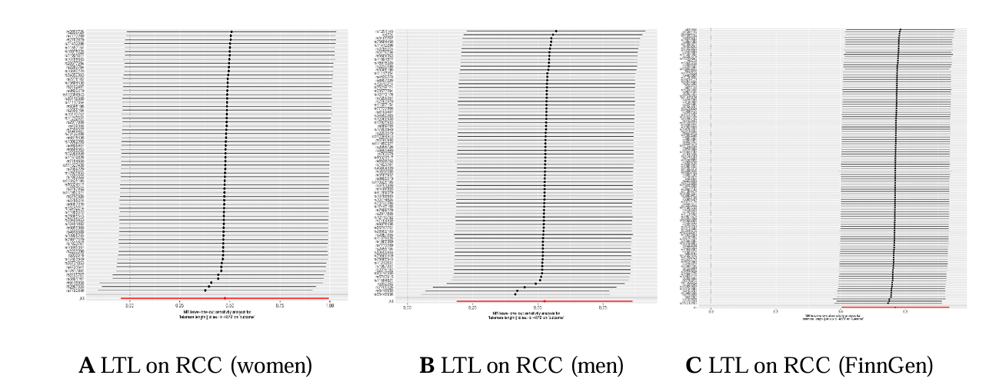
Supplementary Figure S2. Leave-one-out analysis for the impact of individual SNPs on the association between LTL and RCC risk. SNPs: single nucleotide polymorphisms; LTL: leucocyte Telomere length; RCC: renal cell carcinoma

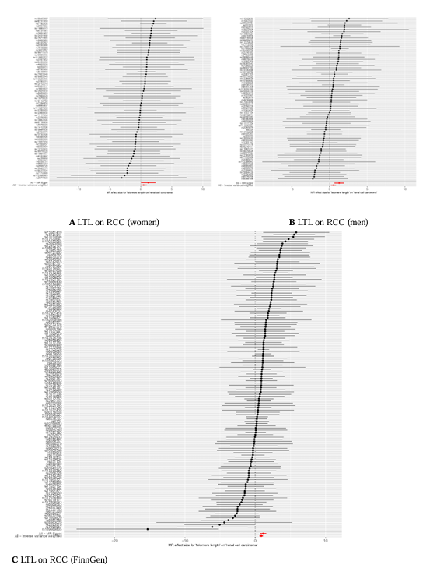
Supplementary Figure 3. Forest plot of SNPs associated with LTL and risk of RCC. SNPs: single nucleotide polymorphisms; LTL: leucocyte Telomere length; RCC: renal cell carcinoma

