Supplementary information
Figure S1
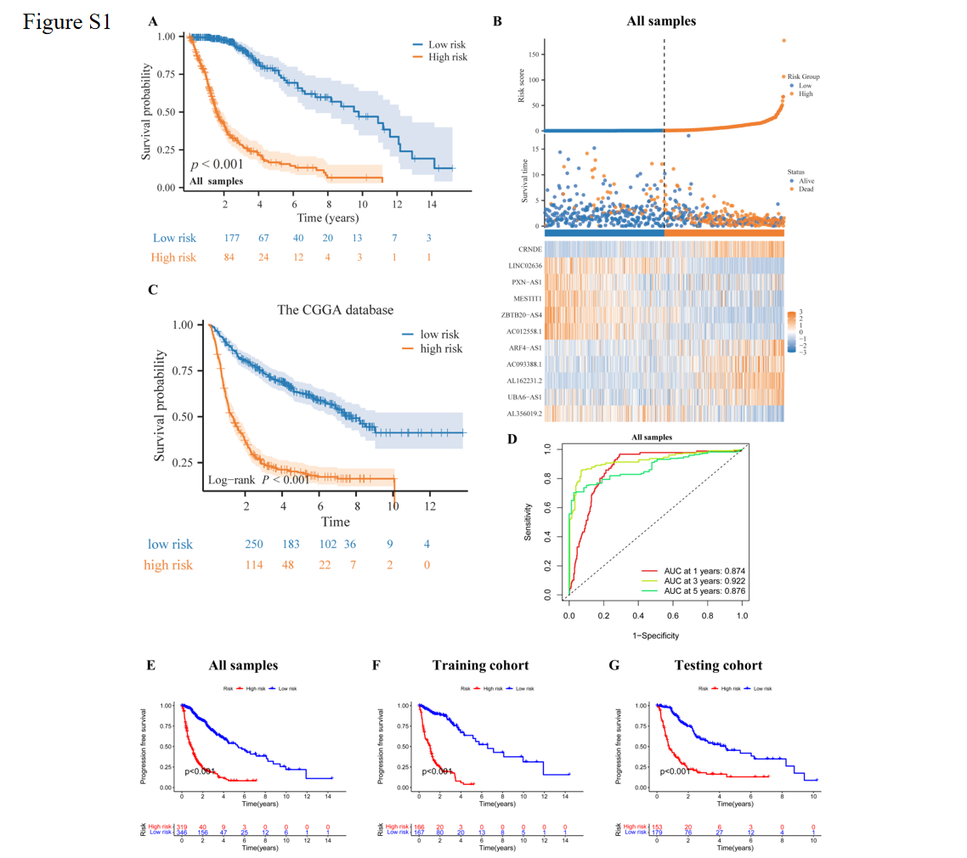
Figure S1 Risk score model assessment of 11 lncRNAs in all samples. (A) Kaplan-Meier survival curves for all high-risk and low-risk groups. (B) Risk scores, survival distribution of patients with high risk scores, and a heat map of lncRNA expression associated with disulfides. (C) Kaplan-Meier survival curve of the CGGA database. (D) ROC curves for predicting OS in all glioma patients based on risk scores. (E-G) Kaplan-Meier survival curve based on PFS.

Figure S2

Figure S2 Application and validation of a disulfidptosis-related prognostic model for glioma patients (A-B) Univariate and multifactorial independent prognostic analysis of risk scores and other clinical information. (C) concordance index of risk scores and other clinical information. (D-E) Nomogram for 1-, 3- and 5-year survival in glioma patients.
