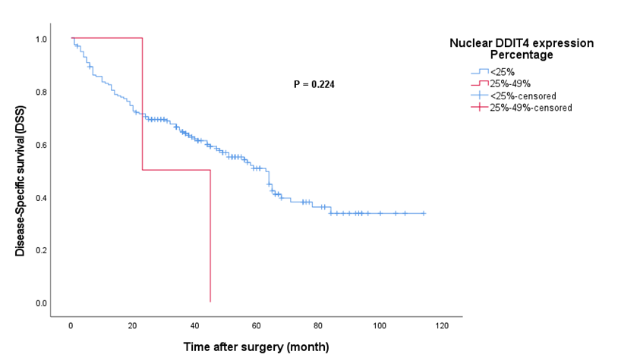
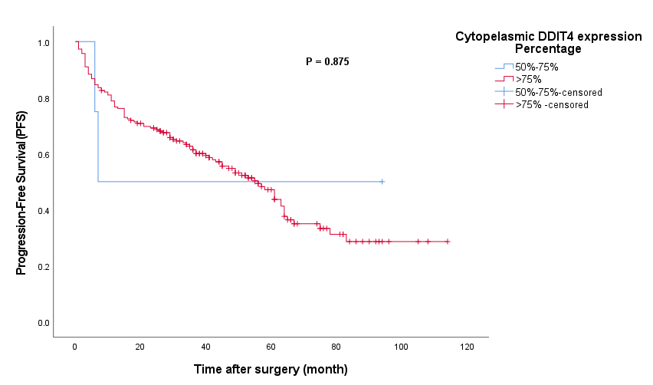
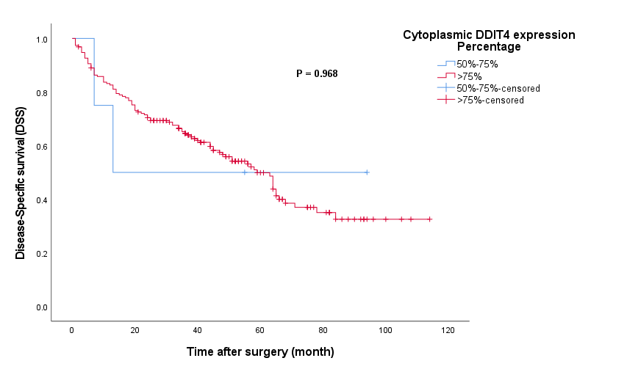
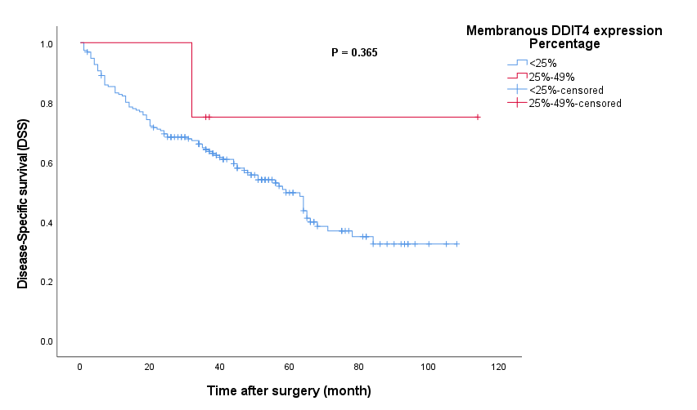
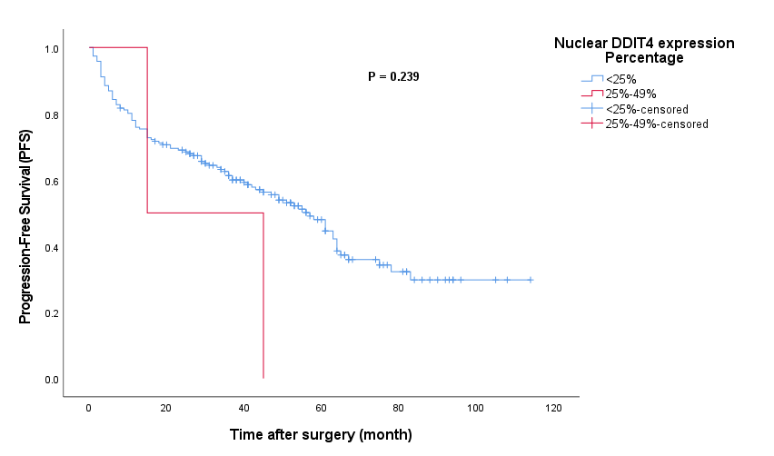
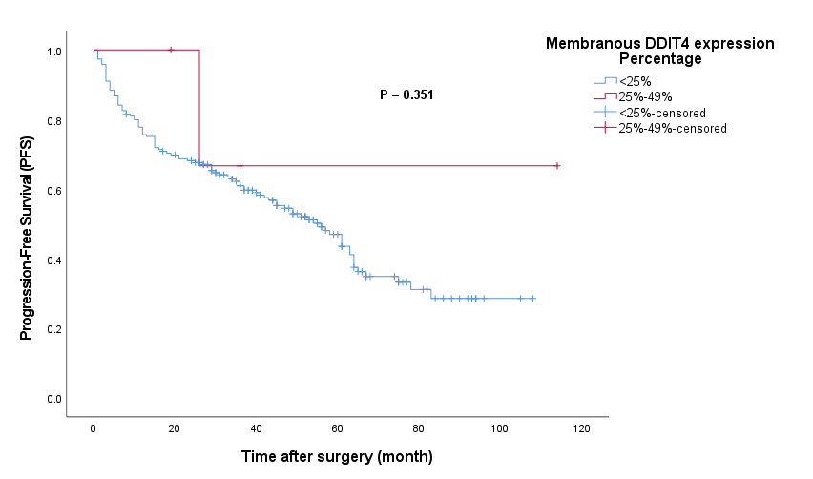
A
B
F
E
D
C

Fig. S2. Kaplan–Meier survival analysis for disease-specific survival (DSS) and progression-free survival (PFS) of Gastric Cancer (GC) patients based on the percentage of nuclear, cytoplasmic and membranous expressions of DDIT4. A, B: The results of Kaplan Meier curves showed that there were no statistically significant differences between DSS (Log-Rank test; P = 0.224) and PFS (Log-Rank test; P = 0.239) between patients group 1 (<25%) and group 2 (25%-49%) nuclear expression of DDIT4 in tumor cells. C, D: The results of Kaplan Meier curves reveled that there were no statistically significant differences in DSS (Log-Rank test; P = 0.968) and PFS (Log-Rank test; P = 0.875) between patients group 3 (50%-75%) and group 4 (>75%) the cytoplasmic expression of DDIT4 in tumor cells. E, F: The results of Kaplan Meier curves indicated that there were no statistically significant differences in DSS (Log-Rank test; P = 0.365) and PFS (Log-Rank test; P = 0.351) between patients group 1 (<25%) and group 2 (25%-49%) membranous expression of DDIT4 in tumor cells.

