Figure 2A. Effects of DIM on the migratory capacity of A549 cells were assessed using a wound healing assay method. The vertical headings in the table represent different experimental groups and the horizontal headings labels, for represent different times.

wound healing assay | 0 h | 6 h | 12 h | 24 h
A549
0μM |  |  | 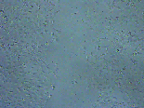 | 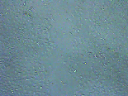
50μM |  |  | 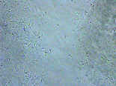 | 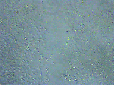
100μM |  | 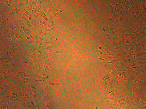 | 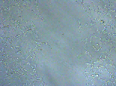 | 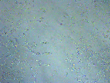

Figure 2B. Effects of DIM on the migratory capacity of H1299 cells were assessed using a wound healing assay method. The vertical headings in the table represent different experimental groups and the horizontal labels represent different times.

wound healing assay | 0 h | 6 h | 12 h | 24 h
H1299
0μM | 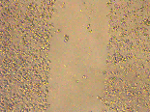 | 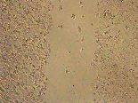 | 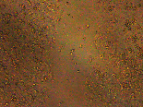 | 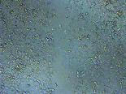
25μM | 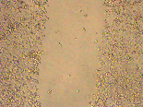 | 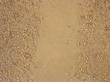 | 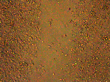 | 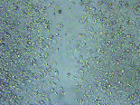
50μM | 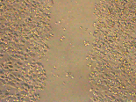 | 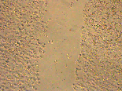 | 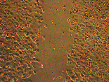 | 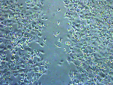

Figure 2C. Transwell assay method to assess changes in the invasive capacity of A549 cells after DIM treatment. The vertical headings in the table represent the different experimental groups, and column 1 is a picture of the manuscript figure.

Transwell
A549 | 1 | 2 | 3 | 4 | 5
0μM | 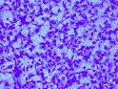 | 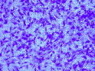 | 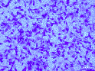 |  | 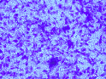
50μM | 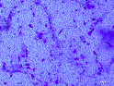 | 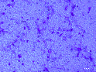 | 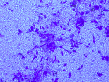 | 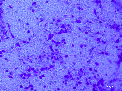 | 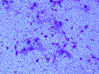
100μM | 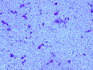 | 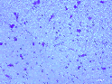 | 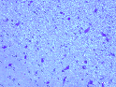 | 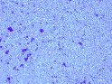 | 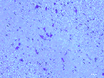

Figure 2D. Transwell assay method to assess changes in the invasive capacity of H1299 cells after DIM treatment. The vertical headings in the table represent the different experimental groups, and column 1 is a picture of the manuscript figure.

Transwell
H1299 | 1 | 2 | 3 | 4 | 5
0μM | 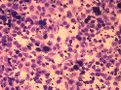 | 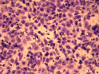 | 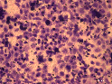 | 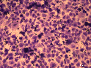 | 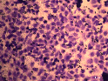
25μM | 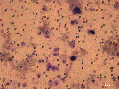 | 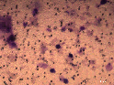 | 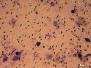 | 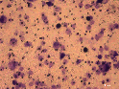 | 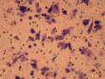
50μM | 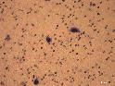 | 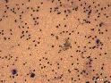 | 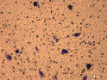 | 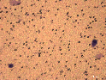 | 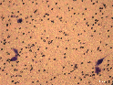

Figure 3A. Fe²⁺ levels were assessed in A549 cells using the Fe²⁺ fluorescent probe assay method. The vertical headings in the table represent the different experimental groups, and column 1 is a picture of the manuscript figure. In order to make the images in the manuscript clearer, we adjusted the brightness and contrast of the images, but please rest assured that all adjustments were made for all groups uniformly, which does not affect the results of our experiments.

Fe | 1 | 2 | 3
A549
0μM | 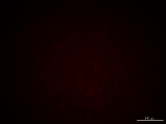 | 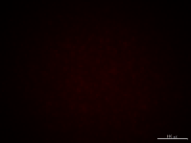
100μM
100μM+CH23191
100μM+Fer-1
100μM+NAC

Figure 3B. Fe²⁺ levels were assessed in H1299 cells using the Fe²⁺ fluorescent probe assay method. The vertical headings in the table represent the different experimental groups, and column 1 is a picture of the manuscript figure.
Fe | 1 | 2 | 3
H1299
0μM
50μM
50μM+CH23191
50μM+Fer-1
50μM+NAC

Figure 3C. ROS levels were determined in A549 cells using the DCFH-DA probe. The vertical headings in the table represent the different experimental groups, and column 1 is a picture of the manuscript application.

ROS
A549 | 1 | 2 | 3
0μM | 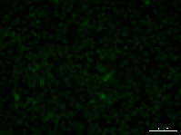 | 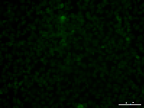 | 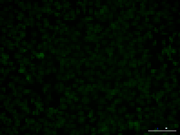
100μM |  | 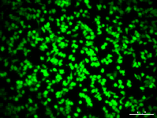 | 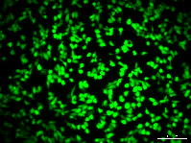
100μM+CH23191 | 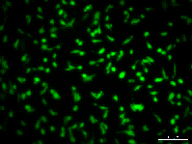 | 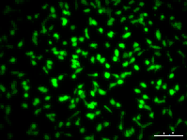 | 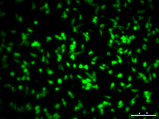
100μM+NAC | 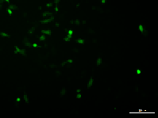 | 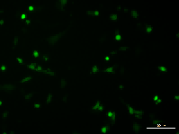 | 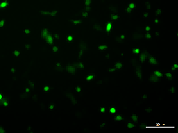

Figure 3D. ROS levels were determined in H1299 cells using the DCFH-DA probe. The vertical headings in the table represent the different experimental groups, and column 1 is a picture of the manuscript application.

ROS
H1299 | 1 | 2 | 3
0μM | 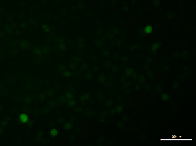 | 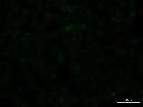 | 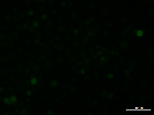
50μM | 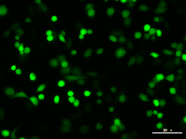 | 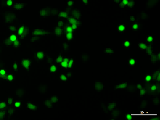 | 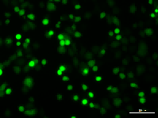
50μM+CH23191 | 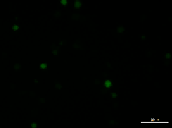 | 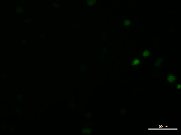 | 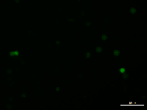
50μM+NAC | 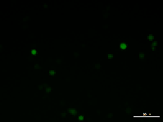 | 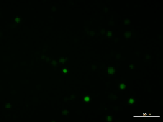 | 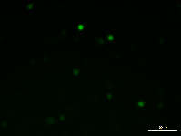

Figure 4A. MMP levels of cells in A549 cells were detected using the JC-1 assay kit, and the data were analyzed by histogram analysis as the ratio of Aggregates to Monomers. The vertical headings in the table represent the different experimental groups, and column 1 is a picture of the manuscript application.

JC-1
A549 | 1 | 2 | 3
0μM | 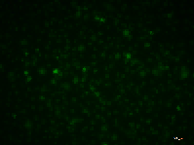 | 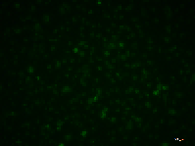 | 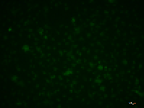
 | 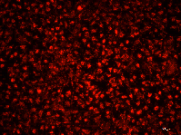 | 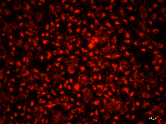 | 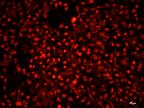
100μM | 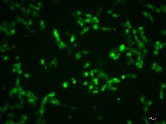 | 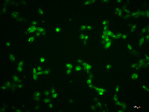 | 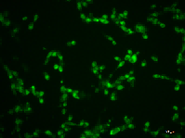
 | 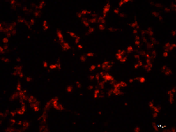 | 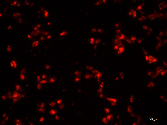 | 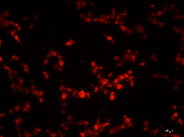
100μM+CH23191 | 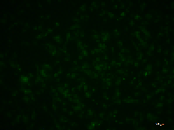 | 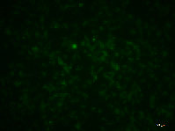 | 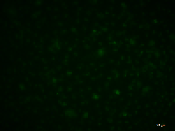
 | 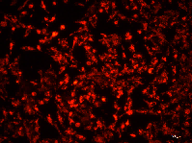 | 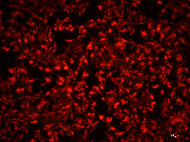 | 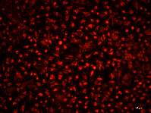
100μM+NAC | 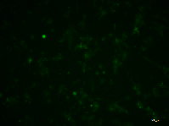 | 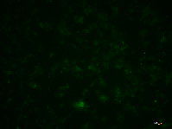 | 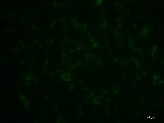
 | 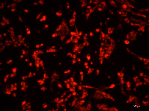 | 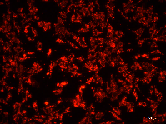 | 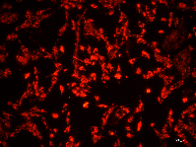
100μM+Fer-1 | 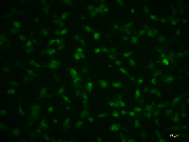 | 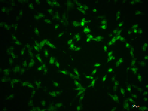 | 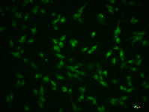
 | 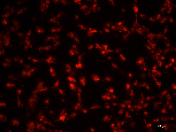 | 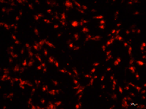 | 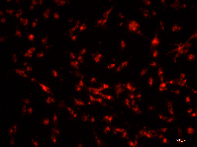

Figure 4B. MMP levels of cells in H1299 cells were detected using the JC-1 assay kit, and the data were analyzed by histogram analysis as the ratio of Aggregates to Monomers. The vertical headings in the table represent the different experimental groups, and column 1 is a picture of the manuscript application.
JC-1
H1299 | 1 | 2 | 3
0μM | 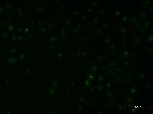 | 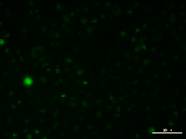 | 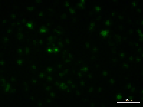
 | 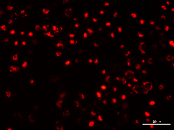 | 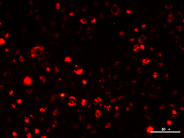 | 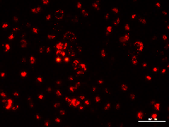
50μM | 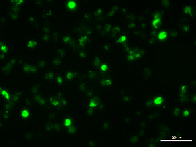 | 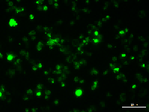 | 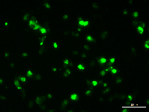
 | 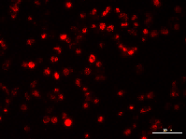 | 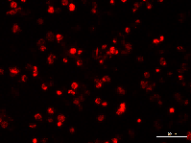 | 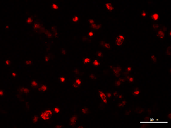
50μM+CH23191 | 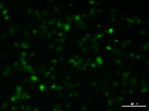 | 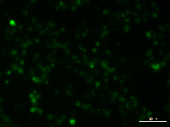 | 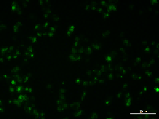
 | 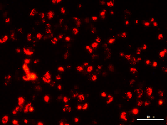 | 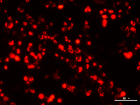 | 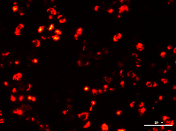
50μM+NAC | 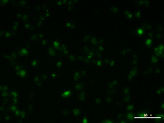 | 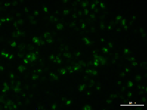 | 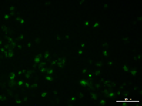
 | 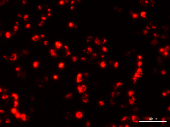 | 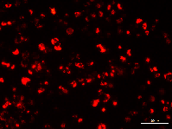 | 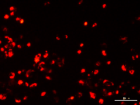
50μM +Fer-1 | 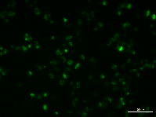 | 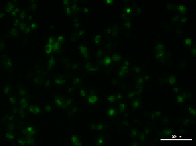 | 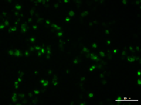
 | 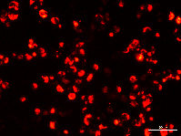 | 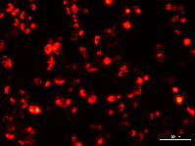 | 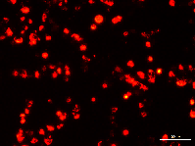

Figure 4C. Mitochondrial morphology of A549 cells in each group after DIM treatment was photographed using transmission electron microscopy. control group on the left and the DIM group on the right.
TEM | Control | Control | DIM | DIM
A549 | under low magnification | under high magnification | under low magnification | under high magnification
 | 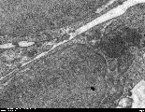 | 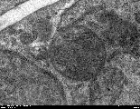 | 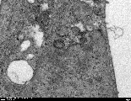 | 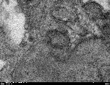

Figure 4D. Mitochondrial morphology of H1299 cells in each group after DIM treatment was photographed using transmission electron microscopy. control group on the left and the DIM group on the right.

TEM | Control | Control | DIM | DIM
H1299 | under low magnification | under high magnification | under low magnification | under high magnification
 | 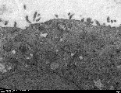 | 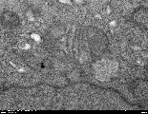 | 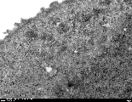 | 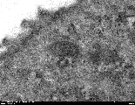

Figure 5C, 6C and 6E. Expression of AHR, NRF2 and GPX4 proteins in A549 cells of each group was detected by immunofluorescence. The vertical headings in the table represent different experimental groups and the horizontal headings represent different molecular. Pictures used in the manuscript are shown in red boxes. In order to make the images in the manuscript clearer, we adjusted the brightness and contrast of the images, but please rest assured that all adjustments were made for all groups together, which does not affect the results of our experiments.

IF | Figure 5C | Figure 6C | Figure 6E
A549 | AHR | NRF2 | GPX4
0μM | 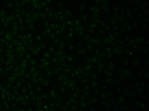 | 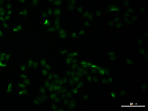 | 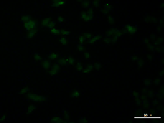
DAPI | 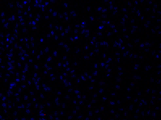 | 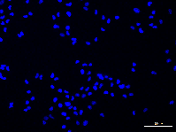 | 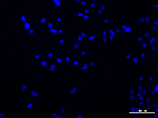
100μM | 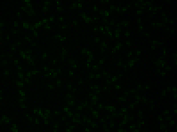 | 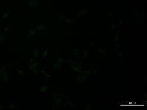 | 
DAPI | 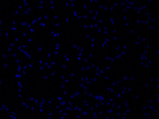 | 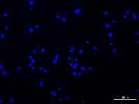 | 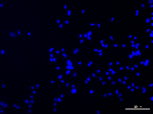
100μM+CH23191 | 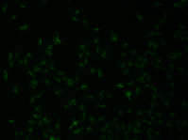 | 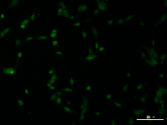 | 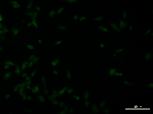
DAPI | 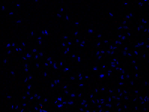 | 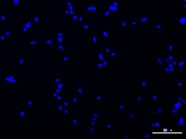 | 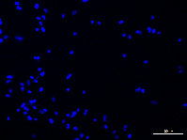
100μM+Fer-1 |  | 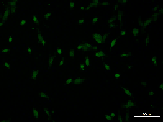 | 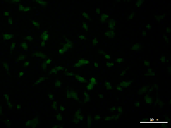
DAPI |  | 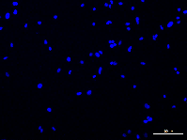 | 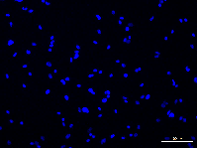
100μM+NAC |  | 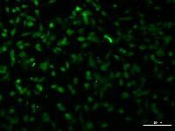 | 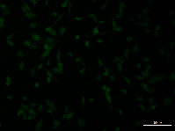
DAPI |  | 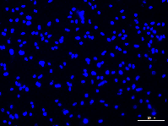 | 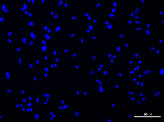

Figure 5E, 6D and 6F. Expression of AHR, NRF2 and GPX4 proteins in H1299 cells of each group was detected by immunofluorescence. The vertical headings in the table represent different experimental groups and the horizontal headings represent different molecular. Pictures used in the manuscript are shown in red boxes. In order to make the images in the manuscript clearer, we adjusted the brightness and contrast of the images, but please rest assured that all adjustments were made for all groups together, which does not affect the results of our experiments.

IF | Figure 5E | Figure 6D | Figure 6F
H1299 | AHR | NRF2 | GPX4
0μM | 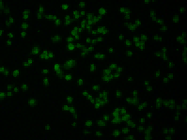 | 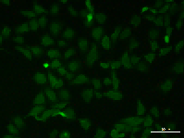 | 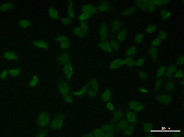
DAPI | 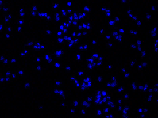 | 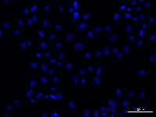 | 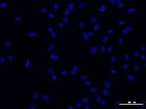
50μM | 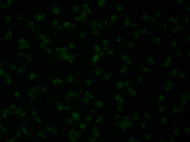 | 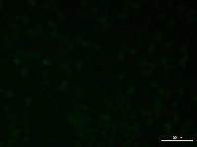 | 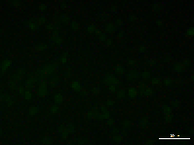
DAPI | 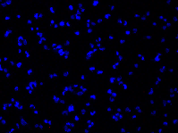 | 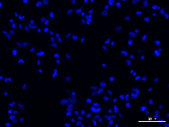 | 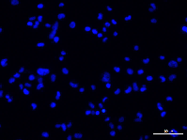
50μM+CH23191 | 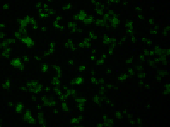 | 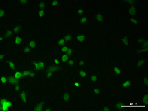 | 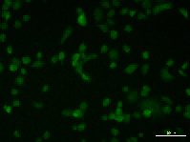
DAPI | 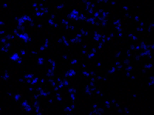 | 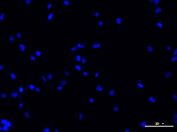 | 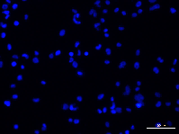
50μM+Fer-1 |  | 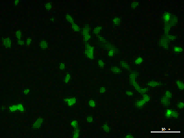 | 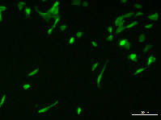
DAPI |  | 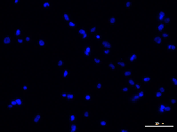 | 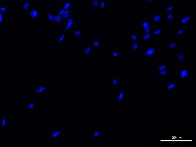
50μM+NAC |  | 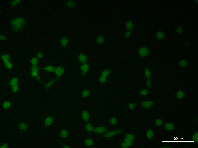 | 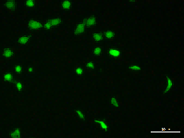
DAPI |  | 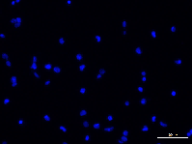 | 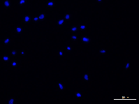

Figure 7A. Expression of NRF2 protein in control and overexpression groups was detected by immunofluorescence. The vertical headings in the table represent different experimental groups and the horizontal headings represent different cells. Pictures used in the manuscript are shown in red boxes.
IF | A549 | H1299
NRF2
Vector | 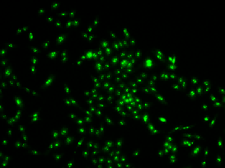 | 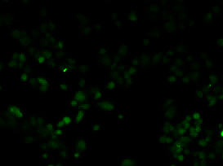
DAPI | 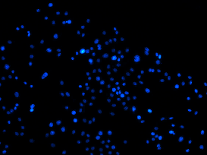 | 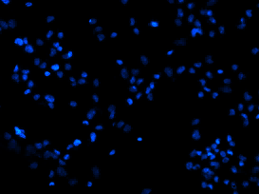
OE-NRF2 | 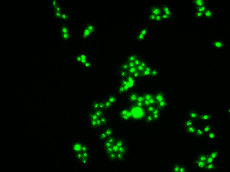 | 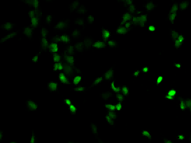
DAPI | 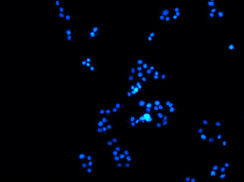 | 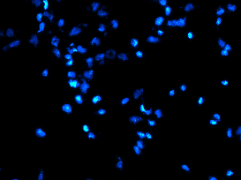

Figure 7D. Fe²⁺ levels were assessed in each group using Fe²⁺ fluorescent probe assay. The vertical headings in the table represent the different experimental groups, and column 1 is a picture of the manuscript application. In order to make the images in the manuscript clearer, we adjusted the brightness and contrast of the images, but please rest assured that all adjustments were made for all groups together, which does not affect the results of our experiments.
Fe | 1 | 2 | 3
A549 | Application Images
Vector
Vector+DIM
OE-NRF2
OE-NRF2+DIM

Fe | 1 | 2 | 3
H1299 | Application Images
Vector
Vector+DIM
OE-NRF2
OE-NRF2+DIM

Figure 8E. Immunohistochemical analysis of the proliferation marker Ki-67 and the key targets of ferroptosis AHR, NRF2, and GPX4.The vertical headings of the table represent the different molecules and the horizontal headings represent the experimental groups.
IHC | Control | DIM | Negative control
AHR
NRF2 | 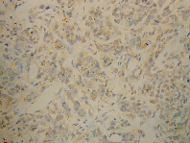 | 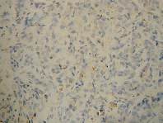 | 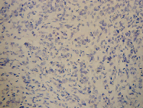
GPX4 | 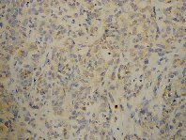 |  | 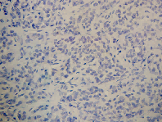
Ki-67 | 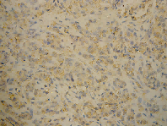 | 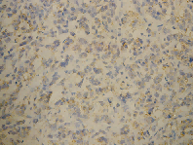 | 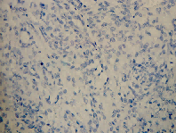

Figure 8F. Histopathological examination of mouse liver, kidney, and tumor tissues using HE staining. Control group on the left and the DIM group on the right.
HE | Control | Control | DIM | DIM
 | under low magnification | under high magnification | under low magnification | under high magnification
Liver
Kidney
Tumor

Figure 8G. Examination of iron content levels in tumor tissues using Prussian blue staining. control group on the left and the DIM group on the right.

Perl | Control | Control | DIM | DIM
 | under low magnification | under high magnification | under low magnification | under high magnification
 | 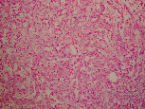 |  | 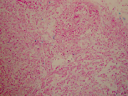 | 