Figure S1 Scatter Plots
These scatter plots illustrate the MR analysis of the relationship between SNP effects on exposures (x-axis) and SNP effects on outcomes (y-axis). Each dot represents an SNP with error bars indicating its standard error. The MR results are derived using four methods: Inverse variance weighted, MR Egger, Weighted median, and Weighted Mode. The lines represent the regression slopes estimated by each method, providing insights into the causal effect of exposure on outcome. The color coding corresponds to different MR methods: light blue for Inverse variance weighted, blue for MR Egger, green for Weighted Median, and dark green for Weighted Mode. The slopes indicate the estimated causal effects under each method.

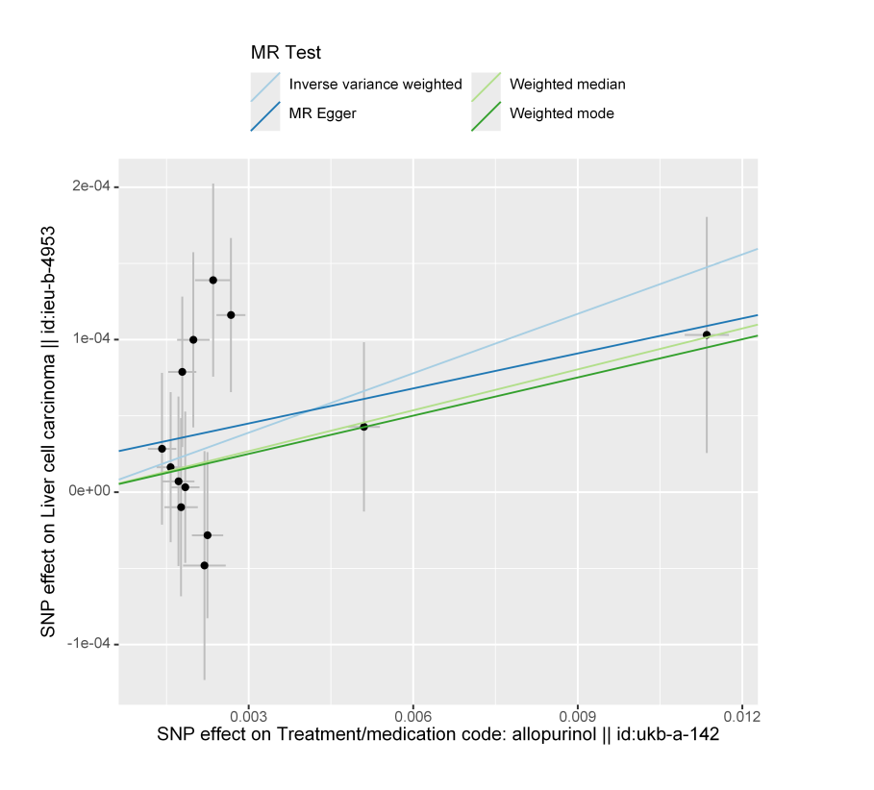
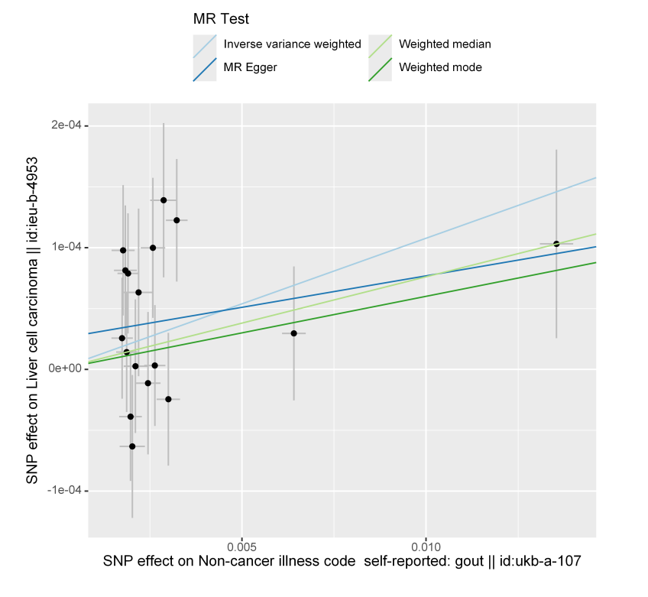
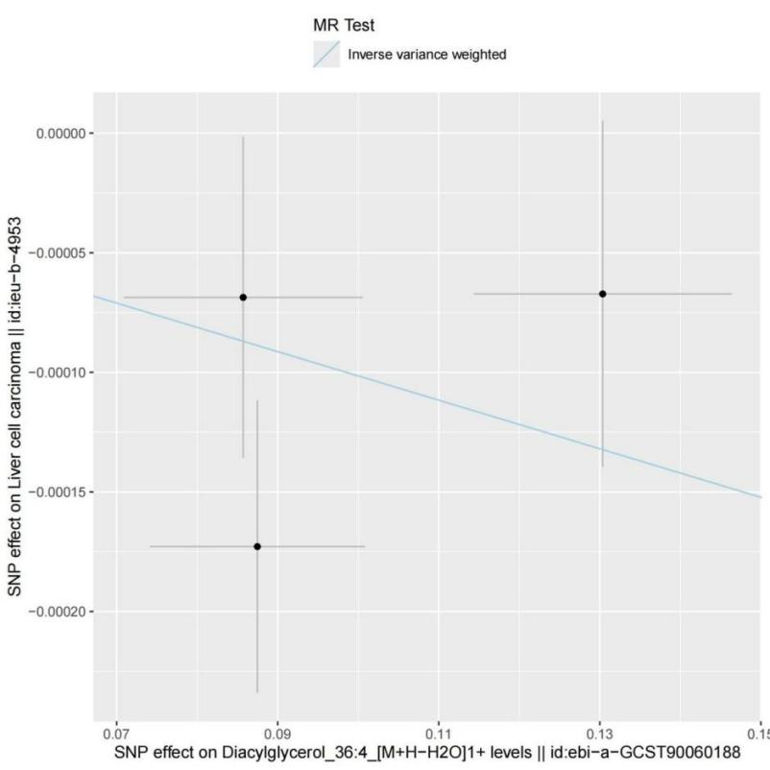

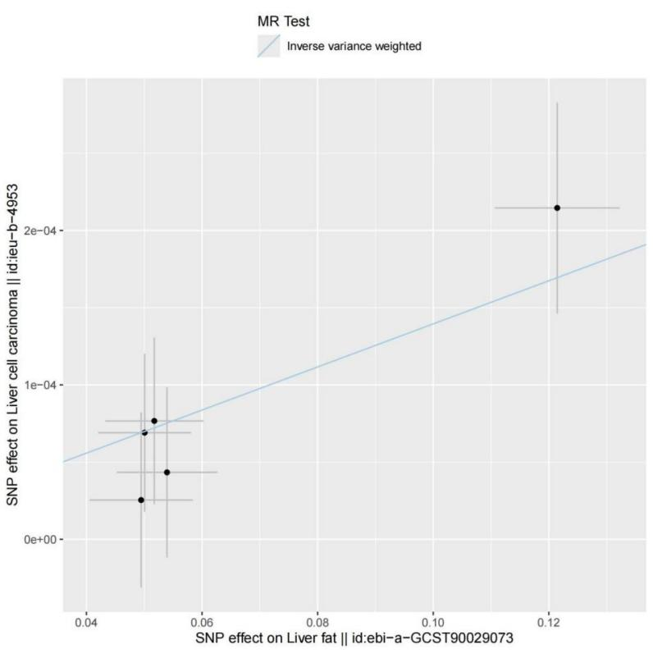

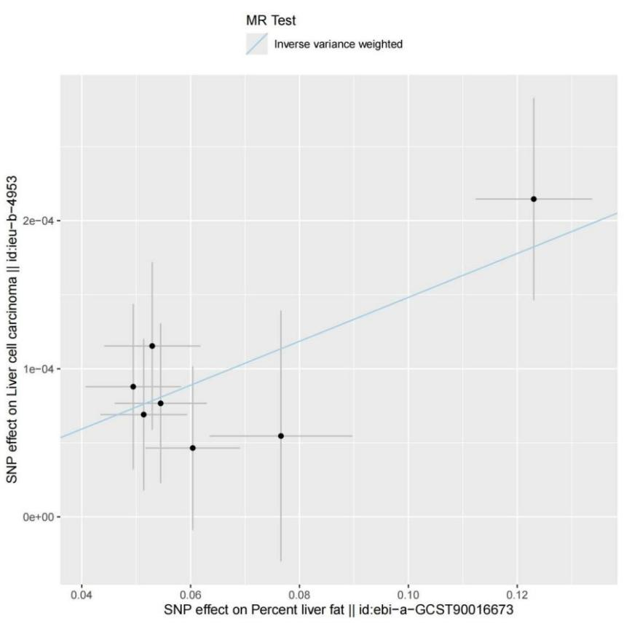

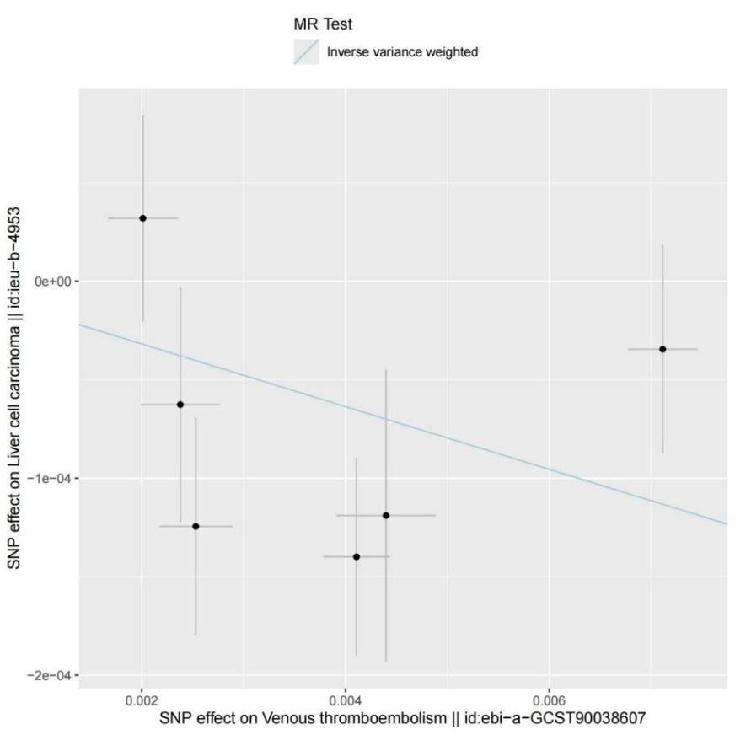

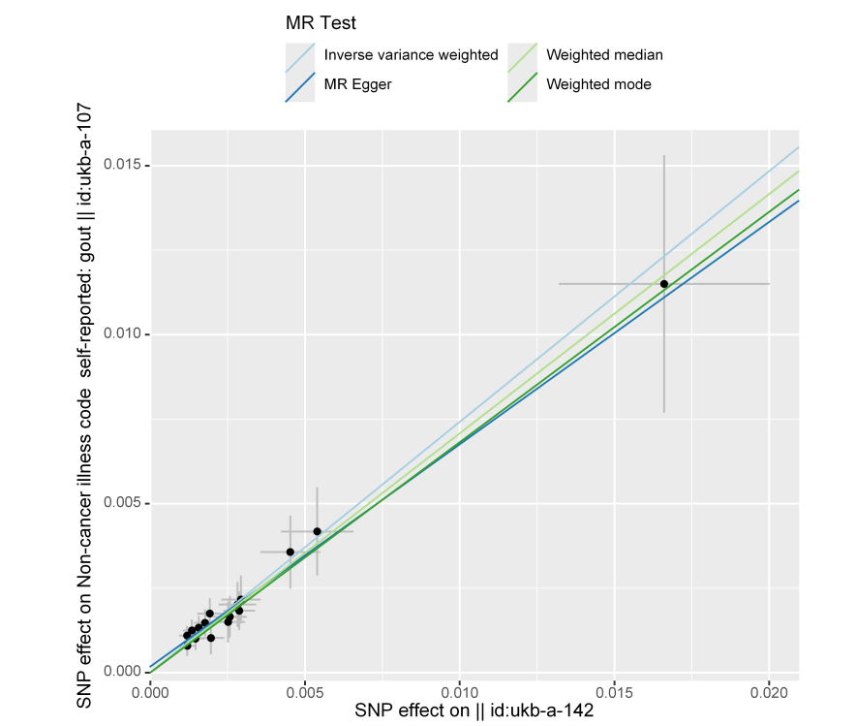

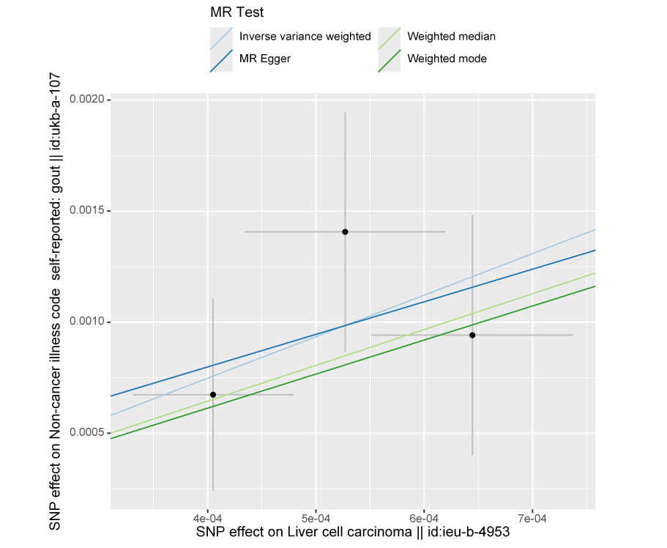

Figure S2 Forrest Plots
These forest plots demonstrate the effect sizes of genetic variants (SNPs) on the outcome in relation to exposure. The x-axis represents the Mendelian randomization (MR) effect size, while the y-axis systematically lists the individual SNPs. Each black dot represents the specific effect size for an individual SNP, with the horizontal line indicating the corresponding 95% confidence interval. The red bar at the bottom synthesizes the overall effect size of the Mendelian randomization analysis.
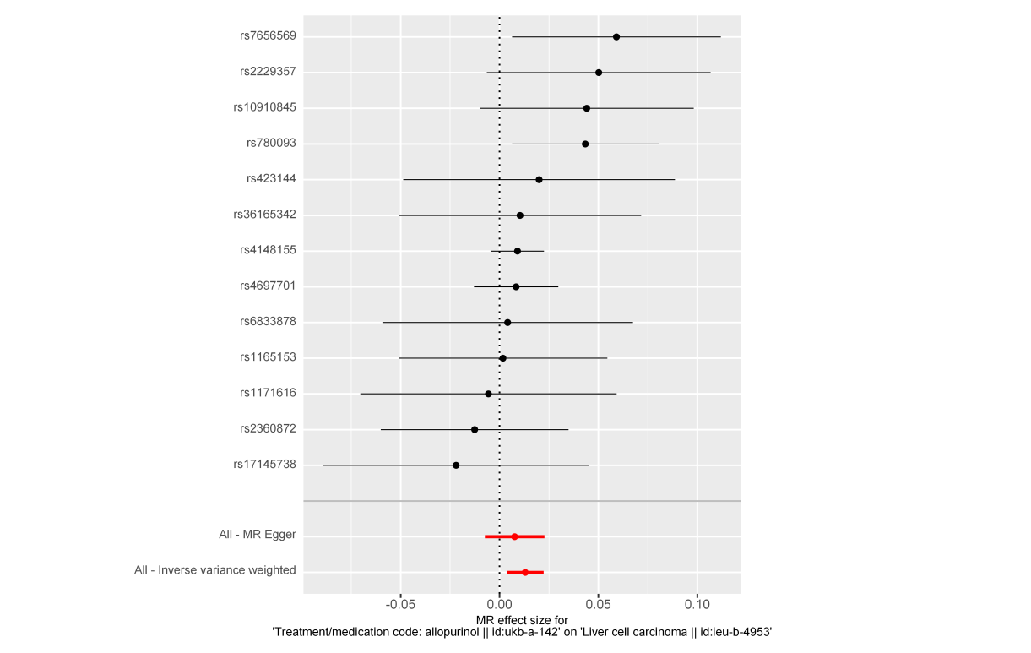
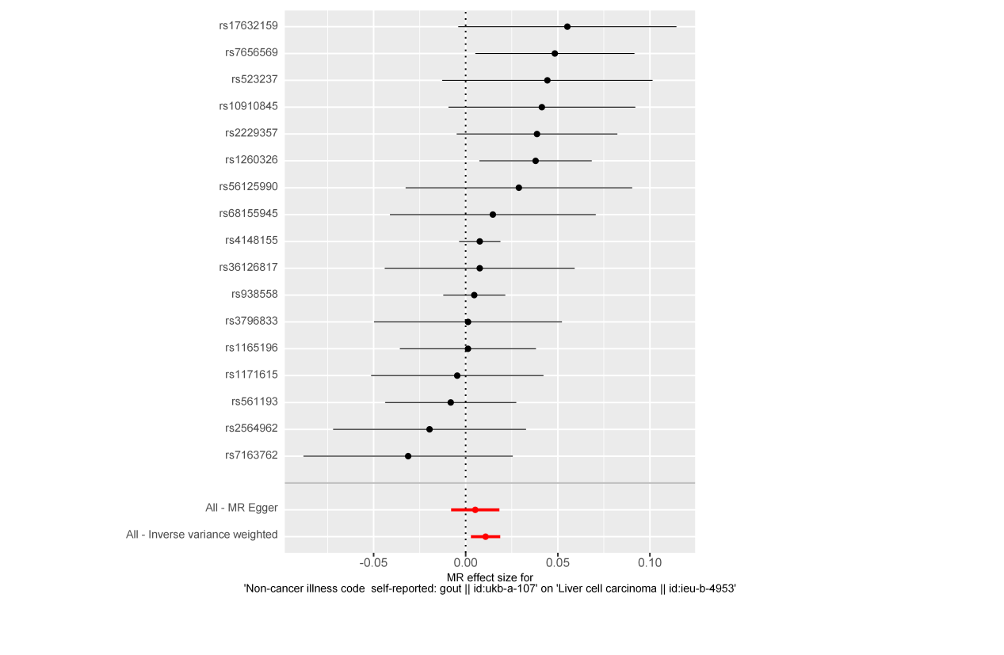
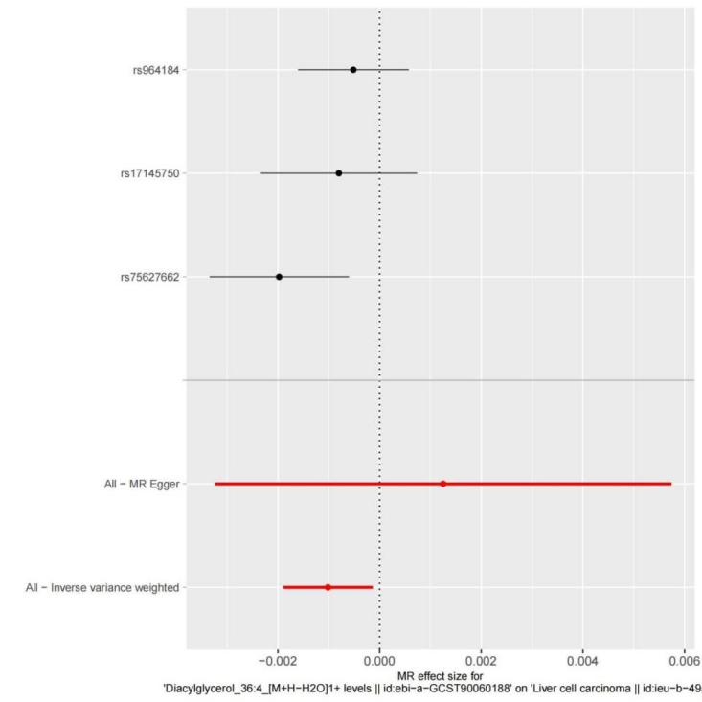
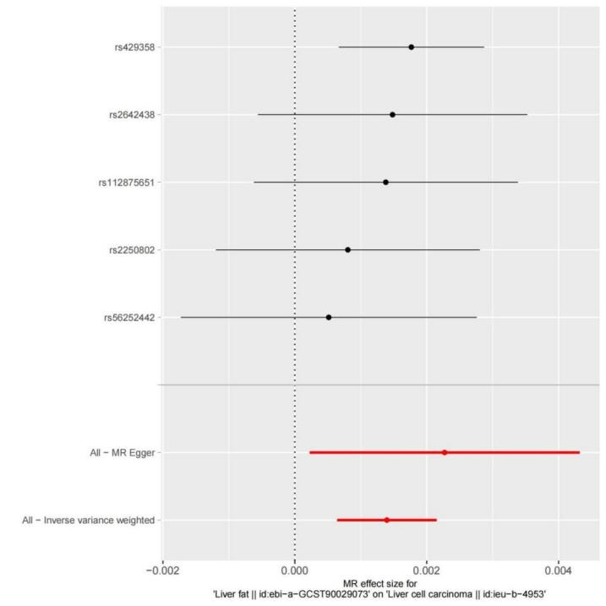

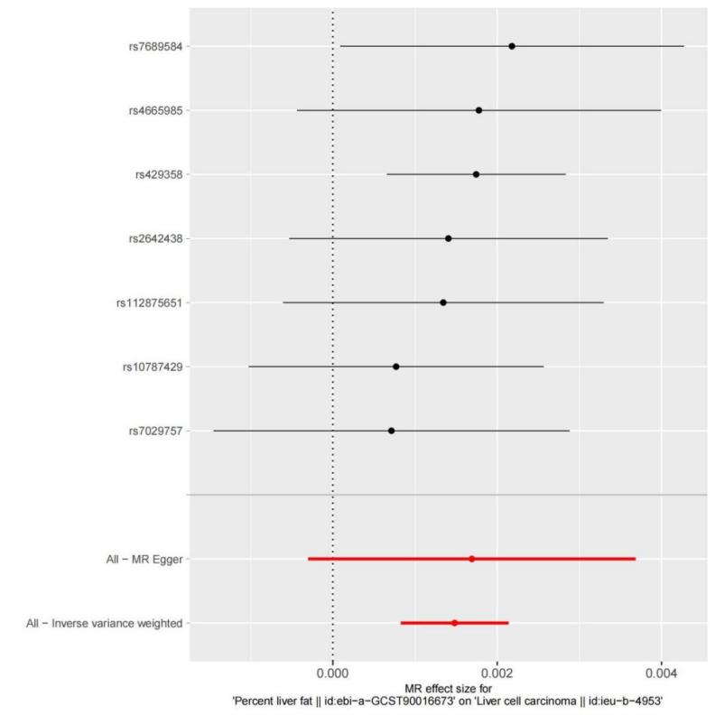

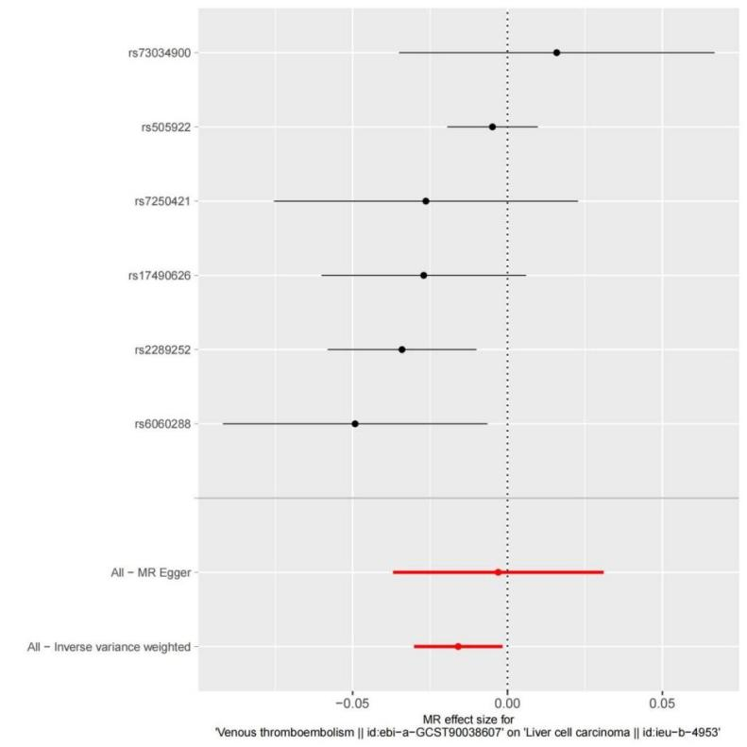

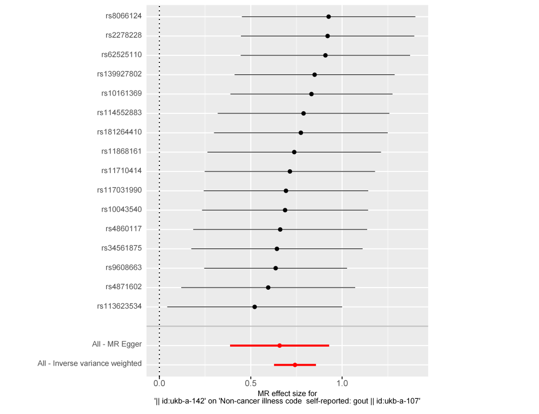

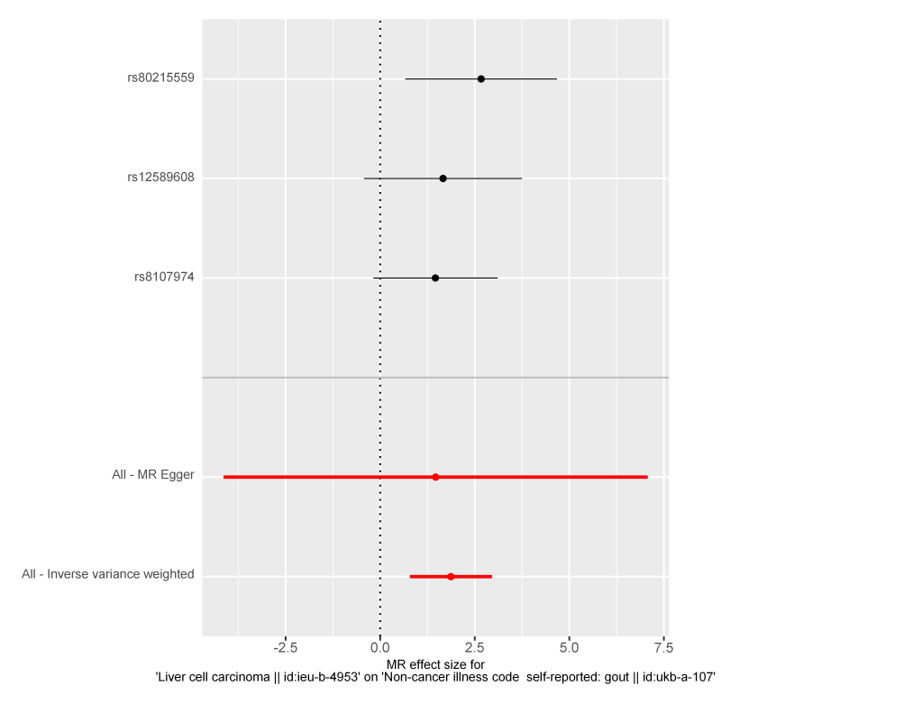

Figure S3 Funnel Plots
These funnel plots illustrate the MR analysis of the effects of exposure on liver outcomes. The x-axis represents the effect size of SNPs, denoted as β_IV, while the y-axis represents the inverse of the standard error (1/SE). Each point corresponds to a specific SNP, and the distribution of points reflects the estimation precision. The symmetric shape of the funnel suggests that the estimates are unbiased.
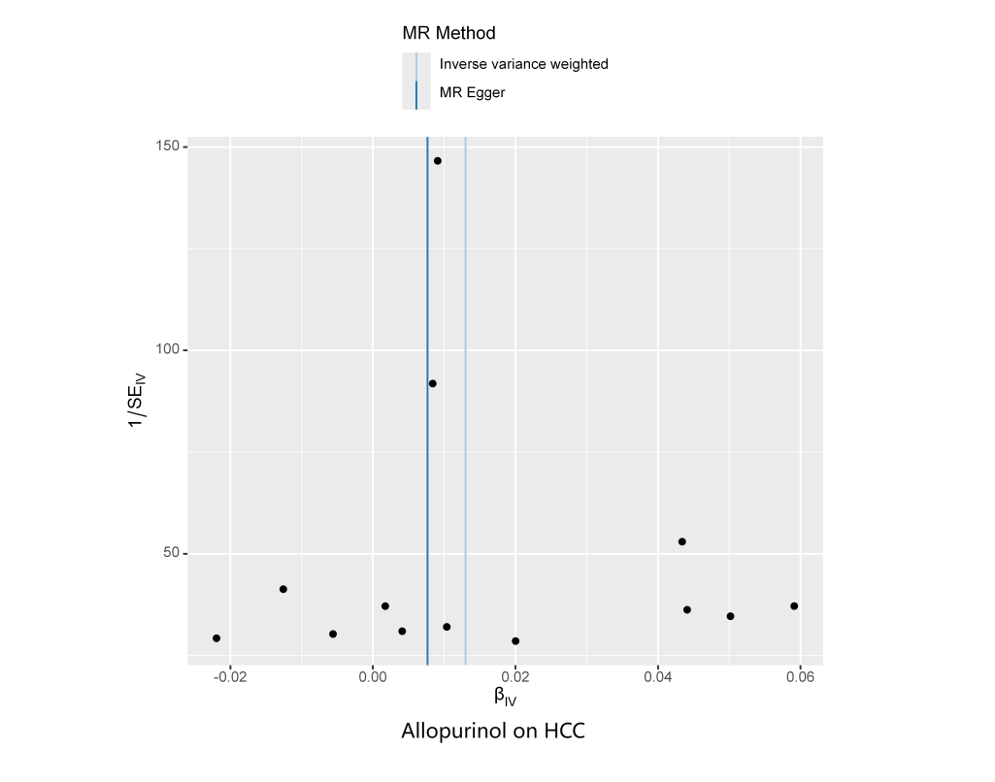
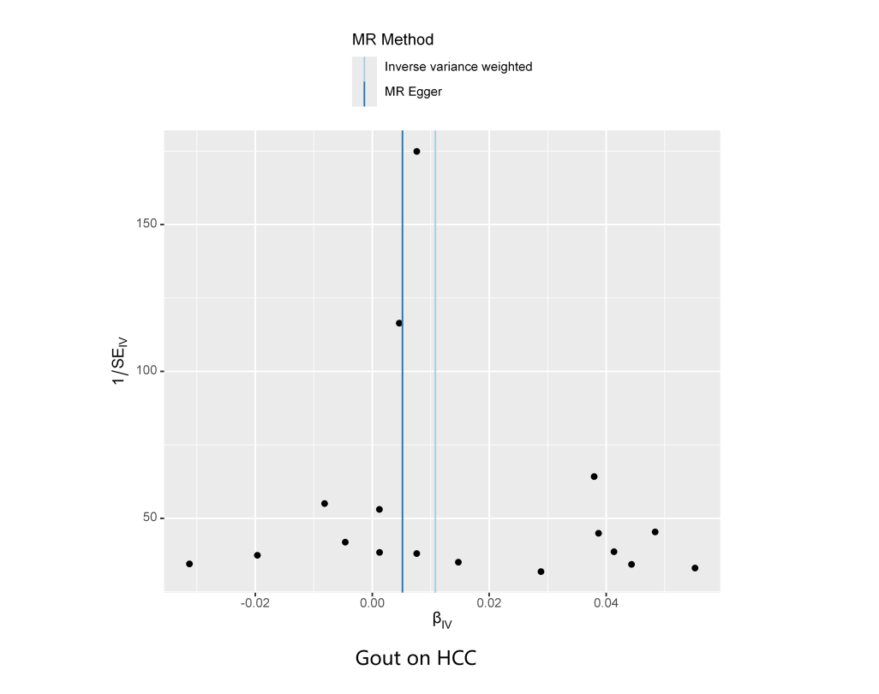
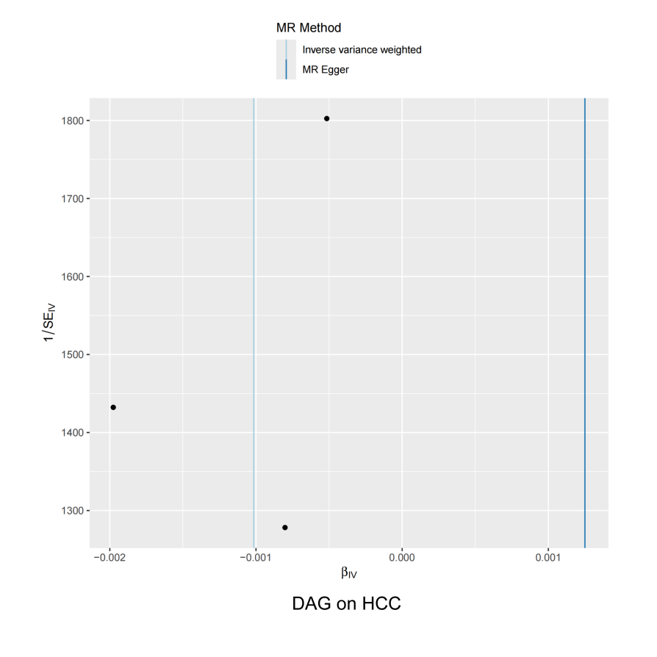
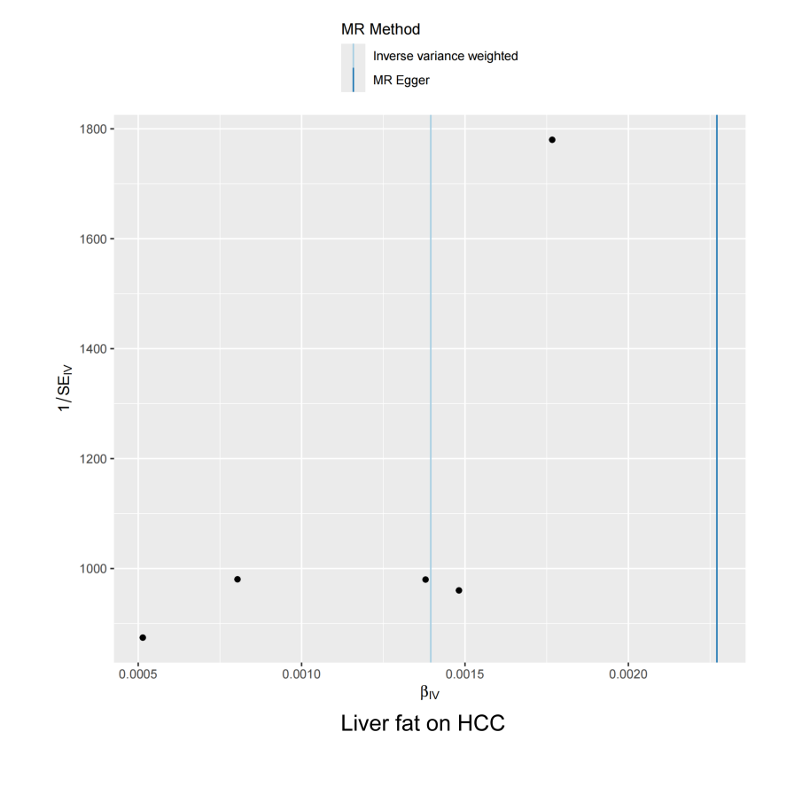
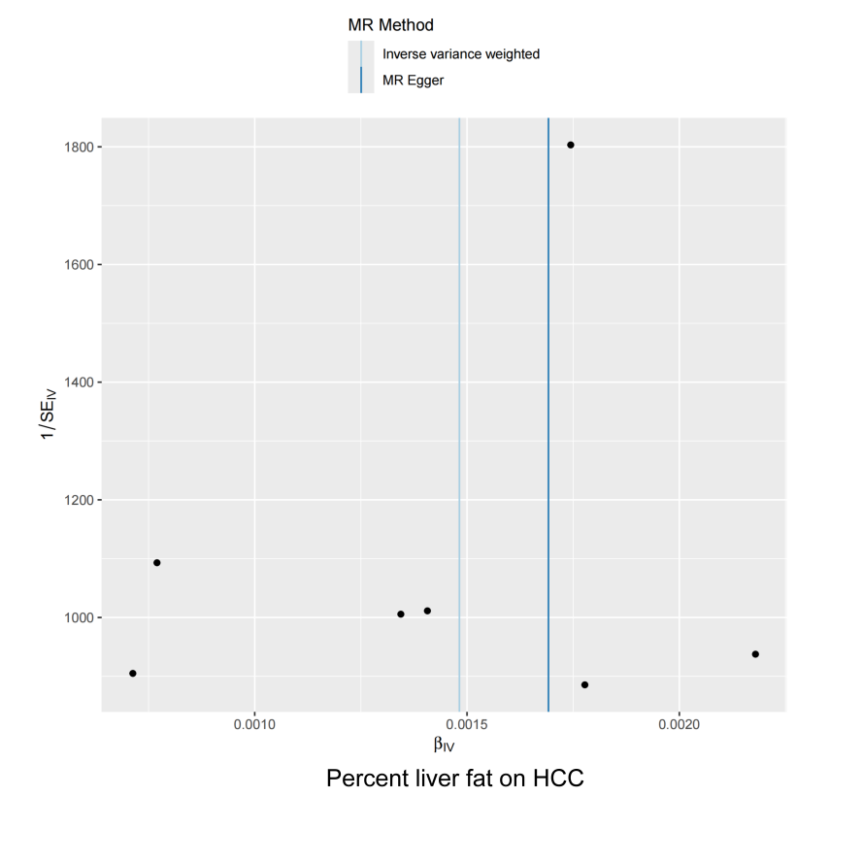
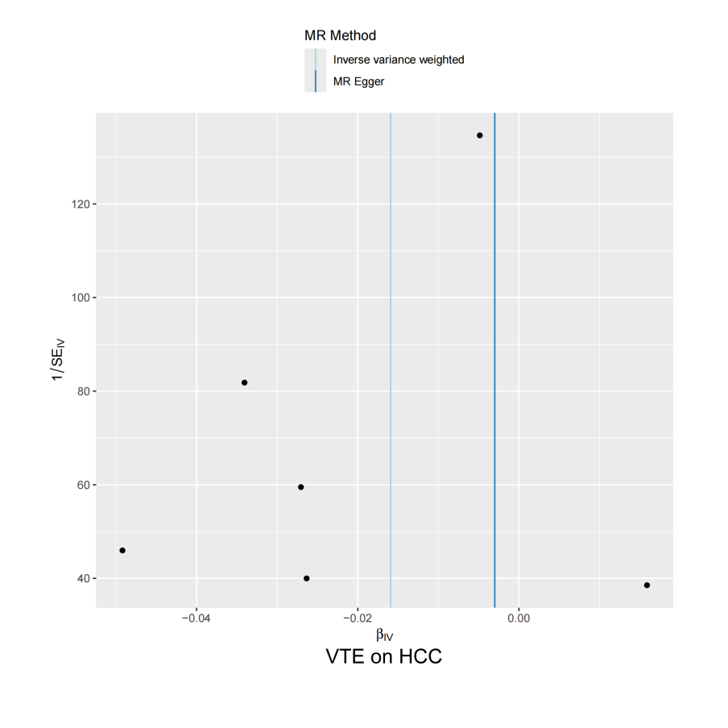
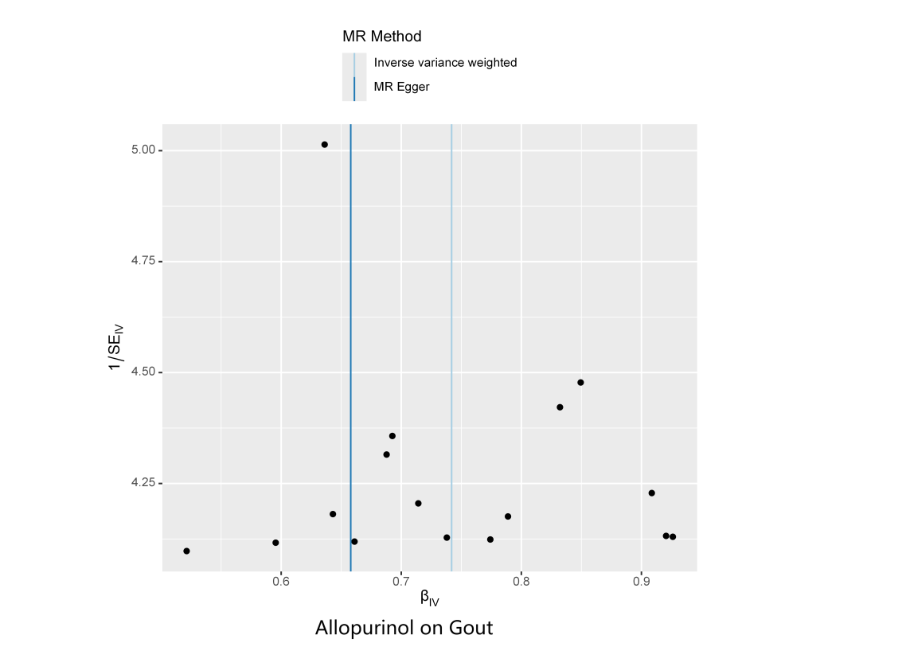

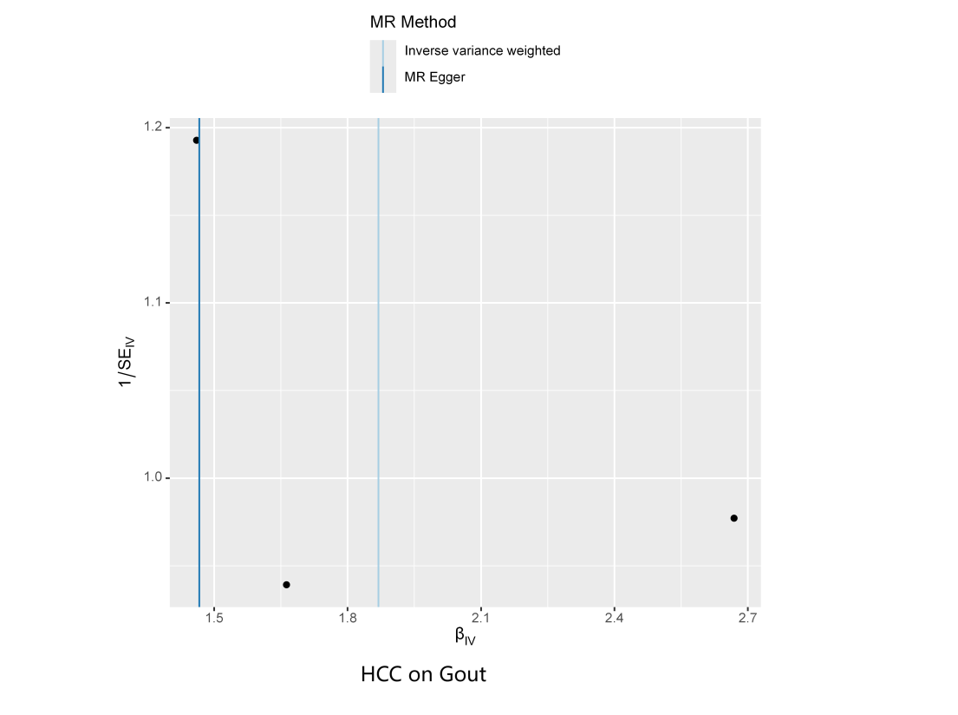

Figure S4 Leave-one-out Analysis
These forest plots presents the results of MR leave-one-out sensitivity analyses. The x-axis represents the MR effect size. Each horizontal line indicates the confidence interval for the effect size of a specific single nucleotide polymorphism (SNP), with the black dot representing the corresponding point estimate when excluding that SNP. The red line at the bottom denotes the combined effect size when all SNPs are included.
