Supplementary Material to:
Global trends in esophageal cancer and metabolic syndrome research: Bibliometric analysis and visualization from 1995 to 2024

Peng-Yu Che^{1†*}, Chun-Jian Zuo^{2†}, Jie Tian^{3,4*}
¹Department of Cardiothoracic Surgery, The People’s Hospital of Chongqing Hechuan, Chongqing 401520, China.
²Department of Thoracic Surgery, Army Medical Center of People’s Liberation Army of China (PLA), Chongqing 400042, China.
³Department of Thoracic Surgery, West China Hospital, Sichuan University, Chengdu 610041, China.
⁴Lung Cancer Center, West China Hospital, Sichuan University, Chengdu 610041, China.

†Peng-Yu Che and Chun-Jian Zuo contributed equally to this work.

*Correspondence author:
Jie Tian, Department of Thoracic Surgery/Lung Cancer Center, West China Hospital, Sichuan University, No. 37, Guoxue Lane, Wuhou District, Chengdu, Sichuan Province, 610041, China. (Email: tianjiehxxwk@163.com)

Peng-Yu Che, Department of Cardiothoracic Surgery, The People’s Hospital of Chongqing Hechuan, Chongqing 401520, China. (Email: 308886223@qq.com)

Contents

Supplementary Figure 1: Publications screening flowchart.
Supplementary Figure 2: The word cloud of keyword on the research of metabolic syndrome in esophageal cancer.
Supplementary Figure 3: The Top 5 countries with the strongest citation bursts.
Supplementary Figure 4: The Top 16 institutions with the strongest citation bursts.
Supplementary Figure 5: The Top 10 authors with the strongest citation bursts.
Supplementary Figure 6: The publication time trend of papers with only one author.
Supplementary Figure 7: The distribution map of the countries of origin for papers with only one author.
Supplementary Figure 8: The distribution map of institutions for papers with only one author.

Supplementary Table 1: Search strategy for the research of metabolic syndrome and esophageal cancer.
Supplementary Table 2: Top 10 co-cited references on the research of metabolic syndrome in esophageal cancer.
Supplementary Table 3: Top 50 keywords on research of metabolic syndrome in esophageal cancer.
Supplementary Table 4: Top 20 pairwise collaboration links and total link strength among countries in metabolic syndrome and esophageal cancer research.
Supplementary Table 5: Country-level international research collaboration: number of partnering countries
Supplementary Table 6: Top 10 highly-cited papers on the research of metabolic syndrome in esophageal cancer.
Supplementary Figure 1: Publications screening flowchart

Records identified through Web of Science Core Collection (n = 1,121)

Items were identified (n = 1,098)

Publications were enrolled (n = 1,008)

Excluded studies (n=90): the publication type was set to “Article” and “Review Article”.

Visualization and Analysis by Microsoft Office Excel 2021, CiteSpace, VOSviewer and R package “bibliometrix”

Excluded studies (n=23):
the language of publication was set to “English”.

Supplementary Figure 2: The word cloud of keyword on the research of metabolic syndrome in esophageal cancer.

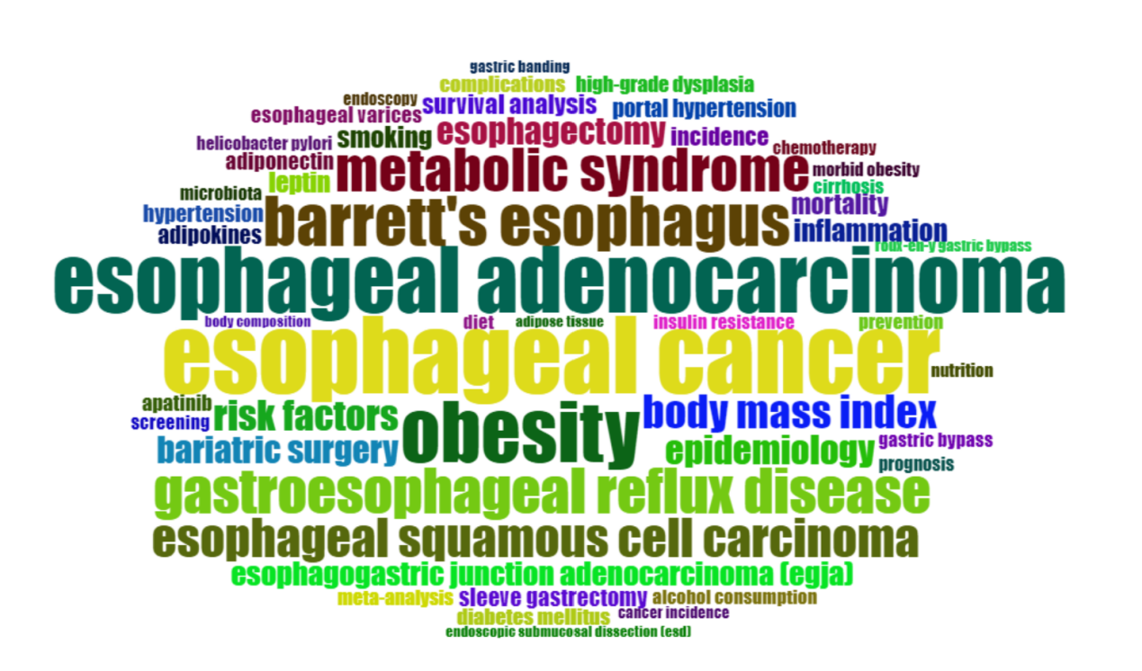

Supplementary Figure 3: The Top 5 Countries with the Strongest Citation Bursts

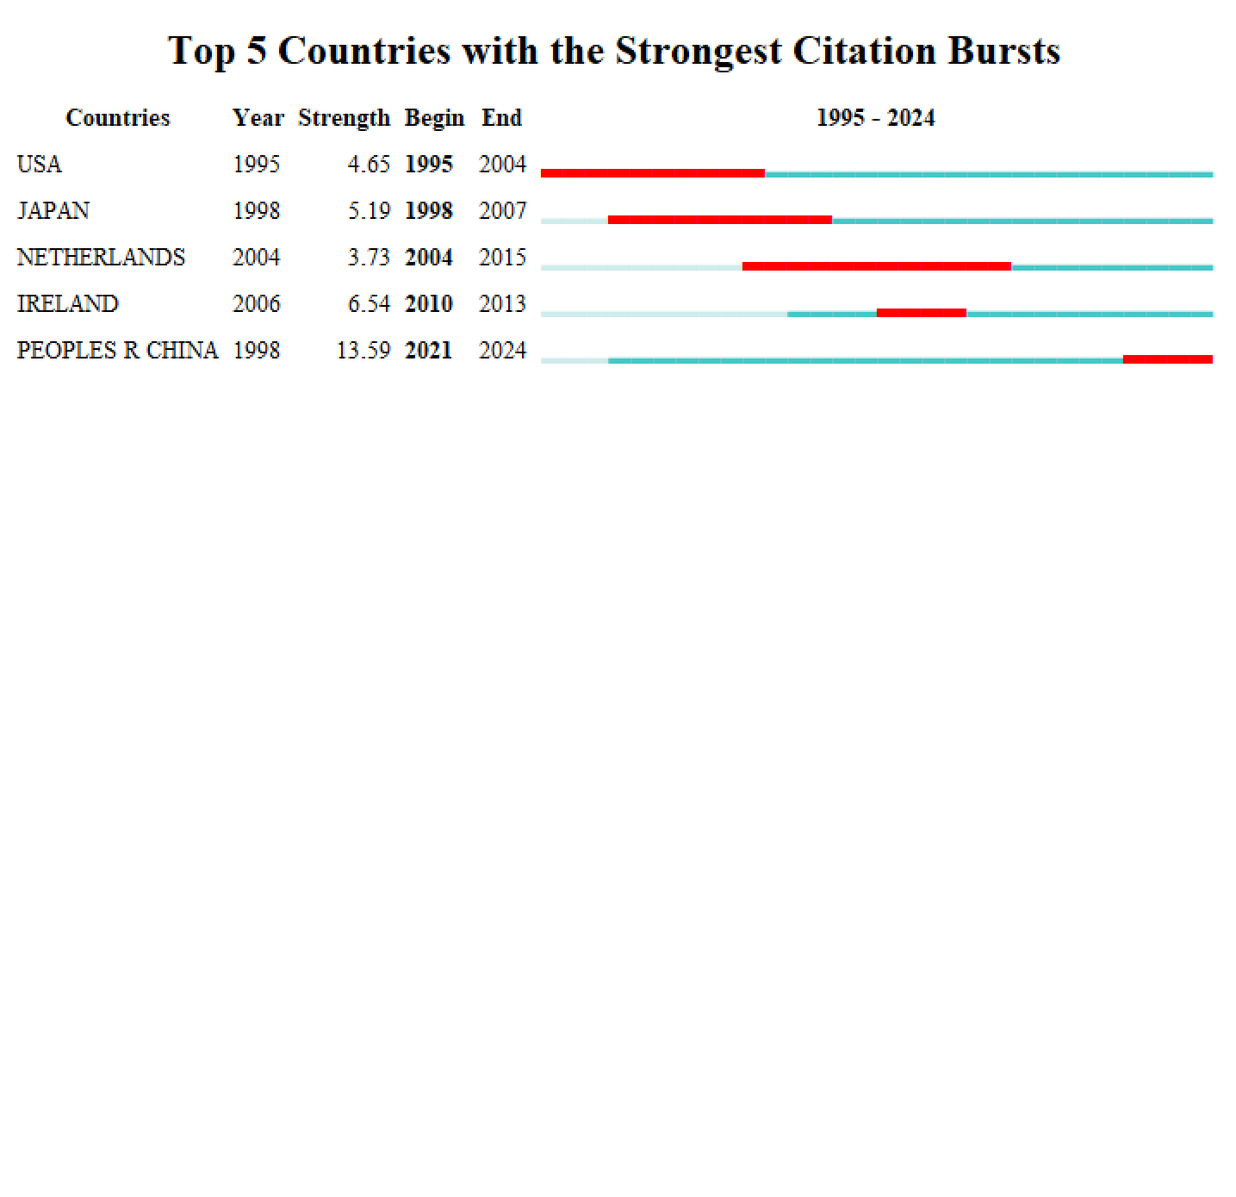

Supplementary Figure 4: The Top 16 Institutions with the Strongest Citation Bursts

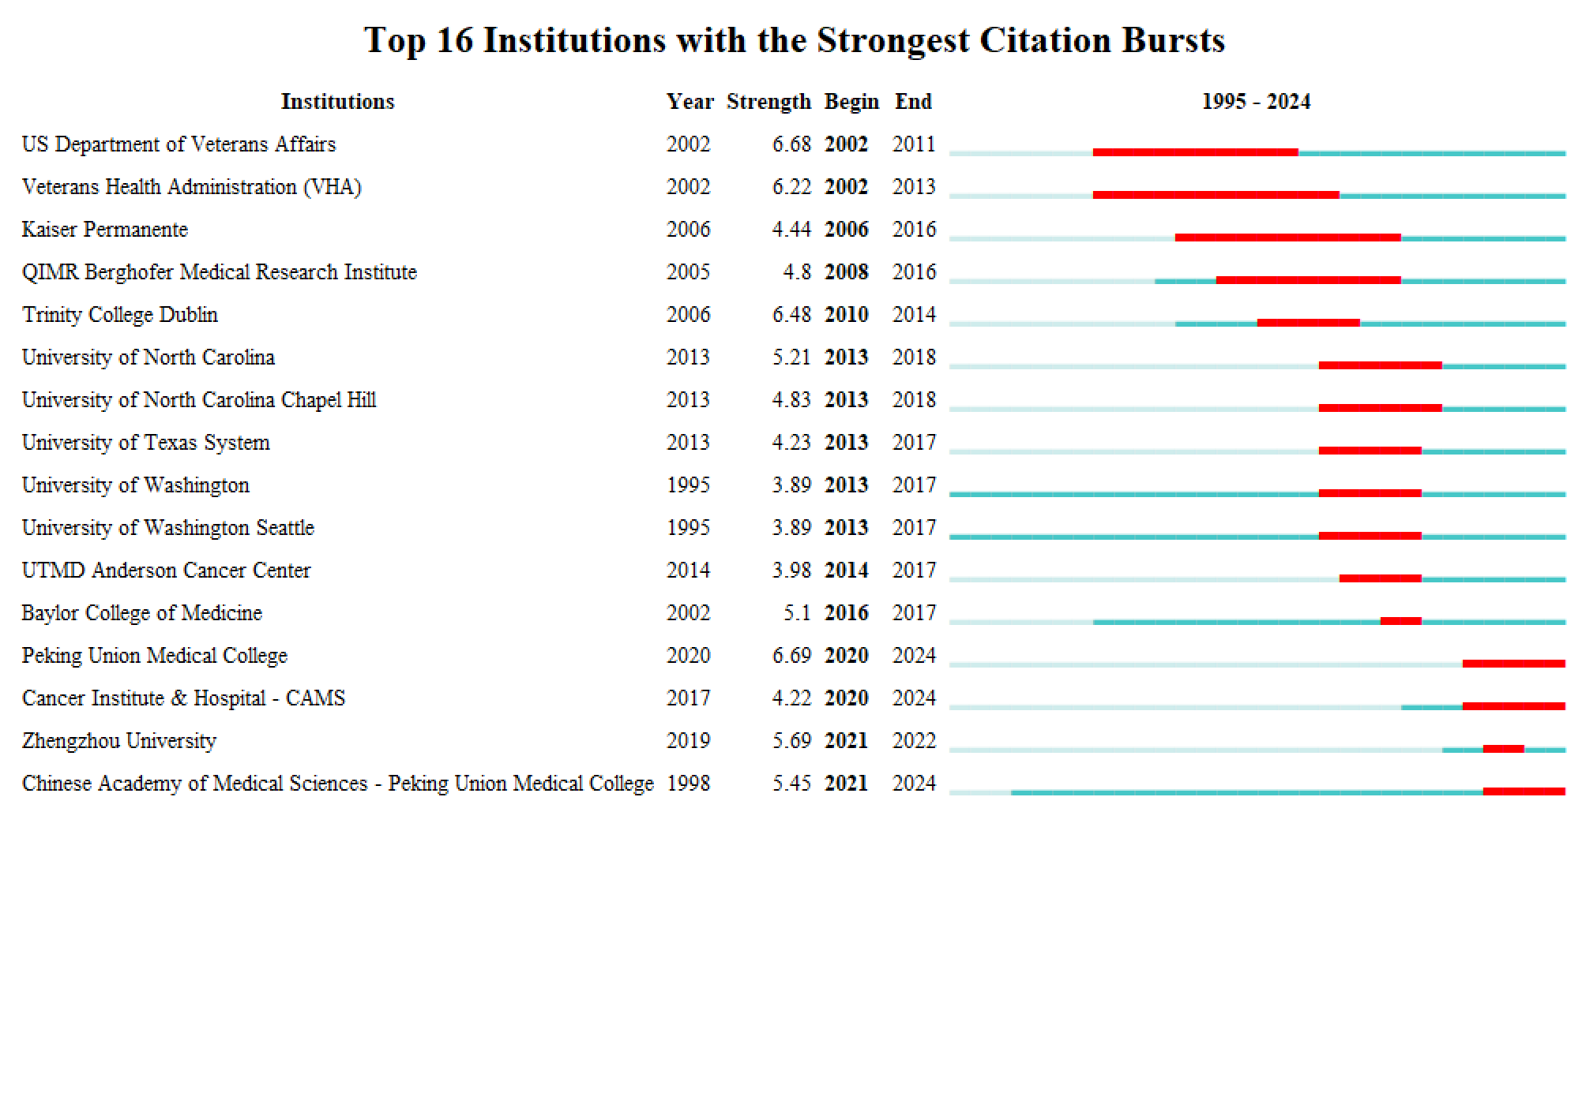

Supplementary Figure 5: The Top 10 Authors with the Strongest Citation Bursts

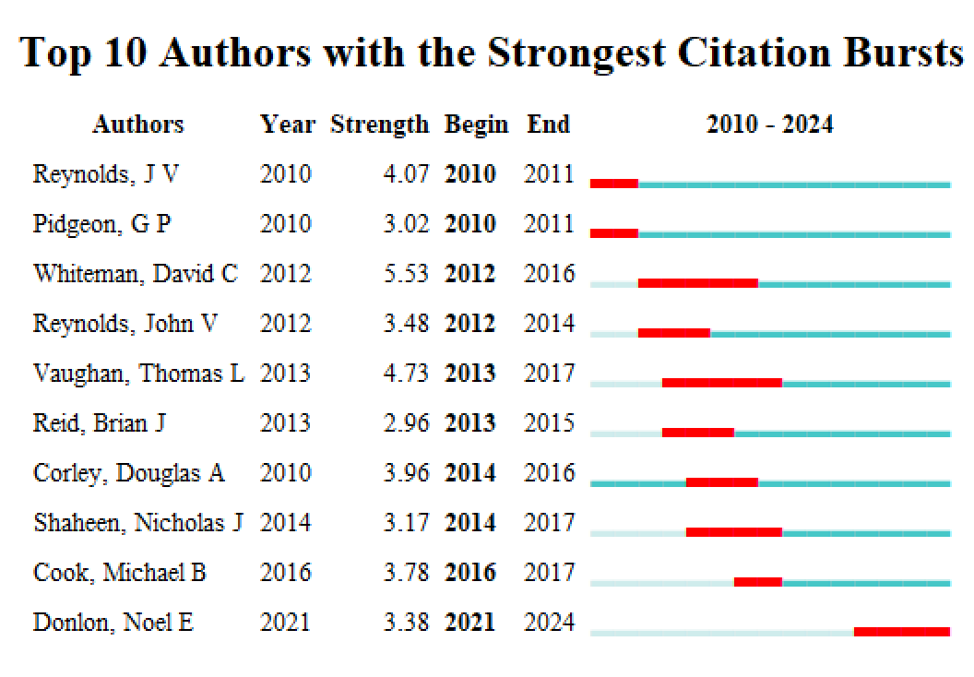

Supplementary Figure 6: The publication time trend of papers with only one author.

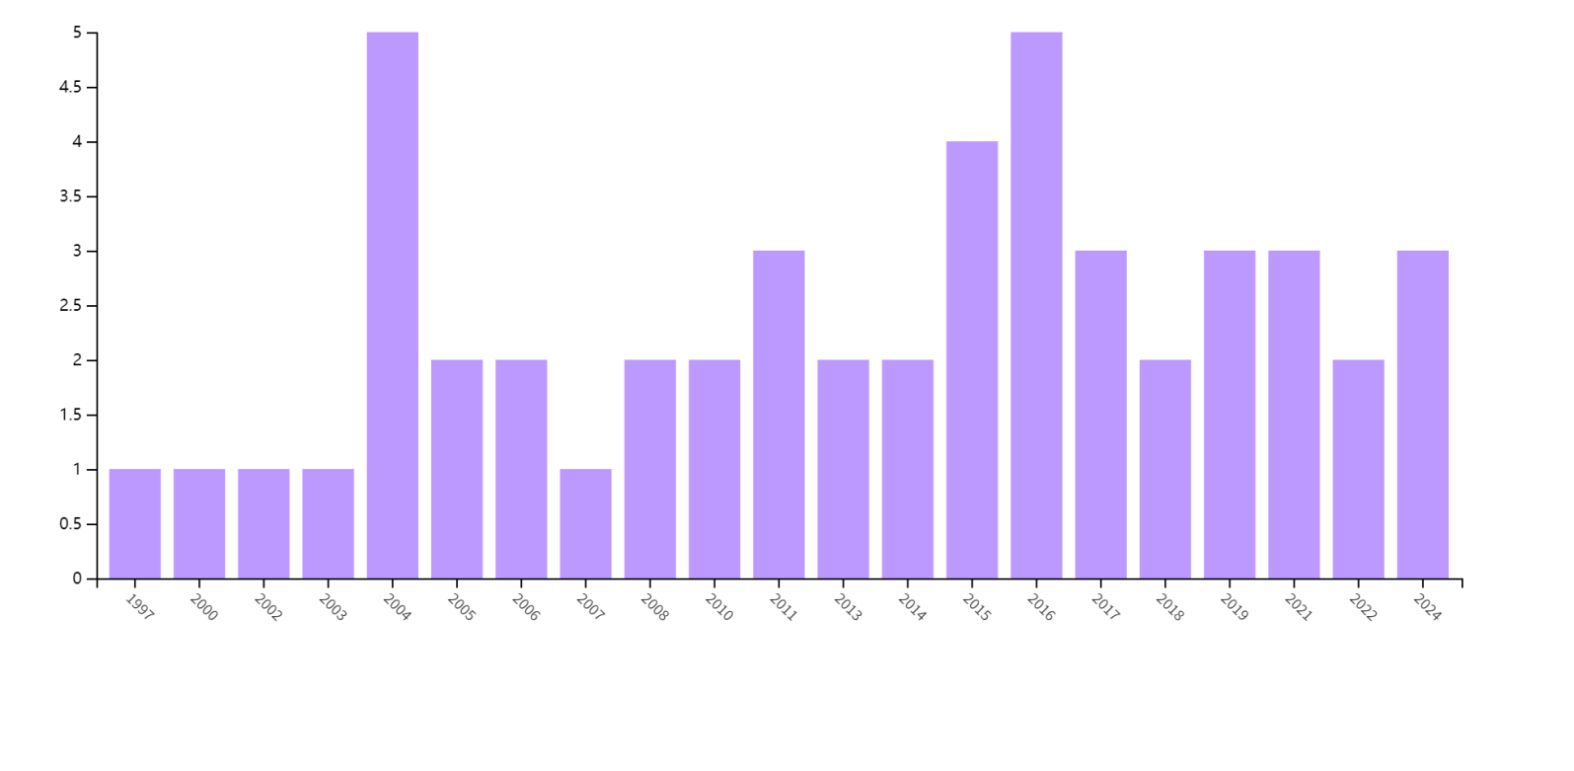

Supplementary Figure 7: The distribution map of the countries of origin for papers with only one author.

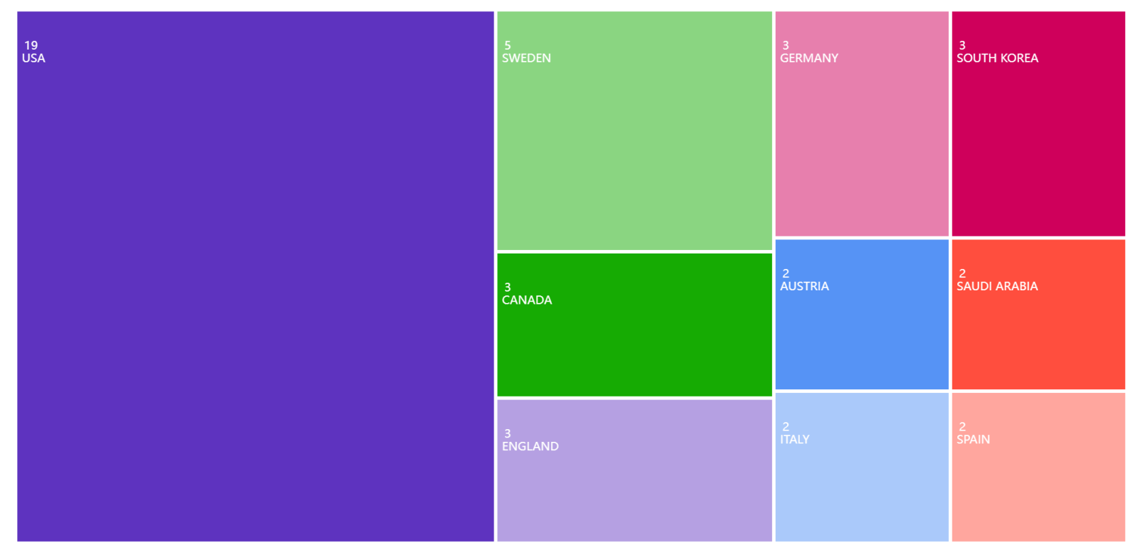

Supplementary Figure 8: The distribution map of institutions for papers with only one author.

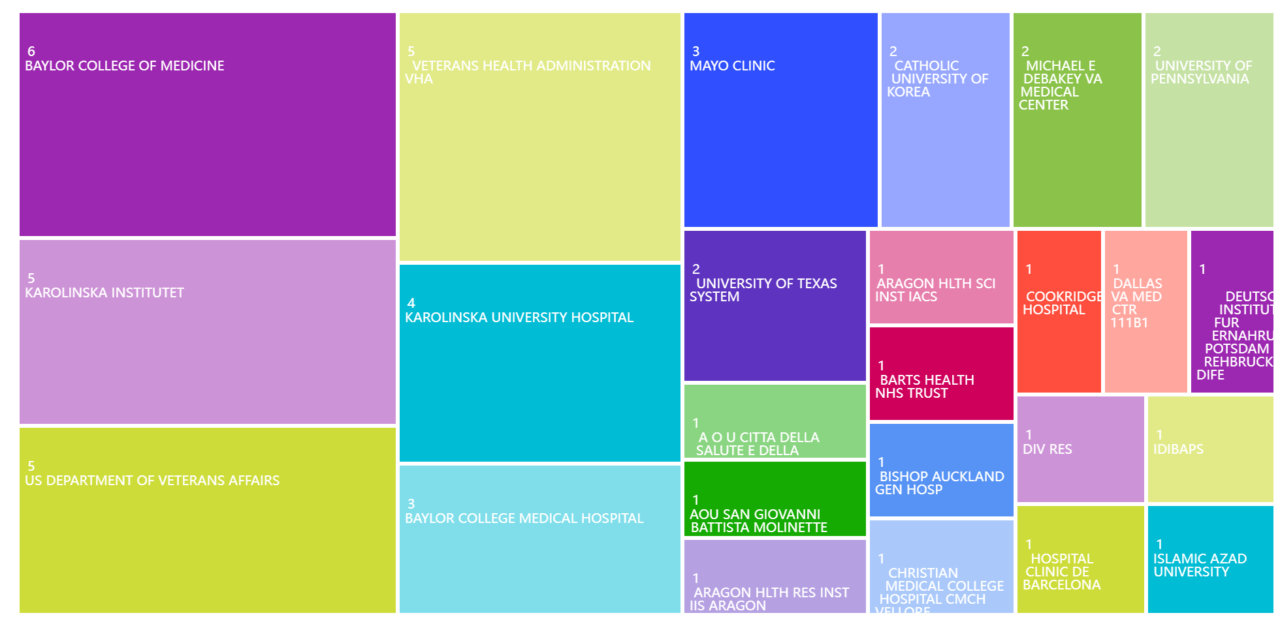

Supplementary Table 1: Search strategy for the research of metabolic syndrome and esophageal cancer.

 | Search Criteria | Records
Records identified through the WosCC database | #1: (TI=((“esophagus” OR “esophageal” OR “oesophagus” OR “oesophageal”) NEAR/6 ("cancer" OR "carcinoma" OR "adenocarcinoma" OR "tumor" OR "malignant" OR "malignancy" OR "neoplasm" OR "neoplasia" OR "oncology" OR "squamous cell carcinoma" OR "adenosquamous carcinoma")) OR AB=((“esophagus” OR “esophageal” OR “oesophagus” OR “oesophageal”) NEAR/6 ("cancer" OR "carcinoma" OR "adenocarcinoma" OR "tumor" OR "malignant" OR "malignancy" OR "neoplasm" OR "neoplasia" OR "oncology" OR "squamous cell carcinoma" OR "adenosquamous carcinoma")) OR AK=((“esophagus” OR “esophageal” OR “oesophagus” OR “oesophageal”) NEAR/6 ("cancer" OR "carcinoma" OR "adenocarcinoma" OR "tumor" OR "malignant" OR "malignancy" OR "neoplasm" OR "neoplasia" OR "oncology" OR "squamous cell carcinoma" OR "adenosquamous carcinoma")))  #2: (TI=("Metabolic Syndrome" OR "Metabolic Disorder" OR "Insulin Resistance" OR "Obesity" OR "Hyperglycemia" OR "Dyslipidemia" OR "Hypertension" OR "Metabolic Syndromes" OR "Syndrome, Metabolic" OR "Syndromes, Metabolic" OR "Metabolic Syndrome X" OR "Insulin Resistance Syndrome X" OR "Syndrome X, Metabolic" OR "Syndrome X, Insulin Resistance" OR "Metabolic X Syndrome" OR "Dysmetabolic Syndrome X" OR "Reaven Syndrome X" OR "Metabolic Cardiovascular Syndrome" OR "Cardiovascular Syndrome, Metabolic" OR "Cardiovascular Syndromes, Metabolic" OR "Cardiometabolic Syndrome" OR "Cardiometabolic Syndromes") OR AB=("Metabolic Syndrome" OR "Metabolic Disorder" OR "Insulin Resistance" OR "Obesity" OR "Hyperglycemia" OR "Dyslipidemia" OR "Hypertension" OR "Metabolic Syndromes" OR "Syndrome, Metabolic" OR "Syndromes, Metabolic" OR "Metabolic Syndrome X" OR "Insulin Resistance Syndrome X" OR "Syndrome X, Metabolic" OR "Syndrome X, Insulin Resistance" OR "Metabolic X Syndrome" OR "Dysmetabolic Syndrome X" OR "Reaven Syndrome X" OR "Metabolic Cardiovascular Syndrome" OR "Cardiovascular Syndrome, Metabolic" OR "Cardiovascular Syndromes, Metabolic" OR "Cardiometabolic Syndrome" OR "Cardiometabolic Syndromes") OR AK=("Metabolic Syndrome" OR "Metabolic Disorder" OR "Insulin Resistance" OR "Obesity" OR "Hyperglycemia" OR "Dyslipidemia" OR "Hypertension" OR "Metabolic Syndromes" OR "Syndrome, Metabolic" OR "Syndromes, Metabolic" OR "Metabolic Syndrome X" OR "Insulin Resistance Syndrome X" OR "Syndrome X, Metabolic" OR "Syndrome X, Insulin Resistance" OR "Metabolic X Syndrome" OR "Dysmetabolic Syndrome X" OR "Reaven Syndrome X" OR "Metabolic Cardiovascular Syndrome" OR "Cardiovascular Syndrome, Metabolic" OR "Cardiovascular Syndromes, Metabolic" OR "Cardiometabolic Syndrome" OR "Cardiometabolic Syndromes"))
Time:1990.1.1–2024.10.11  Languages: English | # 3= #1 AND #2 | 1,121  1,098
Excluded Literature | Meeting Abstract (n=57), Editorial (n=12), Letter (n=11), Proceeding Paper (n=7), Note (n=1), Correction (n=2) | 90
Remaining Publications | 771 Articles, 237 Review Articles | 1,008

Supplementary Table 2: Top 10 co-cited references on the research of metabolic syndrome in esophageal cancer.
Rank | Co-cited reference | Citations | Title | Pubmed ID
1 | lagergren j, 1999, new engl j med, v340, p825, doi:10.1056/nejm199903183401101 | 123 | Symptomatic gastroesophageal reflux as a risk factor for esophageal adenocarcinoma | 10080844
2 | lagergren j, 1999, ann intern med, v130, p883, doi:10.7326/0003-4819-130-11-199906010-00003 | 105 | Association between body mass and adenocarcinoma of the esophagus and gastric cardia | 10375336
3 | renehan ag, 2008, lancet, v371, p569,  doi:10.1016/s0140-6736(08)60269-x | 102 | Body-mass index and incidence of cancer: a systematic review and meta-analysis of prospective observational studies | 18280327
4 | chow wh, 1998, jnci-j natl cancer i, v90, p150, doi:10.1093/jnci/90.2.150 | 97 | Body mass index and risk of adenocarcinomas of the esophagus and gastric cardia | 9450576
5 | calle ee, 2003, new engl j med, v348, p1625, doi:10.1056/nejmoa021423 | 93 | Overweight, obesity, and mortality from cancer in a prospectively studied cohort of U.S. adults | 12711737
6 | hampel h, 2005, ann intern med, v143, p199, doi:10.7326/0003-4819-143-3-200508020-00006 | 86 | Meta-analysis: obesity and the risk for gastroesophageal reflux disease and its complications | 16061918
7 | kubo a, 2006, cancer epidem biomar, v15, p872, doi:10.1158/1055-9965.epi-05-0860 | 80 | Body mass index and adenocarcinomas of the esophagus or gastric cardia: a systematic review and meta-analysis | 16702363
8 | corley da, 2007, gastroenterology, v133, p34, doi:10.1053/j.gastro.2007.04.046 | 69 | Abdominal obesity and body mass index as risk factors for Barrett's esophagus | 17631128
9 | lauby-secretan b, 2016, new engl j med, v375, p794, doi:10.1056/nejmsr1606602 | 68 | Body Fatness and Cancer--Viewpoint of the IARC Working Group | 27557308
10 | singh s, 2013, clin gastroenterol h, v11, p1399, doi:10.1016/j.cgh.2013.05.009 | 64 | Central adiposity is associated with increased risk of esophageal inflammation, metaplasia, and adenocarcinoma: a systematic review and meta-analysis | 23707461

Supplementary Table 3: Top 50 keywords on research of metabolic syndrome in esophageal cancer.
Rank | Keywords | Counts | Rank | Keywords | Counts
1 | Esophageal Cancer | 283 | 26 | Complications | 15
2 | Esophageal Adenocarcinoma | 228 | 27 | Diabetes Mellitus | 15
3 | Obesity | 203 | 28 | Esophageal Varices | 15
4 | Barrett’s Esophagus | 136 | 29 | Apatinib | 14
5 | Gastroesophageal Reflux Disease | 101 | 30 | High-Grade Dysplasia | 14
6 | Metabolic Syndrome | 96 | 31 | Meta-Analysis | 13
7 | Esophageal Squamous Cell Carcinoma | 80 | 32 | Alcohol Consumption | 12
8 | Body Mass Index | 60 | 33 | Cirrhosis | 12
9 | Risk Factors | 52 | 34 | Diet | 12
10 | Epidemiology | 46 | 35 | Insulin Resistance | 12
11 | Bariatric Surgery | 44 | 36 | Prevention | 12
12 | Esophagectomy | 40 | 37 | Microbiota | 11
13 | Esophagogastric Junction Adenocarcinoma (EGJA) | 30 | 38 | Prognosis | 11
14 | Inflammation | 26 | 39 | Chemotherapy | 10
15 | Leptin | 22 | 40 | Helicobacter Pylori | 10
16 | Mortality | 22 | 41 | Morbid Obesity | 10
17 | Roux-en-Y Gastric Bypass | 22 | 42 | Nutrition | 10
18 | Smoking | 22 | 43 | Endoscopy | 9
19 | Survival Analysis | 21 | 44 | Gastric Banding | 8
20 | Incidence | 19 | 45 | Adipose Tissue | 7
21 | Sleeve Gastrectomy | 18 | 46 | Body Composition | 7
22 | Adipokines | 17 | 47 | Esophagitis | 7
23 | Portal Hypertension | 17 | 48 | Metabolic Surgery | 7
24 | Adiponectin | 16 | 49 | Metabolism | 7
25 | Hypertension | 16 | 50 | Waist Circumference | 7

Supplementary Table 4: Top 20 pairwise collaboration links and total link strength among countries in metabolic syndrome and esophageal cancer research.

Country A | Country B | Link | Total Link Strength
United Kingdom | Sweden | 39 | 1989
United States | United Kingdom | 33 | 2970
United States | China | 28 | 2352
United States | Australia | 24 | 2064
United States | Germany | 23 | 1978
United States | Sweden | 23 | 2047
United Kingdom | Australia | 21 | 1050
United States | Italy | 21 | 1764
United Kingdom | Germany | 20 | 980
Sweden | Norway | 17 | 544
United Kingdom | France | 17 | 748
United States | Canada | 17 | 1445
United Kingdom | Italy | 16 | 736
United States | Ireland | 15 | 1260
United Kingdom | Canada | 14 | 616
Germany | France | 13 | 442
Italy | Germany | 13 | 507
United Kingdom | Norway | 13 | 559
United States | France | 13 | 1105
Germany | Sweden | 12 | 540

Supplementary Table 5: Country-Level International Research Collaboration: Number of Partnering Countries

Country | Number of collaborating countries
United Kingdom | 59
France | 47
United States | 47
Italy | 36
Australia | 32
Germany | 32
China | 31
Japan | 29
Spain | 27
Brazil | 17

Supplementary Table 6: Top 10 highly-cited papers on the research of metabolic syndrome in esophageal cancer.
Rank | Highly-cited papers | Citations
1 | Wilke H, et al. Ramucirumab plus paclitaxel versus placebo plus paclitaxel in patients with previously treated advanced gastric or gastro-oesophageal junction adenocarcinoma (RAINBOW): a double-blind, randomised phase 3 trial. Lancet Oncol. 2014 Oct;15(11):1224-35. doi: 10.1016/S1470-2045(14)70420-6. PMID: 25240821. | 1,851
2 | Fuchs CS, et al. REGARD Trial Investigators. Ramucirumab monotherapy for previously treated advanced gastric or gastro-oesophageal junction adenocarcinoma (REGARD): an international, randomised, multicentre, placebo-controlled, phase 3 trial. Lancet. 2014 Jan 4;383(9911):31-39. doi: 10.1016/S0140-6736(13)61719-5. PMID: 24094768. | 1,672
3 | Avgerinos KI, et al. Obesity and cancer risk: Emerging biological mechanisms and perspectives. Metabolism. 2019 Mar;92:121-135. doi: 10.1016/j.metabol.2018.11.001. PMID: 30445141. | 865
4 | Napier KJ, et al. Esophageal cancer: A Review of epidemiology, pathogenesis, staging workup and treatment modalities. World J Gastrointest Oncol. 2014 May 15;6(5):112-20. doi: 10.4251/wjgo.v6.i5.112. PMID: 24834141. | 627
5 | Kyrgiou M, et al. Adiposity and cancer at major anatomical sites: umbrella review of the literature. BMJ. 2017 Feb 28;356:j477. doi: 10.1136/bmj.j477. PMID: 28246088. | 540
6 | Coleman HG, et al. The Epidemiology of Esophageal Adenocarcinoma. Gastroenterology. 2018 Jan;154(2):390-405. doi: 10.1053/j.gastro.2017.07.046. PMID: 28780073. | 374
7 | Steele CB, et al. Vital Signs: Trends in Incidence of Cancers Associated with Overweight and Obesity - United States, 2005-2014. MMWR Morb Mortal Wkly Rep. 2017 Oct 3;66(39):1052-1058. doi: 10.15585/mmwr.mm6639e1. PMID: 28981482. | 242
8 | Pati S, et al. Obesity and Cancer: A Current Overview of Epidemiology, Pathogenesis, Outcomes, and Management. Cancers (Basel). 2023 Jan 12;15(2):485. doi: 10.3390/cancers15020485. PMID: 36672434. | 210
9 | Lu L, et al. A global assessment of recent trends in gastrointestinal cancer and lifestyle-associated risk factors. Cancer Commun (Lond). 2021 Nov;41(11):1137-1151. doi: 10.1002/cac2.12220. Epub 2021 Sep 25. PMID: 34563100. | 153
10 | Huang J, et al. Global Burden, Risk Factors, and Trends of Esophageal Cancer: An Analysis of Cancer Registries from 48 Countries. Cancers (Basel). 2021 Jan 5;13(1):141. doi: 10.3390/cancers13010141. PMID: 33466239. | 122

