Table S1. Comparison of prognostic performance of CP in HCC patients.
 | C-index | Homogeneity (Wald χ2) | AICc
All patients (n = 568) | 0.571 (0.540, 0.602) | 42.6 | 2667.873
Cirrhotic HCC (n = 361) | 0.582 (0.539, 0.625) | 39.7 | 1576.779
Non-cirrhotic HCC (n = 207) | 0.561 (0.518, 0.604) | 9.9 | 782.114

Table S2. Comparison of prognostic performance among CP-based, MELD-based, or ALBI-based staging systems in patients receiving different therapies.
Staging systems | C-index | Homogeneity (Wald χ2) | AICc
Patients receiving curative therapies (n = 258)
BCLC_CP | 0.645 (0.584, 0.706) | 22.8 | 748.945
BCLC_MELD | 0.642 (0.579, 0.705) | 21.3 | 749.585
BCLC_ALBI | 0.656 (0.597, 0.715) | 32.9 | 742.111
CLIP_CP | 0.590 (0.516, 0.664) | 18.5 | 756.872
CLIP_MELD | 0.585 (0.511, 0.659) | 20.2 | 754.844
CLIP_ALBI | 0.626 (0.563, 0.689) | 16.7 | 756.483
JIS_CP | 0.595 (0.532, 0.658) | 15.3 | 756.853
JIS_MELD | 0.585 (0.518, 0.652) | 19.3 | 755.683
JIS_ALBI | 0.637 (0.578, 0.696) | 18.5 | 750.822
CNLC_CP | 0.608 (0.547, 0.669) | 17.3 | 752.061
CNLC_MELD | 0.593 (0.534, 0.652) | 12.1 | 755.731
CNLC_ALBI | 0.611 (0.550, 0.672) | 26.6 | 747.421
HKLC_CP | 0.644 (0.583, 0.705) | 29.7 | 747.845
HKLC_MELD | 0.645 (0.586, 0.704) | 26.1 | 748.805
HKLC_ALBI | 0.681 (0.622, 0.740) | 49.3 | 732.668
Patients receiving non-curative therapies (n = 310)
BCLC_CP | 0.702 (0.667, 0.737) | 74.7 | 1503.699
BCLC_MELD | 0.691 (0.656, 0.726) | 58.6 | 1517.639
BCLC_ALBI | 0.700 (0.667, 0.733) | 74.6 | 1503.098
CLIP_CP | 0.719 (0.682, 0.756) | 91.6 | 1529.358
CLIP_MELD | 0.715 (0.678, 0.752) | 85.5 | 1535.221
CLIP_ALBI | 0.716 (0.679, 0.753) | 87.1 | 1529.818
JIS_CP | 0.737 (0.700, 0.774) | 102.8 | 1499.267
JIS_MELD | 0.731 (0.694, 0.768) | 82.1 | 1512.493
JIS_ALBI | 0.730 (0.695, 0.765) | 87.3 | 1509.422
CNLC_CP | 0.746 (0.713, 0.779) | 99.9 | 1474.983
CNLC_MELD | 0.738 (0.705, 0.771) | 89.0 | 1492.138
CNLC_ALBI | 0.747 (0.716, 0.778) | 104.2 | 1470.818
HKLC_CP | 0.770 (0.739, 0.801) | 125.3 | 1468.770
HKLC_MELD | 0.765 (0.734, 0.796) | 111.5 | 1487.389
HKLC_ALBI | 0.756 (0.725, 0.787) | 124.2 | 1471.876
AICc, corrected Akaike information criteria; ALBI, the Albumin-Bilirubin grade; BCLC, Barcelona Clinic Liver Cancer staging system; CLIP, the Cancer of the Liver Italian Program score; CNLC, China Liver Cancer staging system; CP, Child-Pugh class; HKLC, the Hong Kong Liver Cancer staging system; JIS, the Japan Integrated Staging score; MELD, the model for end-stage liver disease grade.

Table S3. Comparison of prognostic performance among TNM-AJCC 8th, TNM-LCSGJ, Okuda, GRETCH, CUPI, and Tokyo staging systems.
Staging systems | C-index | Homogeneity (Wald χ2) | AICc
All patients
(n = 568)
TNM-AJCC 8th | 0.762 (0.735, 0.789) | 219.9 | 2486.196
TNM-LCSGJ | 0.742 (0.713, 0.771) | 177.1 | 2523.681
Okuda | 0.658 (0.627, 0.689) | 101.4 | 2617.282
GRETCH | 0.614 (0.585, 0.643) | 71.94 | 2646.984
CUPI | 0.662 (0.631, 0.693) | 107.5 | 2608.281
Tokyo | 0.722 (0.691, 0.753) | 160.8 | 2566.994
Patients with HBV-related HCC
(n = 408)
TNM-AJCC 8th | 0.776 (0.745, 0.807) | 170.5 | 1568.334
TNM-LCSGJ | 0.748 (0.713, 0.783) | 127.3 | 1605.063
Okuda | 0.650 (0.611, 0.689) | 76.8 | 1673.053
GRETCH | 0.614 (0.579, 0.649) | 55.3 | 1691.23
CUPI | 0.668 (0.629, 0.707) | 91.6 | 1658.804
Tokyo | 0.735 (0.696, 0.774) | 119.2 | 1634.767
Patients with cirrhotic HCC
(n = 361)
TNM-AJCC 8th | 0.760 (0.725, 0.795) | 142.1 | 1470.000
TNM-LCSGJ | 0.742 (0.705, 0.779) | 120.1 | 1490.334
Okuda | 0.672 (0.633, 0.711) | 80.4 | 1541.489
GRETCH | 0.624 (0.585, 0.663) | 62.3 | 1561.465
CUPI | 0.683 (0.644, 0.722) | 90.7 | 1530.371
Tokyo | 0.723 (0.680, 0.766) | 127.5 | 1506.653
Non-cirrhotic HCC
(n = 207)
TNM-AJCC 8th | 0.767 (0.722, 0.812) | 76.5 | 717.477
TNM-LCSGJ | 0.743 (0.698, 0.788) | 58.1 | 732.944
Okuda | 0.633 (0.580, 0.686) | 21.4 | 772.750
GRETCH | 0.598 (0.557, 0.639) | 9.2 | 783.678
CUPI | 0.625 (0.570, 0.680) | 23.1 | 772.455
Tokyo | 0.713 (0.662, 0.764) | 43.2 | 756.541
Patients receiving curative therapies (n = 258)
TNM-AJCC 8th | 0.640 (0.577, 0.703) | 42.0 | 739.222
TNM-LCSGJ | 0.598 (0.535, 0.661) | 13.7 | 755.294
Okuda | 0.611 (0.550, 0.672) | 18.2 | 751.811
GRETCH | 0.566 (0.513, 0.619) | 6.2 | 760.179
CUPI | 0.550 (0.497, 0.603) | 7.5 | 759.038
Tokyo | 0.594 (0.527, 0.661) | 18.7 | 755.818
Patients receiving non-curative therapies (n = 310)
TNM-AJCC 8th | 0.745 (0.712, 0.778) | 107.3 | 1481.876
TNM-LCSGJ | 0.722 (0.687, 0.757) | 82.5 | 1501.754
Okuda | 0.648 (0.611, 0.685) | 58.6 | 1558.693
GRETCH | 0.630 (0.595, 0.665) | 51.4 | 1565.411
CUPI | 0.681 (0.644, 0.718) | 77.3 | 1536.931
Tokyo | 0.718 (0.679, 0.757) | 74.9 | 1534.238
AICc, corrected Akaike information criteria; CUPI, the Chinese University Prognostic Index score; GRETCH, Groupe d'Etude et de Traitement du Carcinome Hépatocellulaire staging sysem; HBV, Hepatitis B virus infection; HCC, hepatocellular carcinoma; Okuda, Okuda staging system; TNM-AJCC 8th, the American Joint Commission on Cancer 8th edition Tumor-Node-Metastasis staging system; TNM-LCSGJ, TNM staging system by the Liver Cancer Study Group of Japan; Tokyo, Tokyo score.

Figure S1. Distribution of patients in 11 original staging systems for hepatocellular carcinoma.
BCLC, Barcelona Clinic Liver Cancer staging system; CLIP, the Cancer of the Liver Italian Program score; CNLC, China Liver Cancer staging system; CUPI, the Chinese University Prognostic Index score; GRETCH, Groupe d'Etude et de Traitement du Carcinome Hépatocellulaire staging sysem; HKLC, the Hong Kong Liver Cancer staging system; JIS, the Japan Integrated Staging score; Okuda, Okuda staging system; TNM-AJCC 8th, the American Joint Commission on Cancer 8th edition Tumor-Node-Metastasis staging system; TNM-LCSGJ, TNM staging system by the Liver Cancer Study Group of Japan; Tokyo, Tokyo score.

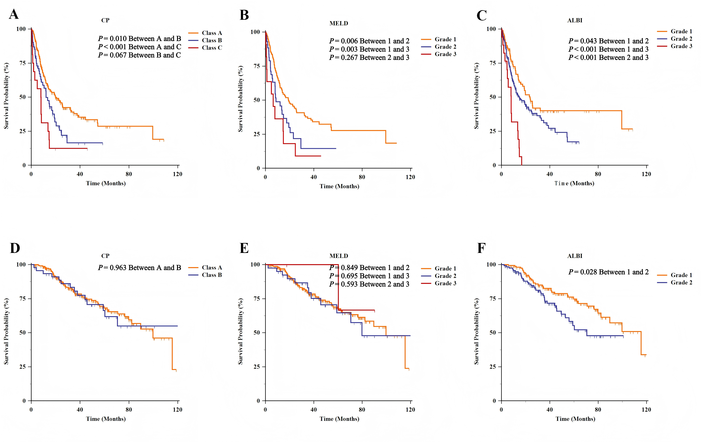
Figure S2. Comparison of survival distributions by the CP, MELD, ALBI grade in patients with non-resectable HCC (A, B, C) and in patients with resectable HCC (D, E, F).

Figure S3. Decision curve analysis (DCA) for 1-year survival probability.
Figure S4. Decision curve analysis (DCA) for 5-years survival probability.

Figure S5. Calibration plots of CP-based, MELD-based, and ALBI-based staging systems for the prediction of OS for patients with hepatocellular carcinoma at 1 years.
Figure S6. Calibration plots of CP-based, MELD-based, and ALBI-based staging systems for the prediction of OS for patients with hepatocellular carcinoma at 5 years.

