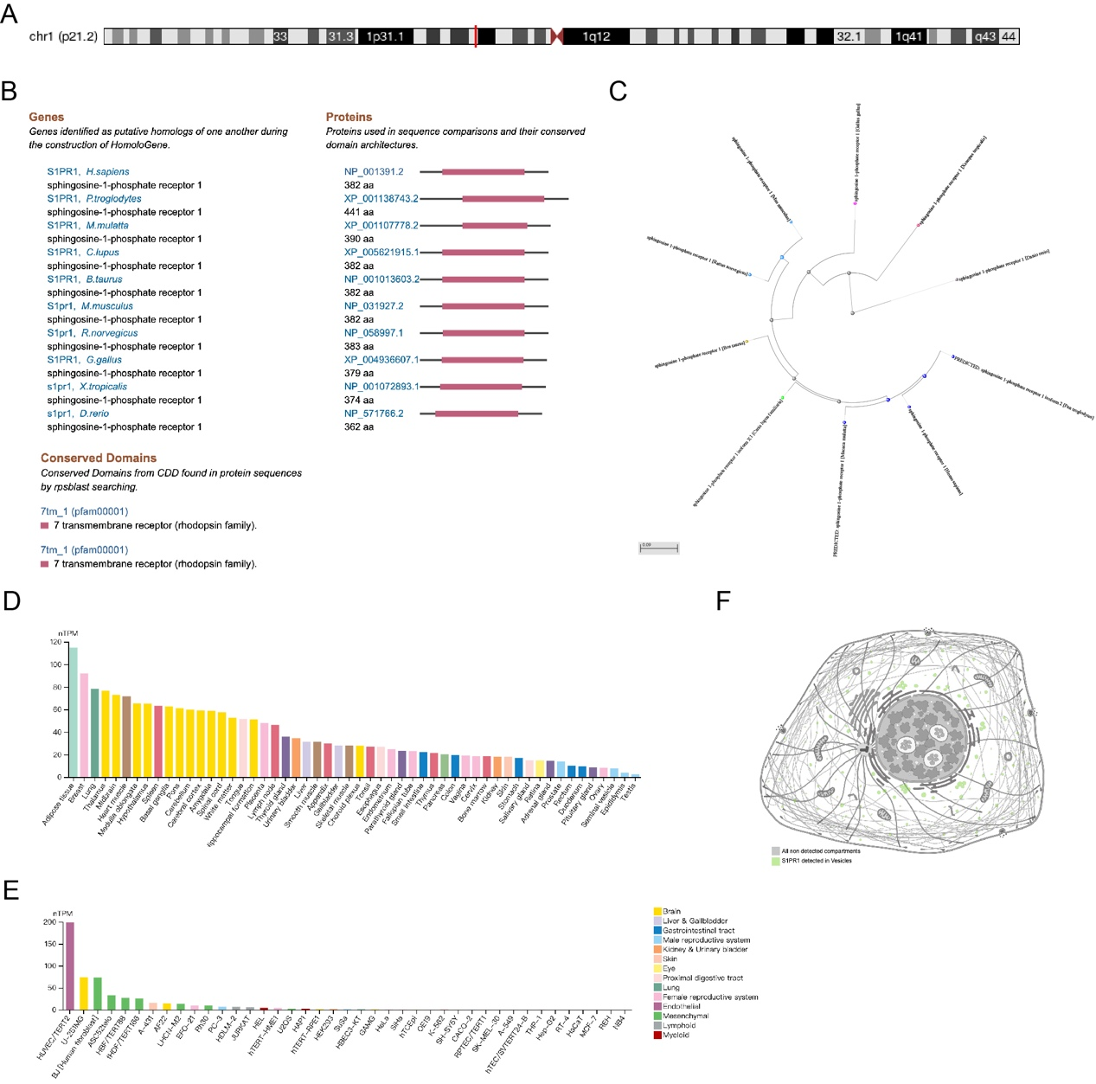
Fig. S1. Analysis of S1PR1 Protein Conservation and Expression Patterns Across Different Species and Tissues. (A) Structural analysis of conserved domains in the S1PR1 protein across various species, performed using the NCBI Conserved Domain Database. (B) Illustration of conserved structural domains of the S1PR1 protein in different species. (C) Phylogenetic tree constructed using MEGA-X software based on S1PR1 protein sequences, employing the maximum likelihood method and 1,000 bootstrap replications to assess node support. (D) Analysis of S1PR1 mRNA expression levels in various human tissues, utilizing datasets from the HPA and GTEx databases. (E - F) Subcellular localization of S1PR1, including its presence in vesicles (E) and its distribution in HUVEC cell lines (F), analyzed using immunofluorescence data from the HPA database.

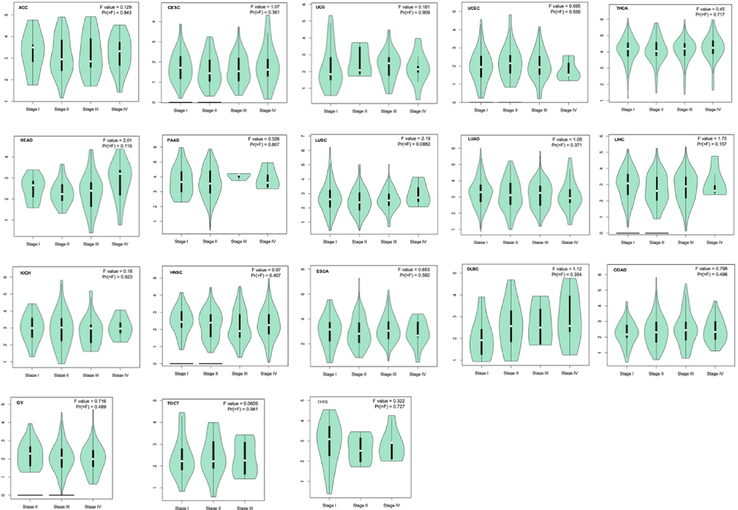
Fig. S2. Expression of S1PR1 Across Different Cancer Pathological Stages. The expression levels of S1PR1 across various cancer types were analyzed using data from the TCGA database, and its expression in different pathological stages I-IV of each cancer type was visualized using the GEPIA2 module.

