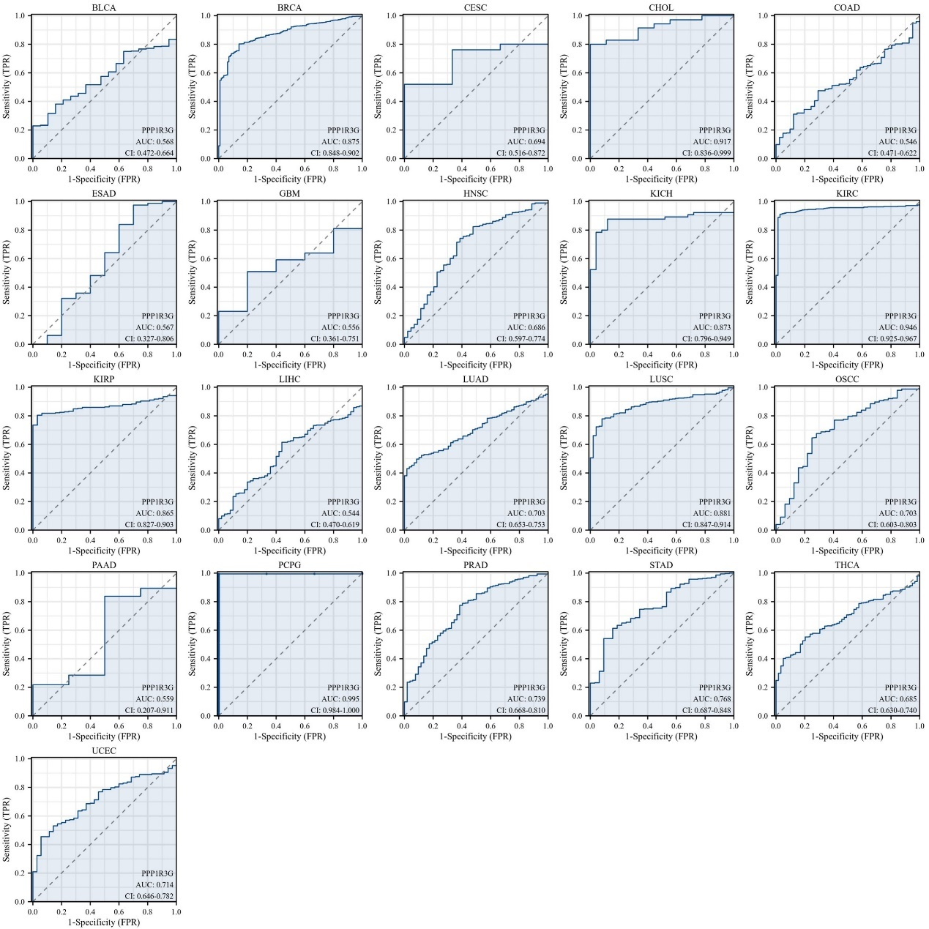
Supplementary Fig. 1 Receiver Operator Characteristic (ROC) curve of PPP1R3G in 21 Cancers.
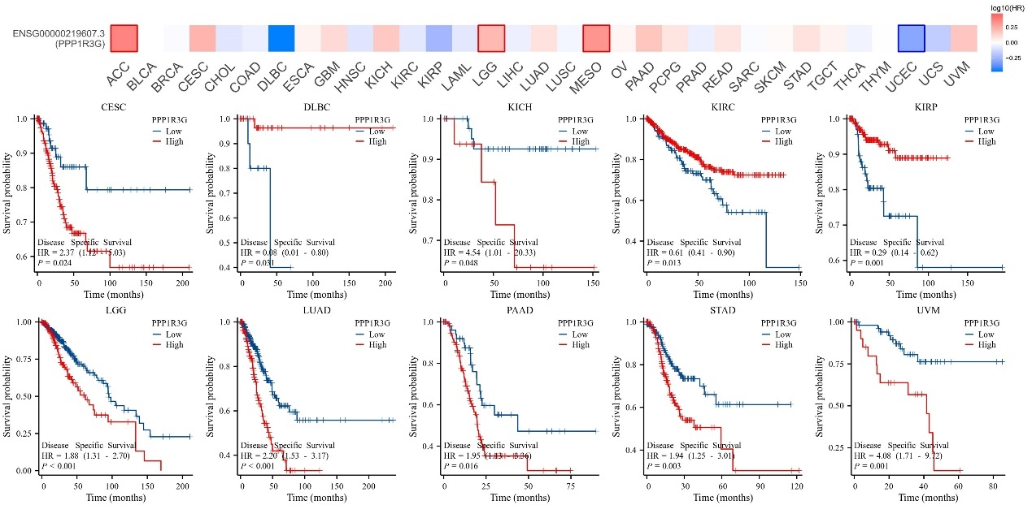
Supplementary Fig. 2 Correlation between PPP1R3G expression and DSS in 10 cancers. The unit of X-axis is month.
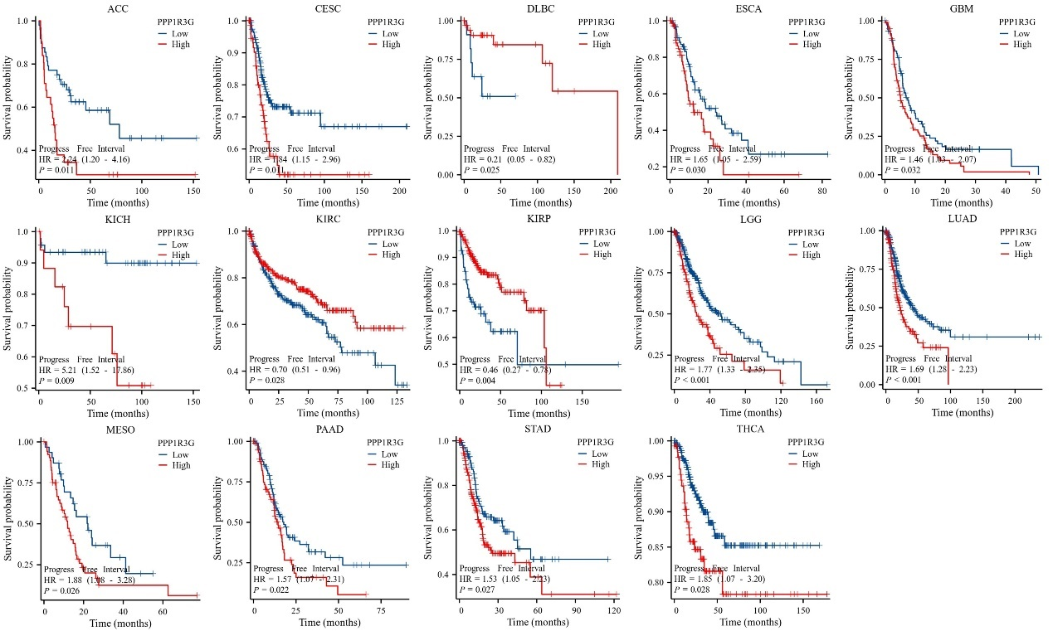
Supplementary Fig. 3 Correlation between PPP1R3G expression and PFI in 14 cancers. The unit of X-axis is month.
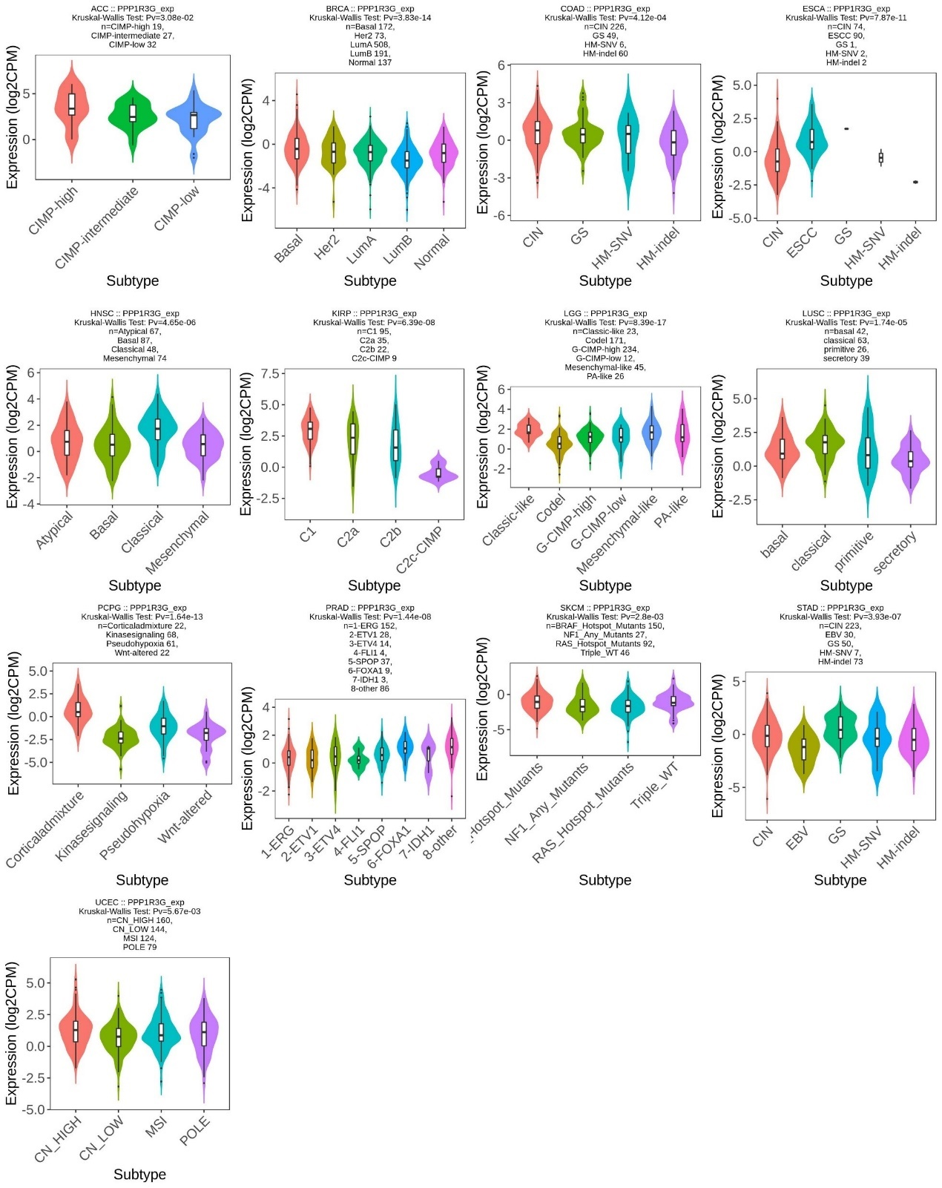
Supplementary Fig. 4 Correlations between PPP1R3G expression and molecular subtypes in 13 cancers.
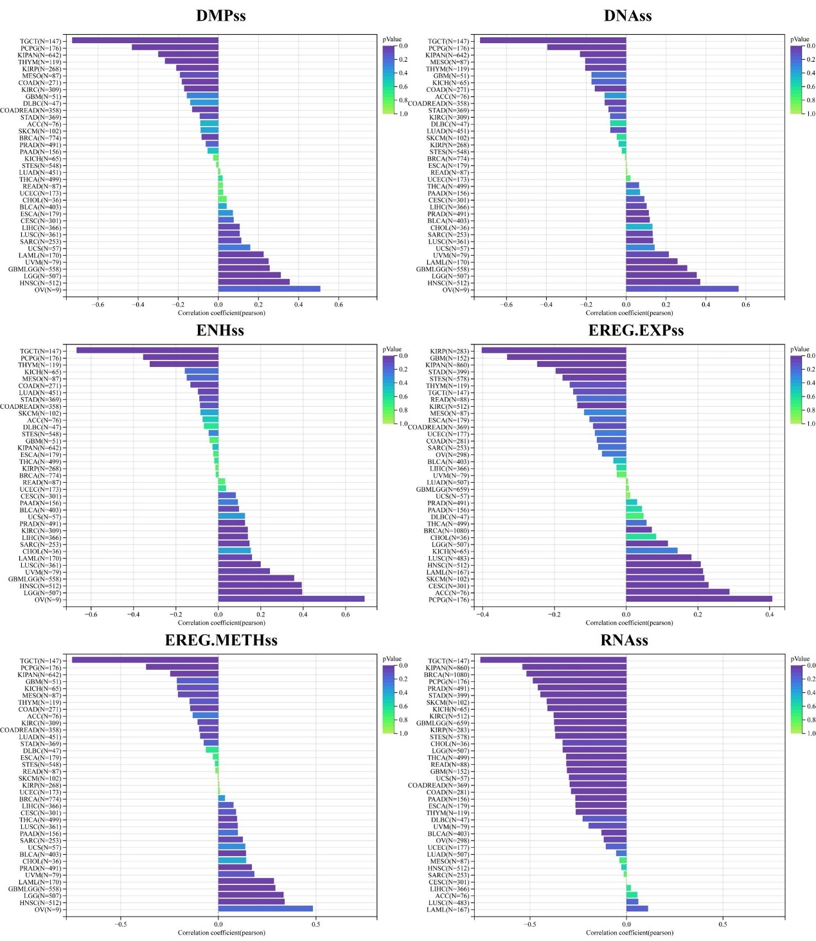
Supplementary Fig. 5 The pan-cancer Pearson analysis of tumor stemness and PPP1R3G expression.
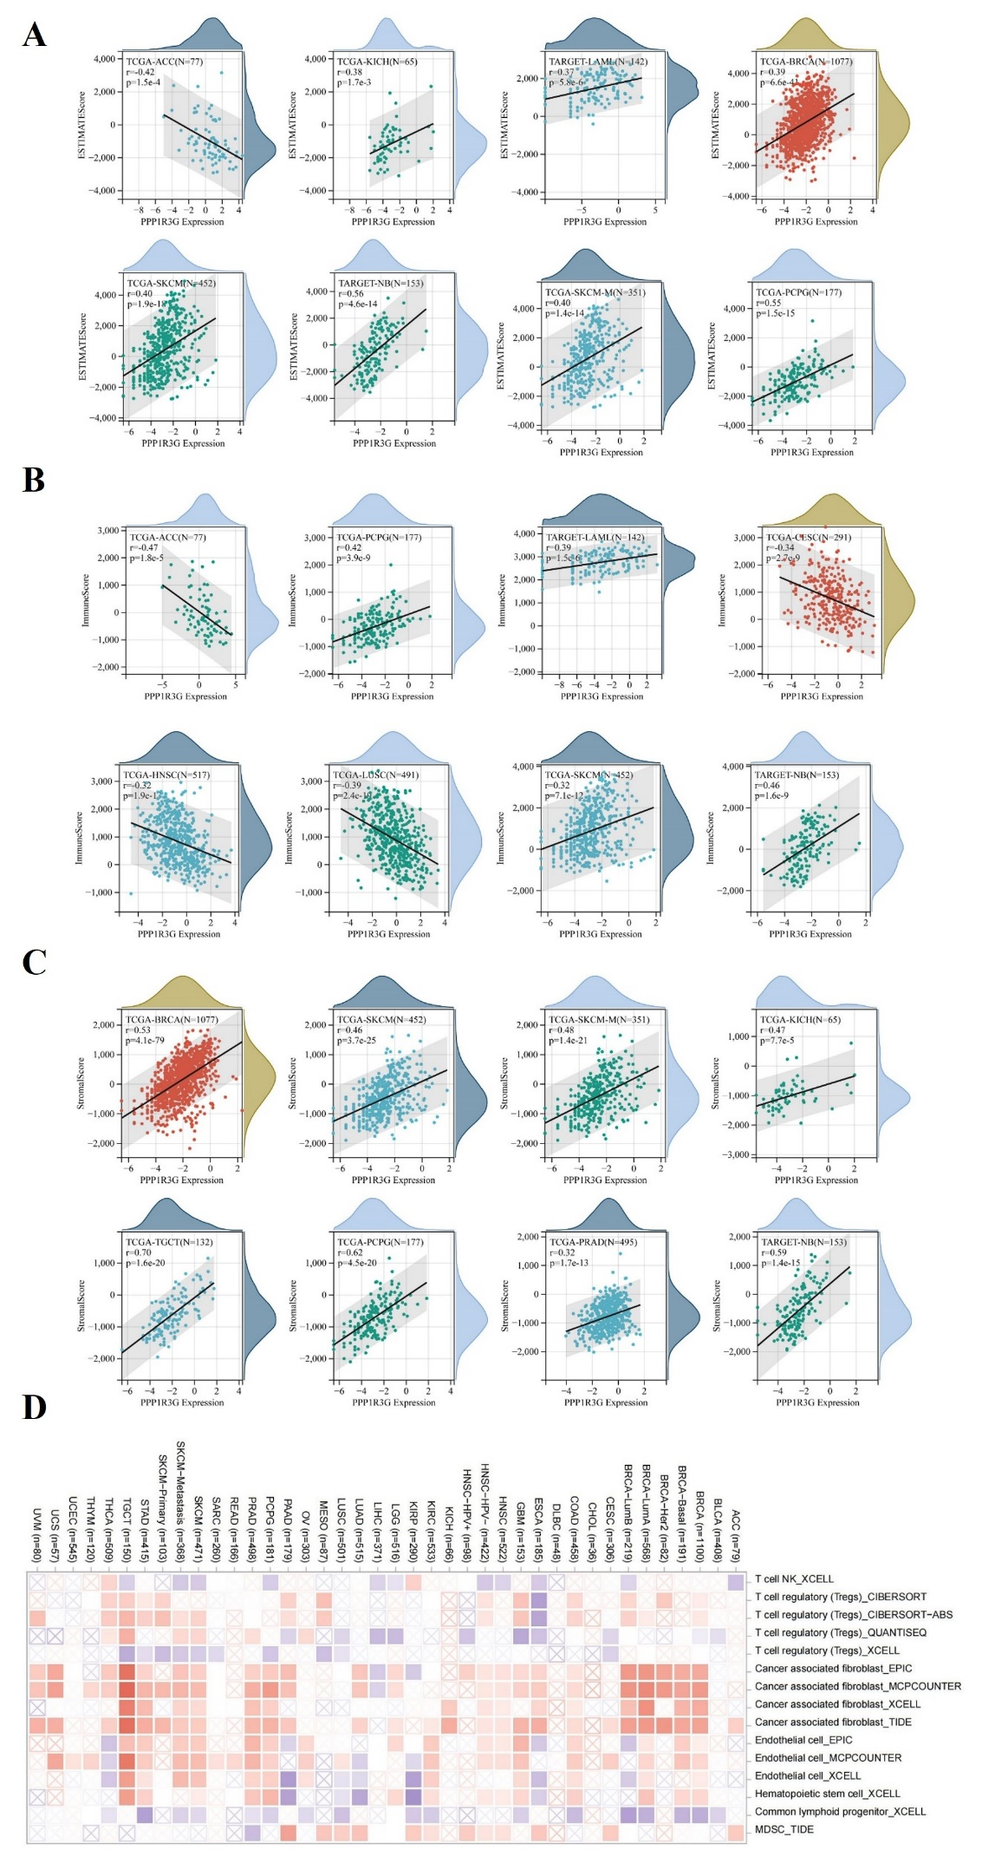
Supplementary Fig. 6 Association of PPP1R3G expression with immunological infiltration. (A-C)The eight cancer types exhibiting the most significant association between PPP1R3G expression and ESTIMATE score, IMMUNE score, and stromal score. (D) Analyzing the relationships between PPP1R3G expression and immune infiltration in all TCGA tumors utilizing TIMER2 algorithms. X-axis: Represents different TCGA cancer types. Y-axis: Represents different immune cell types and immune-related features. Red shades indicate a positive correlation, meaning higher PPP1R3G expression is associated with increased immune infiltration. Blue/purple shades indicate a negative correlation, suggesting that higher PPP1R3G expression is linked to lower immune infiltration. White or near-white squares denote a weak or insignificant correlation between PPP1R3G expression and immune infiltration.

