Supplemental Materials

Supplementary Figure 1
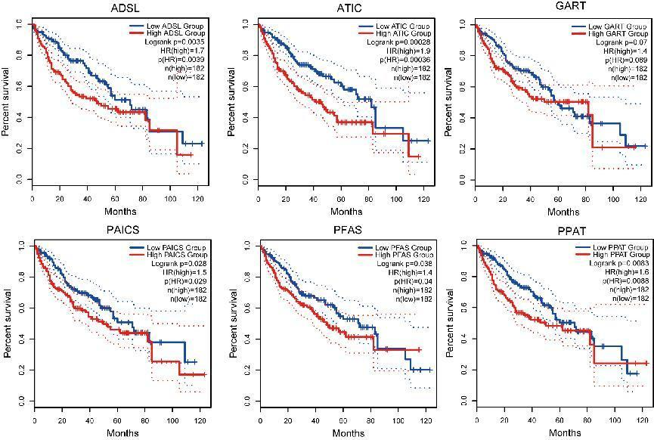

Supplementary Figure 1: Survival curve of the six purinosome-related genes analyzed using the log-Rank test. Survival analysis grouped by the median of gene expression.The log-Rank test indicates the association between the expression of the six genes and patient outcomes.

Supplementary Figure 2
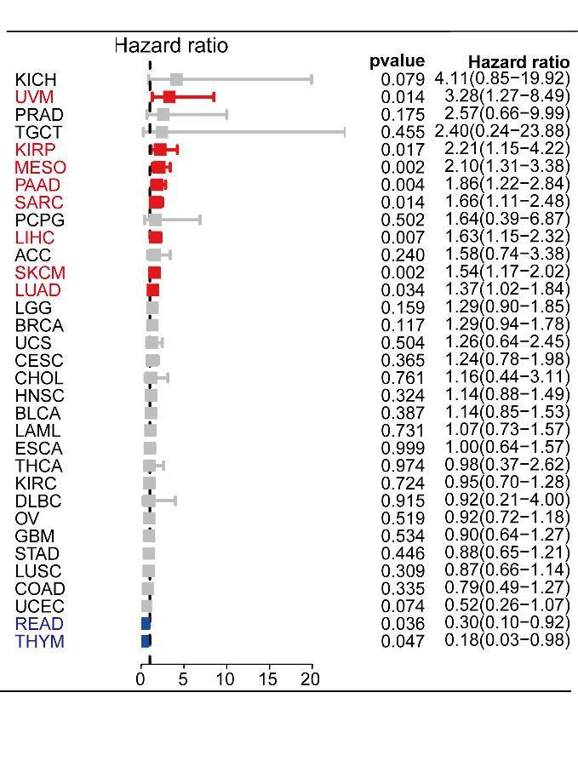
Supplementary Figure 2: Hazard ratio of the purinosome score across 33 different cancer types. The prognostic value of the purinosome score was explored by Cox regression analysis across multiple cancer types in TCGA.

Supplementary Figure 3
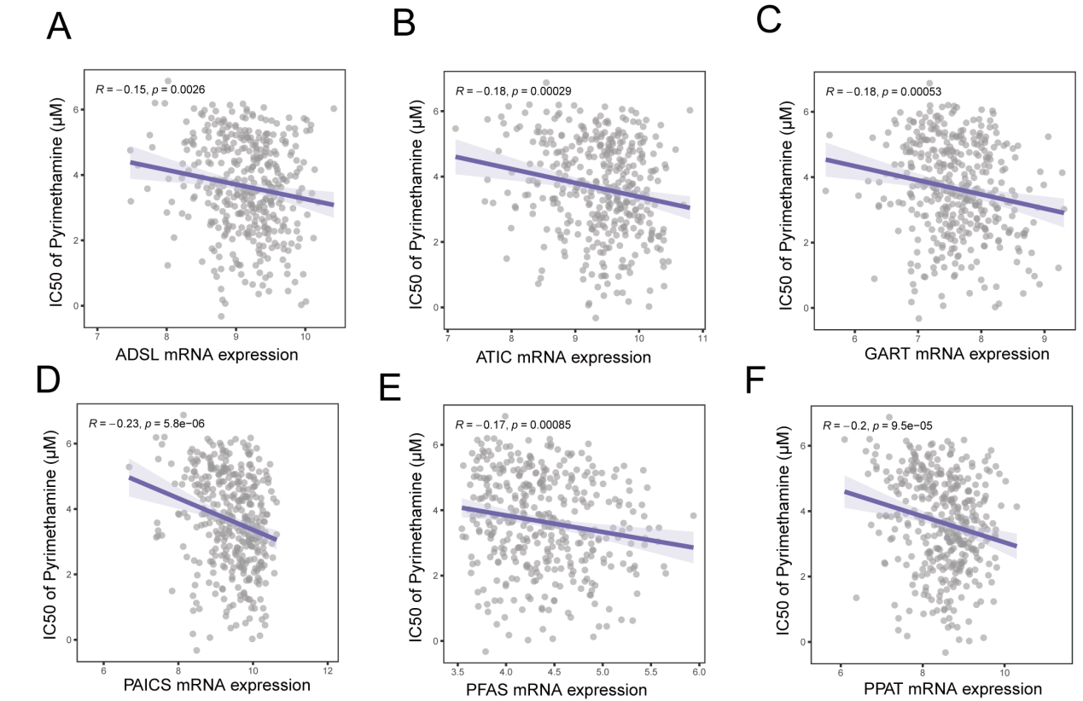
Supplementary Figure 3: Correlation analysis of pyrimethamine effectiveness and purinosome-related gene expression across diverse cancer types. Correlation analysis between the IC50 of pyrimethamine and purinosome-related gene expression in different cancer types in GDSC database.

