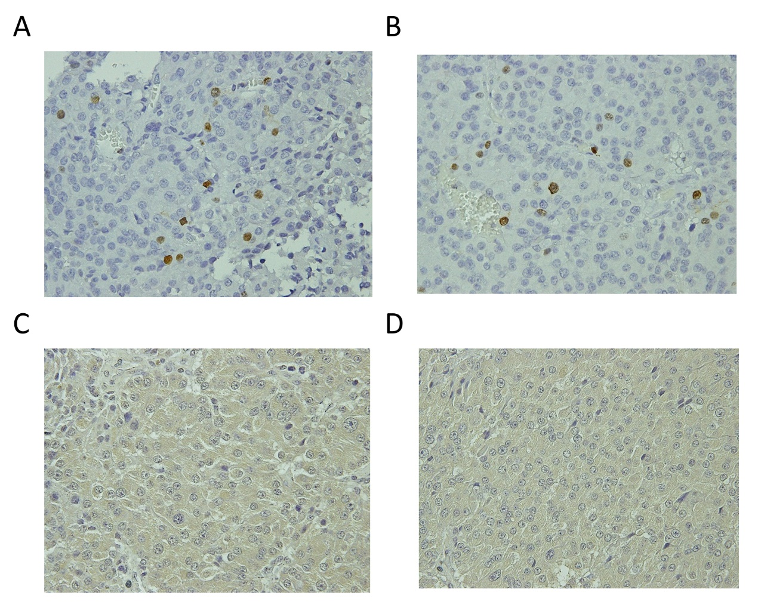Supplementary Fig. S1 Representative Ki-67 immunohistochemical staining (brown staining) in (A) the central and (B) peripheral zones of a prolactin-producing macroadenoma. Representative VEGF immunohistochemical staining (brown staining) in (C) the central and (D) peripheral zones of a pituitary macroadenoma. Magnification: ×400.

