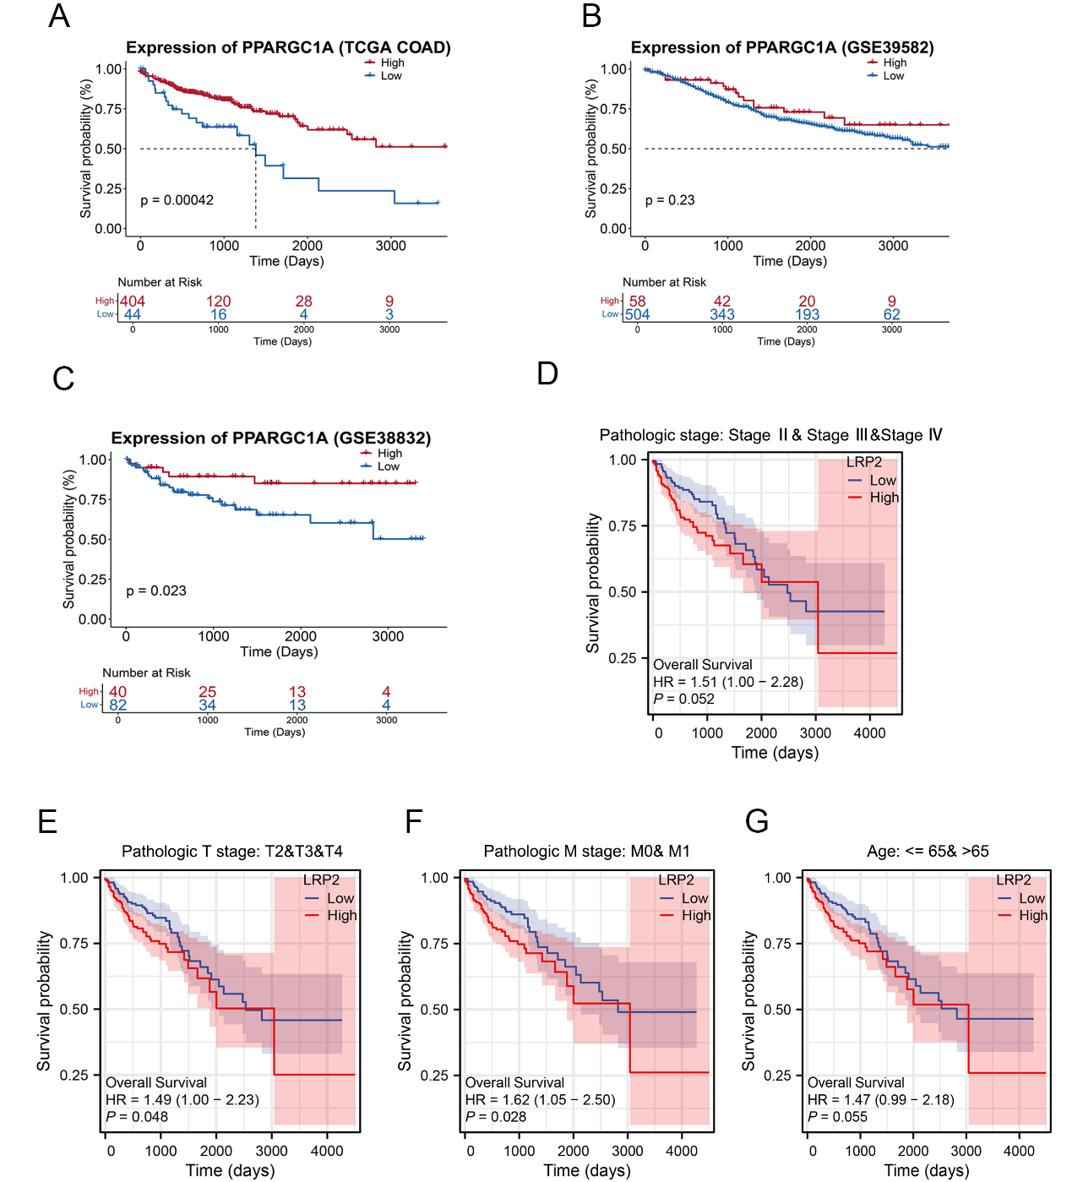
Fig. S2. The prognostic situations of filtered genes were investigated by survival analysis with optimal cut-off expression.
A-C. Kaplan–Meier (KM) curves of COAD patients in TCGA (A), GSE39582 (B) and GSE38832 (C); D-G. KM curves of LRP2 with Pathologic stage (D), T stage (E), M stage (F) and Age (G).

