Supplementary Material: Dexamethasone, celecoxib, and simvastatin-induced 5-fluorouracil resistance in cancer cells: A possible role of lipid droplet accumulation

Duaa S. Sabbah^{1§}, Balqis A Ikhmais ^{2§}, Qasem M. Abdallah^{1*}, Roger M. Phillips³, Nidal A. Qinna¹

Supplementary Table 1. Correlation between IC₅₀ values from GDSC database of traditional chemotherapies and LDs levels of varied cancer cell lines.
Traditional chemotherapies | Correlation between LDs levels and IC₅₀ (r²)
5-FU | 0.6185
Methotrexate | 0.1091
Doxorubicin | 0.001
Cisplatin | 0.2753
Paclitaxal | 0.1683
Mitomycin C | 0.0022
Vinblastin | 0.1062
Bleomycin | 0.1116
Vinorelbine | 0.0459
Etoposide | 0.1023

Supplementary Table 2. IC₅₀ values of 5-FU and corresponding basal LD levels in cancer cell lines.
Cell lines | LD (pg/cell) ± SD | IC₅₀ (µM) ± SD
HCT-116 | 32.18 ± 4.43 | 3.00 ± 0.04
A549 | 35.83 ± 4.86 | 2.74 ± 0.79
MCF7 | 40.01 ± 2.04 | 6.40 ± 0.91
HepG2 | 43.42 ± 2.39 | 14.54 ± 1.90
MDA-MB-231 | 48.65 ± 6.55 | 14.54 ± 4.46
MDA-MB-468 | 57.25 ± 1.47 | 3.07 ± 1.87
K562 | 58.25 ± 1.20 | 21.80 ± 1.98
H1299 | 64.94 ± 4.12 | 26.82 ± 1.30

Supplementary Table 3. Survival rate of cell lines exposed to sub-lethal concentrations of, CXB, DEX and SMV
Cell lines | %Survival  10µM CXB | %Survival  1µM DEX | %Survival  1µM SMV
MDA-MB-468 | 126.10 % | 82.01 % |  | 84.86 %
A549 | 103.80 % | 94.58 % |  | 94.75 %
HCT-116 | 95.18 % | 102.41 % |  | 112.67 %

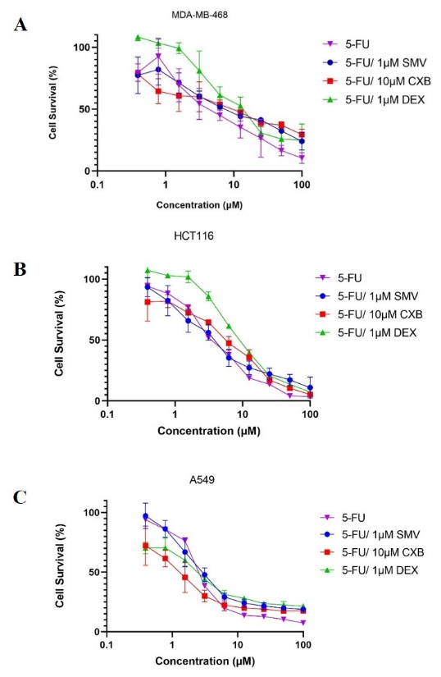
Supplementary Figure 1 a-c. Growth inhibition curves of 5-FU in combination with 1 µM SMV, 10 µM CXB, and 1 µM DEX on (a) MDA-MB-468, (b) HCT116, and (c) A549cells.

