Supplementary material
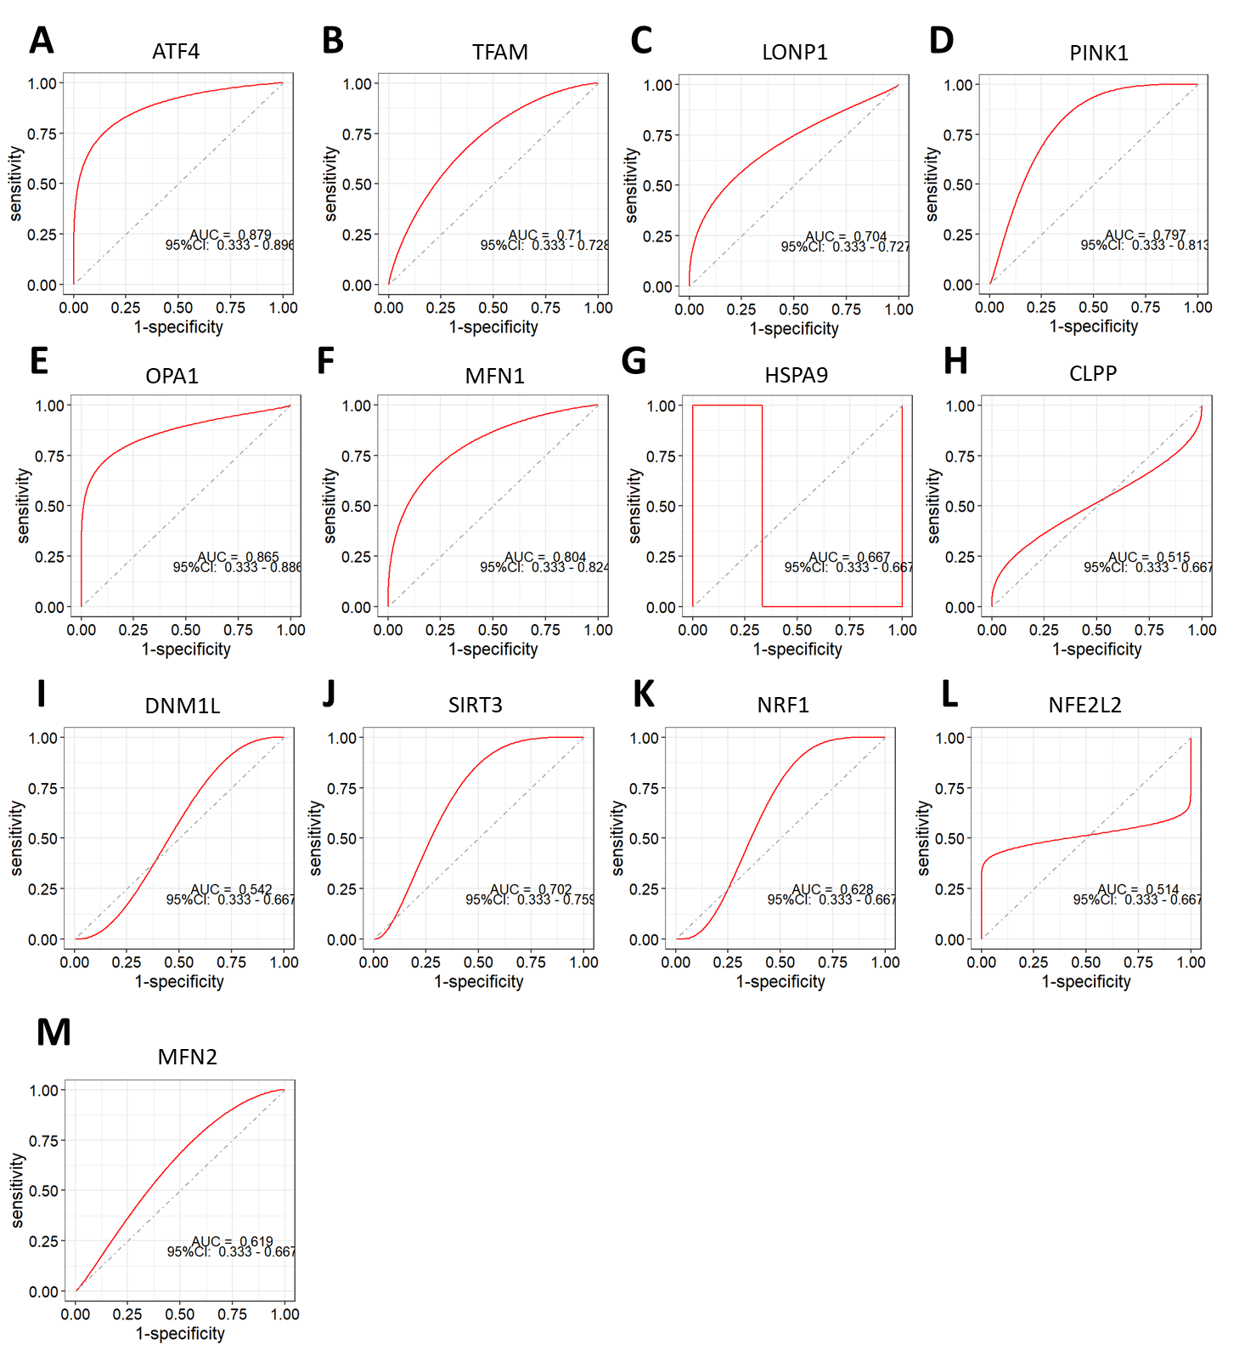
Supplementary Fig. S1. ROC curve analyzing the discriminatory power between normal tissue and tumor tissue for ATF4 (A), TFAM (B), LONP1 (C), PINK1 (D), OPA1 (E), MFN1 (F), HSPA9 (G), CLPP (H), DNM1L (I), SIRT3 (J), NRF1 (K), NFE2L2 (L), and MFN2 (M).

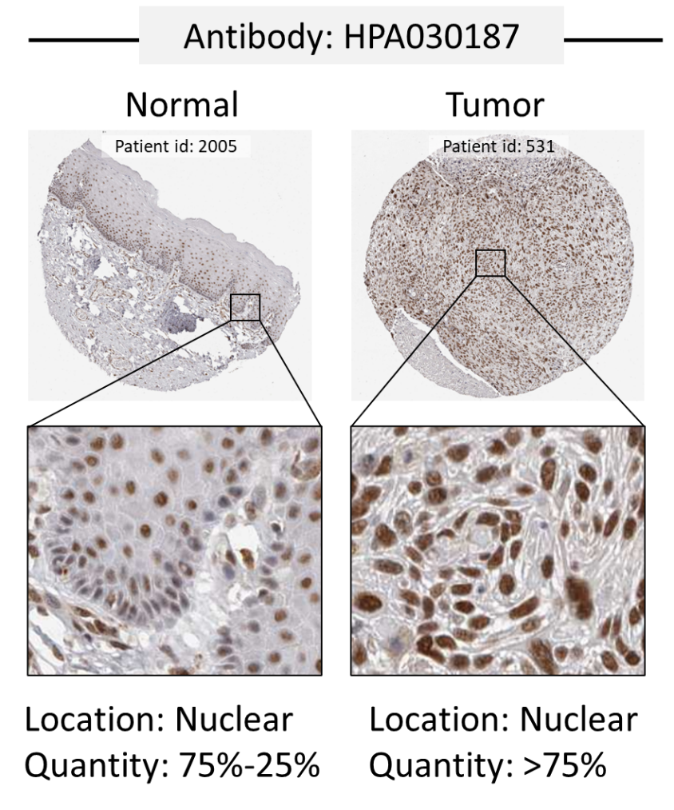
Supplementary Fig. S2. Differential ATF5 protein expression between CESC and normal tissue. Immunohistochemical analysis using anti-ATF5 antibody (HPA030187) reveals elevated ATF5 protein levels in CESC tumor compared to normal cervical epithelium.

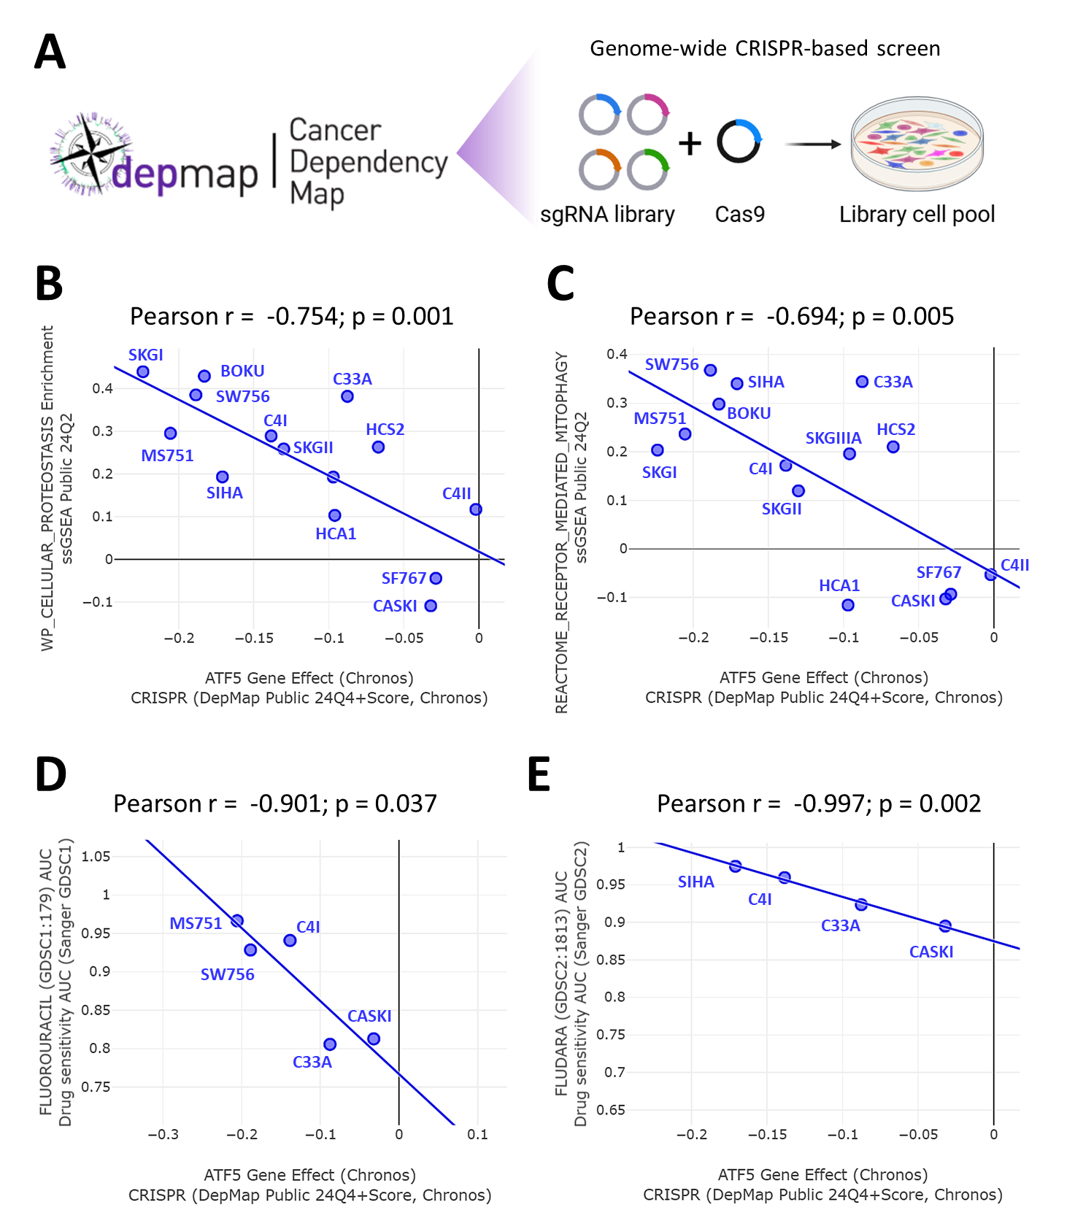
Supplementary Fig. S3. ATF5 dependency correlates with fluorouracil sensitivity in cervical cancer cells. Analysis of CRISPR-based screening data from the DepMap portal (A) links ATF5 dependency to biological pathways and chemotherapeutic response in CESC cell lines. The scatter plots exhibit the correlation between ATF5 Gene Effect scores and cellular proteostasis (B), receptor-mediated mitophagy (C), and fluorouracil sensitivity (AUC, area under curve) based on GDSC1 (D) and GDSC2 (E). Lower Gene Effect scores indicate stronger ATF5 dependency, while higher AUC values represent increased drug resistance.

