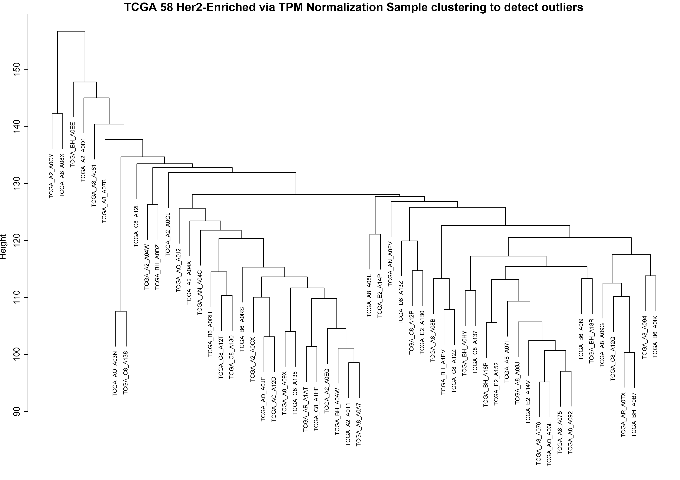
Figure. TCGA 58 HER2-enriched Via TPM Normalization Sample Clustering to Detect Outliers

