Lollipop alterations among individual’s hub genes

TP53 | MYC
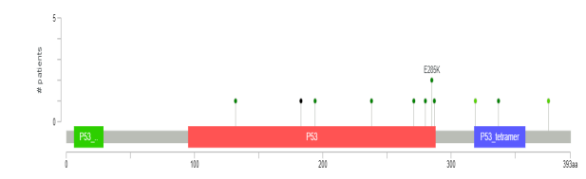 | 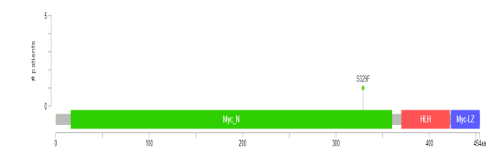
MUC5B | KRT5
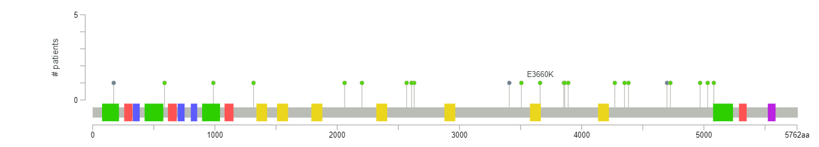 | 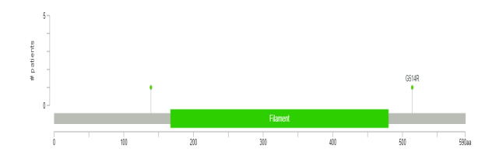
IL1B | CDKN2A
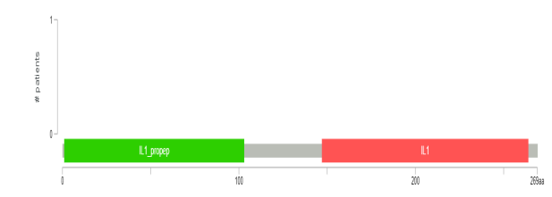 | 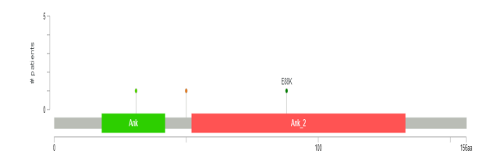
CCR9 | CALML3
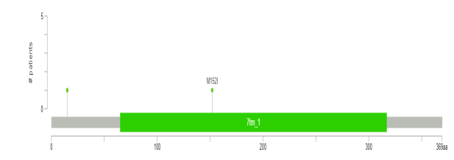 | 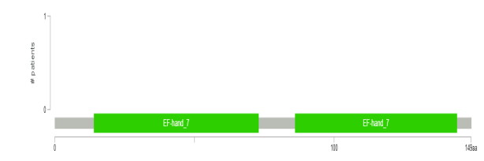
BUB1B | BIRC5
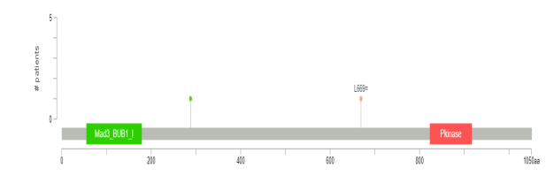 | 