Drugs Targeting Corresponding Genes:
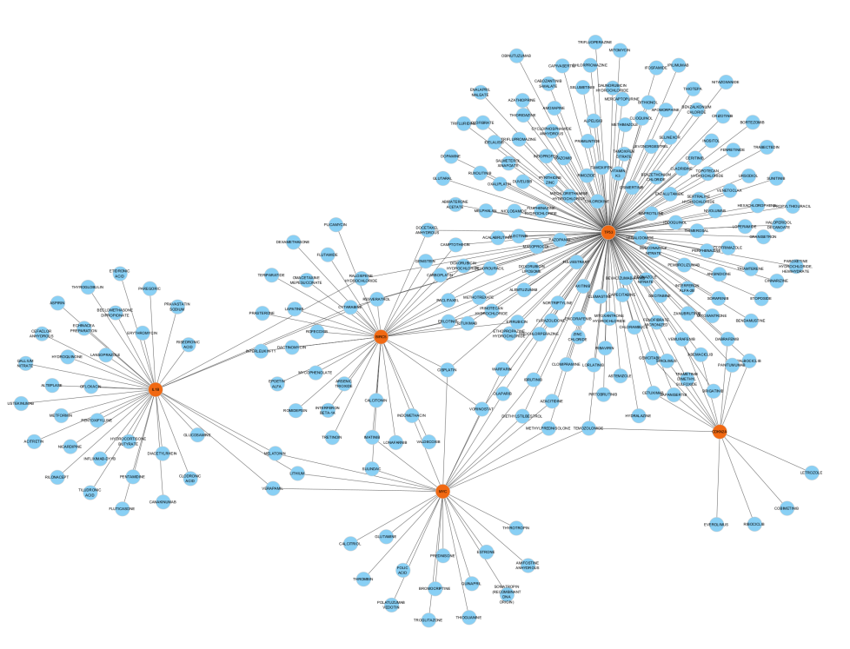
Fig: shows drugs targeting corresponding genes in which orange circle shows hub genes and blue circle shows drugs.

