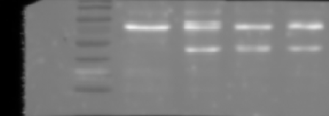
Correspond to the Figure. 5a in the manuscript
3rd Western blot
GAPDH
MASP1
GES1
MKN28
MKN45
MKN74
GES1
MKN28
MKN45
MKN74
2nd Western blot
MASP1
GAPDH
GES1
MKN28
MKN45
MKN74
GES1
MKN28
MKN45
MKN74
1st Western blot

GAPDH
GES1
MKN28
MKN45
MKN74

GES1
MKN28
MKN45
MKN74
Chemiluminescence
Merged blot with marker
GES1
MKN28
MKN45
MKN74
GES1
MKN28
MKN45
MKN74
GES1
MKN28
MKN45
MKN74
GES1
MKN28
MKN45
MKN74
GES1
MKN28
MKN45
MKN74
GES1
MKN28
MKN45
MKN74
MASP1

