Supplementary Figure 1 A:Representative images of intensity and MPC2 staining.B The cut off of MPC2 score using X title.

Supplementary Figure 2 The relative expression of E-cadherin, Vimentin in mock- and OEBmi1 786-O cell

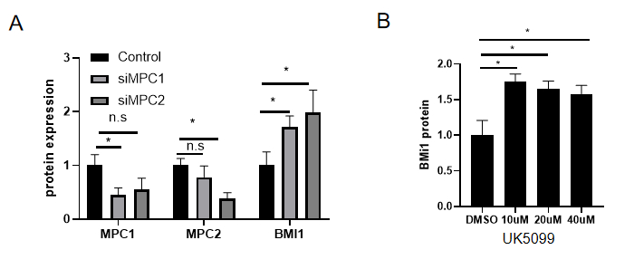

Supplementary Figure 3 A:Quantitation of MPC1, MPC2 and Bmi1 protein in siMPC1-,siMPC2-, control- 786-O cell respectively. B. Quantitation of Bmi1 in 786-O cell treated with different dose of UK5099

Supplementary Table 1. Low mitochondrial pyruvate carrier 2 expression in renal carcinoma and adjacent normal tissue.

MPC2 (low) MPC2 (high) P (value)

Carcinoma 79 71 P = 0.030
Adjacent normal tissues 10 20

Supplementary Table 2. The clinical features of the renal cell carcinoma specimens used in this study.
 | TNM stage
Feature | Ⅰ(n=122) | Ⅱ(n=16) | Ⅲ(n=12)
Gender
Male | 84 | 13 | 10
Female | 38 | 3 | 2
Age at diagnosis
＜50 | 34 | 1 | 1
≥50 | 88 | 15 | 11
Location
Left kidney | 58 | 3 | 6
Right kidney | 64 | 13 | 6
Grade
High | 60 | 2 | 0
Moderate  Poor | 52  10 | 10  4 | 7  5

Supplementary Table 3. The relationship between Low mitochondrial pyruvate carrier 2 expression and clinicopathological features of renal cell carcinoma patients.
 | MPC2
Feature | High (n=71) | Low (n=79) | P
Gender |  |  | P=0.395
Male | 53(74.65%) | 54(68.35%)
Female | 18(25.35%) | 25(31.65%)
Age at diagnosis |  |  | P=0.846
＜50 | 17(23.94%) | 20(25.32%)
≥50 | 54(76.06%) | 59(74.68%)
Location |  |  | P=0.452
Left | 34(47.89%) | 33(41.77%)
Right | 37(52.11%) | 46(58.23%)
Tumor size |  |  | P=0.009
＜7cm | 64(90.14%) | 58(73.41%)
＞=7cm | 7(9.86%) | 21(26.59%)
lymph node metastasis |  |  | P=0.624
N0 | 70(98.60%) | 77(97.80%)
N1-2 | 1(1.40%) | 2 (2.20%)
TNM stage |  |  | P=0.009
Ι | 64(90.14%) | 58(73.42%)
Π+ΙΙΙ | 7(9.86%) | 21(26.58%)
Histological grade |  |  | P=0.173
Well | 24(33.80%) | 38(48.10%)
Moderate | 38(53.52%) | 31(39.24%)
Poor | 9(12.68%) | 10(12.66%)
PD-L1 |  |  | P=0.014
High(＞5%) | 43（60.56%） | 32（40.51%）
Low（≤5%） | 28（39.44%） | 47（59.49%）

