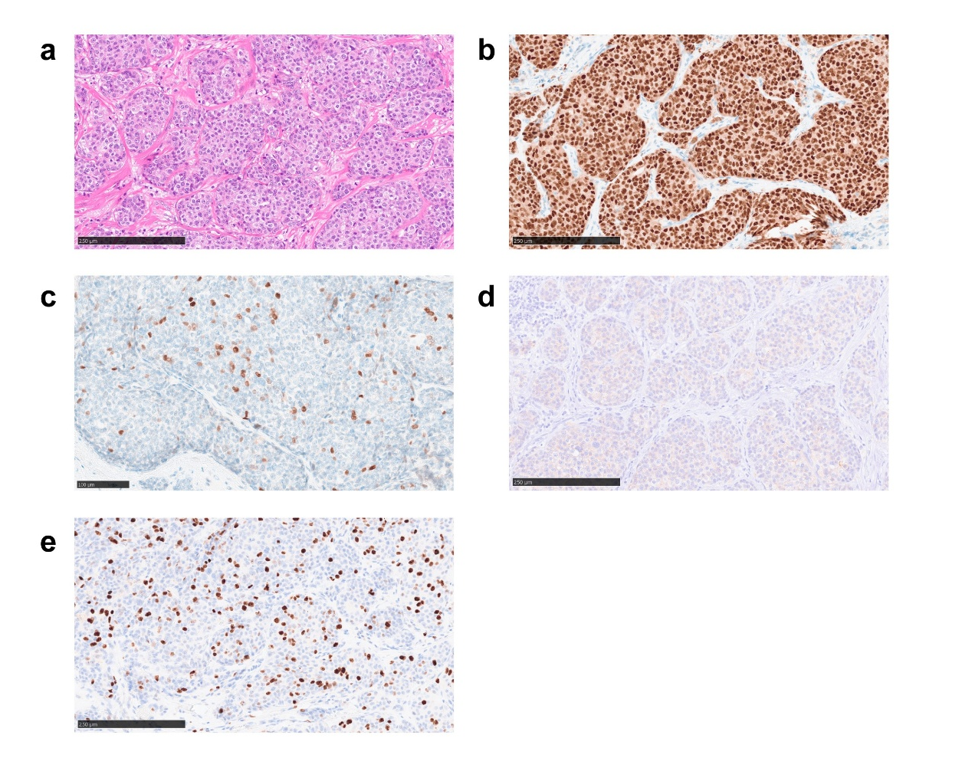Supplementary Figure 1: Concurrently identified contralateral invasive ductal carcinoma (IDC), NOS.
(a) IDC NOS, solid type. (b)- (e) IHC images. The tumor was positive for ER (Allred score 8) (b), PgR (Allred score 6) (c), and negative for HER2 (score 1) (d). (e) Ki67 labeling index was 20 %. Scale bars in (a), (b), (d), (e) = 250 µm, (c) = 100 µm.

