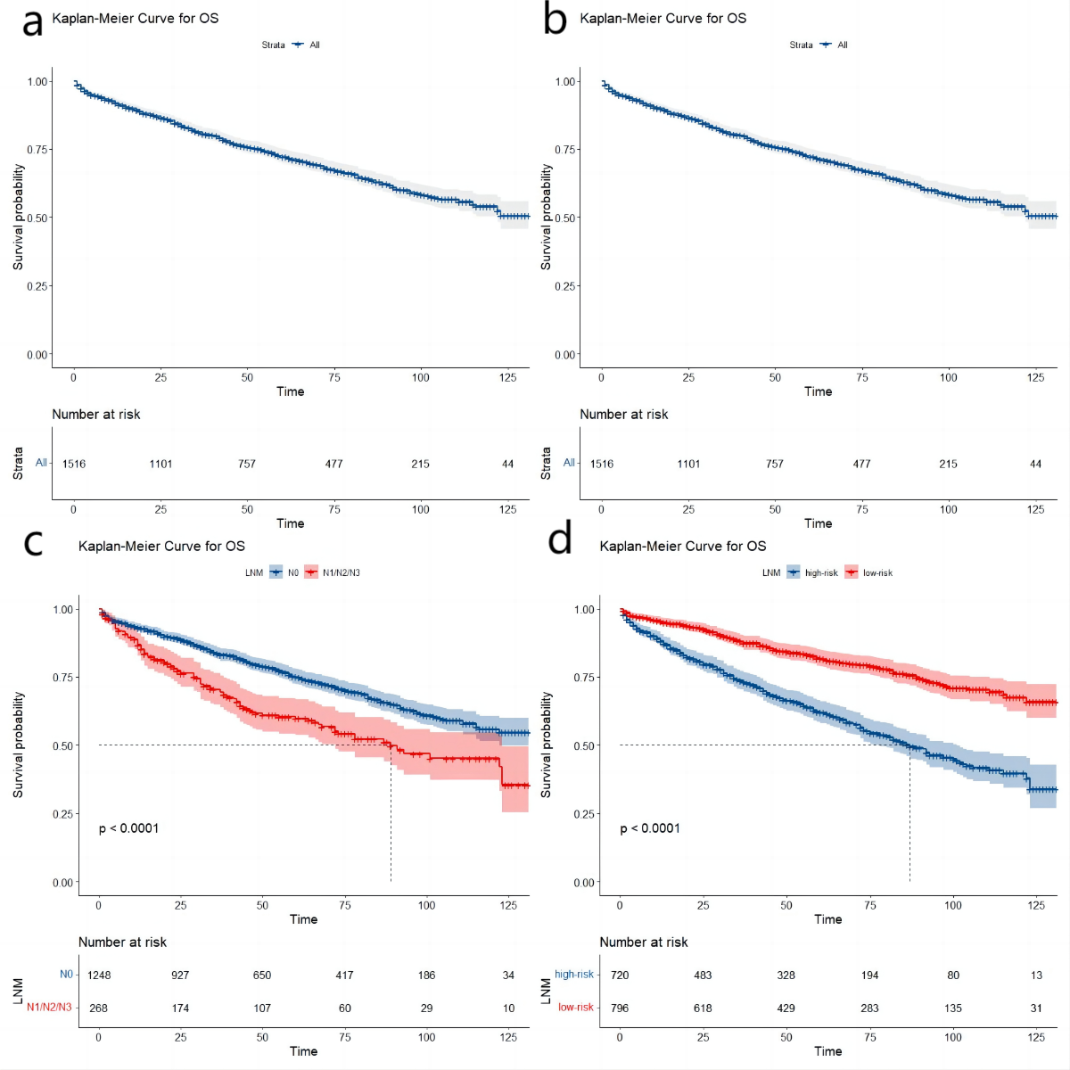
Supplementary Fig. 1 Kaplan-Meier survival analysis of OS. A. overall survival in training cohort; B. overall survival in Chinese cohort; C. overall survival in training cohort according to LNM; D. overall survival in the low- and high-risk groups in training cohort.

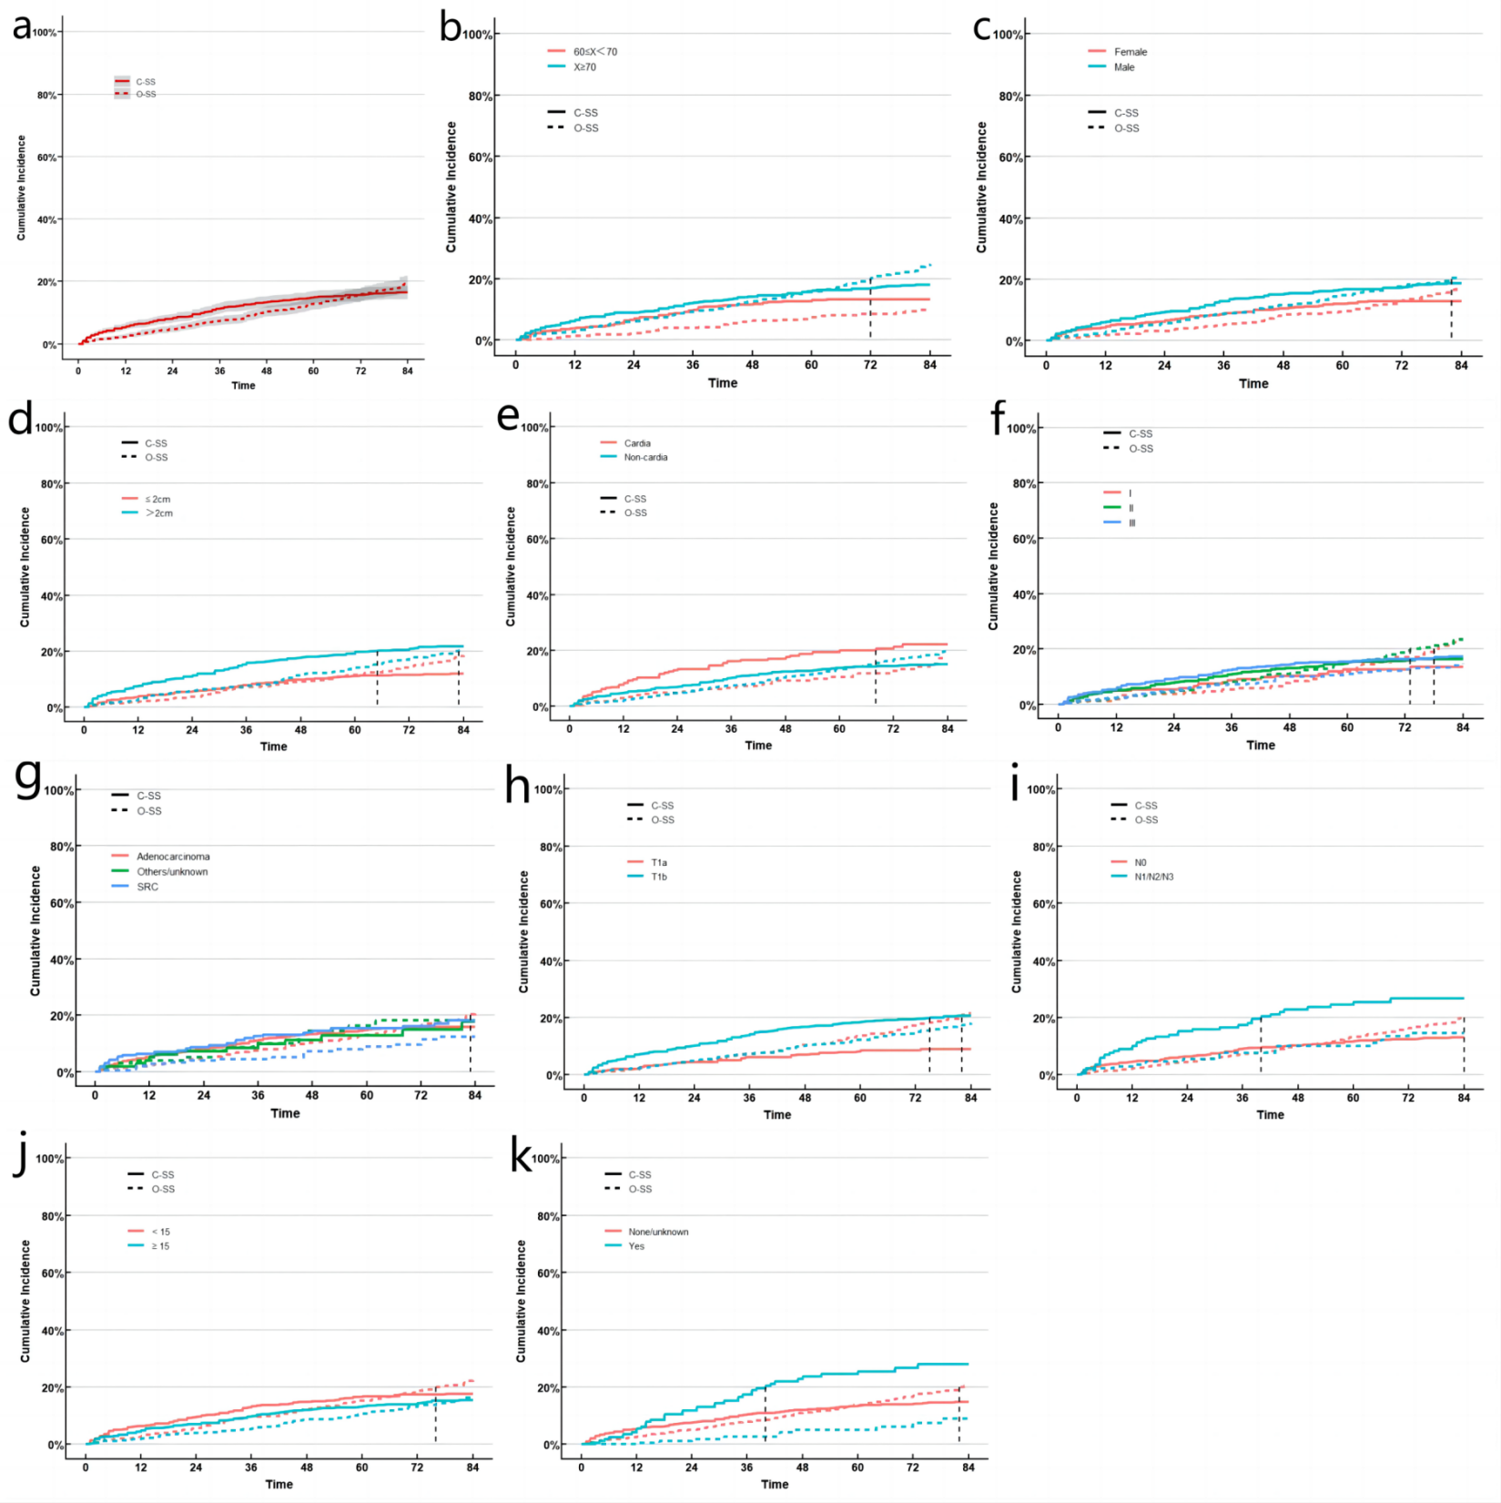
Supplementary Fig. 2 Cumulative risk curves of EGC in different subgroups. (A) all; (B) age; (C) sex; (D) tumor size; (E) tumor location; (F) grade; (G) histology; (H) T stage; (I) N stage; (J) ELNC; (K) chemotherapy

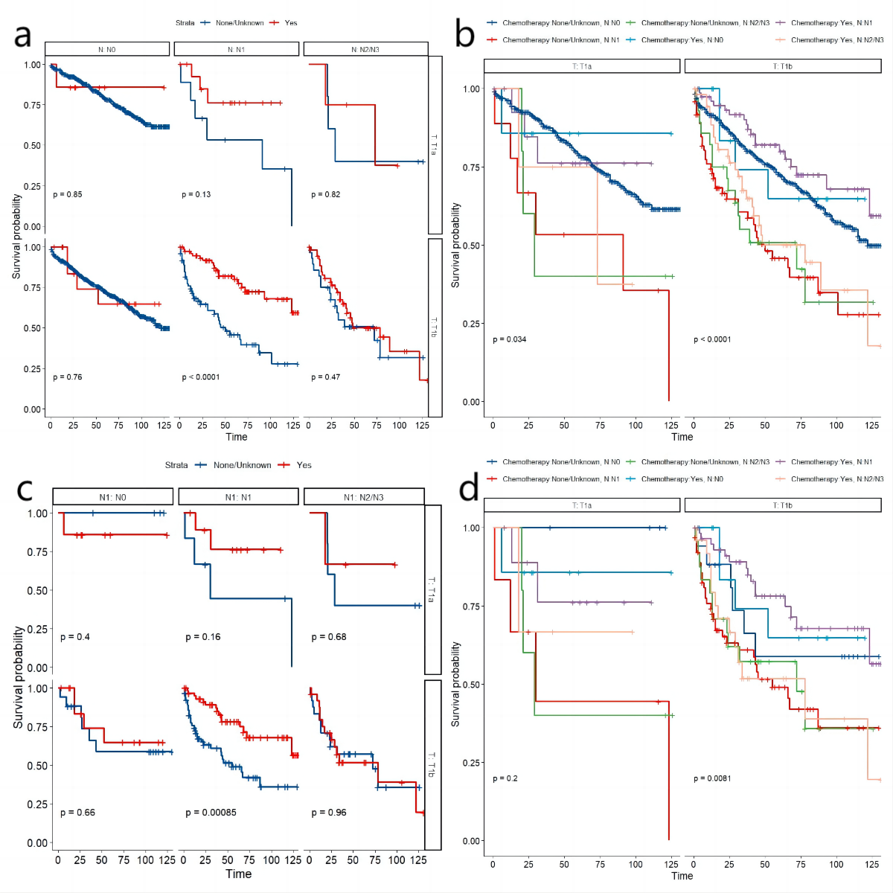

Supplementary Fig. 3 Kaplan-Meier survival analysis of OS. A. patients cohort among chemotherapy group before PSM according to stage T, and stage N; B. patients cohort before PSM according to stage T, stage N, and chemotherapy; C. patients cohort among chemotherapy group after PSM according to stage T, and stage N; D. patients cohort after PSM according to stage T, stage N, and chemotherapy.

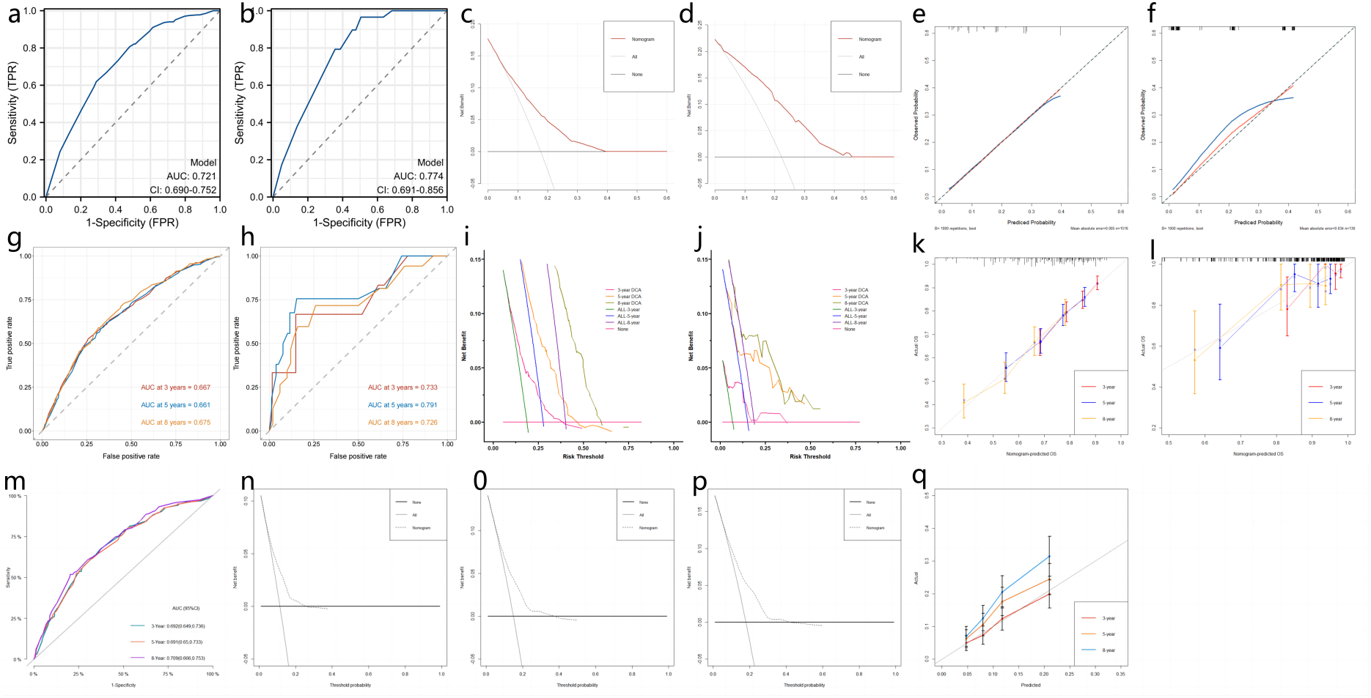

Supplementary Fig. 4 The ROC curves of LNM in training cohort (A), and external validation cohort (B); The DCA curves of LNM in training cohort (C), and external validation cohort (D); The calibration plots of LNM in training cohort (E), and external validation cohort (F); The ROC curves of 3-, 5-, and 8-year OS in training cohort (G), and external validation cohort (H); The DCA curves of OS in training cohort (I), and external validation cohort (J); The calibration plots of OS in the training cohort (K), and external validation cohort (L). The ROC curves of 3-, 5-, and 8-year CSS in training cohort (M); The DCA curves of 3-year (N), 5-year (O), and 8-year (P) CSS in training cohort; The calibration plots of CSS in training cohort (Q).

Supplementary Table 1 The lymph node metastasis rate in SEER cohort.

Variables | All patients, n (%) | N stage, n (%)
Variables | All patients, n (%) | N0 | N1/N2/N3
Total | 1516 (100.00) | 1248 (82.32) | 268 (17.68)
T stage
T1a | 535 (35.29) | 502 (93.83) | 33 (6.17)
T1b | 981 (64.71) | 746 (76.04) | 235 (23.96)

Supplementary Table 2 Univariate and multivariate analyses of LNM risk with EGC in Chinese cohort.

 | All patients  (n=130), n (%) | Univariate analysis |  | Multivariate analysis
 | All patients  (n=130), n (%) | OR (95% CI) | P-value | OR (95% CI) | P-value
Age (years)
60≤X<70 | 94 (72.31) | 1
≥70 | 36 (27.69) | 1.23 (0.50-3.04) | 0.65
Sex
Male | 100 (76.92) | 1
Female | 30 (23.08) | 0.84 (0.31-2.30) | 0.73
Tumor size
≤ 2cm | 90 (69.23) | 1
＞2cm | 40 (30.77) | 1.84 (0.78-4.34) | 0.16
Tumor location
Cardia | 11 (8.46) | 1
Non-cardia | 119 (91.54) | 1.32 (0.27-6.48) | 0.73
Grade
I | 32 (24.62) | 1 |  | 1
II | 61 (46.92) | 3.15 (0.84-11.84) | 0.09 | 2.19 (0.54-8.93) | 0.27
III | 37 (28.46) | 4.09 (1.03-16.29) | 0.046 | 2.78 (0.64-12.10) | 0.17
Histology
Adenocarcinoma | 117 (90.00) | 1
SRC | 6 (4.62) | 1.67 (0.29-9.60) | 0.57
Others/unknown | 7 (5.38) | 0 (0-Inf) | 0.99
T stage
T1a | 49 (37.69) | 1 |  | 1
T1b | 81 (62.31) | 25.36 (3.32-193.55) | 0.002 | 22.60 (2.94-173.59) | 0.003
ELNC
< 15 | 20 (15.38) | 1
≥15 | 110 (84.62) | 2.93 (0.64-13.44) | 0.17
Surgery method
Open | 70 (53.85) | 1
Laparoscope | 60 (46.15) | 0.65 (0.28-1.51) | 0.32

Supplementary Table 3 Univariate and multivariate analyses of OS risk with EGC in Chinese cohort.
 | All patients  (n=130), n (%) | Alive  (n=105), n(%) | Dead  (n=25), n(%) | Univariate analysis |  | Multivariate analysis
 |  |  |  | HR (95% CI) | P-value | HR (95% CI) | P-value
Age (years)
60≤X<70 | 94 (72.31) | 82 (78.10) | 12 (48.00) | 1 |  | 1
≥70 | 36 (27.69) | 23 (21.90) | 13 (52.00) | 3.1 (1.41-6.79) | 0.01 | 3.07 (1.40-6.74) | 0.01
Sex
Male | 100 (76.92) | 79 (75.24) | 21 (84.00) | 1
Female | 30 (23.08) | 26 (24.76) | 4 (16.00) | 0.54 (0.18-1.57) | 0.26
Tumor size
≤ 2cm | 90 (69.23) | 76 (72.38) | 14 (56.00) | 1
＞2cm | 40 (30.77) | 29 (27.62) | 11 (44.00) | 1.91 (0.87-4.20) | 0.11
Tumor location
Cardia | 11 (8.46) | 8 (7.62) | 3 (12.00) | 1
Non-cardia | 119 (91.54) | 97 (92.38) | 22 (88.00) | 0.64 (0.19-2.15) | 0.47
Grade
I | 32 (24.62) | 27 (25.71) | 5 (20.00) | 1
II | 61 (46.92) | 46 (43.81) | 15 (60.00) | 1.35 (0.49-3.74) | 0.56
III | 37 (28.46) | 32 (30.48) | 5 (20.00) | 0.71 (0.2-2.45) | 0.58
Histology
Adenocarcinoma | 117 (90.00) | 95 (90.48) | 22 (88.00) | 1
SRC | 6 (4.62) | 4 (3.81) | 2 (8.00) | 2.23 (0.52-9.51) | 0.28
Others/unknown | 7 (5.38) | 6 (5.71) | 1 (4.00) | 0.59 (0.08-4.42) | 0.61
T stage
T1a | 49 (37.69) | 41 (39.05) | 8 (32.00) | 1
T1b | 81 (62.31) | 64 (60.95) | 17 (68.00) | 1.27 (0.55-2.94) | 0.58
N stage
N0 | 101 (77.69) | 87 (82.86) | 14 (56.00) | 1 |  | 1
N1/N2/N3 | 29 (22.31) | 18 (17.14) | 11 (44.00) | 3.42 (1.55-7.57) | 0.002 | 3.39 (1.53-7.48) | 0.003
ELNC
< 15 | 20 (15.38) | 16 (15.24) | 4 (16.00) | 1
≥15 | 110 (84.62) | 89 (84.76) | 21 (84.00) | 0.89 (0.30-2.59) | 0.83
Chemotherapy
None/unknown | 124 (95.38) | 101 (96.19) | 23 (92.00) | 1
Yes | 6 (4.62) | 4 (3.81) | 2 (8.00) | 3.45 (0.79-15.00) | 0.10
Surgery
Open surgery | 70 (53.85) | 53 (50.48) | 17 (68.00) | 1
Laparoscopic surgery | 60 (46.15) | 52 (49.52) | 8 (32.00) | 0.93 (0.39-2.23) | 0.87

Supplementary Table 4 Baseline characteristics before PSM.

 | All patients  (n=1516), n (%) | Chemotherapy-None/unknown  (n=1341), n (%) | Chemotherapy-Yes  (n=175), n (%) | P-value
Age (years)
60≤X<70 | 576 (37.99) | 490 (36.54) | 86 (49.14)
≥70 | 940 (62.01) | 851 (63.46) | 89 (50.86) | 0.002
Sex
Male | 916 (60.42) | 809 (60.33) | 107 (61.14)
Female | 600 (39.58) | 532 (39.67) | 68 (38.86) | 0.90
Tumor size
≤ 2cm | 843 (55.61) | 778 (58.02) | 65 (37.14)
＞2cm | 673 (44.39) | 563 (41.98) | 110 (62.86) | <0.0001
Tumor location
Cardia | 286 (18.87) | 249 (18.57) | 37 (21.14)
Non-cardia | 1230 (81.13) | 1092 (81.43) | 138 (78.86) | 0.47
Grade
I | 232 (15.30) | 222 (16.55) | 10 (5.71)
II | 593 (39.12) | 532 (39.67) | 61 (34.86)
III | 691 (45.58) | 587 (43.77) | 104 (59.43) | <0.0001
Histology
Adenocarcinoma | 1225 (80.80) | 1087 (81.06) | 138 (78.86)
SRC | 190 (12.53) | 165 (12.30) | 25 (14.29)
Others/unknown | 101 (6.66) | 89 (6.64) | 12 (6.86) | 0.74
T stage
T1a | 535 (35.29) | 509 (37.96) | 26 (14.86)
T1b | 981 (64.71) | 832 (62.04) | 149 (85.14) | <0.0001
N stage
N0 | 1248 (82.32) | 1226 (91.42) | 22 (12.57)
N1 | 177 (11.68) | 82 (6.11) | 95 (54.29)
N2/N3 | 91 (6.00) | 33 (2.46) | 58 (33.14) | <0.0001
ELNC
< 15 | 668 (44.06) | 610 (45.49) | 58 (33.14)
≥15 | 848 (55.94) | 731 (54.51) | 117 (66.86) | 0.003

Supplementary Table 5 Baseline characteristics after PSM.

 | All patients  (n=242), n (%) | Chemotherapy-None/unknown  (n=121), n (%) | Chemotherapy-Yes  (n=121), n (%) | P-value
Age (years)
60≤X<70 | 87 (35.95) | 37 (30.58) | 50 (41.32)
≥70 | 155 (64.05) | 84 (69.42) | 71 (58.68) | 0.11
Sex
Male | 134 (55.37) | 64 (52.89) | 70 (57.85)
Female | 108 (44.63) | 57 (47.11) | 51 (42.15) | 0.52
Tumor size
≤ 2cm | 97 (40.08) | 49 (40.50) | 48 (39.67)
＞2cm | 145 (59.92) | 72 (59.50) | 73 (60.33) | 1
Tumor location
Cardia | 47 (19.42) | 19 (15.70) | 28 (23.14)
Non-cardia | 195 (80.58) | 102 (84.30) | 93 (76.86) | 0.19
Grade
I | 21 (8.68) | 12 (9.92) | 9 (7.44)
II | 86 (35.54) | 37 (30.58) | 49 (40.50)
III | 135 (55.79) | 72 (59.50) | 63 (52.07) | 0.26
Histology
Adenocarcinoma | 189 (78.10) | 90 (74.38) | 99 (81.82)
SRC | 38 (15.70) | 20 (16.53) | 18 (14.88)
Others/unknown | 15 (6.20) | 11 (9.09) | 4 (3.31) | 0.15
T stage
T1a | 36 (14.88) | 16 (13.22) | 20 (16.53)
T1b | 206 (85.12) | 105 (86.78) | 101 (83.47) | 0.59
N stage
N0 | 44 (18.18) | 22 (18.18) | 22 (18.18)
N1 | 141 (58.26) | 70 (57.85) | 71 (58.68)
N2/N3 | 57 (23.55) | 29 (23.97) | 28 (23.14) | 0.99
ELNC
< 15 | 85 (35.12) | 49 (40.50) | 36 (29.75)
≥15 | 157 (64.88) | 72 (59.50) | 85 (70.25) | 0.11

