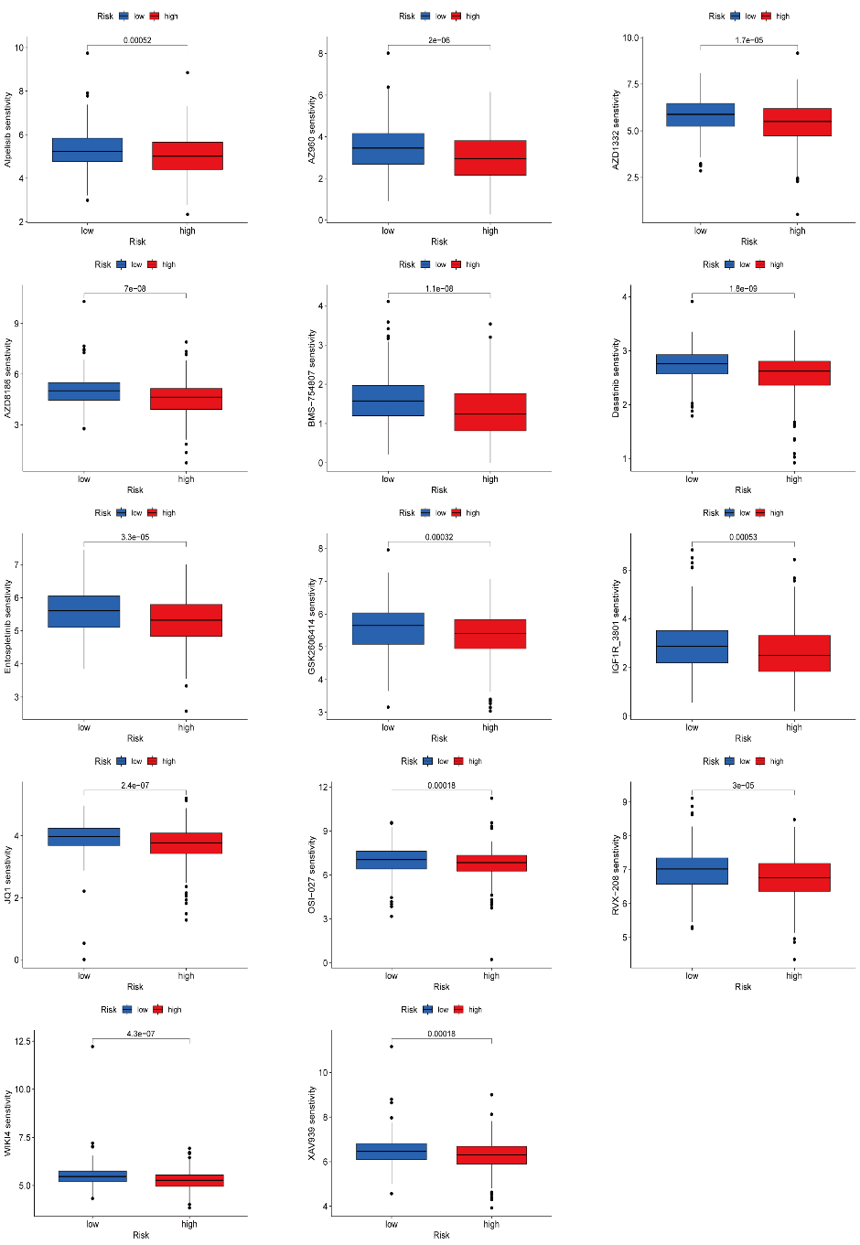
S1 Drug sensitivity analysis between high- and low-risk groups. Drugs to which the low-risk group is more sensitive than the high-risk group
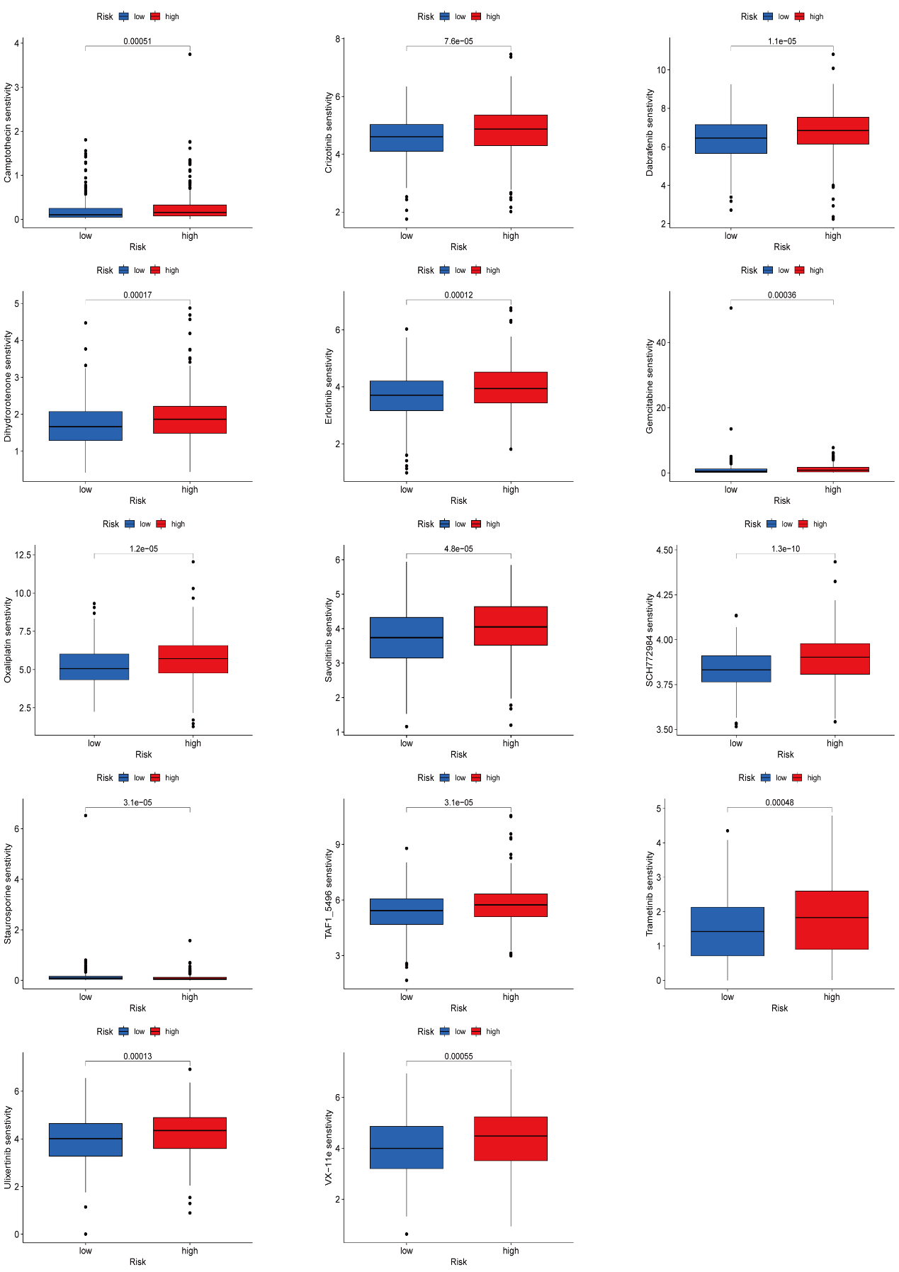
S2 Drug sensitivity analysis between high- and low-risk groups. Drugs to which the high-risk group is more sensitive than the low-risk group

