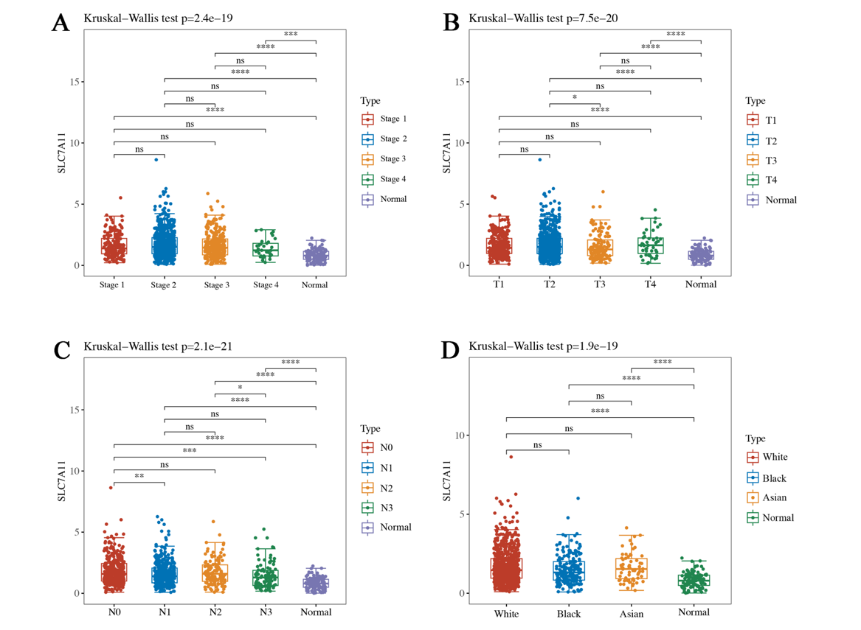
Supplementary figure 1: SLC7A11 expression in breast cancer. A-C. The relationship between differential expression of SLC7A11 and clinical stages, tumor volume level (T), regional lymph nodes (N) of breast cancer on TCGA respectively. D. Association between SLC7A11 expression level and race in breast cancer. (P-value, ns, not significant, *p < 0.05, **p < 0.01, ***p < 0.001, ****p < 0.0001).
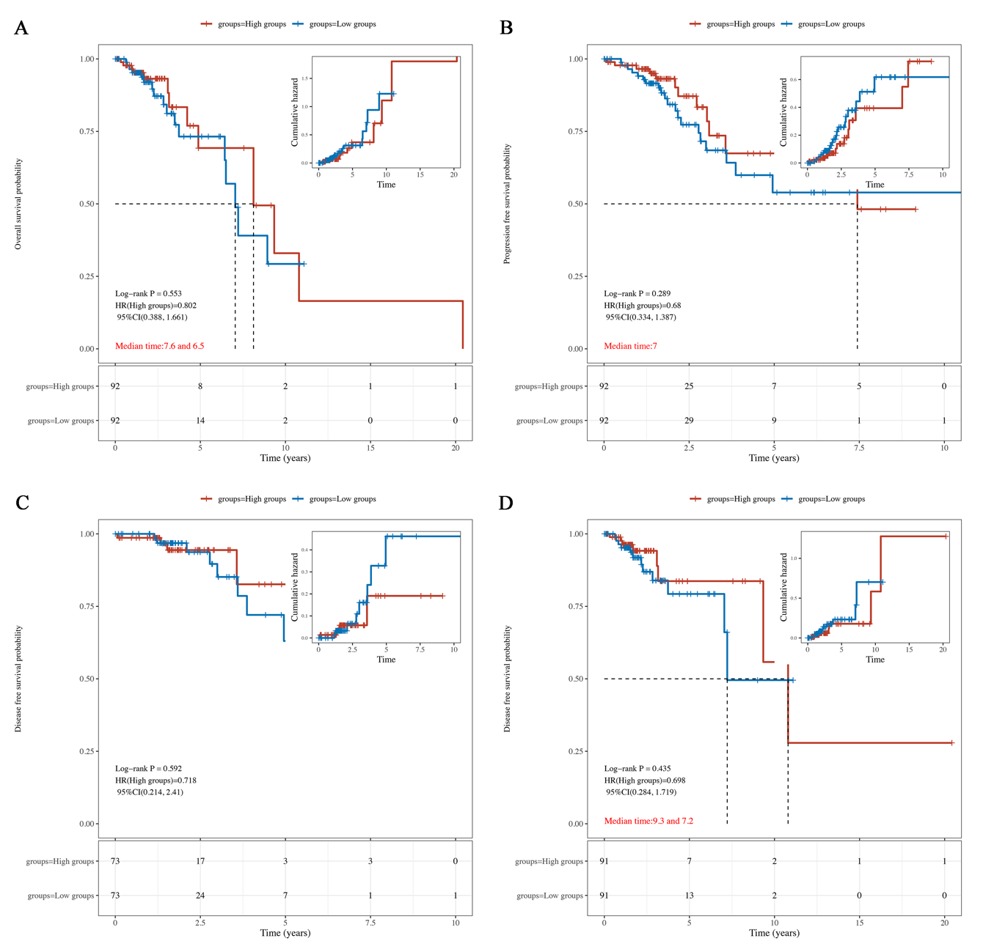
Supplementary figure 2: Relationship between Prognosis value and SLC7A11 gene in breast cancer. A-D: The results of KM for metastasis breast cancer patients (M1) with high SLC7A11 expression had no significant difference on OS, PFS, DFS, DSS statistically. (P-value, ns, not significant, *p < 0.05, **p < 0.01, ***p < 0.001, ****p < 0.0001).
Supplementary figure 3: A. Univariate Cox proportional hazards analysis for 1101 breast cancer patients. B. Multivariate Cox proportional hazards analysis for 1101 breast cancer patients. C. Univariate Cox proportional hazards analysis for 421 Luminal A type patients. D. Multivariate Cox proportional hazards analysis for 421 Luminal A type patients. E. Univariate Cox proportional hazards analysis for 140 Basal-like type patients. F. Multivariate Cox proportional hazards analysis for 140 Basal-like type patients. (P-value, ns, not significant, *p < 0.05, **p < 0.01, ***p < 0.001, ****p < 0.0001).
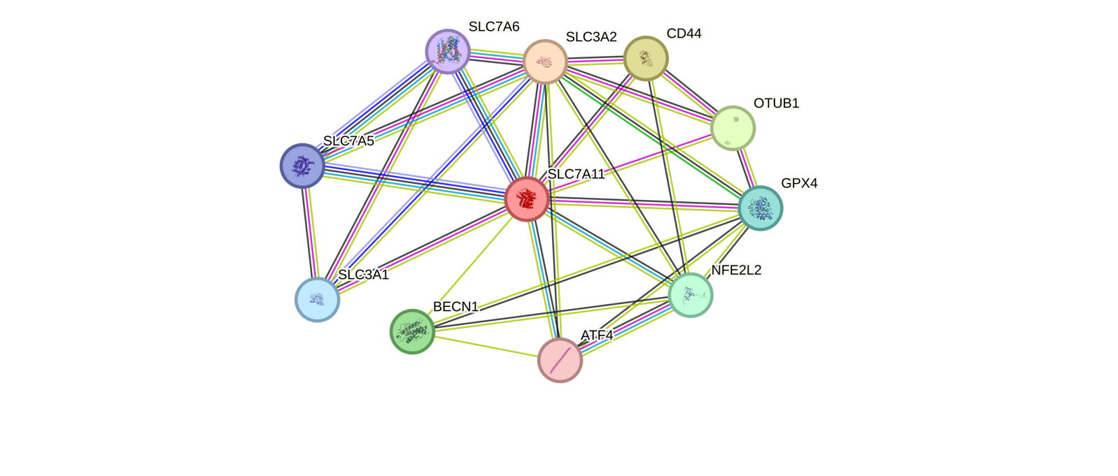
Supplementary figure 4: PPI network of SLC7A11 in breast cancer.

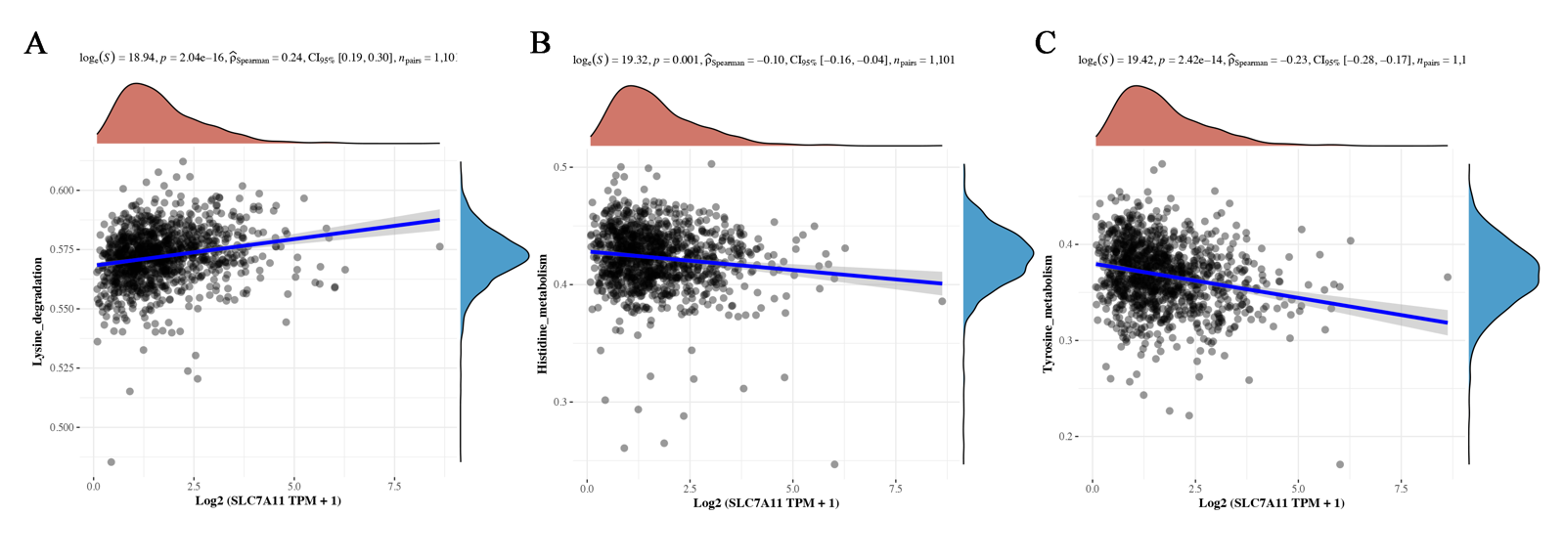
Supplementary figure 5: Relevance to SLC7A11 and amino acid metabolism in breast cancer. A. Lysine degradation (p= 2.04e-16). B. Histidine metabolism (p= 0.001) C. Tyrosine metabolism (p= 2.42e-14). (P-value, ns, not significant, *p < 0.05, **p < 0.01, ***p < 0.001, ****p < 0.0001).

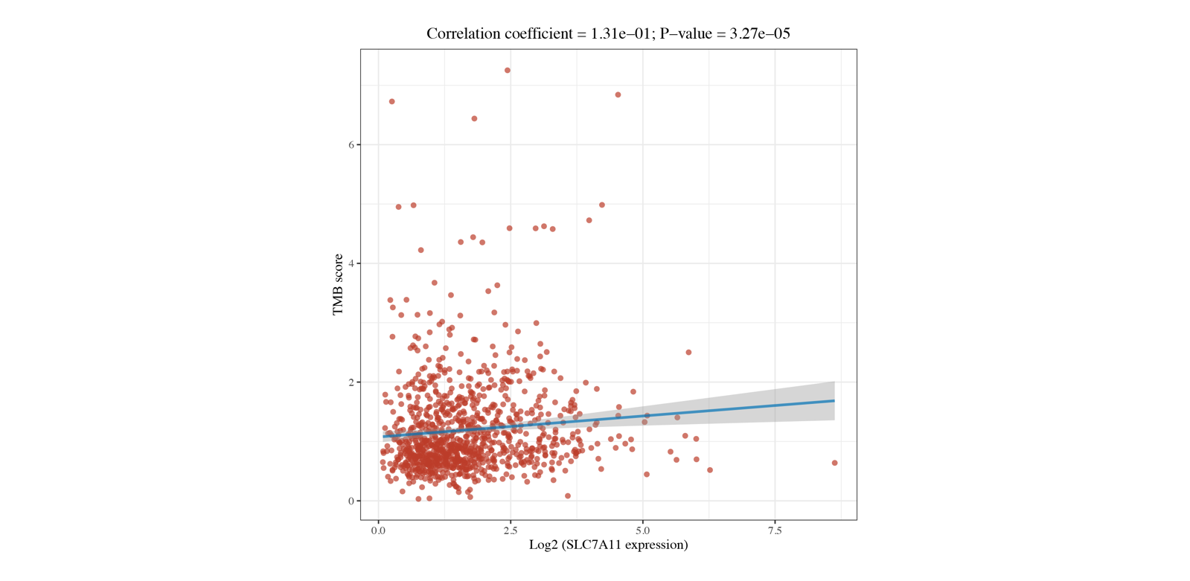
Supplementary figure 6: The relevance of TMB with SLC7A11 expression in breast cancer. (P-value, ns, not significant, *p < 0.05, **p < 0.01, ***p < 0.001, ****p < 0.0001).

