Supplementary Table 1. All primary antibodies information in the Western Blot.
Antibody Name | Source Species | Company | Catalog Number | Antibody Target Size | Dilution Ratio
ERK | Mouse | Cell Signaling Technology | #9107 | 44,42 kDa | 1:1000
p-ERK | Rabbit | Cell Signaling Technology | #4370（Thr202/Tyr204） | 44,42 kDa | 1:1000
p-EGFR | Rabbit | Cell Signaling Technology | #2237（Tyr1045） | 43kDa | 1:500
AKT | Rabbit | abcam | ab179463 | 60kDa | 1:1000
p-AKT | Rabbit | Cell Signaling Technology | #4060（Ser473） | 60kDa | 1:1000
PI3K | Rabbit | Cell Signaling Technology | #4257 | 85kDa | 1:1000
p-PI3K | Rabbit | Cell Signaling Technology | #4228（Tyr458） | 85kDa | 1:1000
Met | Rabbit | abcam | ab51067 | 240 kDa | 1:500
p-Met | Rabbit | Cell Signaling Technology | #3077(Tyr1234/1235) | 145 kDa | 1:1000
EGFL9 | Rabbit | proteintech | 15680-1-AP | 41 kDa | 1:1000
β-actin | Rabbit | SANTA CRUZ | sc-69879 | 43 kDa | 1:5000

Supplementary Table 2. All secondary antibodies information in the Western Blot.
Antibody Name | Company | Catalog Number | Dilution Ratio
HRP-Goat anti Rabbit | ASPEN | AS1107 | 1:10000
HRP-Goat anti Mouse | ASPEN | AS1106 | 1:10000

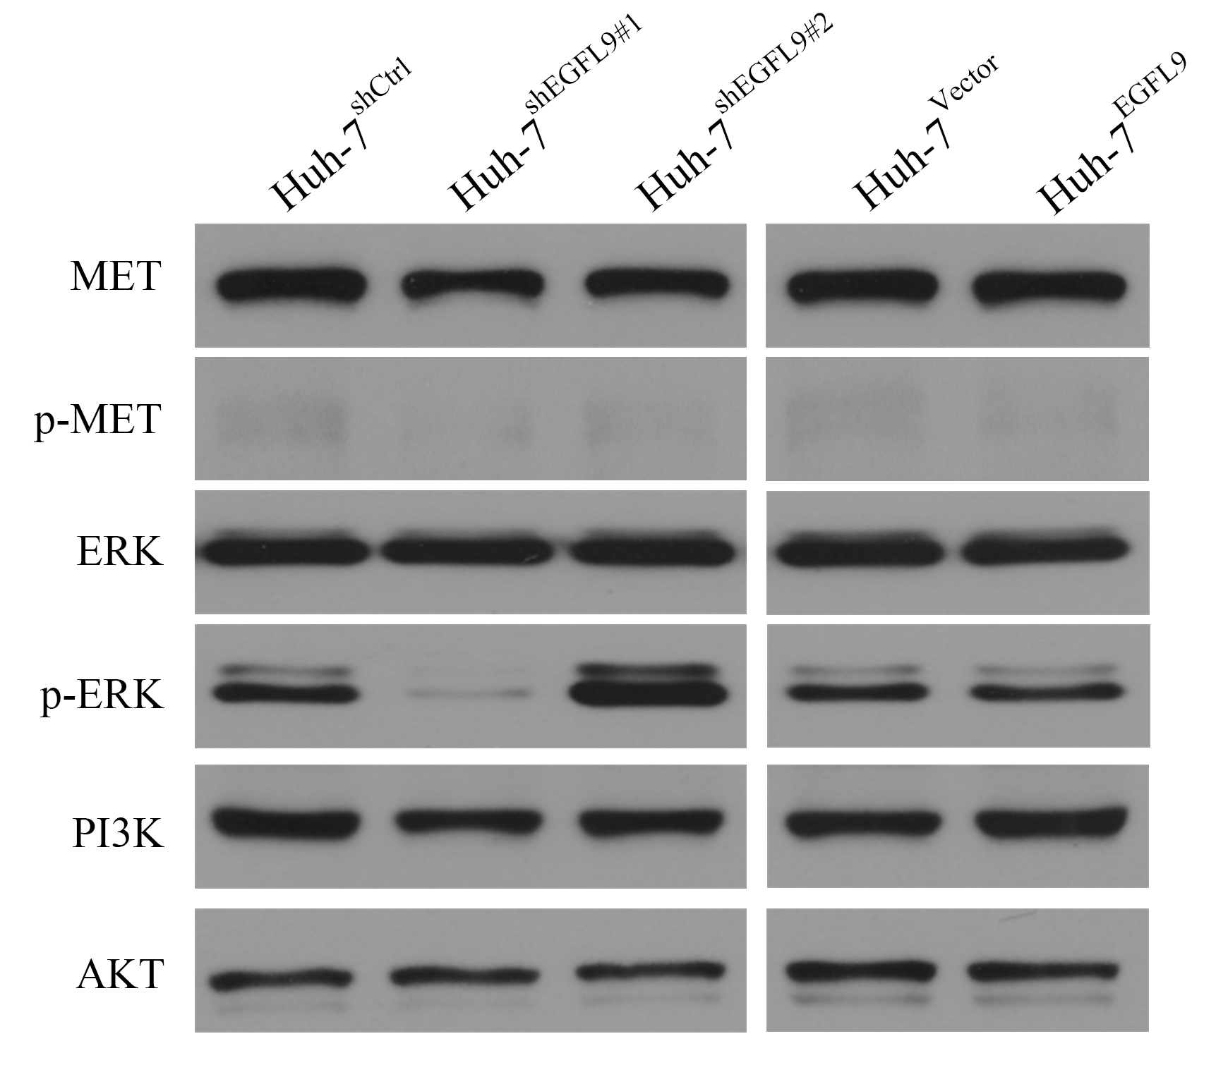
Supplementary Figure 1： Western blot results of signaling pathways after EGFL9 knockdown or overexpression in Huh-7 hepatocellular carcinoma (HCC) cell line.

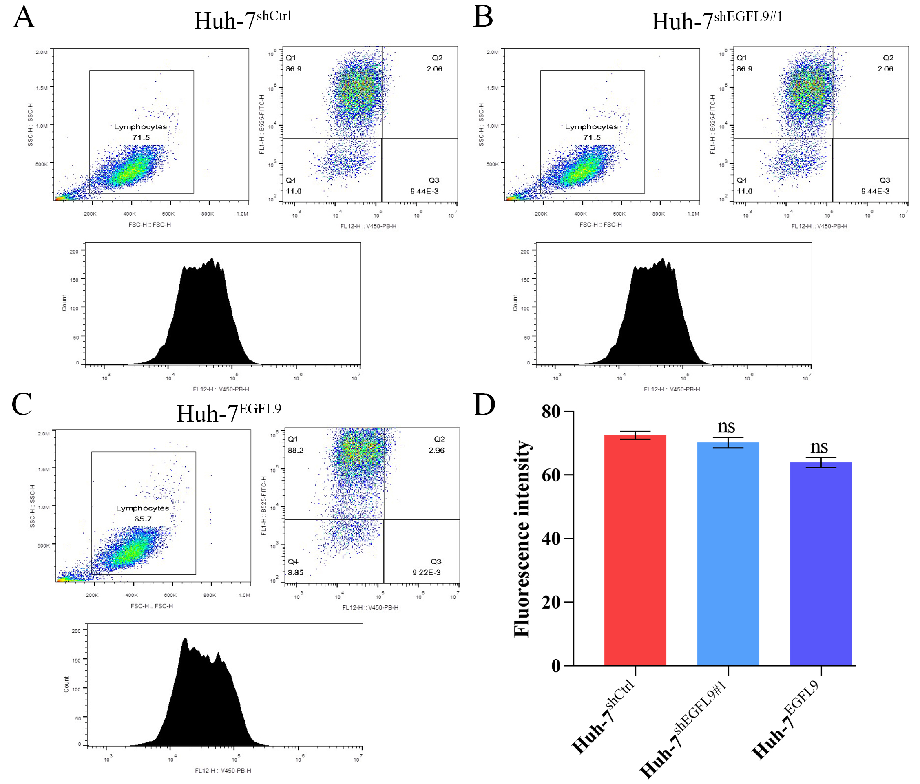
Supplementary Figure 2：Flow cytometry analysis of lipid droplet levels in Huh-7 hepatocellular carcinoma (HCC) cell line. A Lipid droplet level in Huh-7^{shCtrl} HCC cell line. B Lipid droplet level in Huh-7^{shEGFL9#1} HCC cell line. C Lipid droplet level in Huh-7^{EGFL9} HCC cell line. D Comparison of lipid droplet level (fluorescence intensity) among the three groups. ns, no significance compared with Huh-7^{shCtrl} HCC cell line.

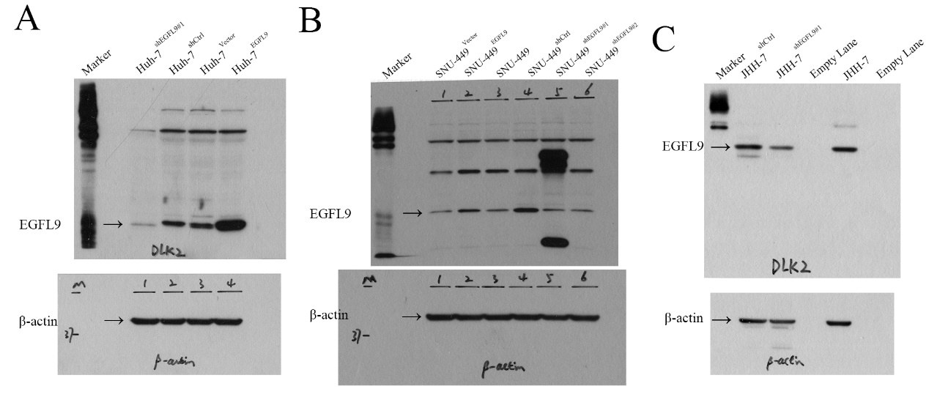
Supplementary Figure 3: A The intact gel band in the Fig. 2A; B The intact gel band in the Fig. 3A; C The intact gel band in the Fig. 4A.

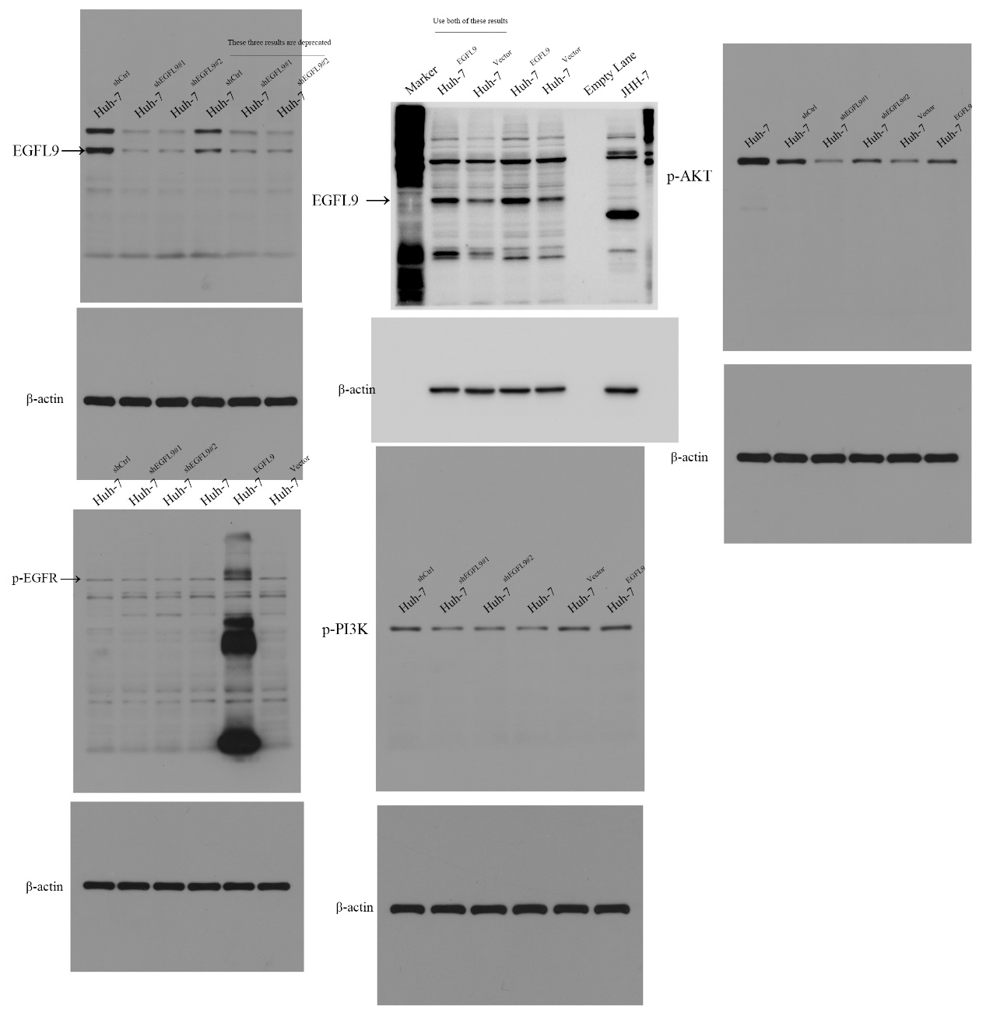
E
D
C
B
A
Supplementary Figure 4: The intact gel band in the Fig. 6A
Note: In panel B, the lanes for the Huh-7^{EGFL9} group and the Huh-7^{Vector} group appear in reversed order compared to their presentation in the main text. To maintain layout consistency, the corresponding gel bands were cropped and horizontally flipped.
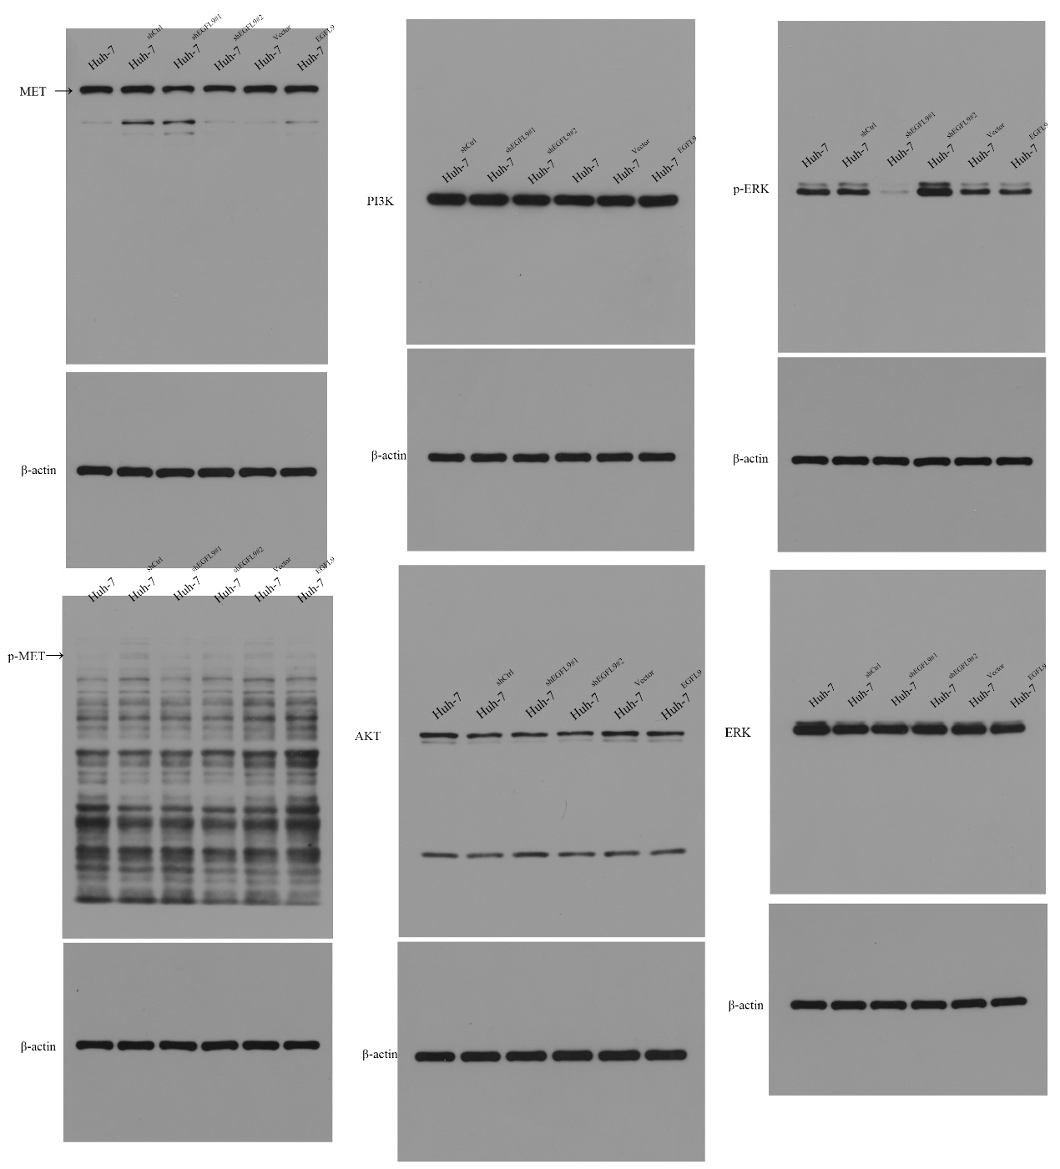
F
E
D
C
B
A
Supplementary Figure 5: The intact gel band in the Supplementary Figure 1.

