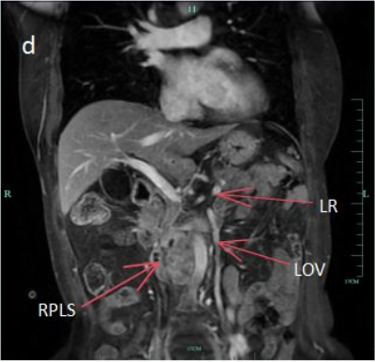
The intersection of the left ovarian vein and iliac vein can be seen in the original image (marked with a yellow arrow), but due to different layers, it may be a bit unclear. Image d can be seen in the original manuscript, and specific annotations can be referred to below.
Fig. 2 Patient preoperative imaging data. (a) CT with CTA revealed retroperitoneal smooth muscle sarcoma (RPLS) invading the inferior vena cava, with the left iliac vein connecting to the left ovarian vein (LOV) and left renal vein (LRV); (b) RPLS sparing the abdominal aorta/right kidney. (c) MRI confirmed LOV-LRV confluence without tumor invasion. (d) MRI revealed LOV extending into the pelvis, uninvolved by RPLS. The vascular pathways and tumor margins were clearly delineated across the imaging modalities.
For further presentation in imaging, the following images are added, which can be found in the supplementary materials. The following image shows preoperative enhanced CT, which shows the intersection of the left iliac vein and the left ovarian vein (marked by a yellow arrow).

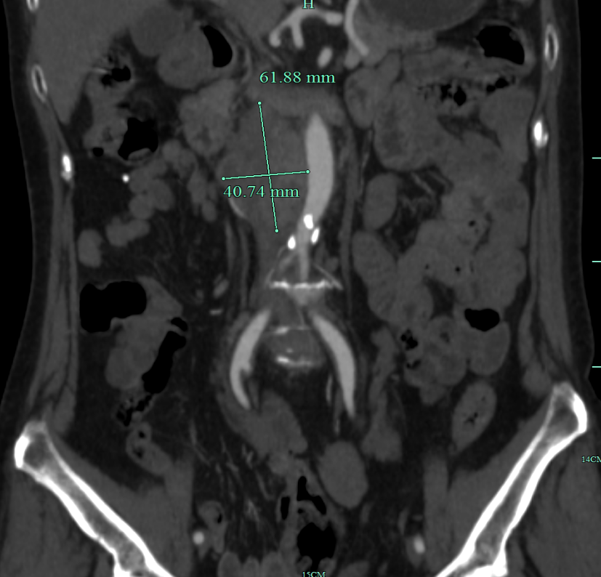
Preoperative enhanced CT scan
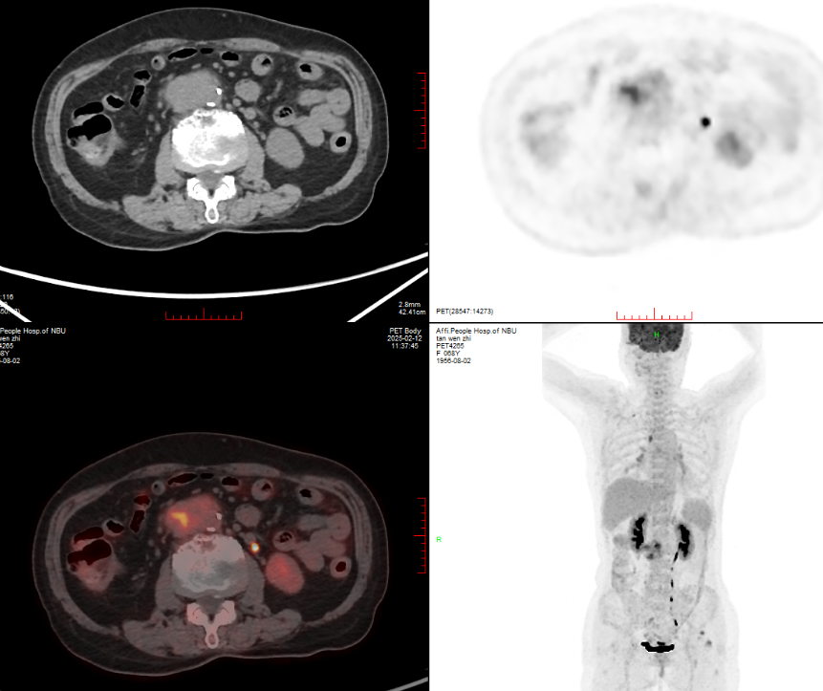

The above figure shows the preoperative PECT of the patient, which clearly shows that the right ovarian vein is not affected, thus confirming the surgical operation in the original text. As for the mention in the original text that “Even if the retroperitoneal leiomyosarcoma invades the left renal vein, reconstruction can still be performed using the unaffected right renal vein[2]”, it is an explanation of another method and is only for reference.

