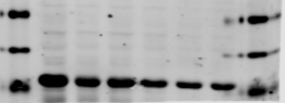
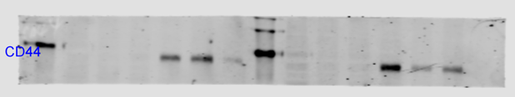
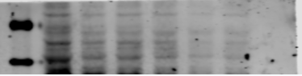
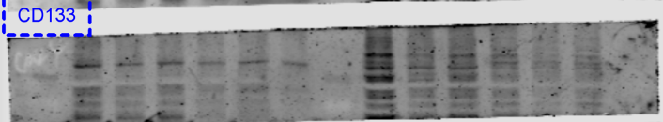
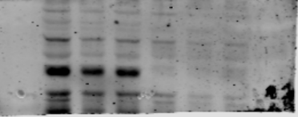
Figure S3
sicon
siSDC1-2
siSDC1-1
siSDC1-2
siSDC1-1
GAPDH
CD44
SOX2
CD133
NANOG
MCF-7
MDA-MB-231
sicon

