Supplementary
Table S 1 General information of training set and validation set
Factors | Training set (n=2084,%) | Validation set (n=894,%) | pª
Age |  |  | 0.86
＜40 | 404 (19.4) | 181 (20.2)
40-60 | 1188 (57.0) | 506 (56.6)
＞60 | 492 (23.6) | 207 (23.2)
Race |  |  | 0.64
Black | 430 (20.6) | 197 (22.0)
White | 1485 (71.3) | 622 (69.6)
Other | 169 (8.11) | 75 (8.4)
Grade |  |  | 0.82
Ⅰ | 10 (0.5) | 4 (0.5)
Ⅱ | 297 (14.3) | 135 (15.1)
Ⅲ | 1768 (84.8) | 753 (84.2)
Ⅳ | 9(0.4) | 2(0.2)
Laterality |  |  | 0.44
Right | 1036 (49.7) | 430 (48.1)
Left | 1048 (50.3) | 464 (51.9)
AJCC Stage |  |  | 0.41
Ⅰ | 211 (10.1) | 81 (9.1)
Ⅱ | 1203 (57.7) | 541 (60.5)
Ⅲ | 588 (28.2) | 233 (26.1)
Ⅳ | 82 (3.9) | 39 (4.4)
T |  |  | 0.53
1 | 353 (16.9) | 142 (15.9)
2 | 1147 (55.0) | 518 (57.9)
3 | 375 (18.0) | 153 (17.1)
4 | 209 (10.0) | 81 (9.1)
N |  |  | 0.16
0 | 926 (44.4) | 415 (46.4)
1 | 807 (38.7) | 334 (37.4)
2 | 193 (9.3) | 65 (7.3)
3 | 158 (7.6) | 80 (8.9)
M |  |  | 0.66
0 | 2002 (96.1) | 855 (95.6)
1 | 82 (3.9) | 39 (4.4)
Tumor Size(mm) |  |  | 0.08
10-30 | 985 (47.3) | 390 (43.6)
30-50 | 637 (30.6) | 315 (35.2)
50-70 | 290 (13.9) | 111 (12.4)
70-90 | 128 (6.1) | 63 (7.1)
90-100 | 44 (2.1) | 15 (1.7)
Surgery |  |  | 0.10
Breast-Conserving Surgery | 856 (41.1) | 368 (41.2)
Mastectomy | 1228 (58.9) | 526 (58.8)
Chemotherapy |  |  | 0.38
Systemic therapy before surgery | 1542 (74.0) | 683 (76.4)
Systemic therapy after surgery | 103 (4.9) | 40 (4.5)
Systemic therapy both before and after surgery | 439 (21.1) | 171 (19.1)
Radiation |  |  | 0.34
no | 787 (37.8) | 355 (39.7)
yes | 1297 (62.2) | 539 (60.3)
Pathological Response after Neoadjuvant Therapy |  |  | 0.18
pCR | 1018 (48.8) | 412 (46.1)
pPR | 864 (41.5) | 378 (42.3)
pNR | 202 (9.7) | 104 (11.6)
Status |  |  | 0.92
Alive | 1446 (69.4) | 618 (69.1)
Dead | 638 (30.6) | 276 (30.9)
- Pearson’s Chi-squared test; Fisher’s exact test
Table S 2 Comparison table of English abbreviations
Abbreviations | Full title
TNBC | Triple-Negative Breast Cancer
HER-2 | Human Epidermal Growth Factor Receptor 2
SEER | Surveillance, Epidemiology, and End Results
OS | Overall survival
C-index | Concordance index
ROC | Receiver Operating Characteristic curve
DCA | Decision Curve Analysis
AJCC | American Joint Committee on Cancer
AUC | Area under the curve
TNM | Tumor-node-metastasis
ER | Estrogen Receptor
PR | Progesterone Receptor
ICD-O-3 | International Classification of Diseases for Oncology , third edition
pCR | pathological Complete Response
pPR | pathological Partial Response
pNR | pathological No Response
HR | Hazard ratios
PD-L1 | Programmed Death-Ligand 1
TILs | Tumor-infiltrating lymphocyte levels

Table S 3 Quantitative calibration metrics of the nomogram model across timepoints
Time Point | Dataset | Calibration Intercept | Calibration Slope | E_avg* | E_max* | Predicted survival | Actual survival | 60% Threshold Difference*
1-year | Training | 0.000 | 1.122 | 0.006 | 0.009 | 0.894 | 0.887 | -0.007
3-year | Training | 0.0031 | 1.046 | 0.015 | 0.025 | 0.475 | 0.466 | -0.009
5-year | Training | 0.0051 | 1.026 | 0.015 | 0.033 | 0.637 | 0.626 | -0.011
1-year | Validation | 0.0011 | 1.483 | 0.013 | 0.031 | 0.913 | 0.882 | -0.031
3-year | Validation | 0.0041 | 1.003 | 0.011 | 0.017 | 0.737 | 0.742 | +0.005
5-year | Validation | 0.004 | 0.949 | 0.014 | 0.036 | 0.629 | 0.614 | -0.015
Note: *E_avg = mean absolute error between predicted probabilities and Kaplan-Meier estimates; E_max = maximum absolute error; 60% threshold difference calculated at point closest to 60% predicted survival probability. All error metrics are expressed in probability units and are below the clinically acceptable threshold of ±5%.

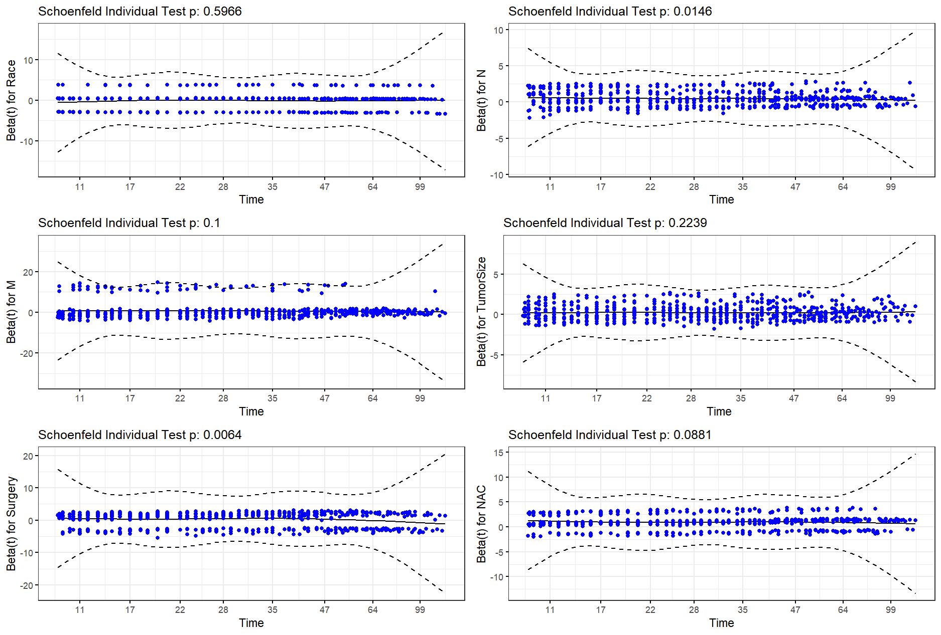
Figure S 1 Diagnostic Plots for Proportional Hazards Assumption (Initial Model)
Note: Schoenfeld residuals with smoothing splines are plotted against time for each variable in the initial, non-stratified Cox model. Non-horizontal lines and low p-values for 'N stage' and 'Surgery' indicate significant time-varying effects, constituting a violation of the proportional hazards assumption. This necessitated model stratification.
Table S 4 Proportional Hazards Assumption Test for the Initial Cox Model.
 | χ² | df | P
Race | 0.28 | 1 | 0.5966
N | 5.96 | 1 | 0.0146
M | 2.71 | 1 | 0.1000
TumorSize | 1.48 | 1 | 0.2239
Surgery | 7.44 | 1 | 0.0064
NAC | 2.91 | 1 | 0.0881
GLOBAL | 14.64 | 6 | 0.0233
Note: The proportional hazards assumption test revealed significant violations for N stage (p=0.0146) and surgical approach (p=0.0064), with a global test p-value of 0.023. Based on these findings, the final model incorporated stratification for these two variables. All other variables satisfied the proportional hazards assumption (p>0.05).
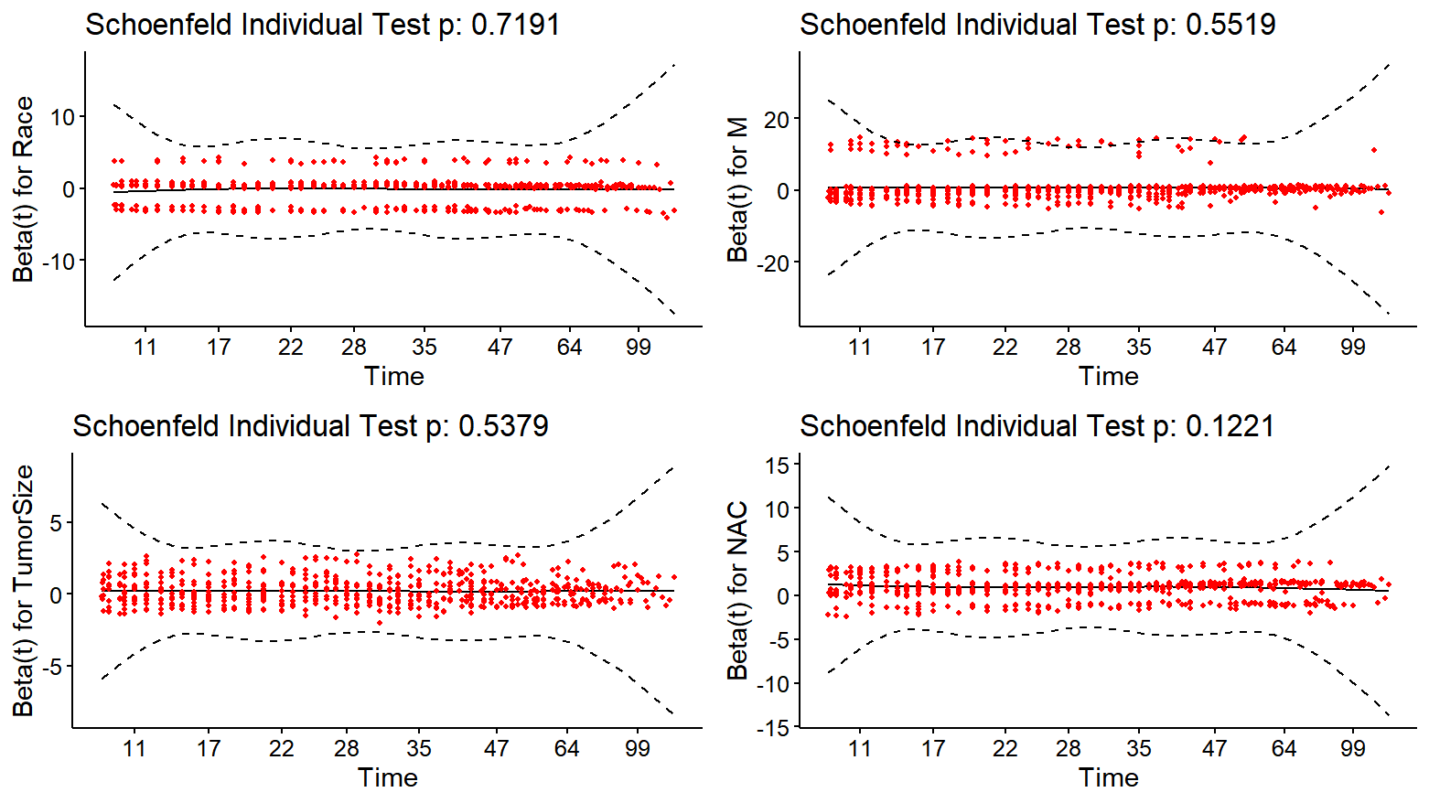
Figure S 2 Post-Stratification Proportional Hazards Validation
Note: Residual plots after stratification by N and Surgery. Horizontal patterns confirm proportional hazards assumption is met.
Table S 5 Proportional Hazards Assumption Test for the Final Stratified Cox Model.
 | χ² | df | P
Race | 0.129 | 1 | 0.72
M | 0.354 | 1 | 0.55
TumorSize | 0.379 | 1 | 0.54
NAC | 2.390 | 1 | 0.12
GLOBAL | 3.084 | 4 | 0.54
Note: Proportional hazards assumption testing for the final model stratified by N stage and surgical approach. The non-significant p-values for all covariates (Race, M stage, Tumor size, and Pathological response) and the global test (p=0.54) confirm that the proportional hazards assumption is satisfied after stratification, validating the statistical propriety of the final model.

