Supplementary Information
Discover Oncology

Unveiling the Role of Anoikis Resistance in Lung Squamous Cell Carcinoma: A Prognostic Model and Immune Microenvironment Insights

Dong Ou^{1,2}, HongPing Wang³, Yi Liu⁴, Jin Nie⁵, Daishun Liu^{1,6,7} *

¹Medical College of Soochow University, Suzhou 215000, China
²Department of Oncology, the Third Affiliated Hospital of Zunyi Medical University (the First People's Hospital of Zunyi), Zunyi 563000, China
³Bishan Hospital of Chongqing, Bishan hospital of Chongqing Medical University, Chongqing 402760, China
⁴Pulmonary and Critical Care Medicine. Xi Shui County People's Hospital, Guizhou, Zunyi 564600, China
⁵Pulmonary and Critical Care Medicine, Affiliated Hospital of Zunyi Medical University, Zunyi, Guizhou 563000, China
⁶Zunyi Medical University, Zunyi 563000, China
⁷ Department of Respiratory and Critical Care Medicine, Guizhou Provincial People’s Hospital, Guiyang, Guizhou, 550002, China

*Corresponding author: Daishun Liu
Email: ldslwtg@126.com

Supplementary Fig. S1 Overexpression of SDCBP primer sequence profile.

Supplementary Fig. S2 Differences in immunoregulatory genes between the high- and low-risk groups
(a) Immunosuppressive factors, (b) Immunostimulatory factors, (c) Chemokines, (d) Chemokine receptors, and (e) Immune regulatory factors

Supplementary Text 1 The gene editing including primer sequences:
>NM_005625.4:59-955 Homo sapiens syndecan binding protein (SDCBP), transcript variant 1, mRNA CDS: ATGTCTCTCTATCCATCTCTCGAAGACTTGAAGGTAGACAAAGTAATTCAGG CTCAAACTGCTTTTTCTGCAAACCCTGCCAATCCAGCAATTTTGTCAGAAG CTTCTGCTCCTATCCCTCACGATGGAAATCTCTATCCCAGACTGTATCCAGA GCTCTCTCAATACATGGGGCTGAGTTTAAATGAAGAAGAAATACGTGCAAA TGTGGCCGTGGTTTCTGGTGCACCACTTCAGGGGCAGTTGGTAGCAAGAC CTTCCAGTATAAACTATATGGTGGCTCCTGTAACTGGTAATGATGTTGGAATT CGTAGAGCAGAAATTAAGCAAGGGATTCGTGAAGTCATTTTGTGTAAGGAT CAAGATGGAAAAATTGGACTCAGGCTTAAATCAATAGATAATGGTATATTTG TTCAGCTAGTCCAGGCTAATTCTCCAGCCTCATTGGTTGGTCTGAGATTTGG GGACCAAGTACTTCAGATCAATGGTGAAAACTGTGCAGGATGGAGCTCTGA TAAAGCGCACAAGGTGCTCAAACAGGCTTTTGGAGAGAAGATTACCATGA CCATTCGTGACAGGCCCTTTGAACGGACGATTACCATGCATAAGGATAGCA CTGGACATGTTGGTTTTATCTTTAAAAATGGAAAAATAACATCCATAGTGAA AGATAGCTCTGCAGCCAGAAATGGTCTTCTCACGGAACATAACATCTGTGA AATCAATGGACAGAATGTCATTGGATTGAAGGACTCTCAAATTGCAGACAT ACTGTCAACATCTGGGACTGTAGTTACTATTACAATCATGCCTGCTTTTATCT TTGAACATATTATTAAGCGGATGGCACCAAGCATTATGAAAAGCCTAATGGA CCACACCATTCCTGAGGTTTAA

SDCBP F：CTCCAGCCTCATTGGTTGGT
SDCBP R：TTCAAAGGGCCTGTCACGAA

CT >NM_002953.4:161-2368 Homo sapiens ribosomal protein S6 kinase A1 (RPS6KA1), transcript variant 1, mRNA CDS： ATGCCGCTCGCCCAGCTCAAGGAGCCCTGGCCGCTCATGGAGCTAGTGCCT CTGGACCCGGAGAATGGACAGACCTCAGGGGAAGAAGCTGGACTTCAGC CGTCCAAGGATGAGGGCGTCCTCAAGGAGATCTCCATCACGCACCACGTC AAGGCTGGCTCTGAGAAGGCTGATCCATCCCATTTCGAGCTCCTCAAGGTT CTGGGCCAGGGATCCTTTGGCAAAGTCTTCCTGGTGCGGAAAGTCACCCG GCCTGACAGTGGGCACCTGTATGCTATGAAGGTGCTGAAGAAGGCAACGC TGAAAGTACGTGACCGCGTCCGGACCAAGATGGAGAGAGACATCCTGGCT GATGTAAATCACCCATTCGTGGTGAAGCTGCACTATGCCTTCCAGACCGAG GGCAAGCTCTATCTCATTCTGGACTTCCTGCGTGGTGGGGACCTCTTCACC
CGGCTCTCAAAAGAGGTGATGTTCACGGAGGAGGATGTGAAGTTTTACCT GGCTGAGCTGGCTCTGGGCCTGGATCACCTGCACAGCCTGGGTATCATTTA CAGAGACCTCAAGCCTGAGAACATCCTTCTGGATGAGGAGGGCCACATCA AACTCACTGACTTTGGCCTGAGCAAAGAGGCCATTGACCACGAGAAGAAG GCCTATTCTTTCTGCGGGACAGTGGAGTACATGGCCCCTGAGGTCGTCAAC CGCCAGGGCCACTCCCATAGTGCGGACTGGTGGTCCTATGGGGTGTTGATG TTTGAGATGCTGACGGGCTCCCTGCCCTTCCAGGGGAAGGACCGGAAGGA GACCATGACACTGATTCTGAAGGCGAAGCTAGGCATGCCCCAGTTTCTGAG CACTGAAGCCCAGAGCCTCTTGCGGGCCCTGTTCAAGCGGAATCCTGCCA ACCGGCTCGGCTCCGGCCCTGATGGGGCAGAGGAAATCAAGCGGCATGTC TTCTACTCCACCATTGACTGGAATAAGCTATACCGTCGTGAGATCAAGCCAC CCTTCAAGCCAGCAGTGGCTCAGCCTGATGACACCTTCTACTTTGACACCG AGTTCACGTCCCGCACACCCAAGGATTCCCCAGGCATCCCCCCCAGCGCTG GGGCCCATCAGCTGTTCCGGGGCTTCAGCTTCGTGGCCACCGGCCTGATGG AAGACGACGGCAAGCCTCGTGCCCCGCAGGCACCCCTGCACTCGGTGGTA CAGCAACTCCATGGGAAGAACCTGGTTTTTAGTGACGGCTACGTGGTAAAG GAGACAATTGGTGTGGGCTCCTACTCTGAGTGCAAGCGCTGTGTCCACAA GGCCACCAACATGGAGTATGCTGTCAAGGTCATTGATAAGAGCAAGCGGGA TCCTTCAGAAGAGATTGAGATTCTTCTGCGGTATGGCCAGCACCCCAACAT CATCACTCTGAAAGATGTGTATGATGATGGCAAACACGTGTACCTGGTGAC AGAGCTGATGCGGGGTGGGGAGCTGCTGGACAAGATCCTGCGGCAGAAGT TCTTCTCAGAGCGGGAGGCCAGCTTTGTCCTGCACACCATTGGCAAAACTG TGGAGTATCTGCACTCACAGGGGGTTGTGCACAGGGACCTGAAGCCCAGC AACATCCTGTATGTGGACGAGTCCGGGAATCCCGAGTGCCTGCGCATCTGT GACTTTGGTTTTGCCAAACAGCTGCGGGCTGAGAATGGGCTCCTCATGACA CCTTGCTACACAGCCAACTTTGTGGCGCCTGAGGTGCTGAAGCGCCAGGG CTACGATGAAGGCTGCGACATCTGGAGCCTGGGCATTCTGCTGTACACCAT GCTGGCAGGATATACTCCATTTGCCAACGGTCCCAGTGACACACCAGAGGA AATCCTAACCCGGATCGGCAGTGGGAAGTTTACCCTCAGTGGGGGAAATTG GAACACAGTTTCAGAGACAGCCAAGGACCTGGTGTCCAAGATGCTACACG TGGATCCCCACCAGCGCCTCACAGCTAAGCAGGTTCTGCAGCATCCATGGG TCACCCAGAAAGACAAGCTTCCCCAAAGCCAGCTGTCCCACCAGGACCTA CAGCTTGTGAAGGGAGCCATGGCTGCCACGTACTCCGCACTCAACAGCTC CAAGCCCACCCCCCAGCTGAAGCCCATCGAGTCATCCATCCTGGCCCAGCG GCGAGTGAGGAAGTTGCCATCCACCACCCTGTGA

RPS6KA1 F：CACAGCCAACTTTGTGGCG
RPS6KA1 R：CCCCCACTGAGGGTAAACTTC

ITGA3 >NM_002204.4 Homo sapiens integrin subunit alpha 3 (ITGA3), mRNA CDS: ATGGGCCCCGGCCCCAGCCGCGCGCCCCGCGCCCCACGCCTGATGCTCTGT GCGCTCGCCTTGATGGTGGCGGCCGGCGGCTGCGTCGTCTCCGCCTTCAAC CTGGATACCCGATTCCTGGTAGTGAAGGAGGCCGGGAACCCGGGCAGCCTC
TTCGGCTACTCGGTCGCCCTCCATCGGCAGACAGAGCGGCAGCAGCGCT ACCTGCTCCTGGCTGGTGCCCCCCGGGAGCTCGCTGTGCCCGATGGCTACA CCAACCGGACTGGTGCTGTGTACCTGTGCCCACTCACTGCCCACAAGGATG ACTGTGAGCGGATGAACATCACAGTGAAAAATGACCCTGGCCATCACATTA TTGAGGACATGTGGCTTGGAGTGACTGTGGCCAGCCAGGGCCCTGCAGGC AGAGTTCTGGTCTGTGCCCACCGCTACACCCAGGTGCTGTGGTCAGGGTCA GAAGACCAGCGGCGCATGGTGGGCAAGTGCTACGTGCGAGGCAATGACCT AGAGCTGGACTCCAGTGATGACTGGCAGACCTACCACAACGAGATGTGCA ATAGCAACACAGACTACCTGGAGACGGGCATGTGCCAGCTGGGCACCAGC GGTGGCTTCACCCAGAACACTGTGTACTTCGGCGCCCCCGGTGCCTACAAC TGGAAAGGAAACAGCTACATGATTCAGCGCAAGGAGTGGGACTTATCTGA GTATAGTTACAAGGACCCAGAGGACCAAGGAAACCTCTATATTGGGTACAC GATGCAGGTAGGCAGCTTCATCCTGCACCCCAAAAACATCACCATTGTGAC AGGTGCCCCACGGCACCGACATATGGGCGCGGTGTTCTTGCTGAGCCAGG AGGCAGGCGGAGACCTGCGGAGGAGGCAGGTGCTGGAGGGCTCGCAGGT GGGCGCCTATTTTGGCAGCGCCATTGCCCTGGCAGACCTGAACAATGATGG GTGGCAGGACCTCCTGGTGGGCGCCCCCTACTACTTCGAGAGGAAAGAGG AAGTAGGGGGTGCCATCTATGTCTTCATGAACCAGGCGGGAACCTCCTTCC CTGCTCACCCCTCACTCCTTCTTCATGGCCCCAGTGGCTCTGCCTTTGGTTT ATCTGTGGCCAGCATTGGTGACATCAACCAGGATGGATTTCAGGATATTGCT GTGGGAGCTCCGTTTGAAGGCTTGGGCAAAGTGTACATCTATCACAGTAGC TCTAAGGGGCTCCTTAGACAGCCCCAGCAGGTAATCCATGGAGAGAAGCT GGGACTGCCTGGGTTGGCCACCTTCGGCTATTCCCTCAGTGGGCAGATGGA TGTGGATGAGAACTTCTACCCAGACCTTCTAGTGGGAAGCCTGTCAGACCA CATTGTGCTGCTGCGGGCCCGGCCCGTCATCAACATCGTCCACAAGACCTT GGTGCCCAGGCCAGCTGTGCTGGACCCTGCACTTTGCACGGCCACCTCTTG TGTGCAAGTGGAGCTGTGCTTTGCTTACAACCAGAGTGCCGGGAACCCCA ACTACAGGCGAAACATCACCCTGGCCTACACTCTGGAGGCTGACAGGGAC CGCCGGCCGCCCCGGCTCCGCTTTGCCGGCAGTGAGTCCGCTGTCTTCCAC GGCTTCTTCTCCATGCCCGAGATGCGCTGCCAGAAGCTGGAGCTGCTCCTG ATGGACAACCTCCGTGACAAACTCCGCCCCATCATCATCTCCATGAACTACT CTTTACCTTTGCGGATGCCCGATCGCCCCCGGCTGGGGCTGCGGTCCCTGG ACGCCTACCCGATCCTCAACCAGGCACAGGCTCTGGAGAACCACACTGAG GTCCAGTTCCAGAAGGAGTGCGGGCCTGACAACAAGTGTGAGAGCAACTT GCAGATGCGGGCAGCCTTCGTGTCAGAGCAGCAGCAGAAGCTGAGCAGG CTCCAGTACAGCAGAGACGTCCGGAAATTGCTCCTGAGCATCAACGTGAC GAACACCCGGACCTCGGAGCGCTCCGGGGAGGACGCCCACGAGGCGCTG CTCACCCTGGTGGTGCCTCCCGCCCTGCTGCTGTCCTCAGTGCGCCCCCCC GGGGCCTGCCAAGCTAATGAGACCATCTTTTGCGAGCTGGGGAACCCCTTC AAACGGAACCAGAGGATGGAGCTGCTCATCGCCTTTGAGGTCATCGGGGT GACCCTGCACACAAGGGACCTTCAGGTGCAGCTGCAGCTCTCCACGTCGA GTCACCAGGACAACCTGTGGCCCATGATCCTCACTCTGCTGGTGGACTATA CACTCCAGACCTCGCTTAGCATGGTAAATCACCGGCTACAAAGCTTCTTTG GGGGGACAGTGATGGGTGAGTCTGGCATGAAAACTGTGGAGGATGTAGGA
AGCCCCCTCAAGTATGAATTCCAGGTGGGCCCAATGGGGGAGGGGCTGGT GGGCCTGGGGACCCTGGTCCTAGGTCTGGAGTGGCCCTACGAAGTCAGCA ATGGCAAGTGGCTGCTGTATCCCACGGAGATCACCGTCCATGGCAATGGGT CCTGGCCCTGCCGACCACCTGGAGACCTTATCAACCCTCTCAACCTCACTC TTTCTGACCCTGGGGACAGGCCATCATCCCCACAGCGCAGGCGGCGACAG CTGGATCCAGGGGGAGGCCAGGGCCCCCCACCTGTCACTCTGGCTGCTGC CAAAAAAGCCAAGTCTGAGACTGTGCTGACCTGTGCCACAGGGCGTGCCC ACTGTGTGTGGCTAGAGTGCCCCATCCCTGATGCCCCCGTTGTCACCAACG TGACTGTGAAGGCACGAGTGTGGAACAGCACCTTCATCGAGGATTACAGA GACTTTGACCGAGTCCGGGTAAATGGCTGGGCTACCCTATTCCTCCGAACC AGCATCCCCACCATCAACATGGAGAACAAGACCACGTGGTTCTCTGTGGA CATTGACTCGGAGCTGGTGGAGGAGCTGCCGGCCGAAATCGAGCTGTGGC TGGTGCTGGTGGCCGTGGGTGCAGGGCTGCTGCTGCTGGGGCTGATCATCC TCCTGCTGTGGAAGTGCGGCTTCTTCAAGCGAGCCCGCACTCGCGCCCTGT ATGAAGCTAAGAGGCAGAAGGCGGAGATGAAGAGCCAGCCGTCAGAGAC AGAGAGGCTGACCGACGACTACTGA

ITGA3 F：GGGACAGTGATGGGTGAGTC
ITGA3 R：ATACAGCAGCCACTTGCCAT

Supplementary Text 2 Construction Workflow for SDCBP Overexpression Plasmid
1、Vector/Backbone Specifications
Vector Name: pcDNA3.1(+)
Promoter: CMV promoter (with downstream CMV enhancer)
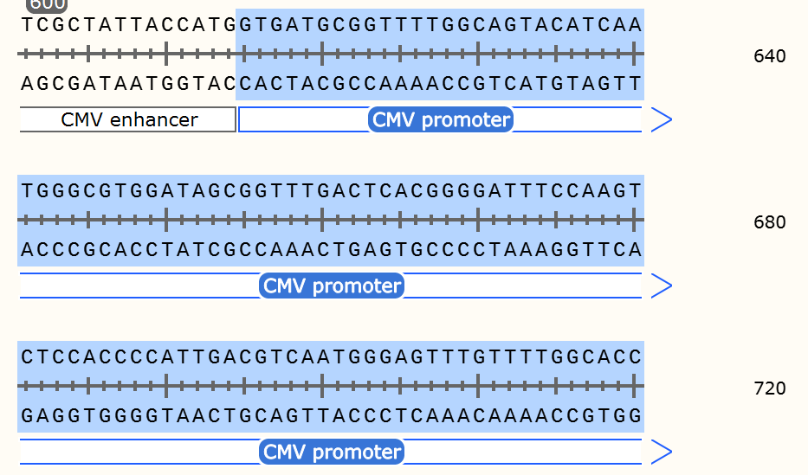
Tag: Tag-free
Selectable marker (resistance gene): Ampicillin resistance gene.
bGH poly(A) signal: Efficiently and accurately terminates transcription and adds a poly(A) tail to newly synthesized mRNA.
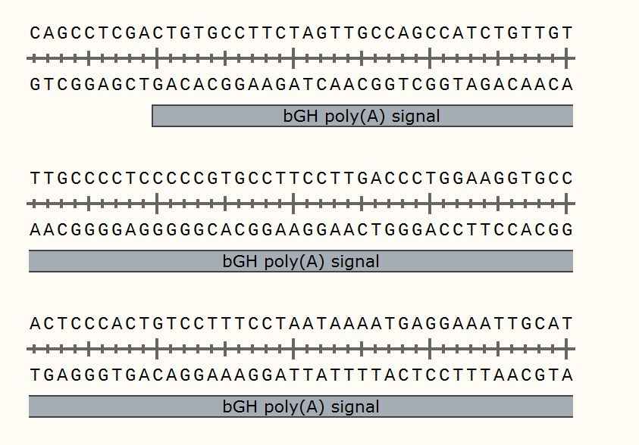
Ori: E. coli replication origin
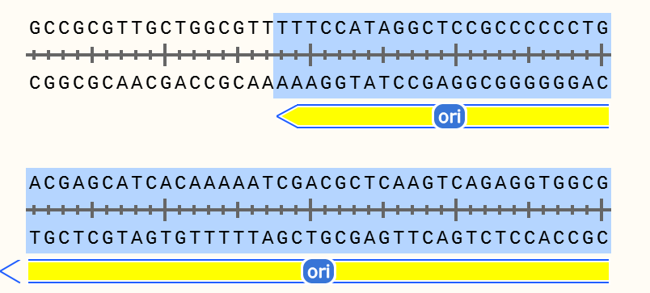
2. Insertion sequence and length
Insertion of gene name: SDCBP
Sequence length: 897 bp
Note: The insertion sequence is located between the HindIII and EcoRI restriction enzyme sites.
3. Restriction Enzyme Sites and Assembly Strategies
Cloning strategy: Double digestion - Homologous recombination
The used restriction sites:
Upstream (5' end): HindIII - Recognition sequence: 5'-AAGCTT-3'
Downstream (3' end): EcoRI - Recognition sequence: 5'-GAATTC-3'
Assembly process:
Plasmid vector preparation: Perform double digestion of the empty backbone vector using HindIII and EcoRI enzymes to generate compatible sticky ends. Purify and recover the linearized vector fragments by gel electrophoresis to prevent vector self-ligation.
Preparation of the inserted fragment (target gene):
Scheme A (PCR amplification): Use F/R primers and conduct PCR to amplify the target gene from the template.
Enzymatic digestion: Perform double enzymatic digestion on the PCR-purified product using the same HindIII and EcoRI enzymes.
Recombination: Mix the purified vector backbone and the inserted fragment at a certain molar ratio (1:3), add the homologous recombination enzyme, and perform the recombination reaction at 50℃ for 15 minutes.
Transformation and Screening: The ligated products are transformed into competent cells (DH5α), and then plated on plates containing the corresponding antibiotic (Amp+). Single colonies are picked and subjected to colony PCR verification.
Sequence verification: The accuracy of the inserted sequence has been confirmed through DNA sequencing.
4. Primer Design
In order to amplify your target gene using the PCR method and introduce the required restriction enzyme sites at both ends, a pair of specific primers needs to be designed.
Upstream Primer:
Sequence structure: 5' - Homologous arm 15bp + [HindIII site] + [Genetic specific sequence] - 3'
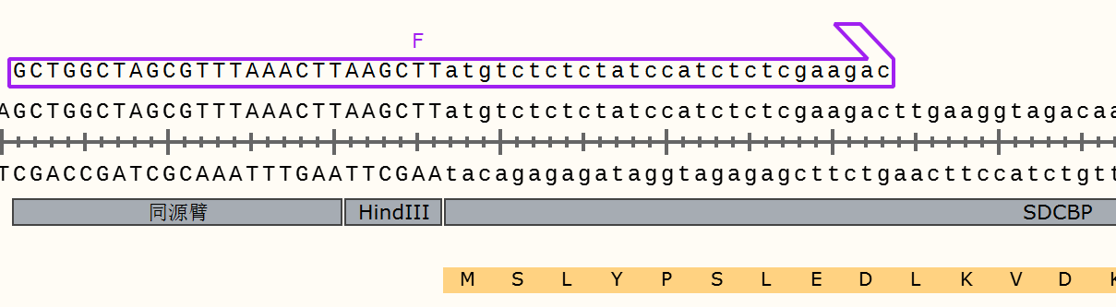
AAGCTT is the recognition site of HindIII.
ATG is the start codon, ensuring the correct reading frame.
Downstream primer (Reverse Primer):
Sequence structure: 5' - Homologous arm 15bp + [EcoRI site] + [Genespecific reverse complementary sequence] - 3'
