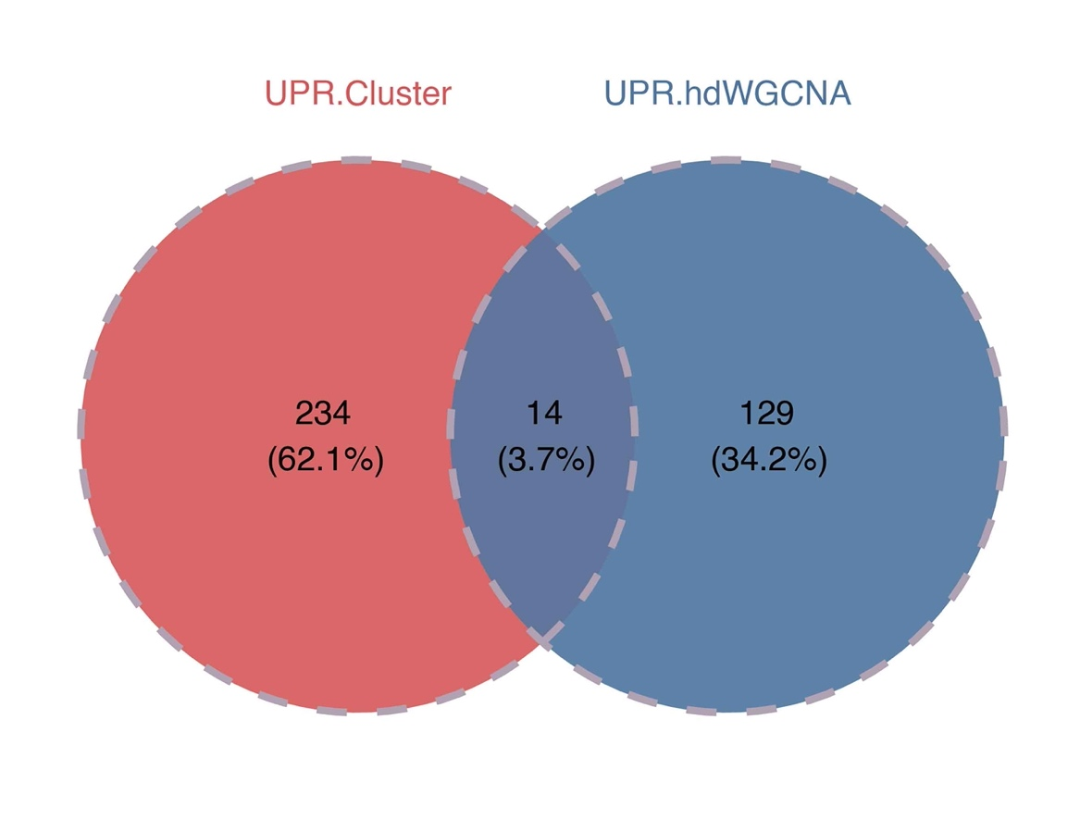
Figure S1. Venn plot showing the intersected genes between UPR-related clusters-based DEGs and hdWGCNA-derived module genes.
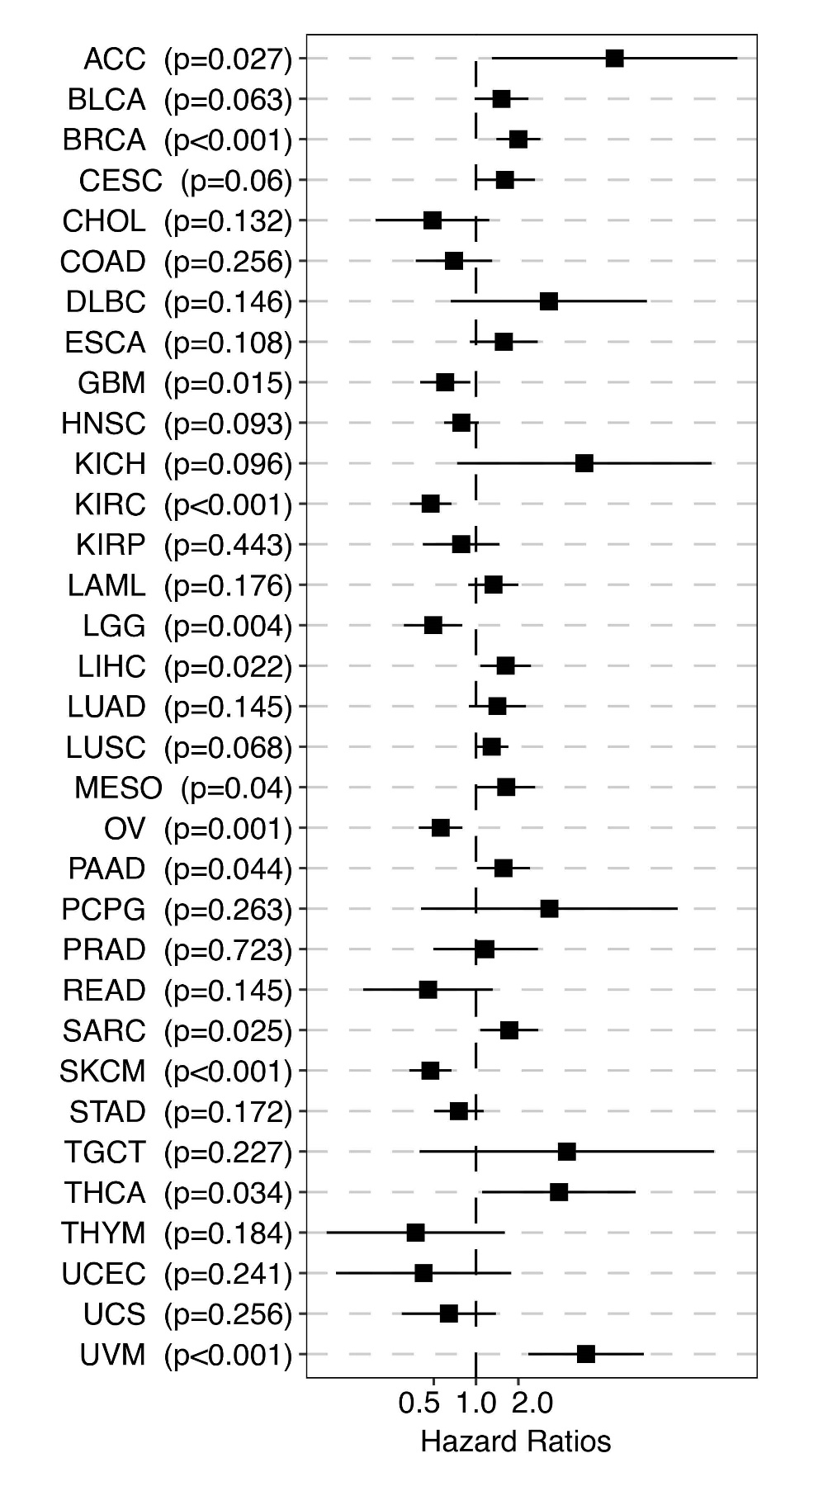
Figure S2. Pancancer role of KIF5B.

