Table S1. Univariate logistic regression results.

Characteristics | Estimate | SE | Z-value | P-value | Odds Ratio (OR) | Lower  (95% CI) | Upper  (95% CI)
PCA3 | -0.24189 | 0.04567 | -5.297 | 1.18e-07 | 0.79 | 0.72 | 0.86
Age | 0.05493 | 0.01640 | 3.349 | 0.00081 | 1.06 | 1.02 | 1.09
Serum PSA | 0.10009 | 0.04206 | 2.380 | 0.01731 | 1.11 | 1.02 | 1.2
(T2 vs. T1) | 0.3744 | 0.2694 | 1.390 | 0.165 | 1.45 | 0.86 | 2.47
(T3 vs. T1) | 2.1162 | 0.4442 | 4.764 | 1.90e-06 | 8.30 | 3.47 | 19.82

Table S2. Multivariate logistic regression results.
Characteristics | Estimate | SE | Z-value | P-value | Odds Ratio  (OR) | Lower  (95% CI) | Upper  (95% CI)
PCA3 | -0.20640 | 0.05614 | -3.676 | 0.000237 | 0.81 | 0.73 | 0.91
Age | 0.05892 | 0.02023 | 2.913 | 0.003585 | 1.06 | 1.02 | 1.1
Serum PSA | 0.10443 | 0.06048 | 1.727 | 0.084211 | 1.11 | 0.99 | 1.25
T classification
(T2 vs. T1) | 0.15961 | 0.28570 | 0.559 | 0.576391 | 1.17 | 0.67 | 2.05
(T3 vs. T1) | 1.65640 | 0.45331 | 3.654 | 0.000258 | 5.24 | 2.16 | 12.74

Table S3. Primer sequences
Gene | F | R
TFR | ACCATTGTCATATACCCGGTTCA | CAATAGCCCAAGTAGCCAATCAT
GAPDH | GGAGCGAGATCCCTCCAAAAT | GGCTGTTGTCATACTTCTCATGG

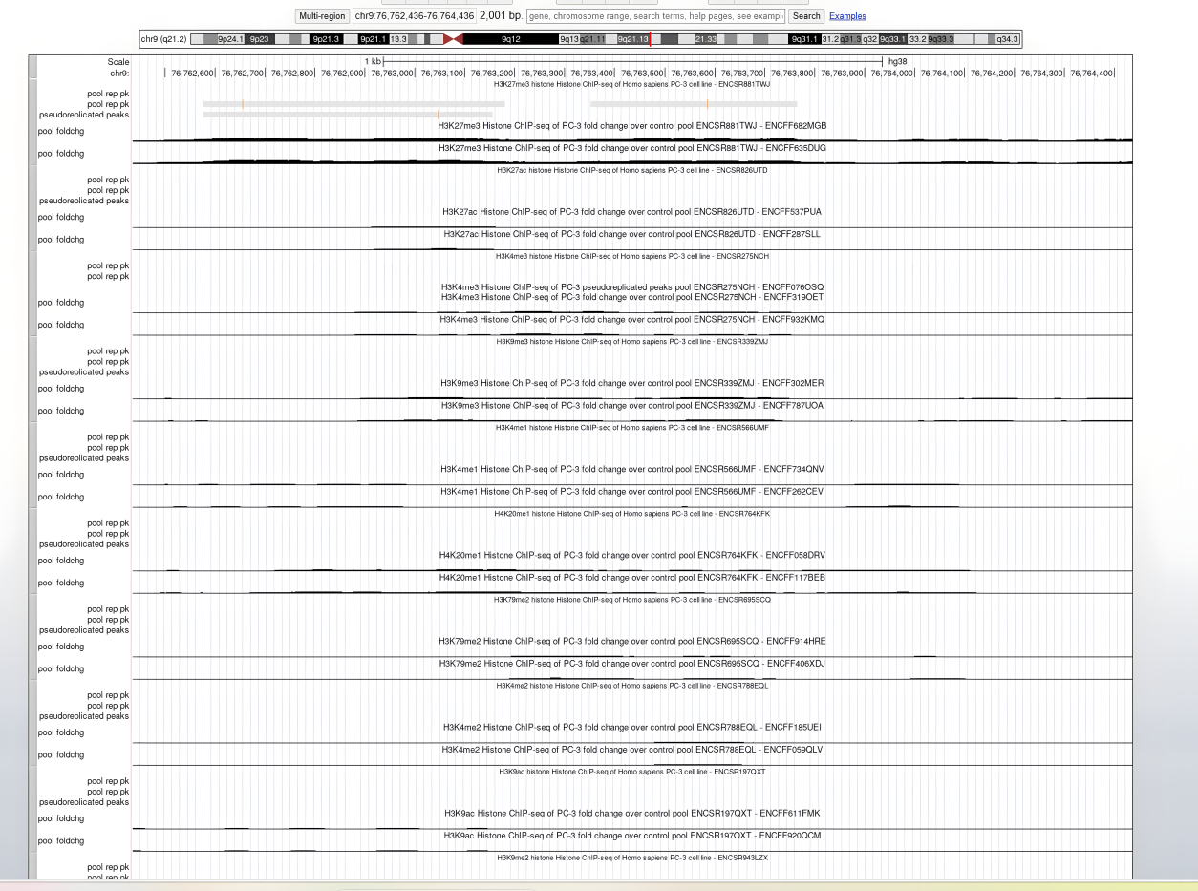

Figure S1. Epigenetic modification of PCA3 promoter in PC3 cell.

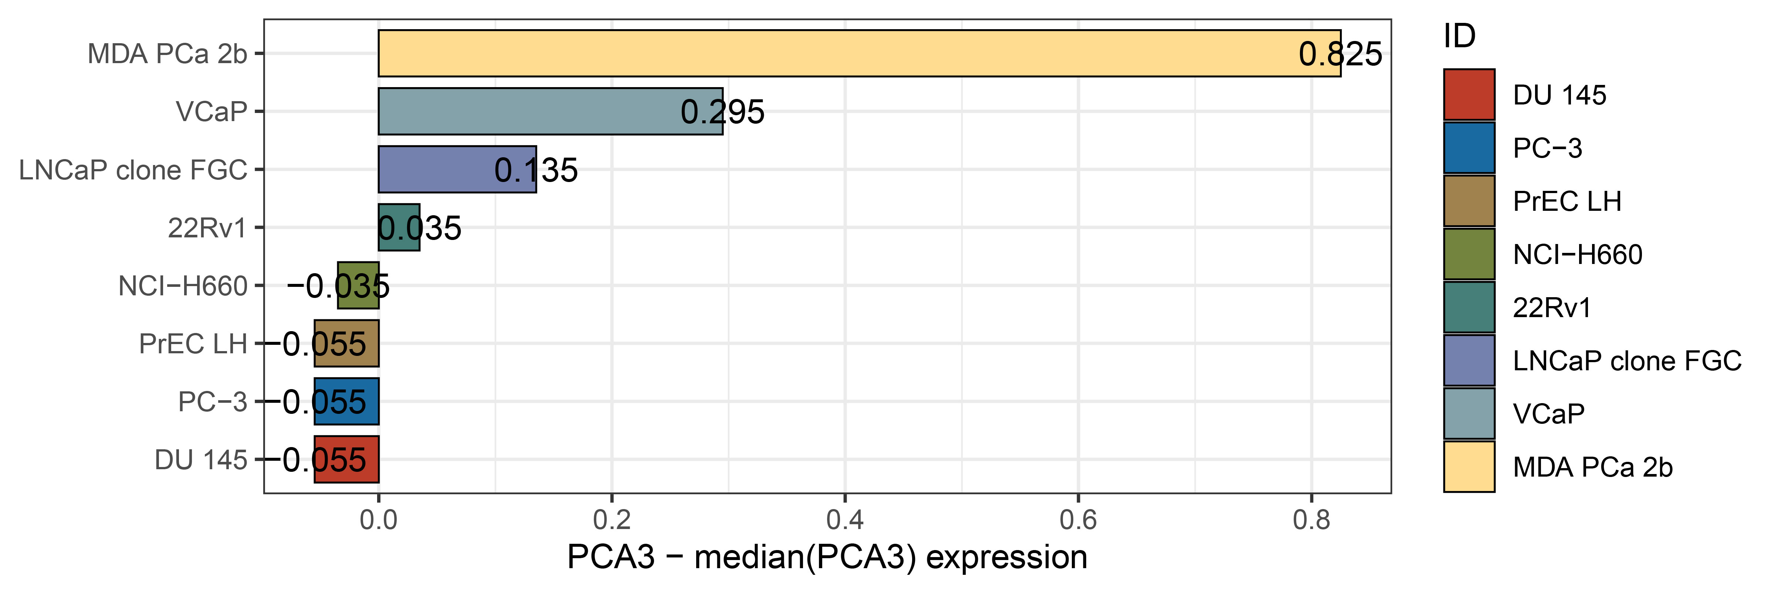
Figure S2. PCA3 expression in different prostate cancer cell lines.

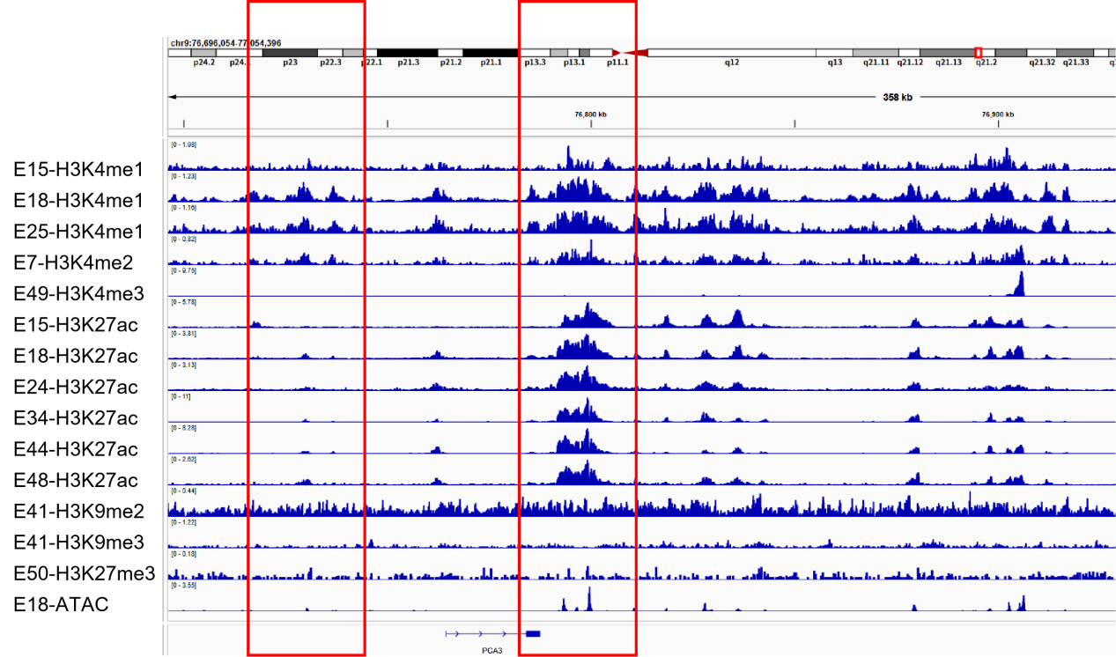
Figure S3. Epigenetic modification of PCA3 promoter in LNCap cell.

