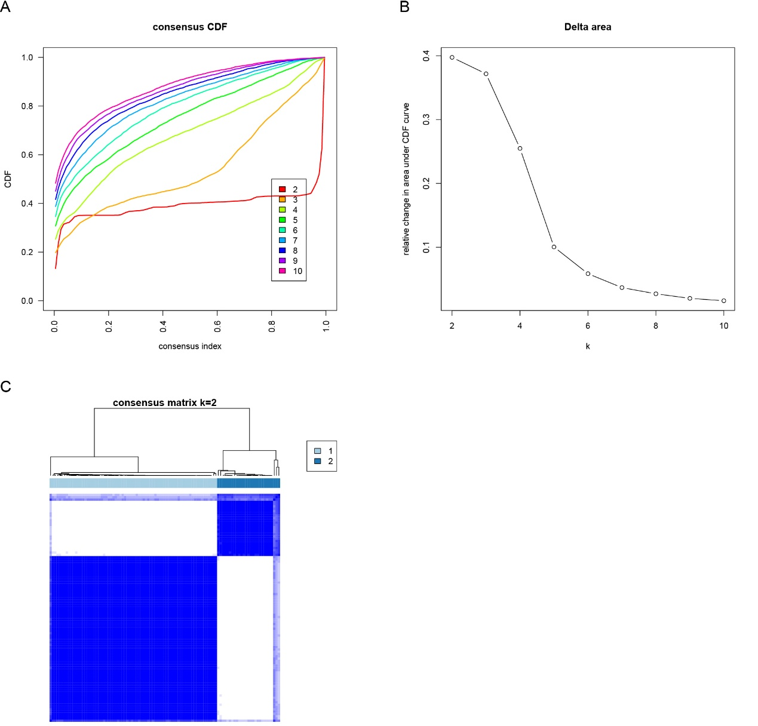
Figure S1. Consensus clustering based on differential methylation values of methylation-driven genes.
(A) Consensus cumulative distribution function (CDF) plot. (B) Delta area plot. (C) Consensus matrix heatmap for k = 2.
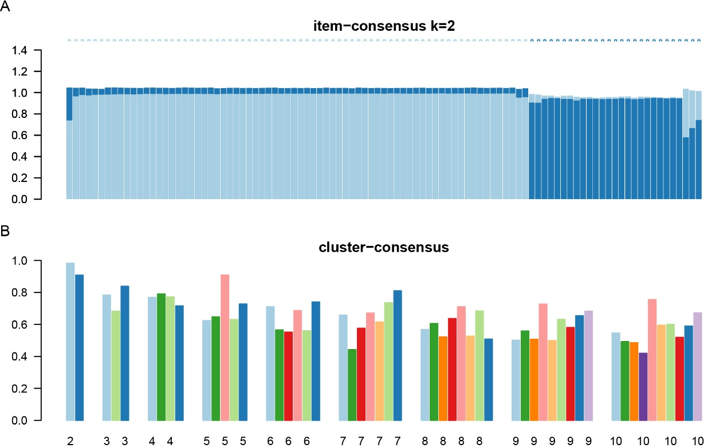
Figure S2. Cluster-consensus and item-consensus analyses.
(A) Item-consensus plot for k = 2. (B) Cluster-consensus values across k.
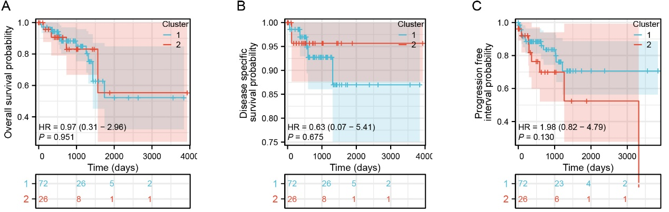
Figure S3. Survival analysis of the two methylation-based subtypes.
Kaplan–Meier curves comparing cluster 1 versus cluster 2 for (A) overall survival, (B) disease-specific survival, and (C) progression-free interval.
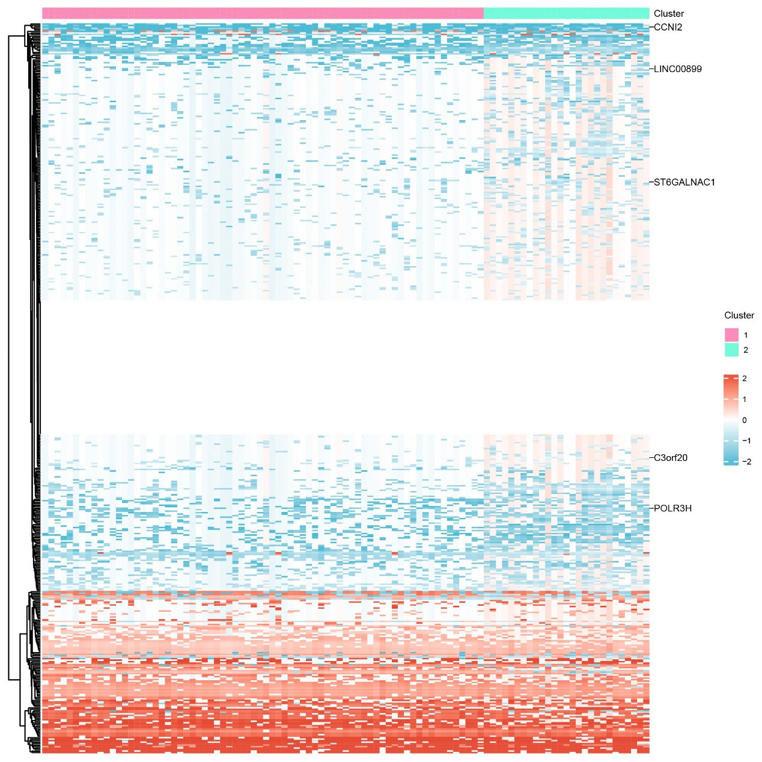
Figure S4. Heatmap of differential methylation values stratified by clusters.

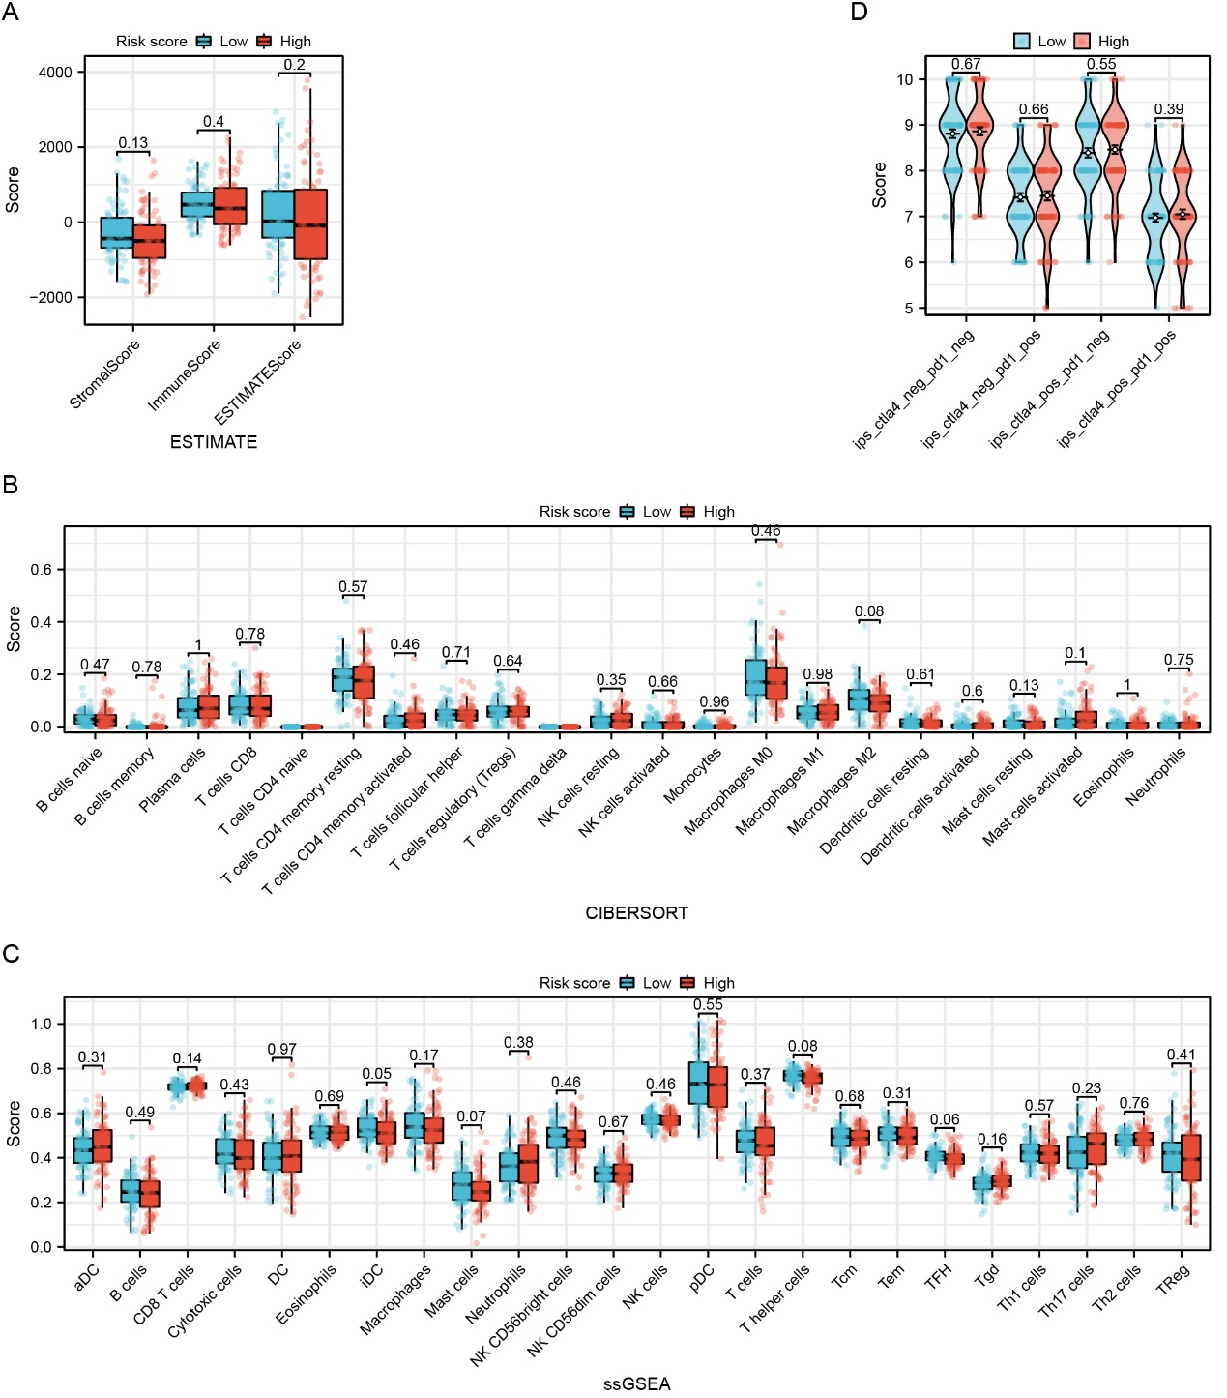
Figure S5. Tumor immune microenvironment characterization.
(A) ESTIMATE immune/stromal/estimate scores. (B) CIBERSORT immune cell proportions. (C) ssGSEA immune signatures. (D) Immunophenoscore (IPS) by predicted checkpoint response categories.

