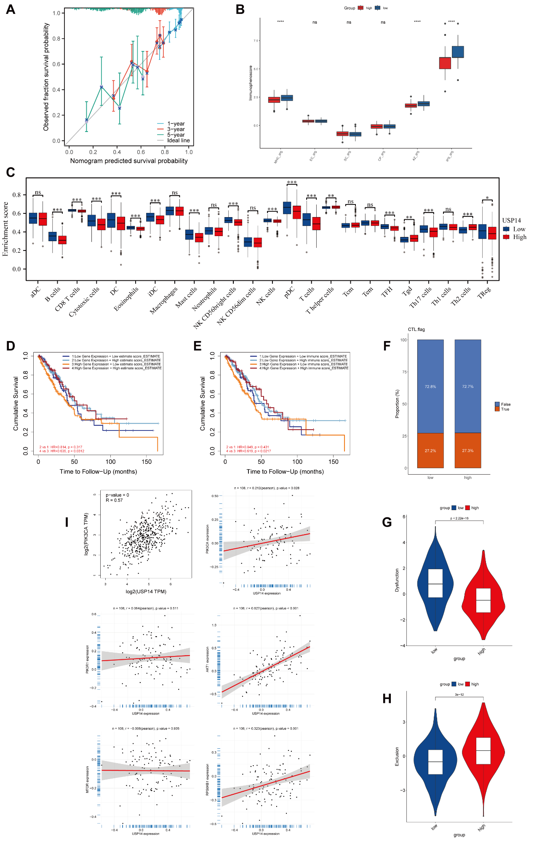

Supplementary Figure 1. (A) Calibration curve for the nomogram model showing the consistency between the predicted and actually observed 1-, 3-, and 5-year survival probability. (B) Immunophenotype (IPS) scores of the high expression group vs. the low expression group of USP14 in TCGA database. (C) Barplot shows the proportion of 24 kinds of TICs of the high expression group vs. the low expression group of USP14 in the TCGA-LUAD database by ssGSEA algorithm. (D, E) OS analysis for patients grouped by USP14 expression levels and Immune, Estimate scores in TCGA database. (F-H) The comparison of CTL.flag (F), Dysfunction scores (G), Exclusion scores (H) between the low expression and high expression group of USP14. (I) Correlation analysis between USP14 expression and PIK3CA through GEPIA, and correlation analysis between USP14 expression and PIK3CA, PIK3R1, AKT1, MTOR, and RPS6KB1 in Academia Sinica LUAD-100 Proteome. MHC, MHC molecules; CP, Checkpoints/Immunomodulators; EC, Effector cells; SC, Suppressor cells; AZ, Antigen presentation / T-cell homing.

