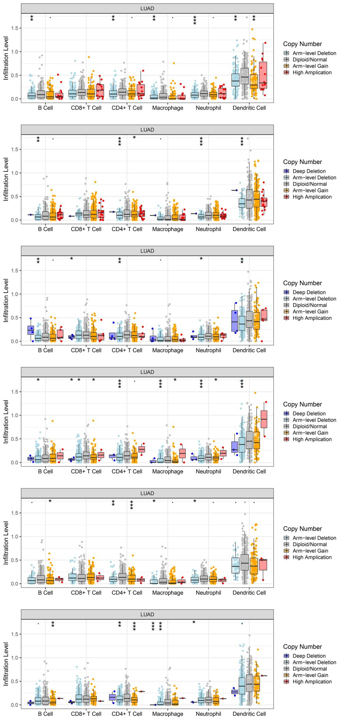
Figure S1. The correlation between SCNA of the XRCC family members and immune infiltration in LUAD.

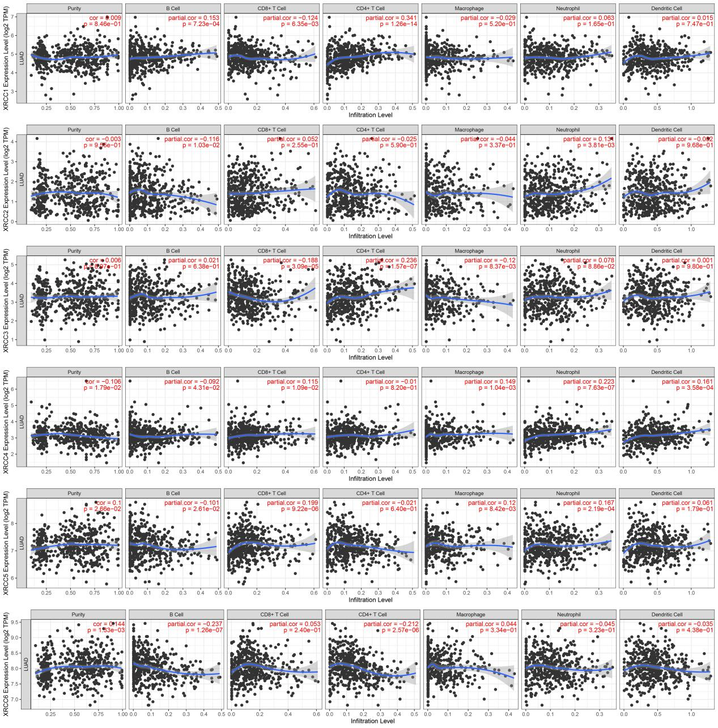
Figure S2. The correlation between the expression of XRCC family members and immune cell infiltration in LUAD.

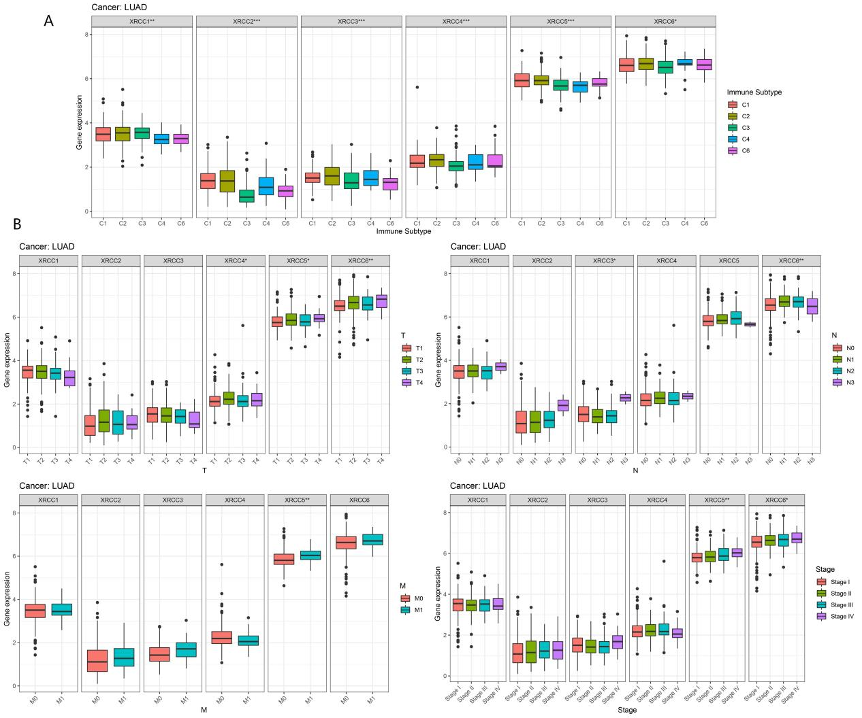
Figure S3. The role of XRCC family in LUAD progression. (A) Differential expression of XRCC family members in different LUAD immune subtypes. (B) The correlation between XRCC family and clinical characteristics of LUAD.

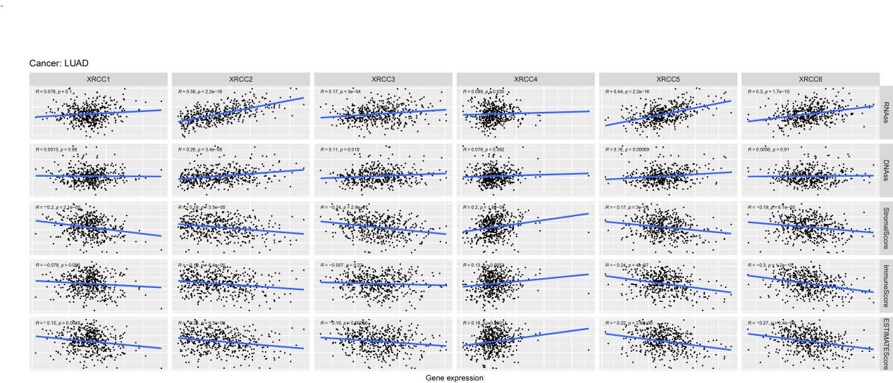
Figure S4. The effect of XRCC family on tumor stemness and immune microenvironment in LUAD.

