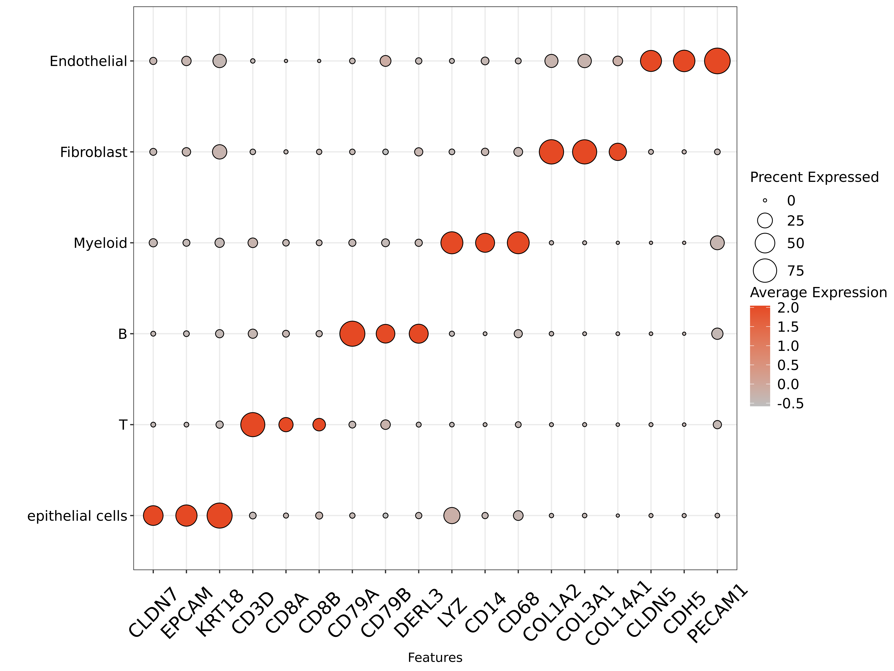
Supplementary Figure 1. Expression of marker genes for the six major cell populations.
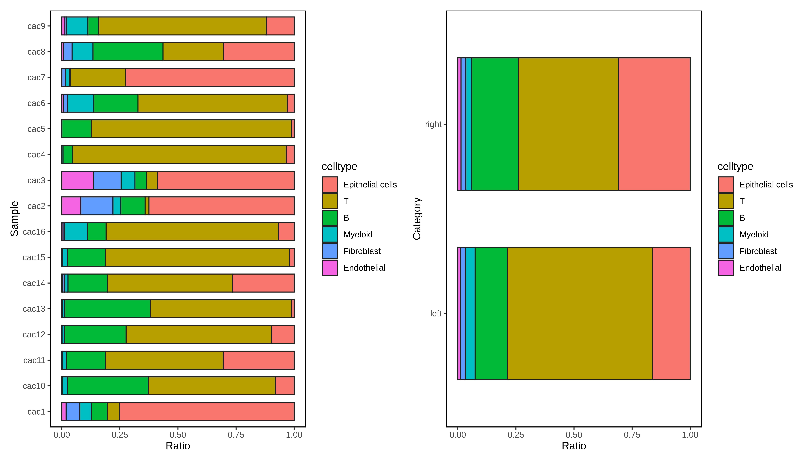
Supplementary Figure 2. The proportions of the six main cell populations in RCRC and LCRC, as well as in individual patient samples.
Supplementary Figure 3. Results of the inferred developmental trajectories of tumor cell subpopulations.
Supplementary Figure 4. The validation results for the MTRNR2L8 gene using TCGA data.
Supplementary Figure 5. The qPCR validation results of the MTRNR2L8 gene based on tumor samples from local CRC patients.
Supplementary Figure 6. GO and KEGG enrichment results for genes specifically expressed in the CD8-EFFECTOR 3 subpopulation.
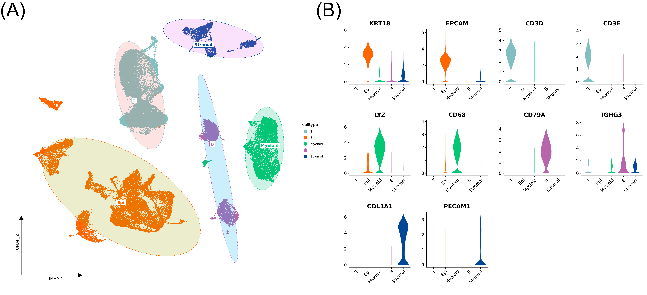
Supplementary Figure 7. The preliminary dimensionality reduction and clustering results of the single-cell transcriptomic data from the validation cohort.
Supplementary Figure 8. The validation results of the proportional differences of the CD8-EFFECTOR 3 subpopulation between LCRC and RCRC.
Supplementary Figure 9. Overall differential genes between T cells in RCRC and LCRC, along with the enrichment results for these genes.
Supplementary Figure 10. Differences in Myeloid subpopulations between LCRC and RCRC.
Supplementary Figure 11. Overall differential genes between Myeloid in RCRC and LCRC, along with the enrichment results for these genes.
Supplementary Figure 12. Differences in fibroblasts between RCRC and LCRC.
Supplementary Figure 13. Differences in B cells between RCRC and LCRC.
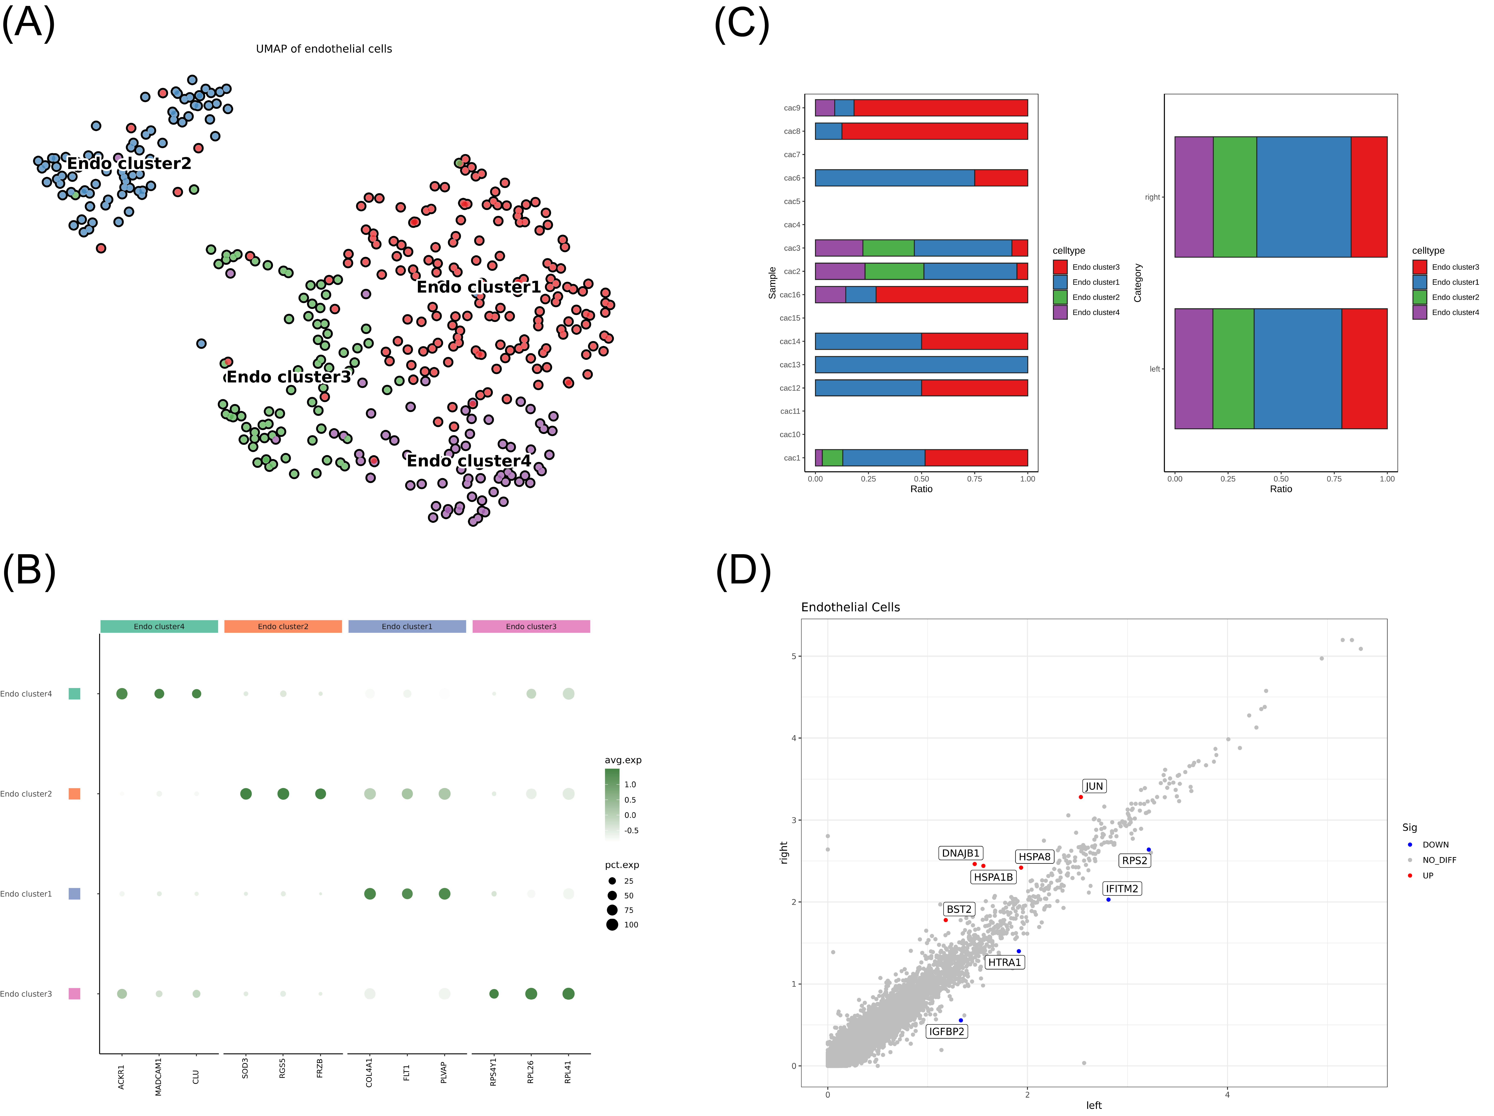
Supplementary Figure 14. Differences in endothelial cells between RCRC and LCRC.

