Supplementary figures

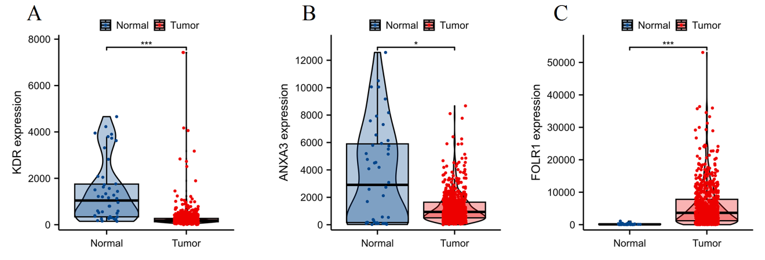
Figure S1 Verify the gene expression levels of core toxicity targets using the TNMplot database. *p < 0.05, ***p < 0.001. ns indicates no significant difference.

