Supplement files

Table 1 Comparison of high- and low- value of activated MCs in the clinical parameters in TCGA-COADREAD dataset
Variables | high (N=318) | low (N=319) | P value
Age (years) | 68.0 (60.0 to 76.0) | 67.0 (57.0 to 76.0) | 0.228
Gender |  |  | 0.455
NA | 1 (0.3%) | 2 (0.6%)
Female | 156 (49.1%) | 142 (44.5%)
Male | 161 (50.6%) | 175 (54.9%)
Location
COAD | 248 (78%) | 223 (69.9%) | 0.026
READ | 70 (22%) | 96 (30.1%)
Histological type
NA | 7 (2.2%) | 7 (2.2%) | 0.039
Adenocarcinoma | 261 (82.1%) | 283 (88.7%)
Mucinous | 50 (15.7%) | 29 (9.1%)
T stage
NA | 1 (0.3%) | 3 (0.9%) | 0.630
T1 | 9 (2.8%) | 12 (3.8%)
T2 | 59 (18.6%) | 49 (15.4%)
T3 | 215 (67.6%) | 217 (68%)
T4 | 34 (10.7%) | 38 (11.9%)
N stage
NA | 1 (0.3%) | 3 (0.9%) | 0.594
N0 | 187 (58.8%) | 174 (54.5%)
N1 | 69 (21.7%) | 83 (26%)
N2 | 60 (18.9%) | 58 (18.2%)
NX | 1 (0.3%) | 1 (0.3%)
M stage
NA | 5 (1.6%) | 7 (2.2%) | 0.326
M0 | 237 (74.5%) | 233 (73%)
M1 | 49 (15.4%) | 40 (12.5%)
MX | 27 (8.5%) | 39 (12.2%)
Tumor stage
NA | 6 (1.9%) | 17 (5.3%) | 0.098
I | 58 (18.2%) | 50 (15.7%)
II | 119 (37.4%) | 115 (36.1%)
III | 85 (26.7%) | 97 (30.4%)
IV | 50 (15.7%) | 40 (12.5%)
NA: Not available

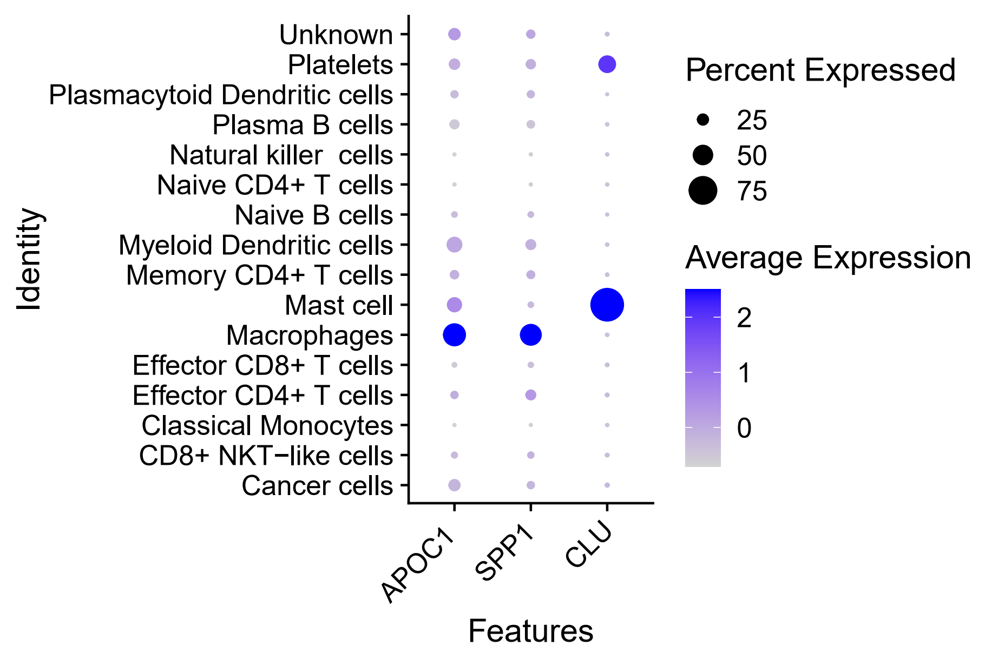
Figure S1 Expression of APOC1, SPP1, CLU in different cell types of scRNA-seq dataset (GSE178318)

