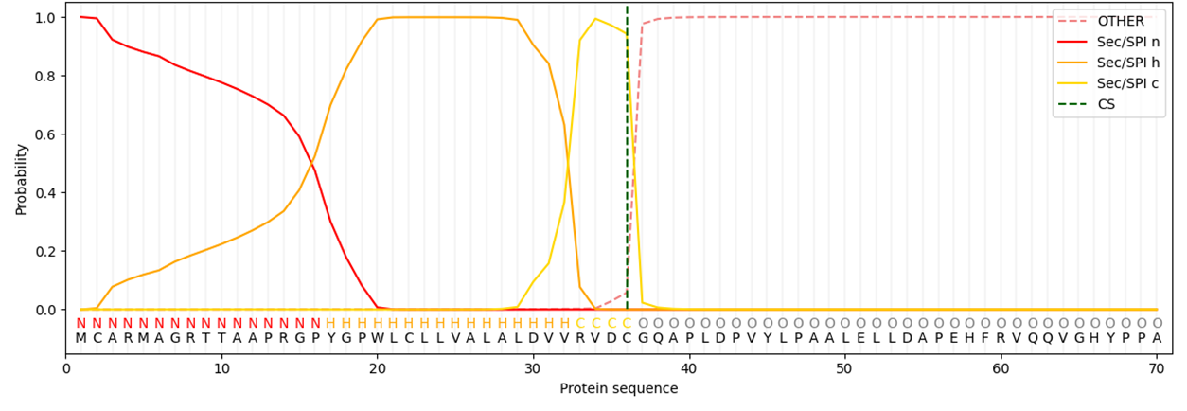
Supplementary Figure 2. Signal peptide prediction of TMEM132A.
Signal peptide analysis performed using SignalP predicted that residues 1-20 of TMEM132A constitute a signal peptide. The highest-scoring predicted S-palmitoylation site (Cys2), identified by CSS-Palm, is located within this region.

