Supplementary Figures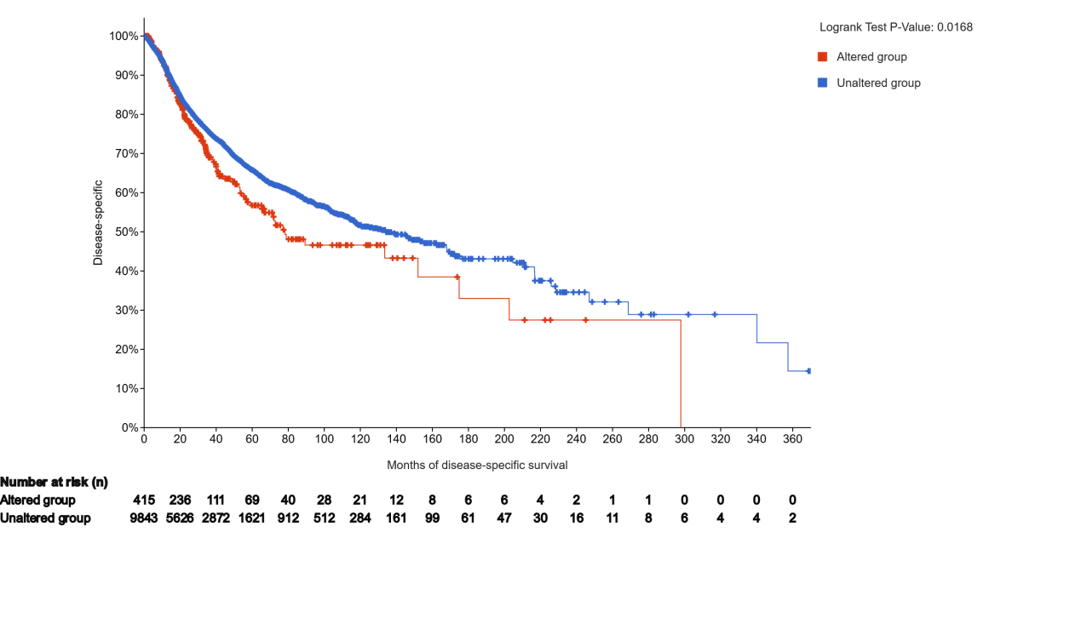

Fig. 1 Kaplan-Meier analysis of DDFS comparing CCT5-mutated and wild-type groups.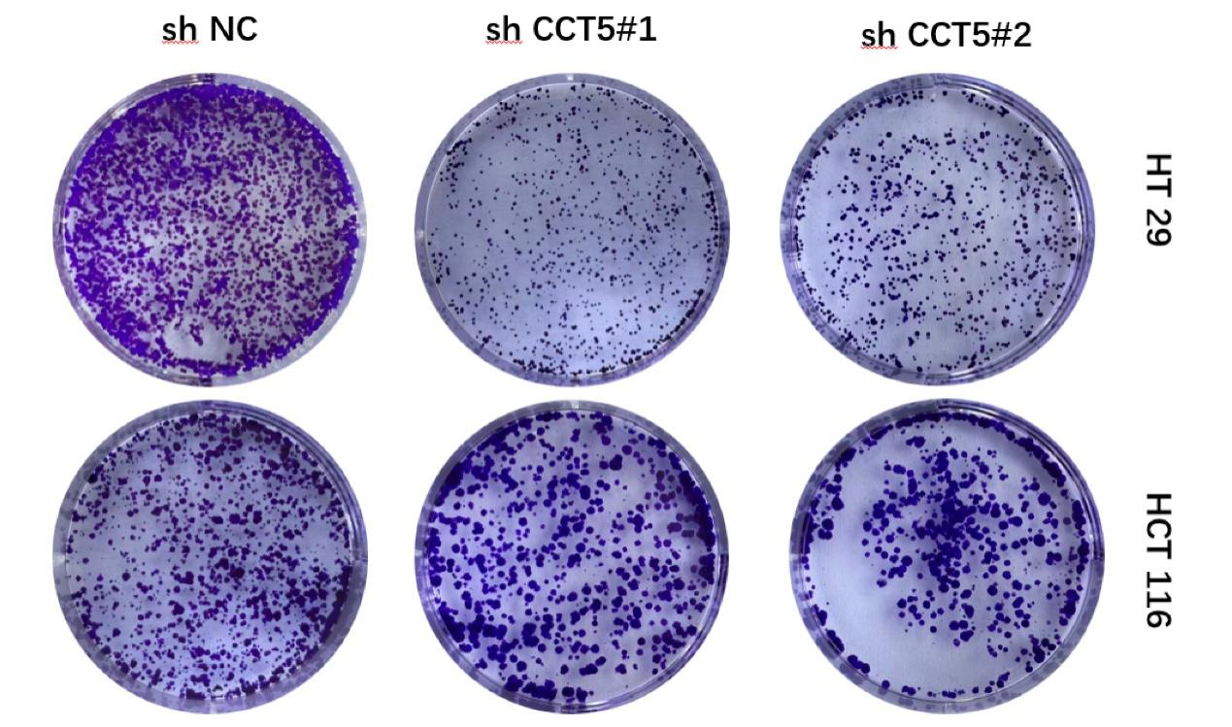

Fig. 2 Colony formation assay demonstrates reduced colony formation capacity following CCT5 knockdown.
Fig. 3 Quantitative analysis of Wnt3A, β-catenin, c-Myc, and cyclin D1 protein expression in HT29 and HCT116 cells.
Western blot raw image
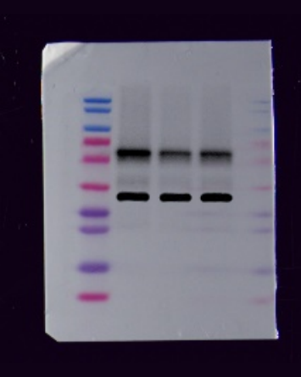
Fig. 4 Original figure for protein expression validation following CCT5 knockdown in HCT116 Cells.
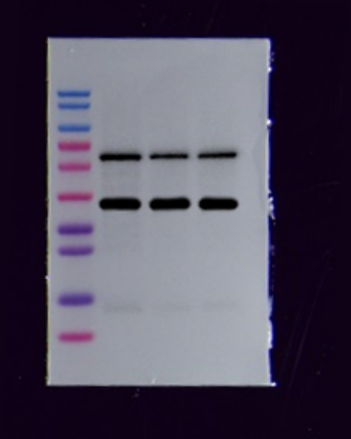
Fig. 5 Original figure for protein expression validation following CCT5 knockdown in HT29 Cells.
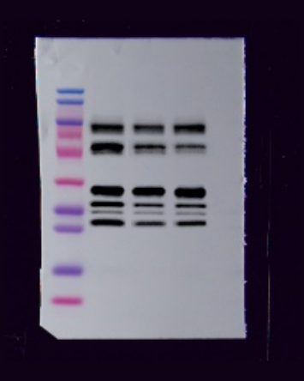
Fig. 6 Original image of Wnt, β-catenin, Myc, Cyclin D1 and GAPDH protein expression in HCT116 cells following CCT5 knockdown.
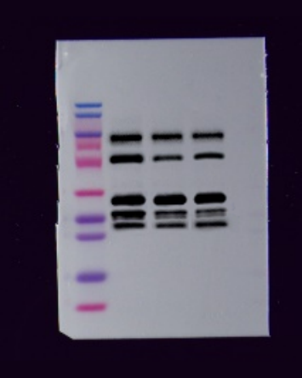
Fig. 7 Original image of Wnt, β-catenin, Myc, Cyclin D1 and GAPDH protein expression in HT29 cells following CCT5 knockdown.
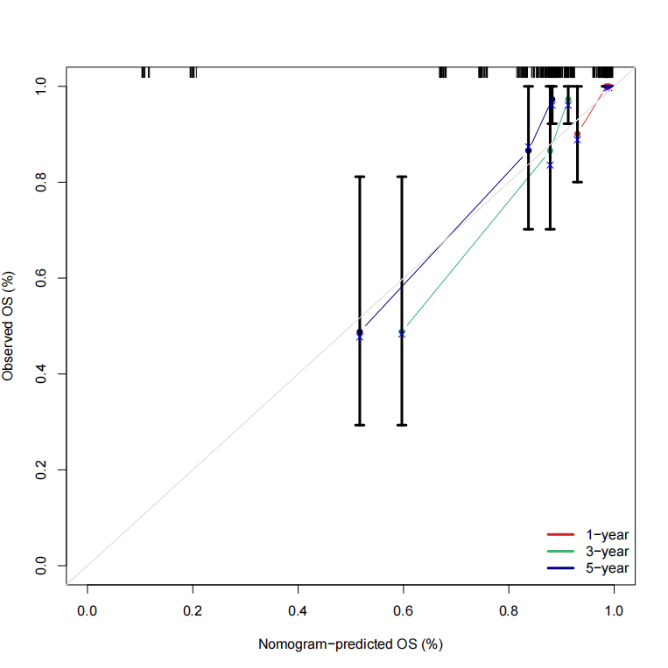
Fig. 8 Nomogram Calibration
Table 1: Information on Antibodies Used in the Experiment.
Antibody | Host Species | Manufacturer | Catalog No. | Dilution
CCT5 | Rabbit | Thermo Fisher Scientific | PA5-78955 | 1：1000
Wnt3a | Rabbit | Servicebio | GB113750 | 1：1000
β-catenin | Rabbit | Servicebio | GB150016 | 1：1000
c-Myc | Rabbit | Promab | P20935 | 1：1000
Cyclin D1 | Rabbit | Servicebio | GB151372 | 1：1000
GAPDH | Rabbit | Servicebio | GB15004 | 1：10000

Survival plot summary | Number of Cases, Total | Number of Events | Median Months Overall (95% CI)
Altered group | 425 | 168 | 56.71 (43.30 - 75.48)
Unaltered group | 10378 | 3345 | 80.84 (75.09 - 85.51)
Table 2: The total number of OS survival curves and events in the cct5 mutation group and non mutation group.

Hazard ratio ( ±95% confidence interval) | Altered group | Unaltered group
Altered group | 1.000 (0.792-1.263) | 0.834 (0.705-0.987)
Unaltered group | 1.199 (1.014-1.419) | 1.000 (0.953-1.049)
Table 3: Hazard Ratio (HR) and 95% Confidence Interval (CI) Analysis of the Impact of CCT5 Mutations on Overall Survival (OS).

Table 4: Results of Univariate Cox Proportional Hazards Analysis.
id | β | HR | HR.95L | HR.95H | pvalue
Age | -0.008 | 0.992 | 0.947 | 1.038 | 0.725
Sex | 0.181 | 1.199 | 0.420 | 3.422 | 0.735
N | 1.266 | 3.547 | 1.557 | 8.077 | 0.003
Stage | 1.050 | 2.859 | 1.331 | 6.140 | 0.007
CCT5 | 0.429 | 1.536 | 1.249 | 1.889 | 0.000

Table 5: Results of Multivariate Cox Proportional Hazards Analysis.
id | β | HR | HR.95L | HR.95H | pvalue
Age | -0.014 | 0.986 | 0.940 | 1.035 | 0.572
Sex | 0.171 | 1.187 | 0.369 | 3.814 | 0.773
N | 0.130 | 1.139 | 0.425 | 3.056 | 0.796
Stage | 1.253 | 3.500 | 1.148 | 10.667 | 0.028
CCT5 | 0.413 | 1.511 | 1.189 | 1.920 | 0.001

