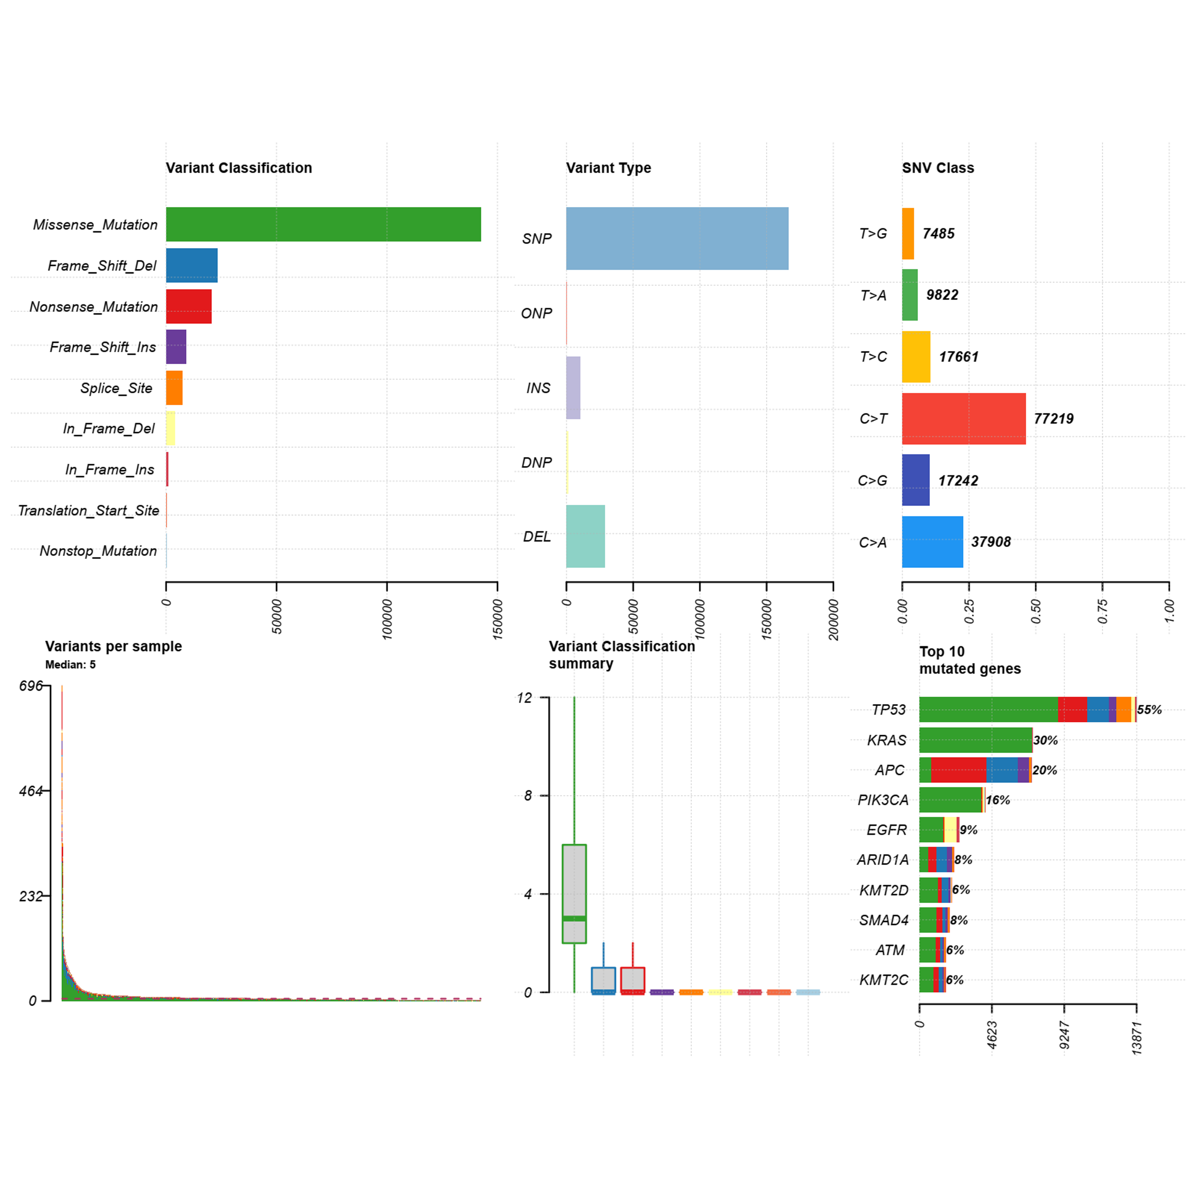
Supplemental Figure 1 Gene mutation status in all breast cancer patients.
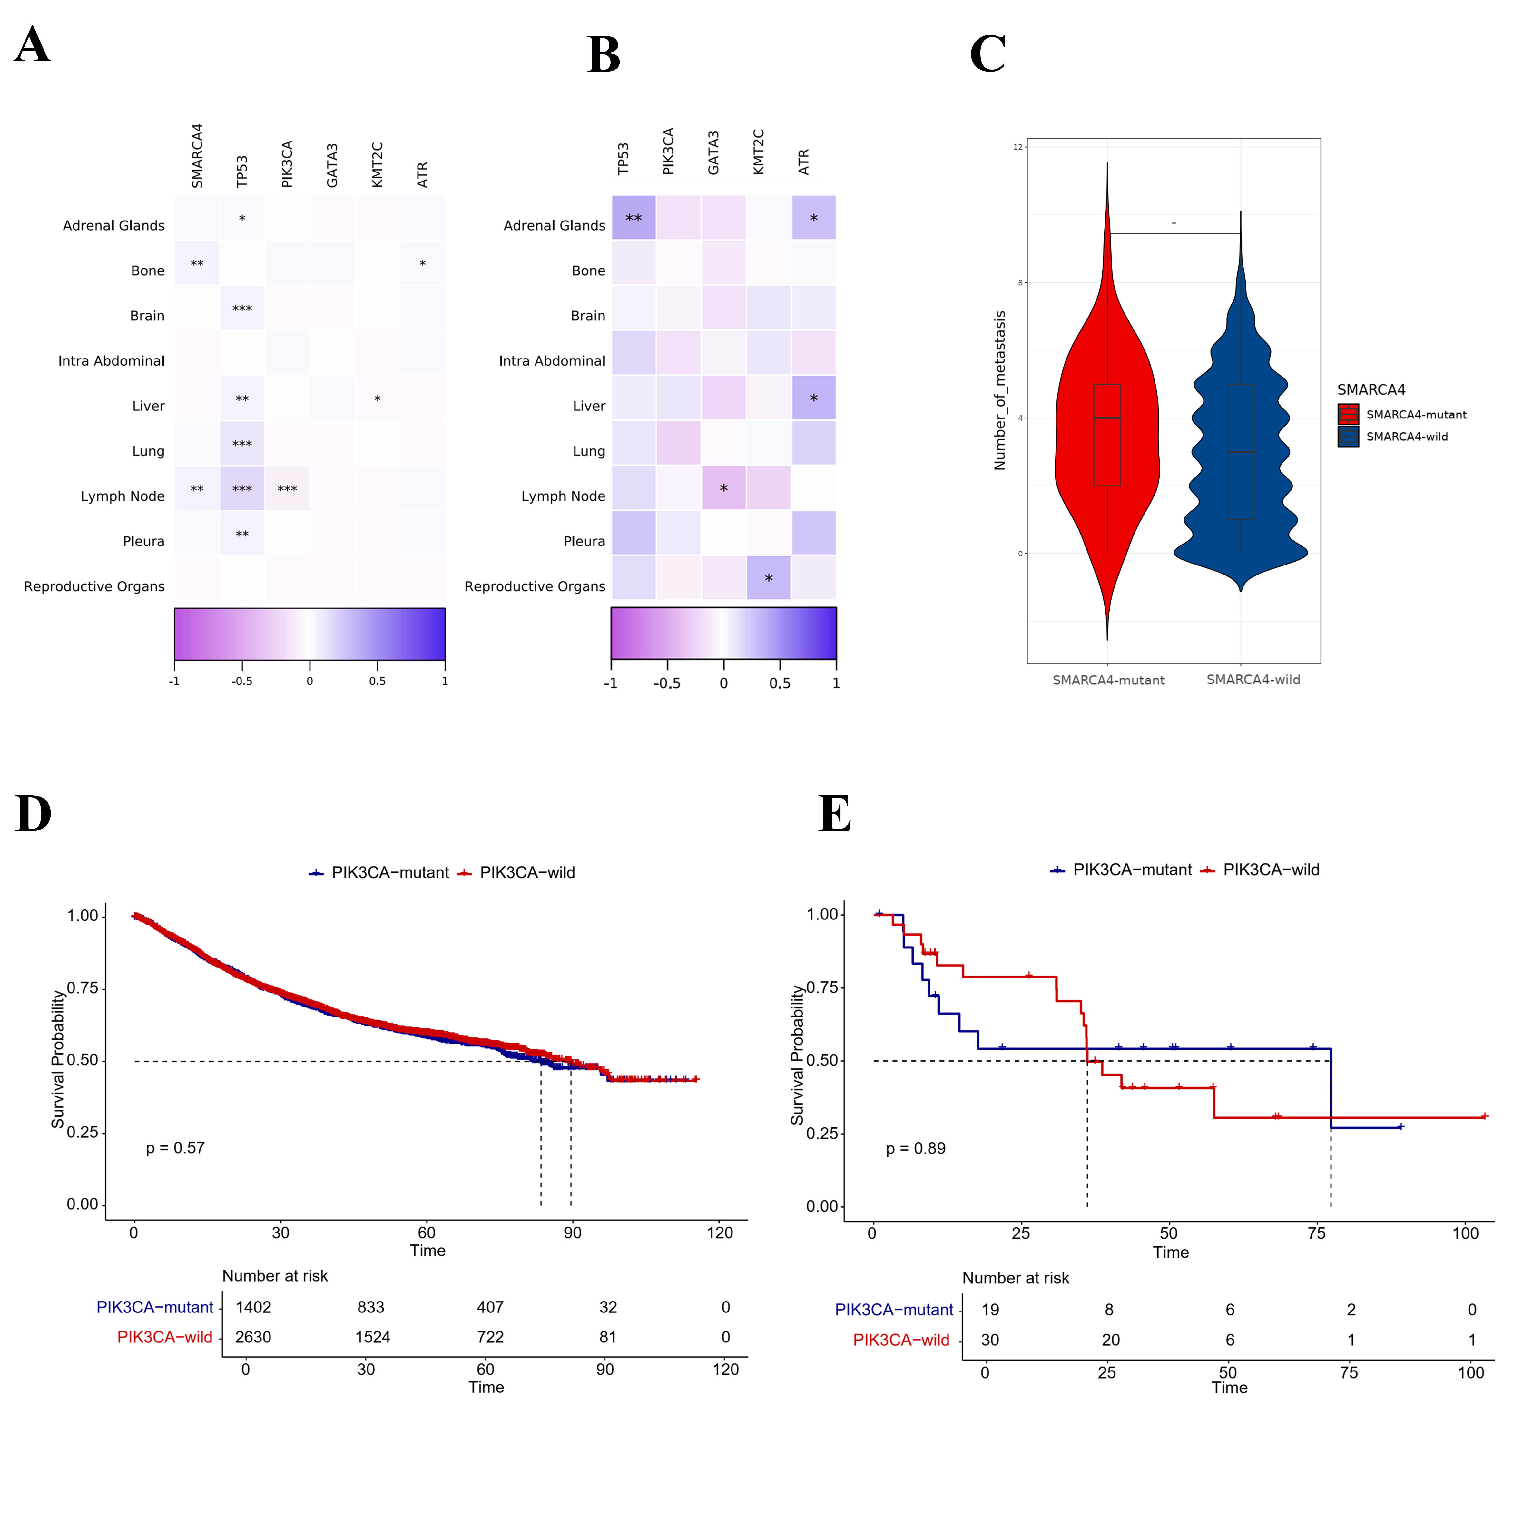
Supplemental Figure 2 A) Relation between gene mutation and metastasis in all patients. B) Relation between gene mutation and metastasis in SMARCA4 mutant patients C) The number of metastasis sites between two groups (*p< 0.05). D) Role of PIK3CA in SMARCA4 wild group. E) Role of PIK3CA in SMARCA4 mutant patients. 533/1402 participants in PIK3CA mutant group, 953/2630 participants in PIK3CA-wild group, 16/30 in PIK3CA-wild with SMARCA4-mutant group and 9/19 in PIK3CA-mutant with SMARCA4-mutant group experienced outcome events.

